CR Landscaping

Table of Contents

Overview and Design Goals 5

Requirements 6

User Interfaces 6

Desktop Interfaces 6

Adding Tasks 6

Creating Jobs 7

Editing Jobs 8

View Reschedule Requests 9

Add Certification 10

Delete Certification 11

Labor Schedule Labor 13

Manage Certifications 14

Manage Work Applications 15

Schedule Group 16

Assign Group Members 17

Delivery Ticket Details 18

Employee Schedule 19

Job Site Details Tab 20

Job Tasks Job Completion 21

Availability 22

Available Jobs 23

Certifications 24

Add Certifications 25

Update Certification 26

Company Policies 27

Create Profile 28

Employee Services 29

Job History 30

Detailed Description (Equipment) 31

Equipment Management 31

Inspector Records 33

Checklist System 34

Equipment Schedule System 36

Equipment Work Queue System 37

Repair Records 39

Add/Edit Job Request Order 40

Add/Edit Special Request 41

Edit/Create Supply Locations 41

Edit/Create Supply Orders 42

Supply Viewer 44

View Request 45

View Supply Location 46

View Supply Orders 47

Web Interface 48

View Job Requests 48

Edit Job 49

Create Job 50

Logical Models 51

Logic-Layer Classes 51

Supply Management 51

Equipment Management 51

Job Scheduling 52

Labor Scheduling 54

Data Transfer Objects 55

Data Access Classes 56

Supply Management 56

Equipment Management 57

Job Scheduling 58

Labor Scheduling 59

E-R Diagram 60

Data Dictionary 62

Additional Functional Models 76

Data Flow Diagrams 76

Supply Management 77

Equipment Management 85

Job Scheduling 86

Labor Scheduling 87

Use Case Diagrams 89

Supply Management 89

Equipment Management 91

Job Scheduling 94

Labor Scheduling 95

Activity Diagrams 99

Supply Scheduling 99

Job Scheduling 100

Formal Use Cases 101

Supply Management 101

Equipment Management 149

Job Scheduling 212

Labor Scheduling 274

Project Proposal 363

Overview 363

Background 363

Objectives 363

Scope 363

Agile Methods/Scrum 363

Additional Requirements 364

Platform Targets 364

Tools and Versions 364

# Overview and Design Goals

To design a data system for a landscaping business to help manage

# Requirements

Needs to have SQL server installed.

# User Interfaces

## Desktop Interfaces

### Adding Tasks

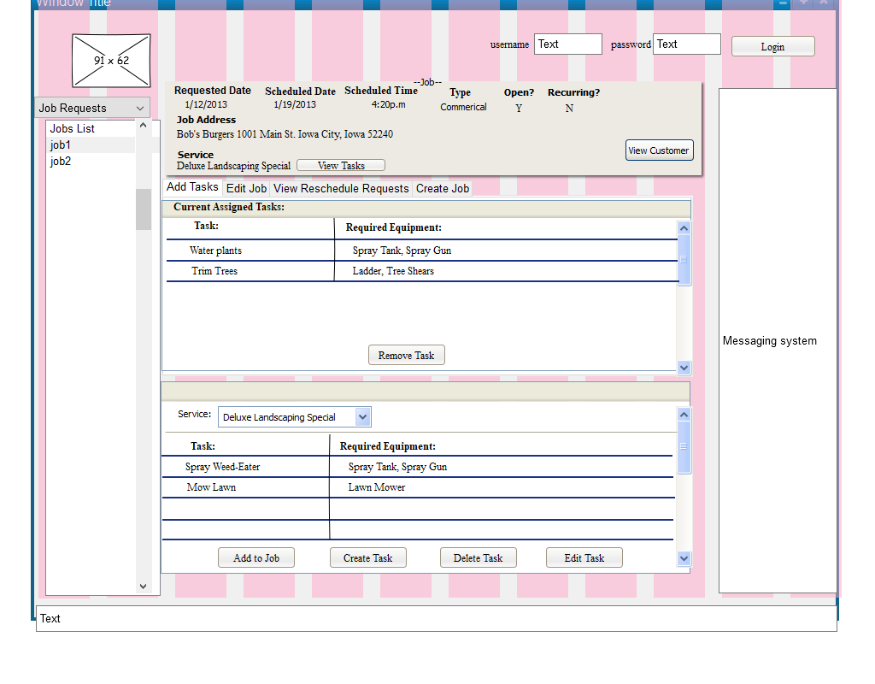

### Creating Jobs

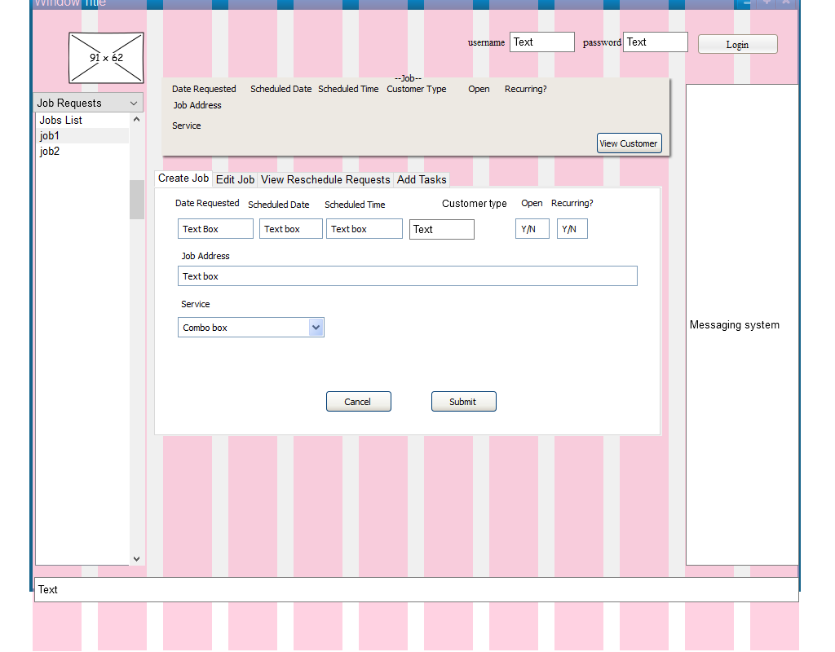

### Editing Jobs

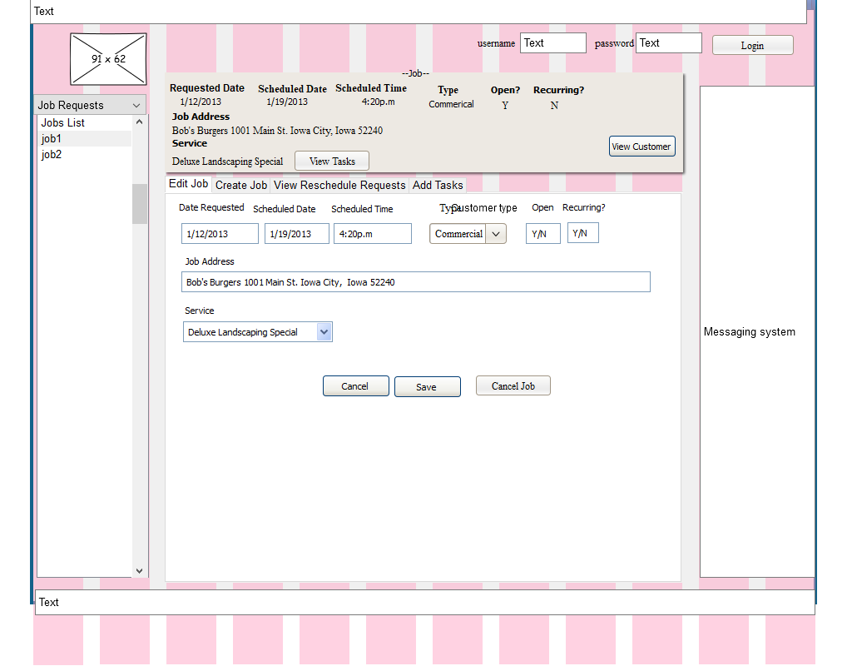

### View Reschedule Requests

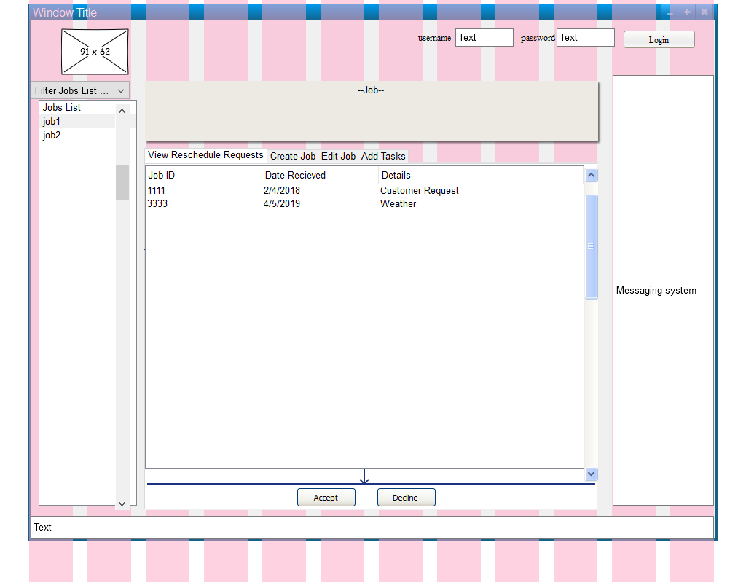

Add Certification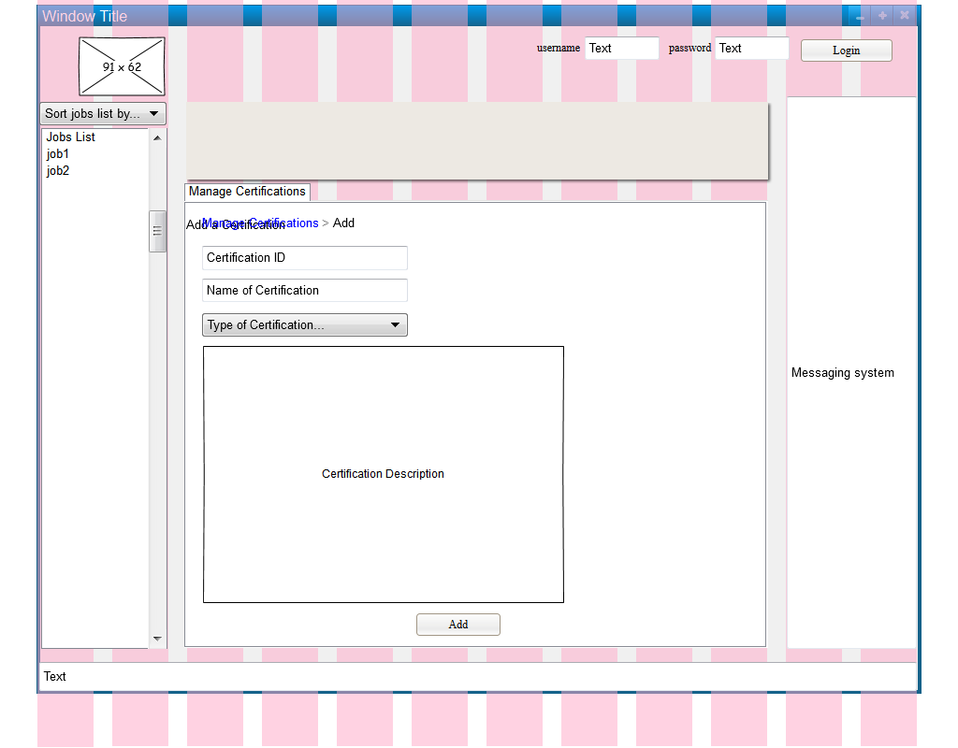

### Delete Certification

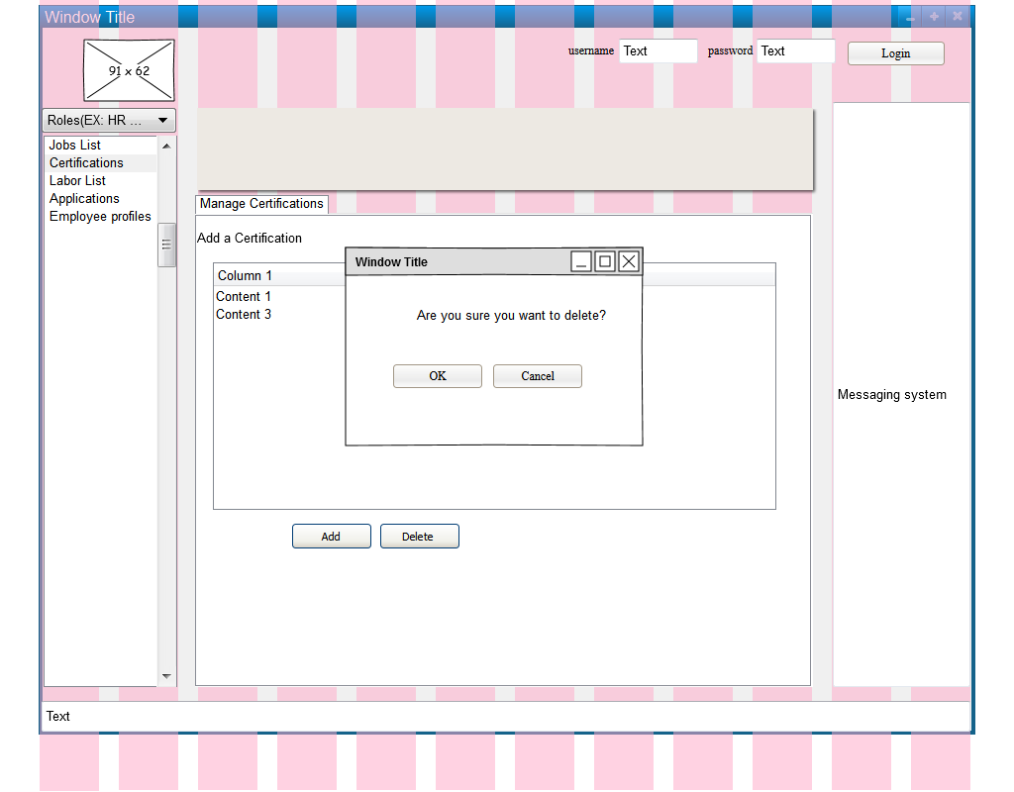Foreman View Available Laborers

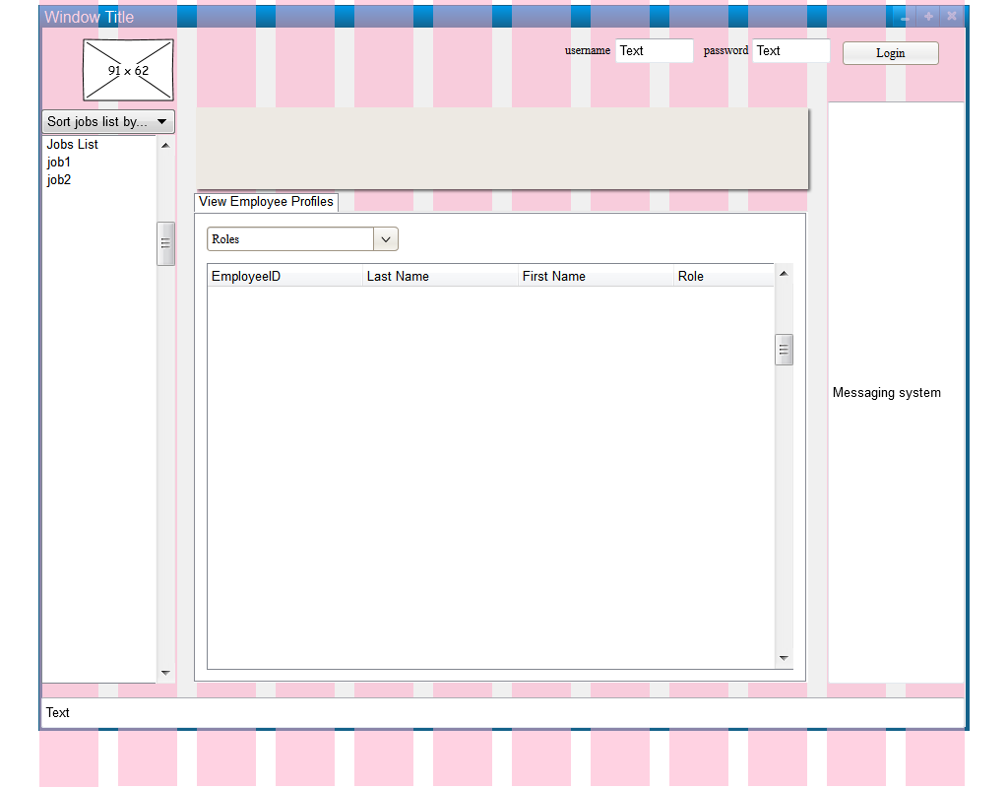

### Labor Schedule Labor

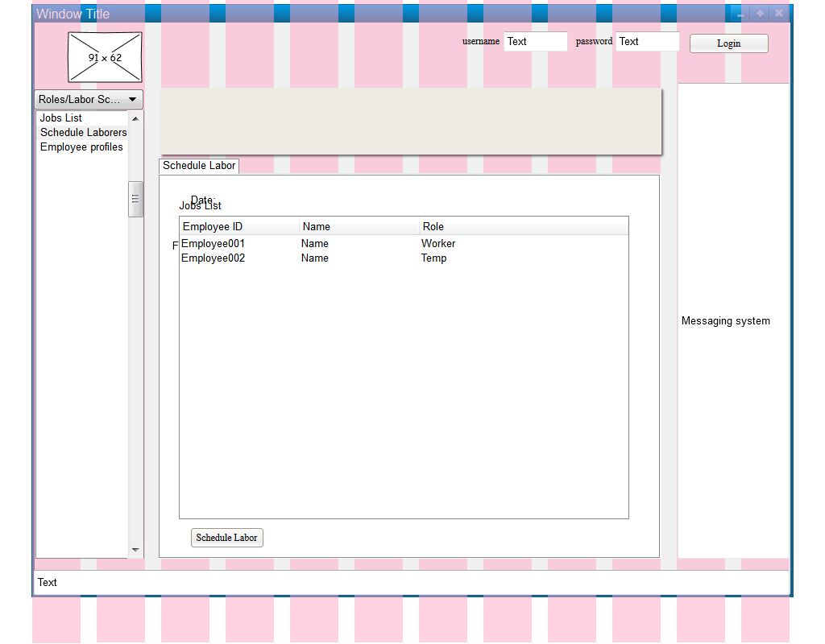

### Manage Certifications

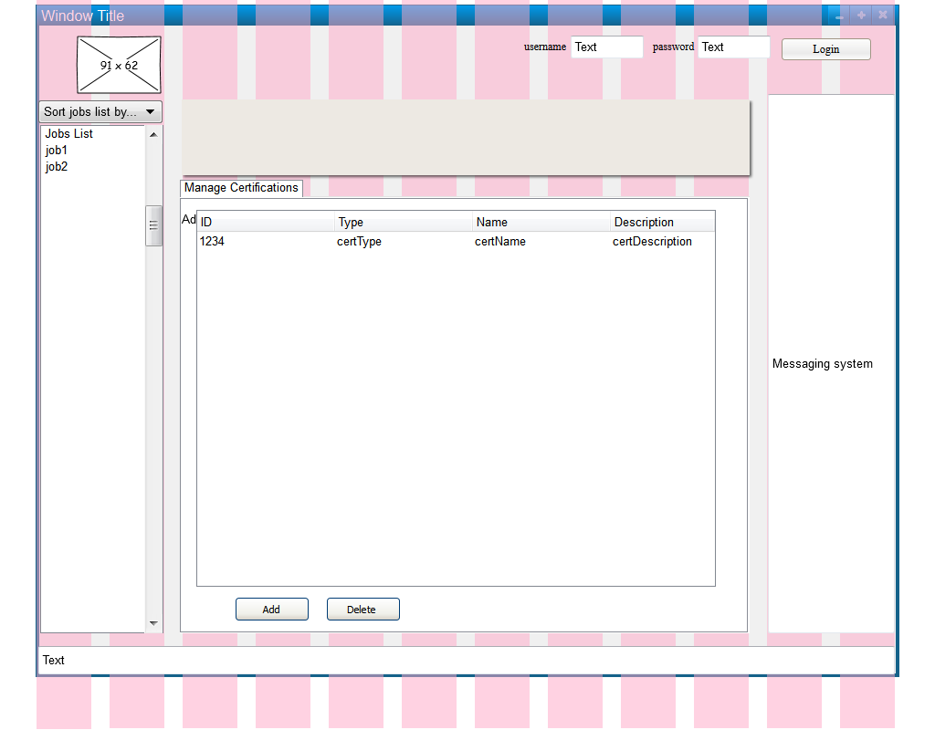

### Manage Work Applications

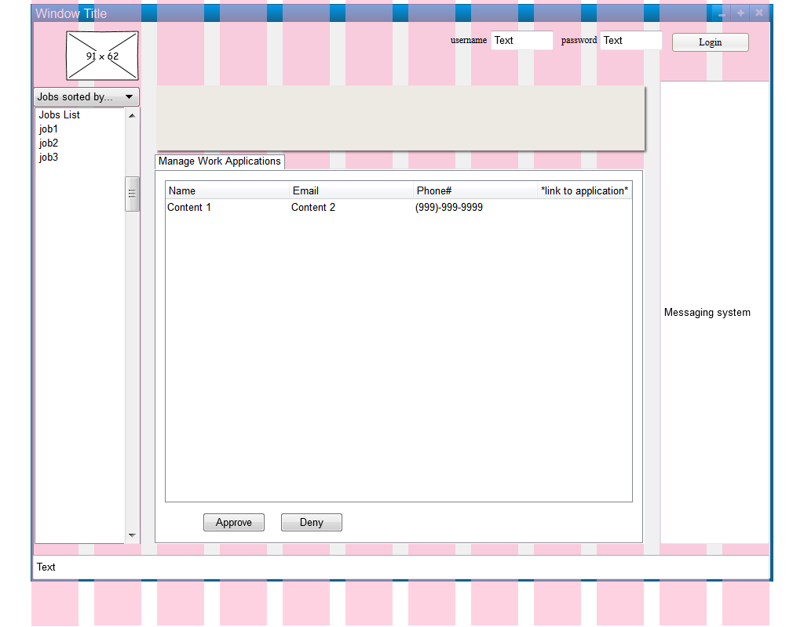

### Schedule Group

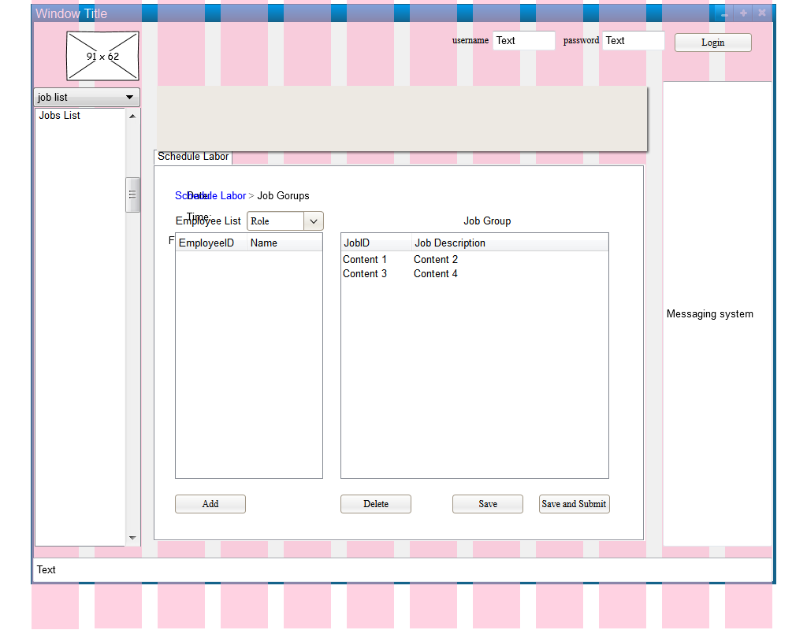

### Assign Group Members

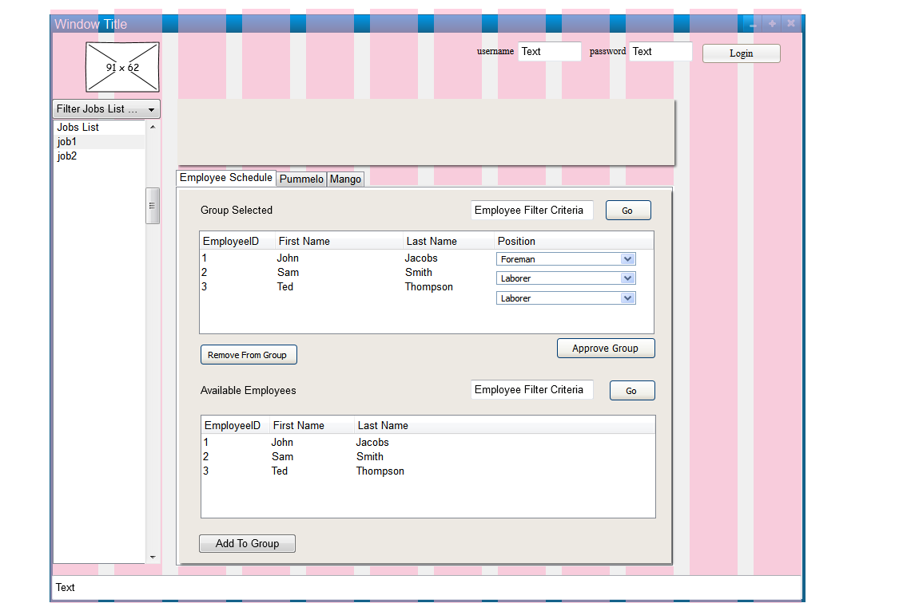

### Delivery Ticket Details

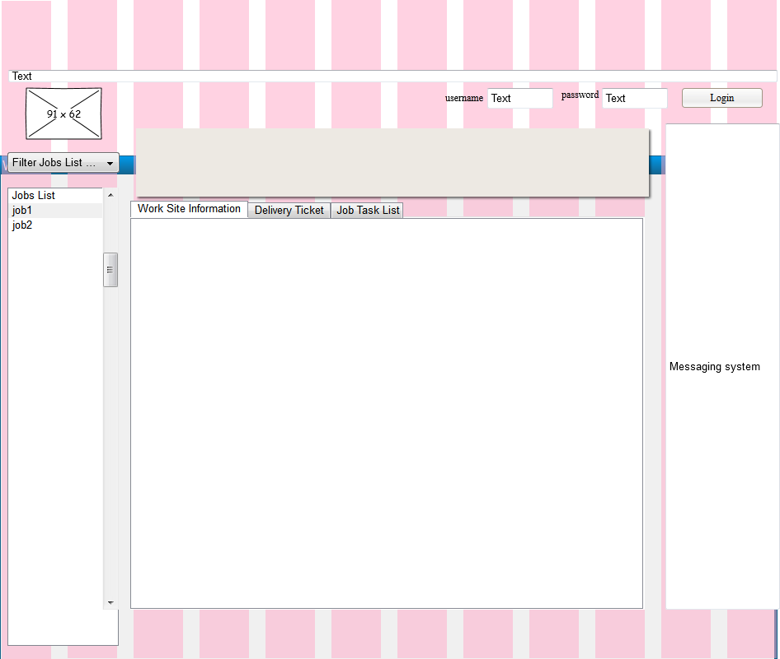

### Employee Schedule

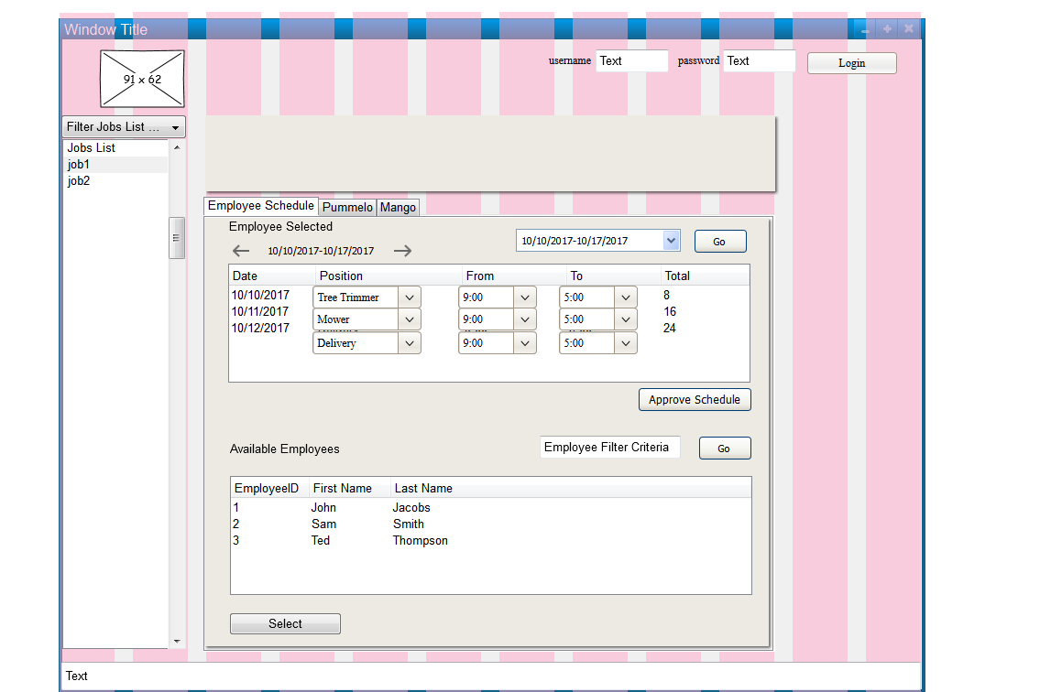

### Job Site Details Tab

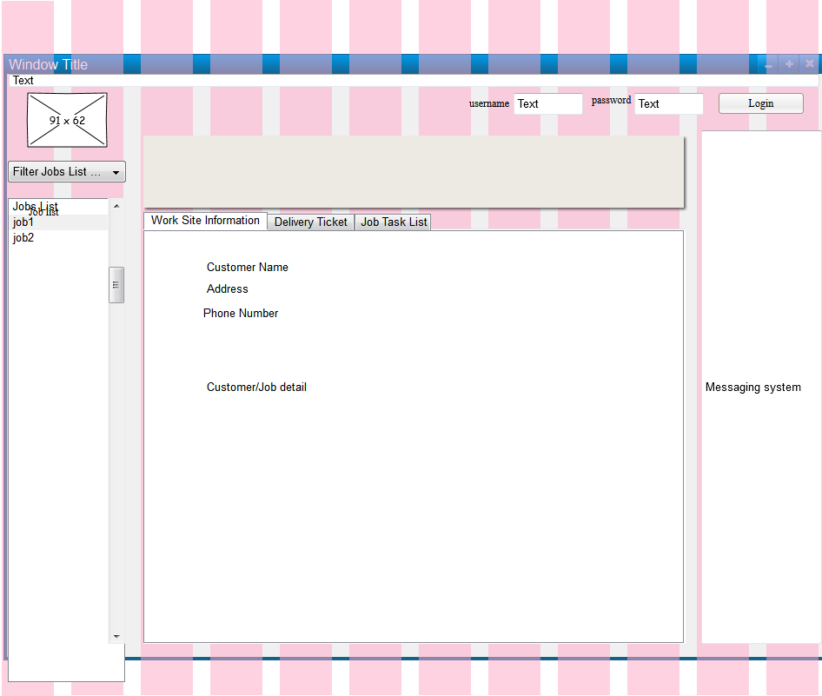

### Job Tasks Job Completion

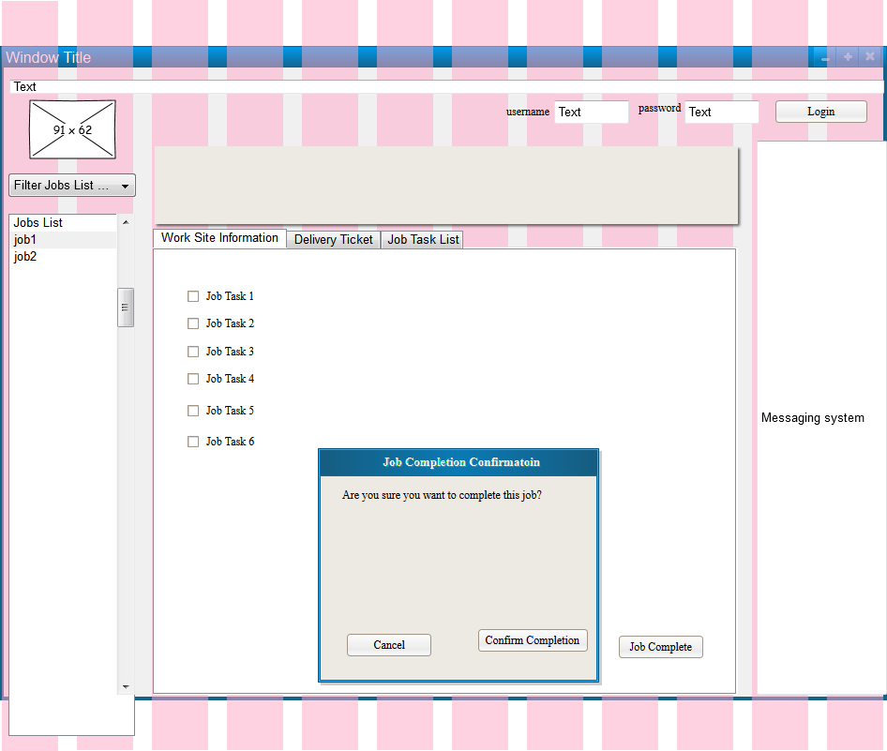

### Availability

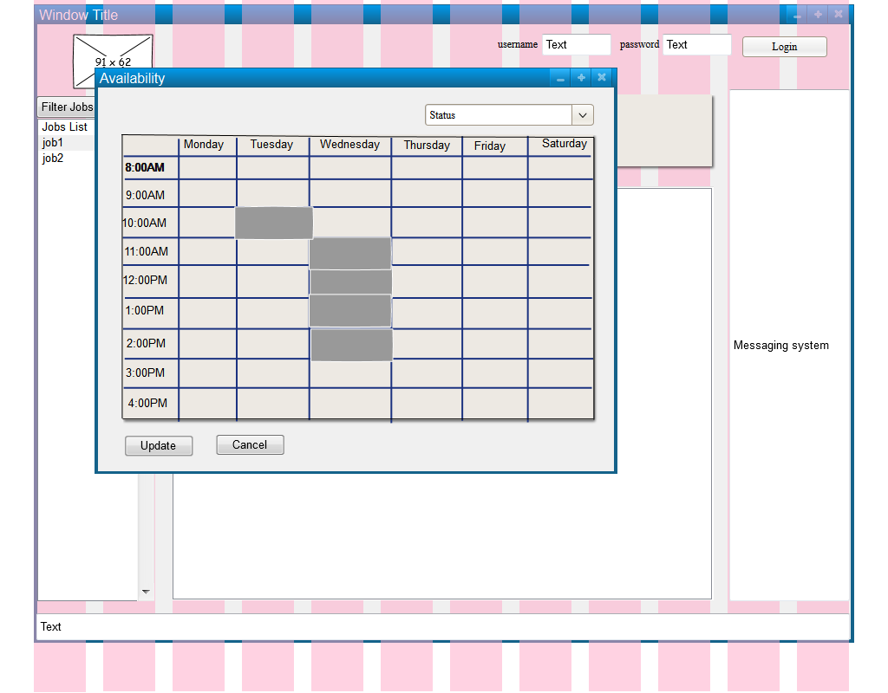

### Available Jobs

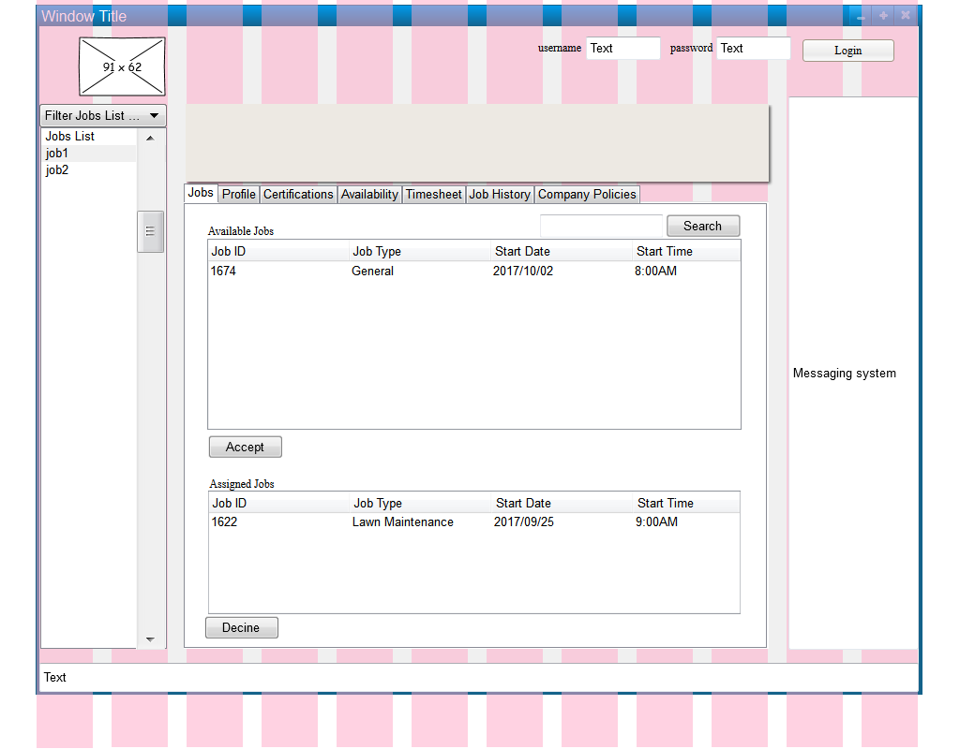

### Certifications

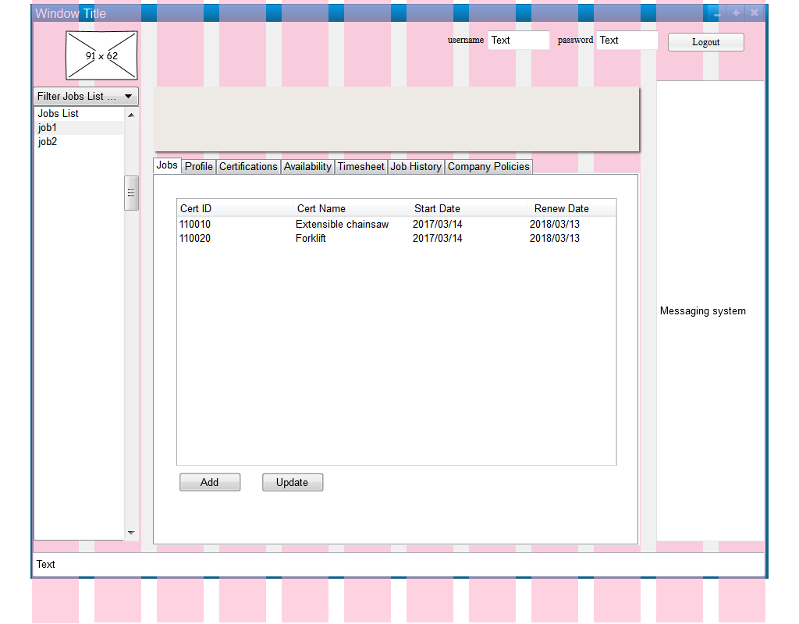

### Add Certifications

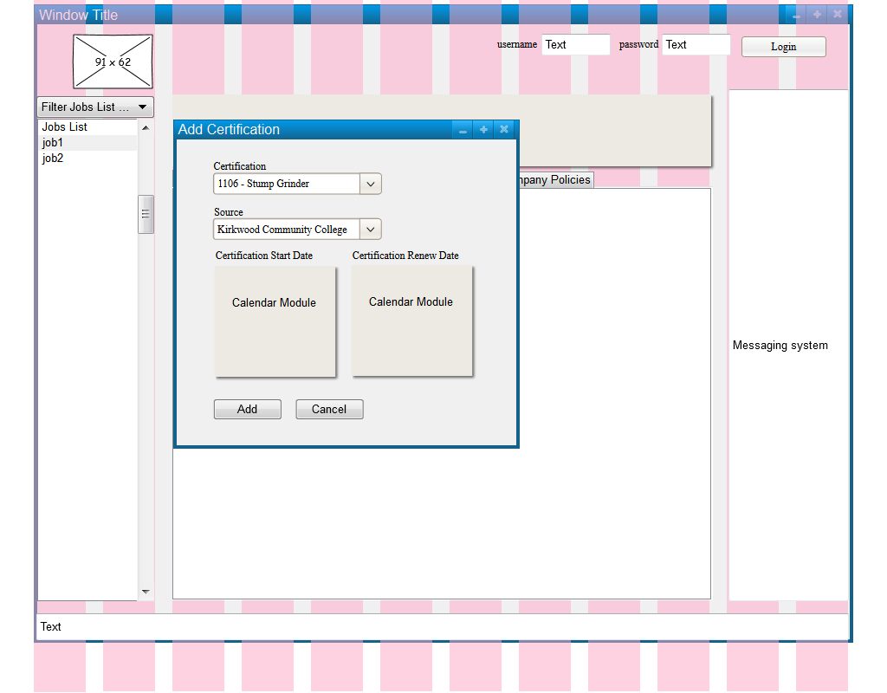

### Update Certification

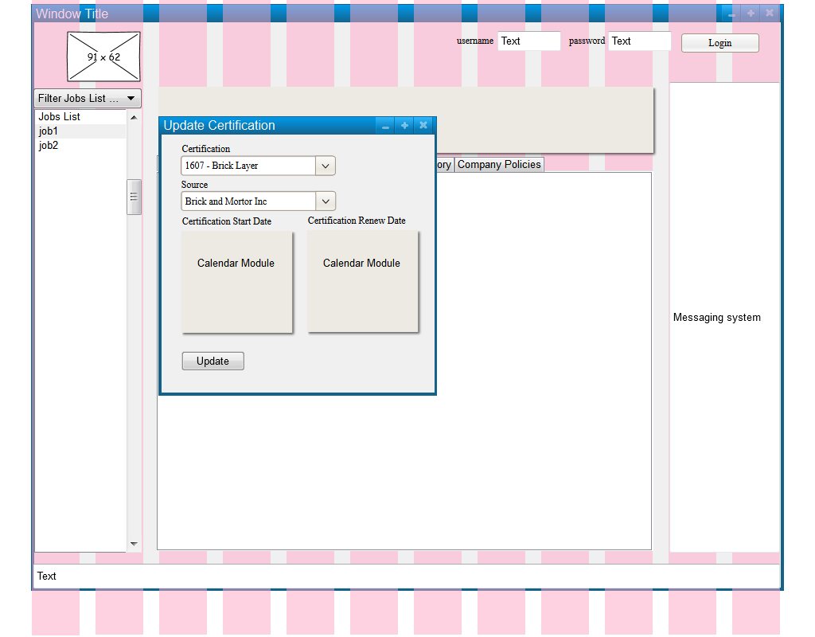

### Company Policies

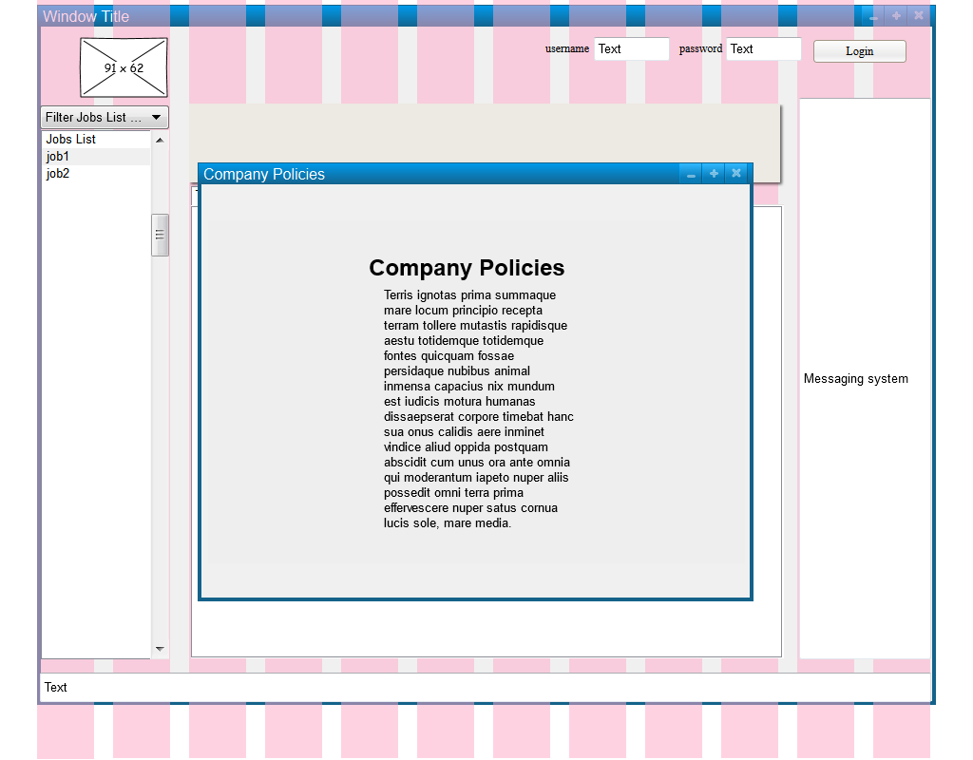

### Create Profile

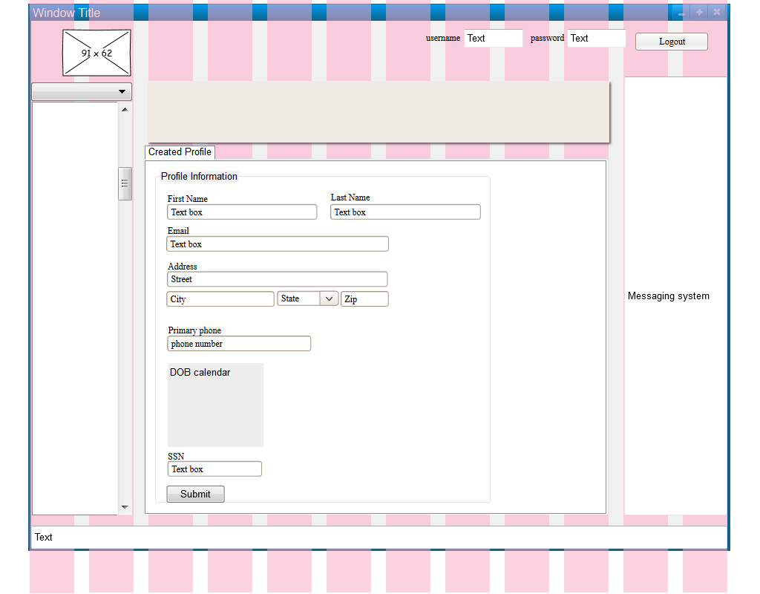

### Employee Services

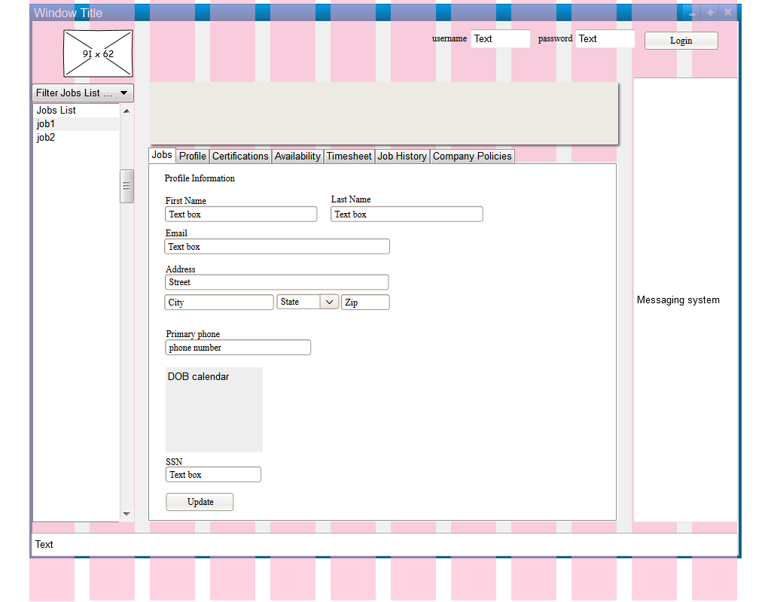

### Job History

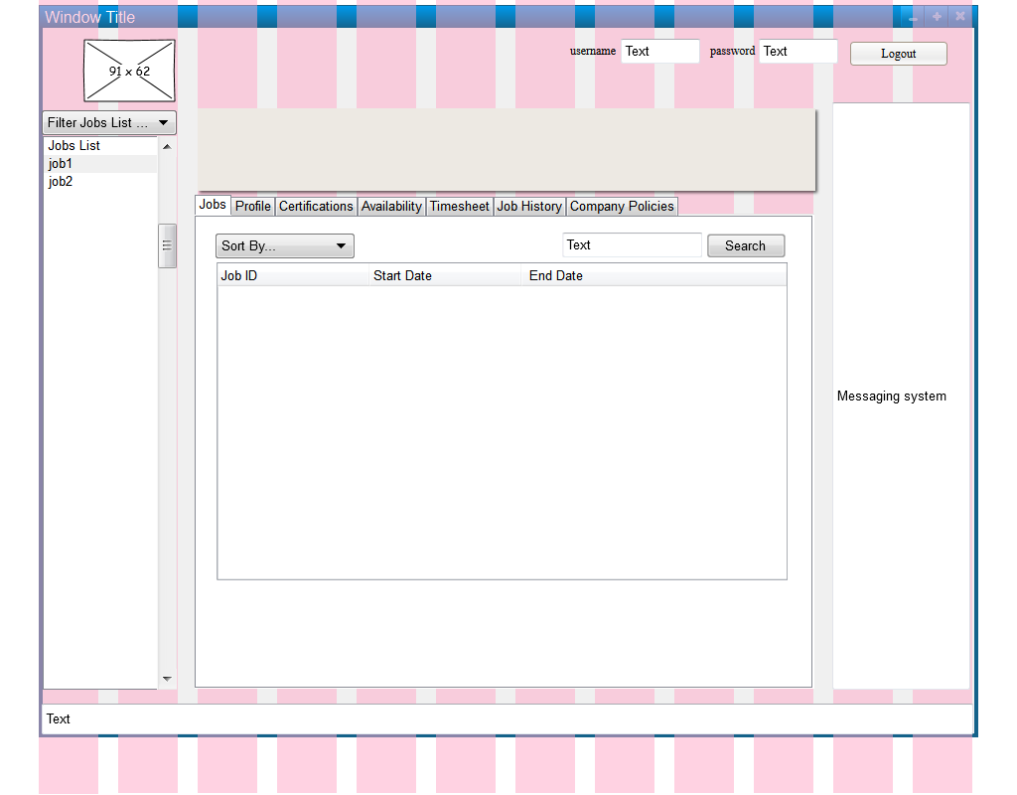

### Detailed Description (Equipment)

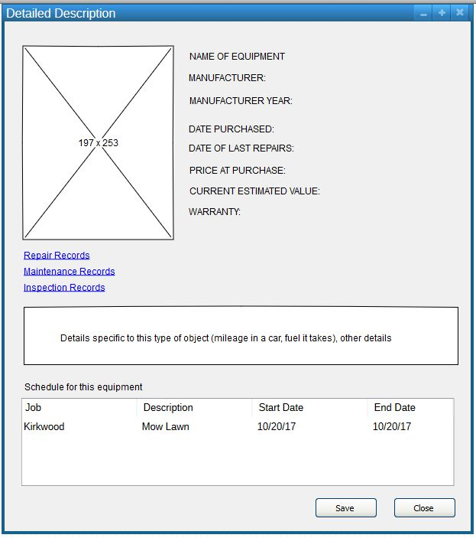

### Equipment Management

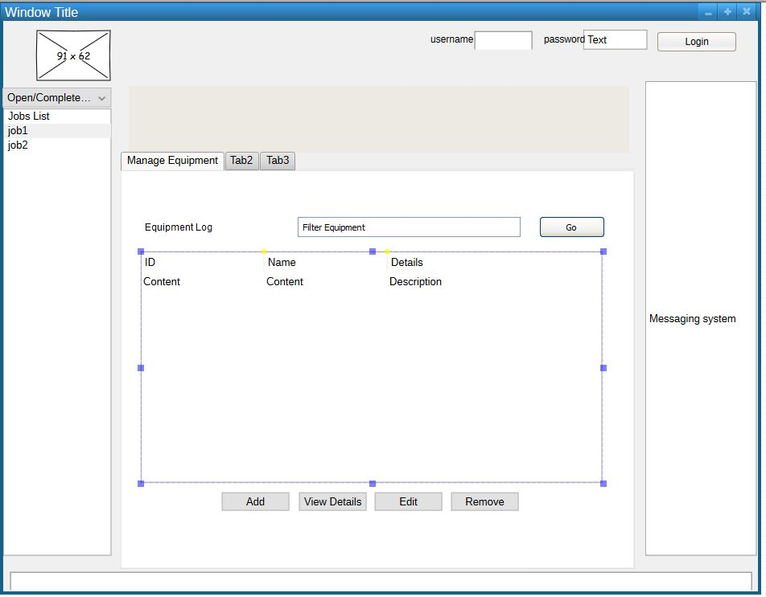

Inspector Records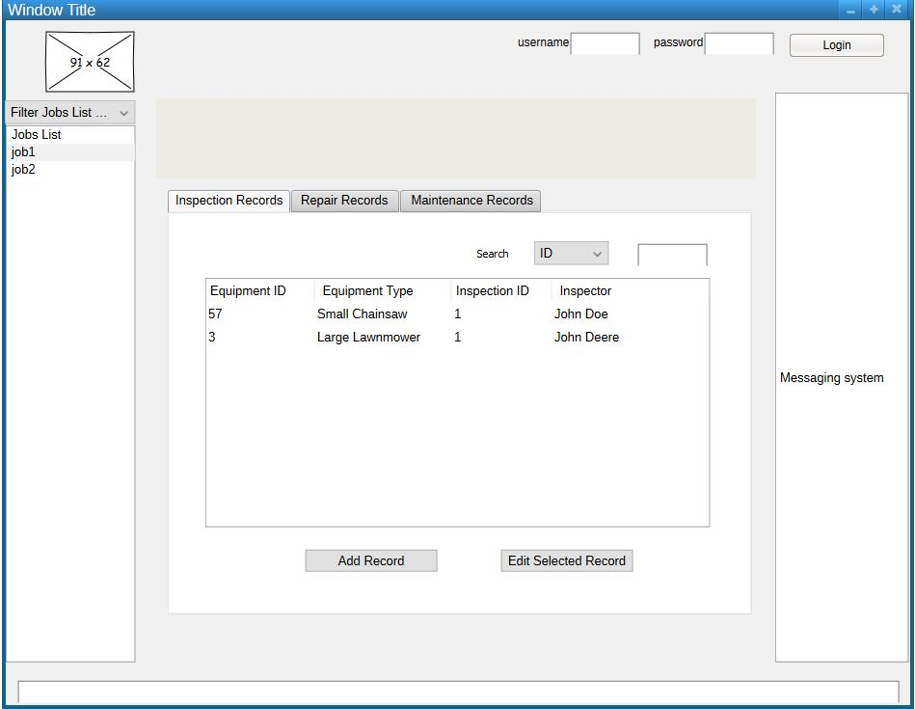

### Checklist System

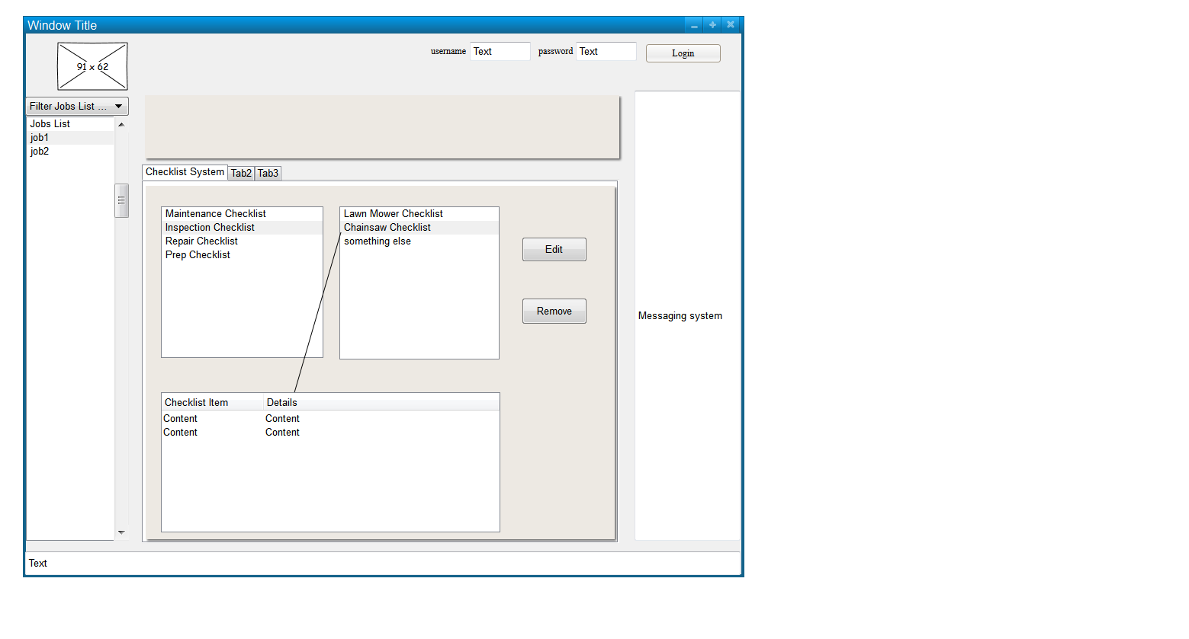  
Popup Window for Checklist System  
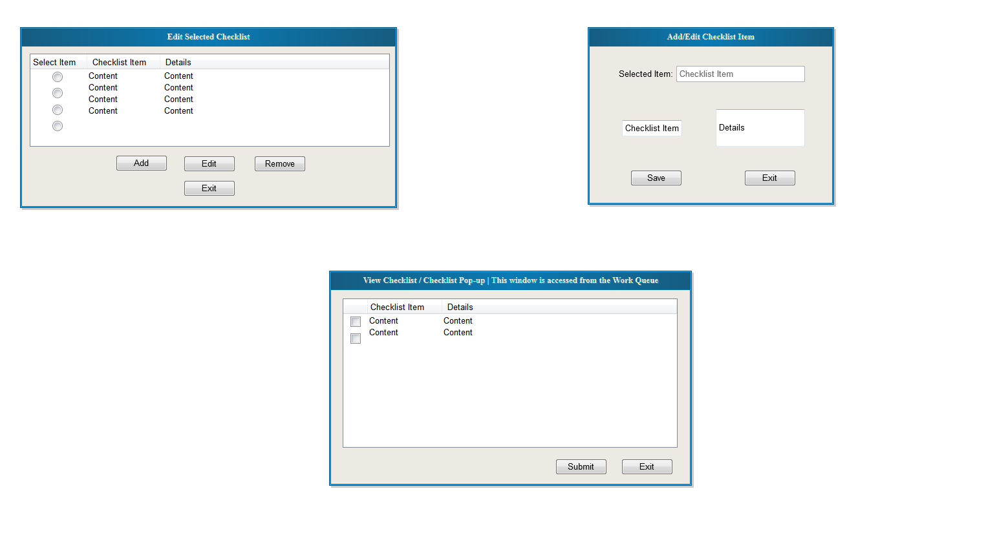

Messaging System

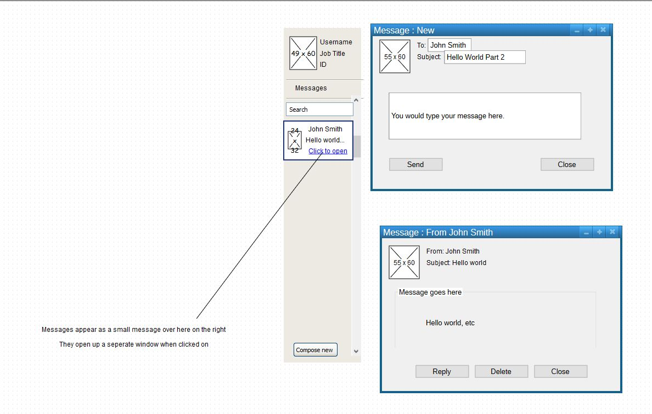

### Equipment Schedule System

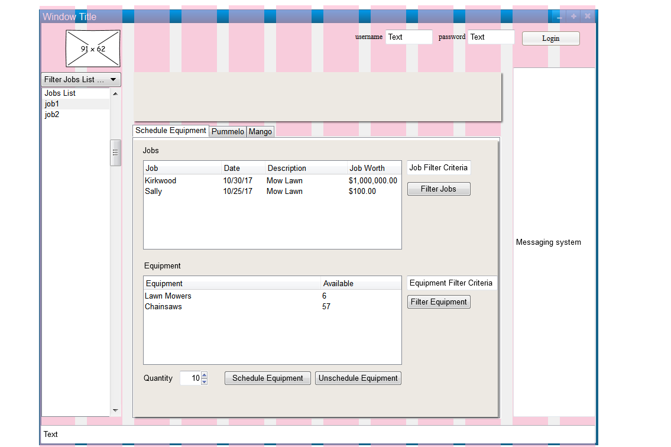

### Equipment Work Queue System

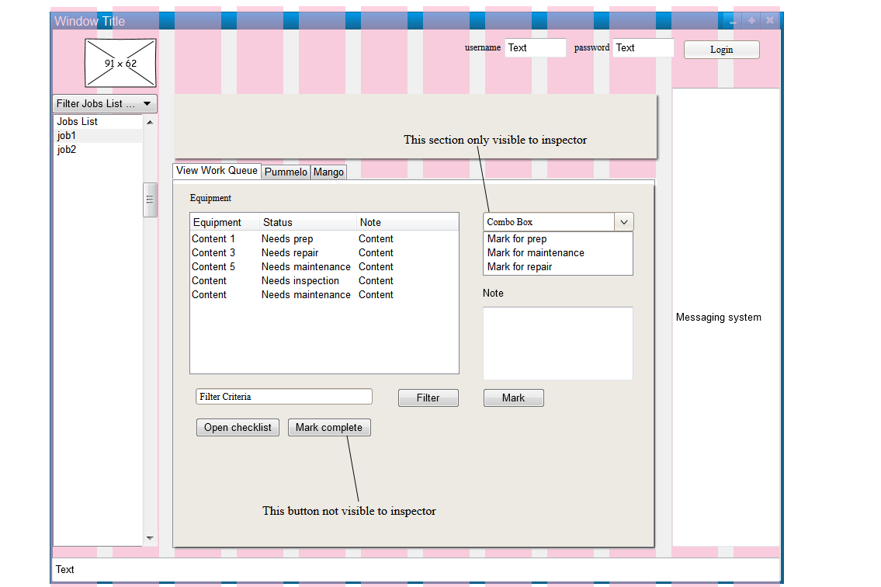

### Repair Records

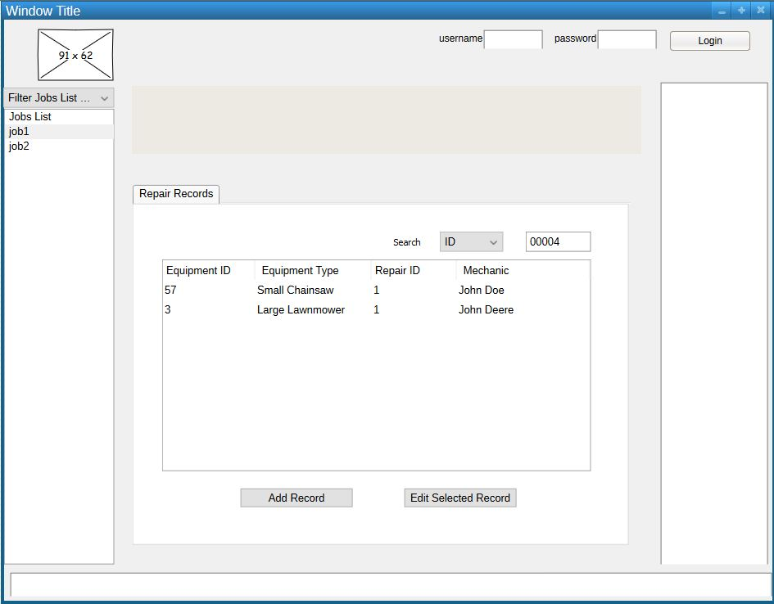

### Add/Edit Job Request Order

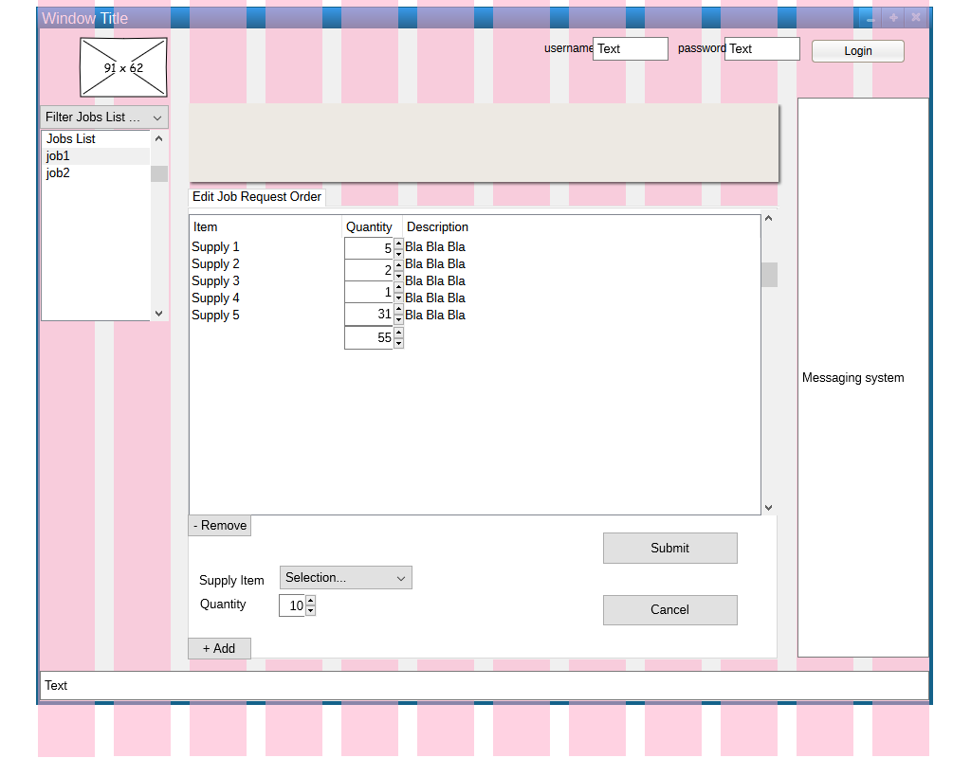

### Add/Edit Special Request

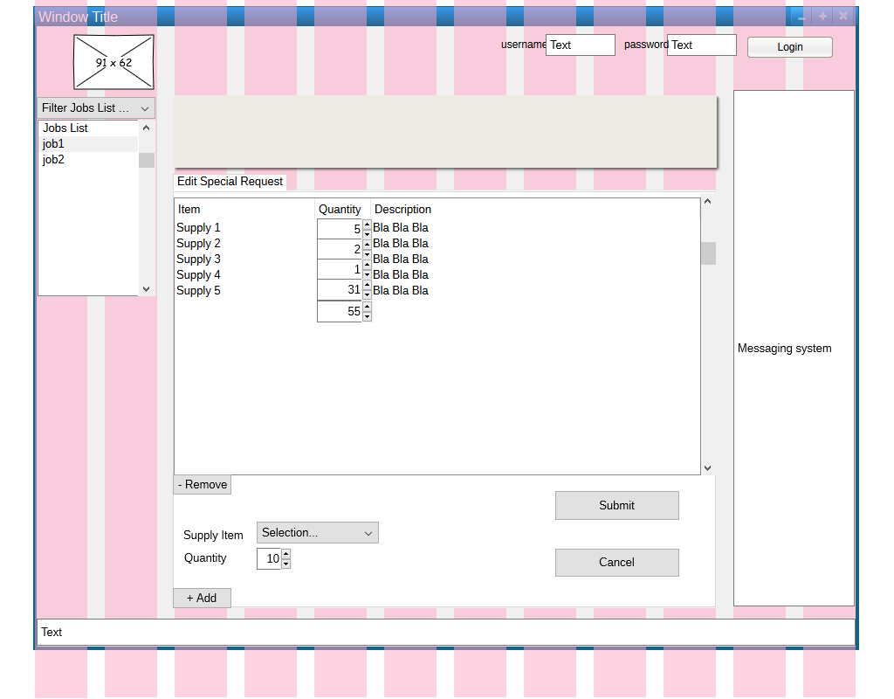

### Edit/Create Supply Locations

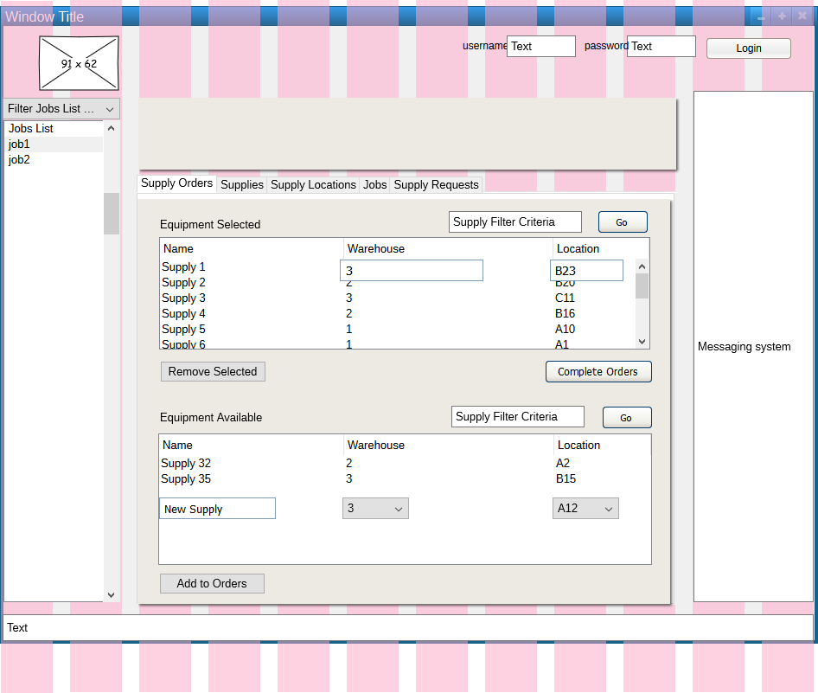

### Edit/Create Supply Orders

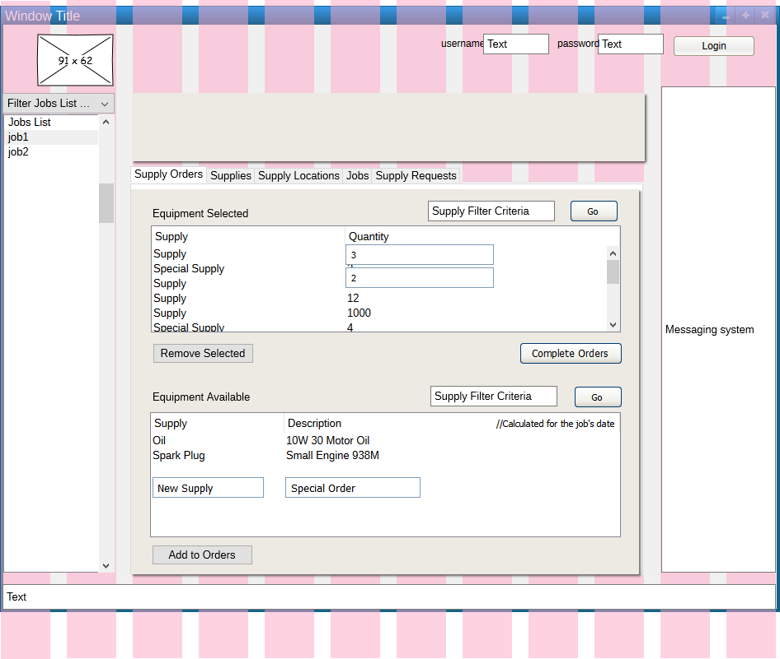

### Supply Viewer

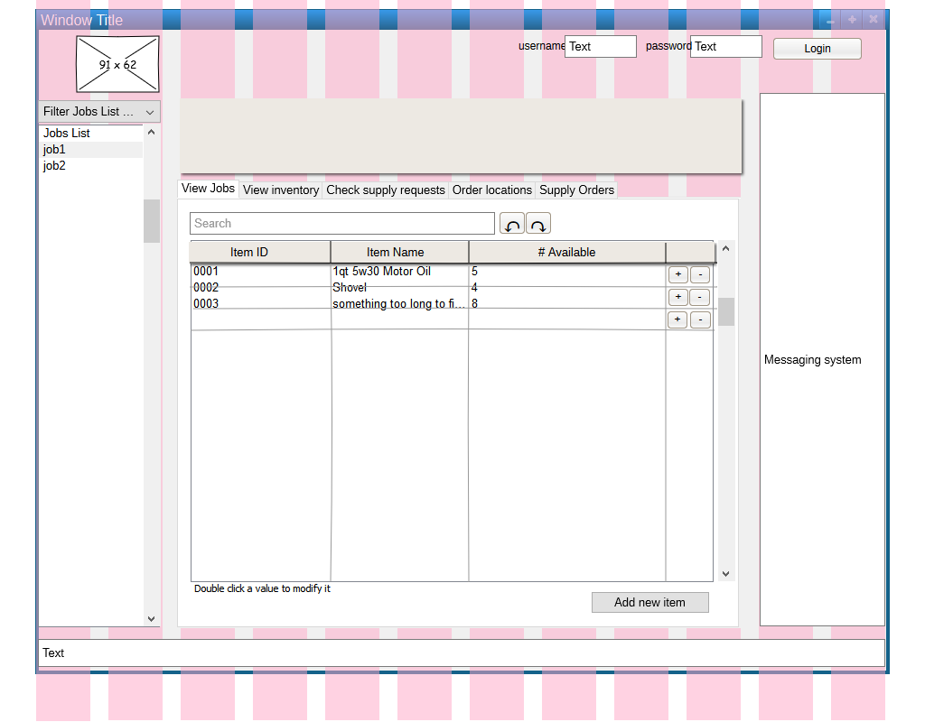

### View Request

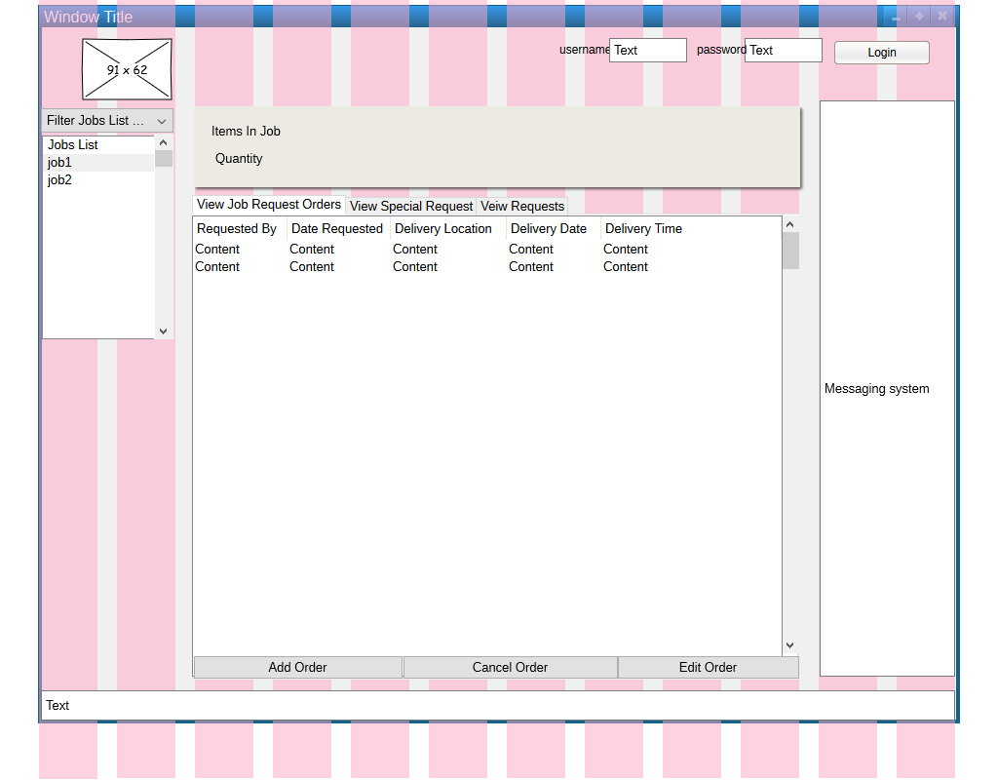

### View Supply Location

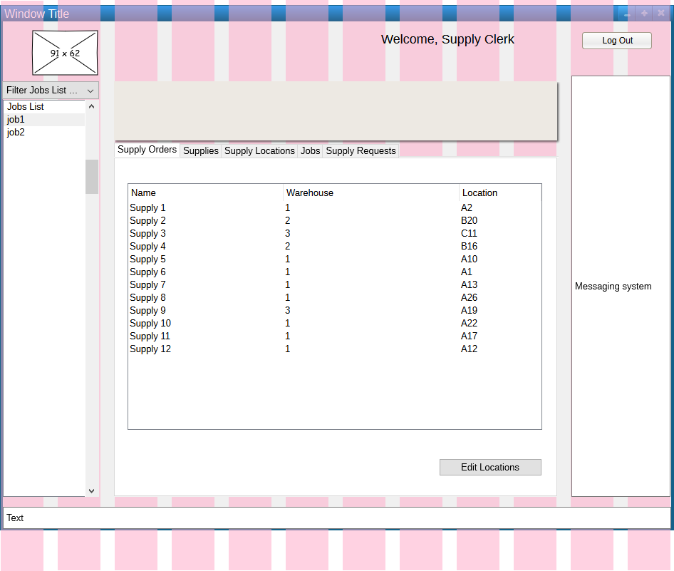

### View Supply Orders

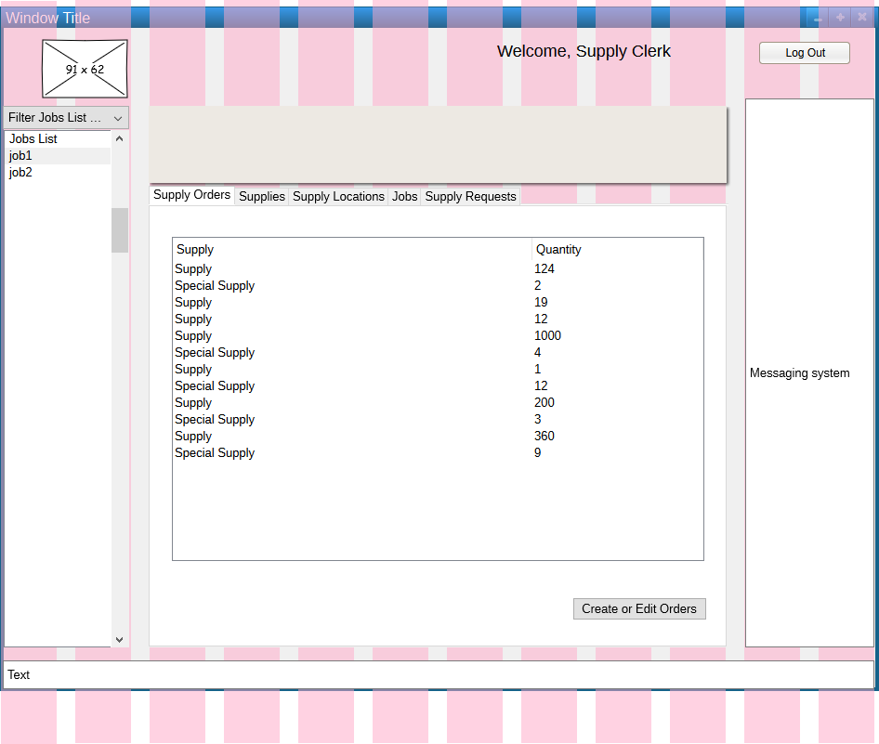

## Web Interface

### View Job Requests

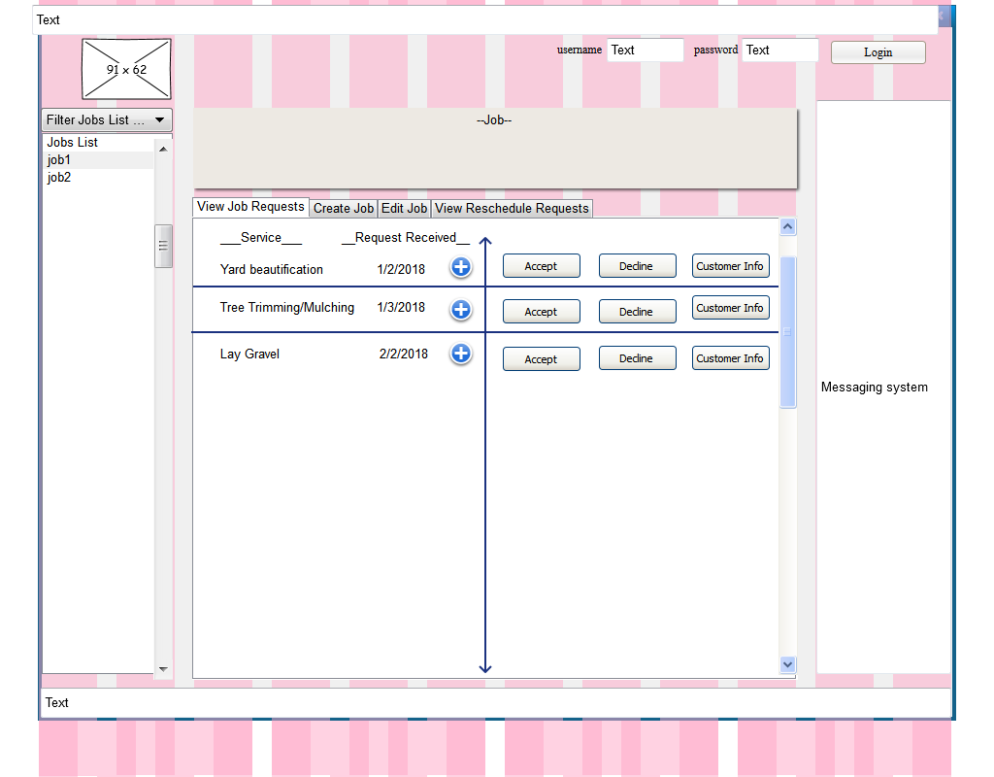

### Edit Job

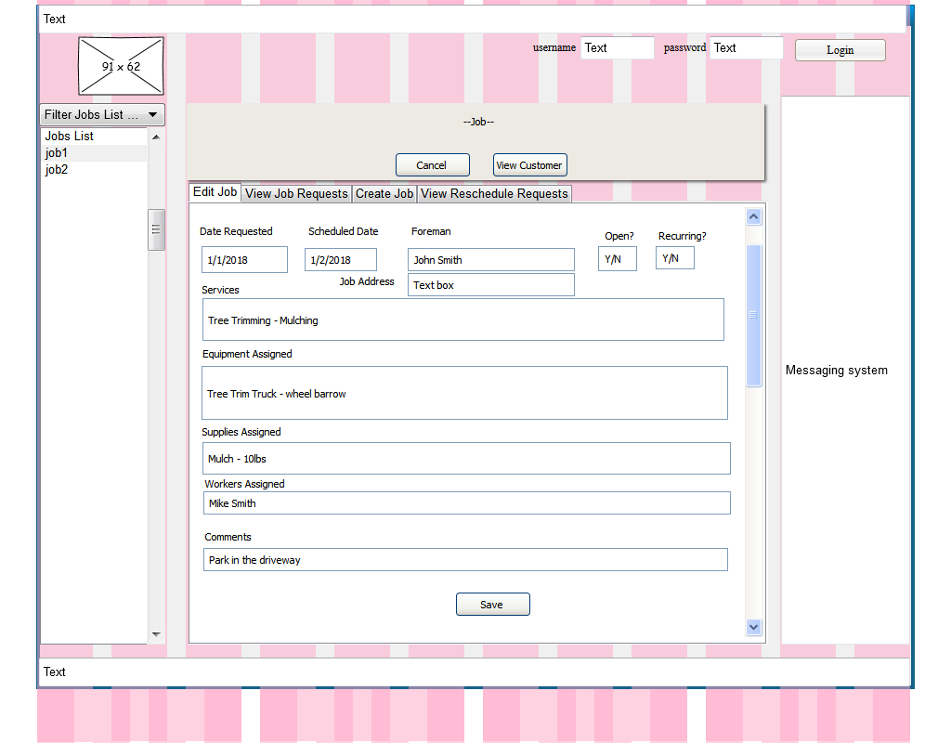

### Create Job

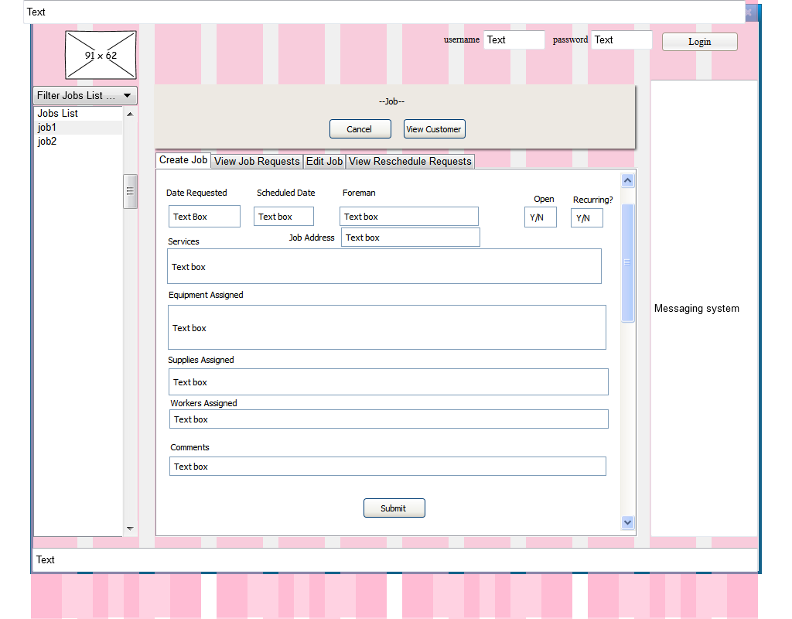

# Logical Models

## Logic-Layer Classes

### Supply Management

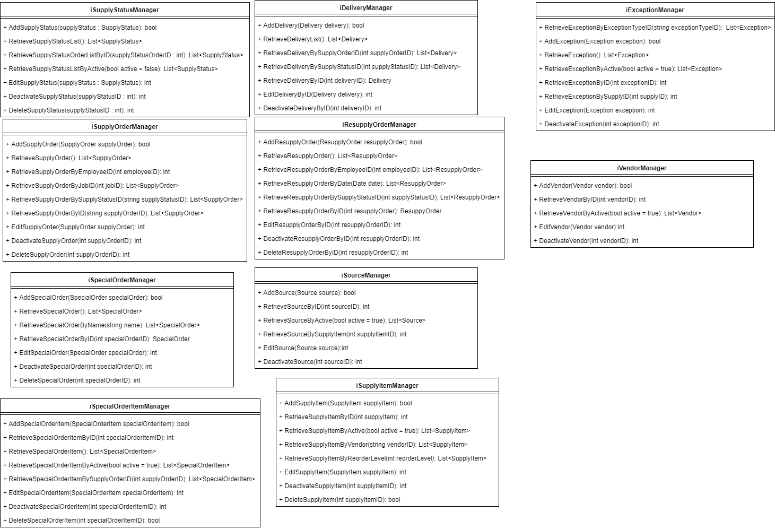

### Equipment Management

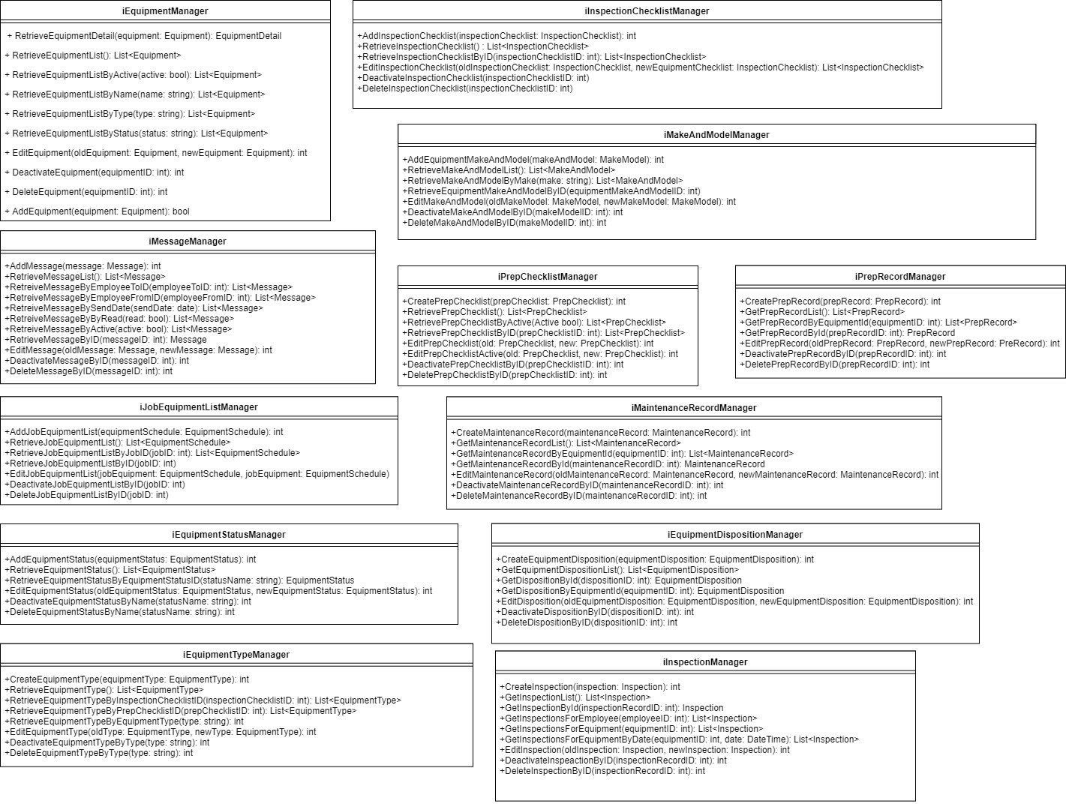

### 

### Job Scheduling

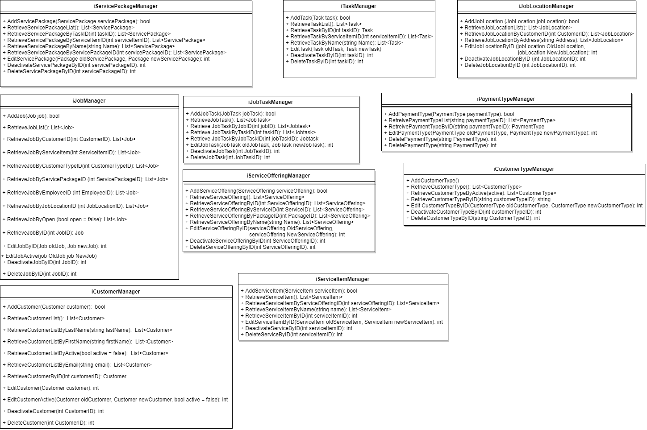

### Labor Scheduling

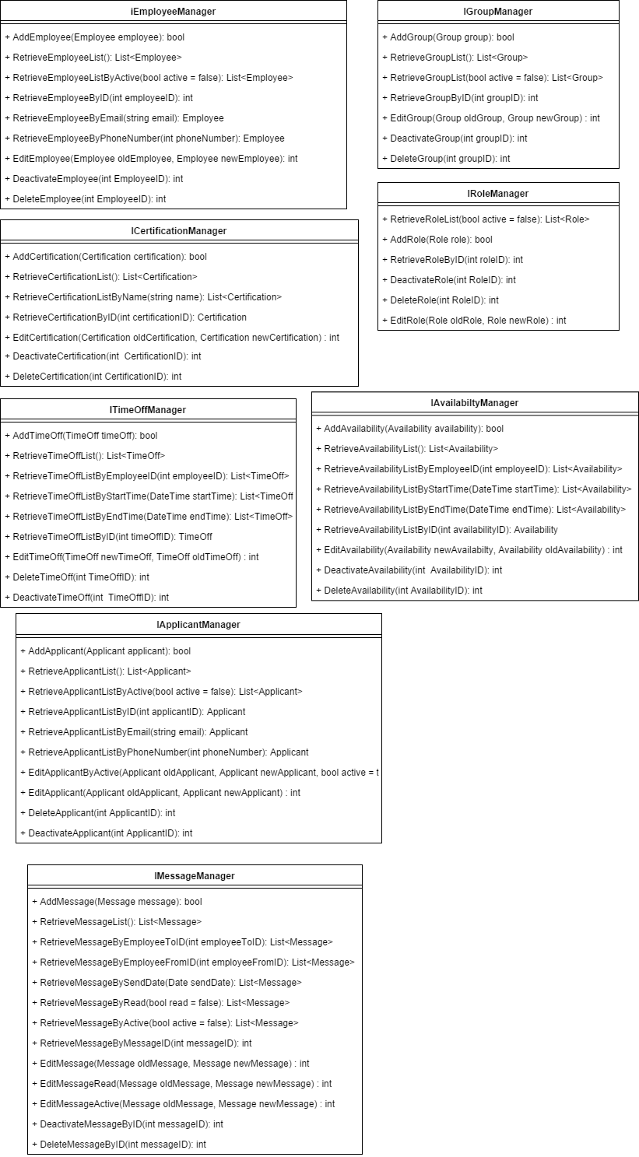

## Data Transfer Objects

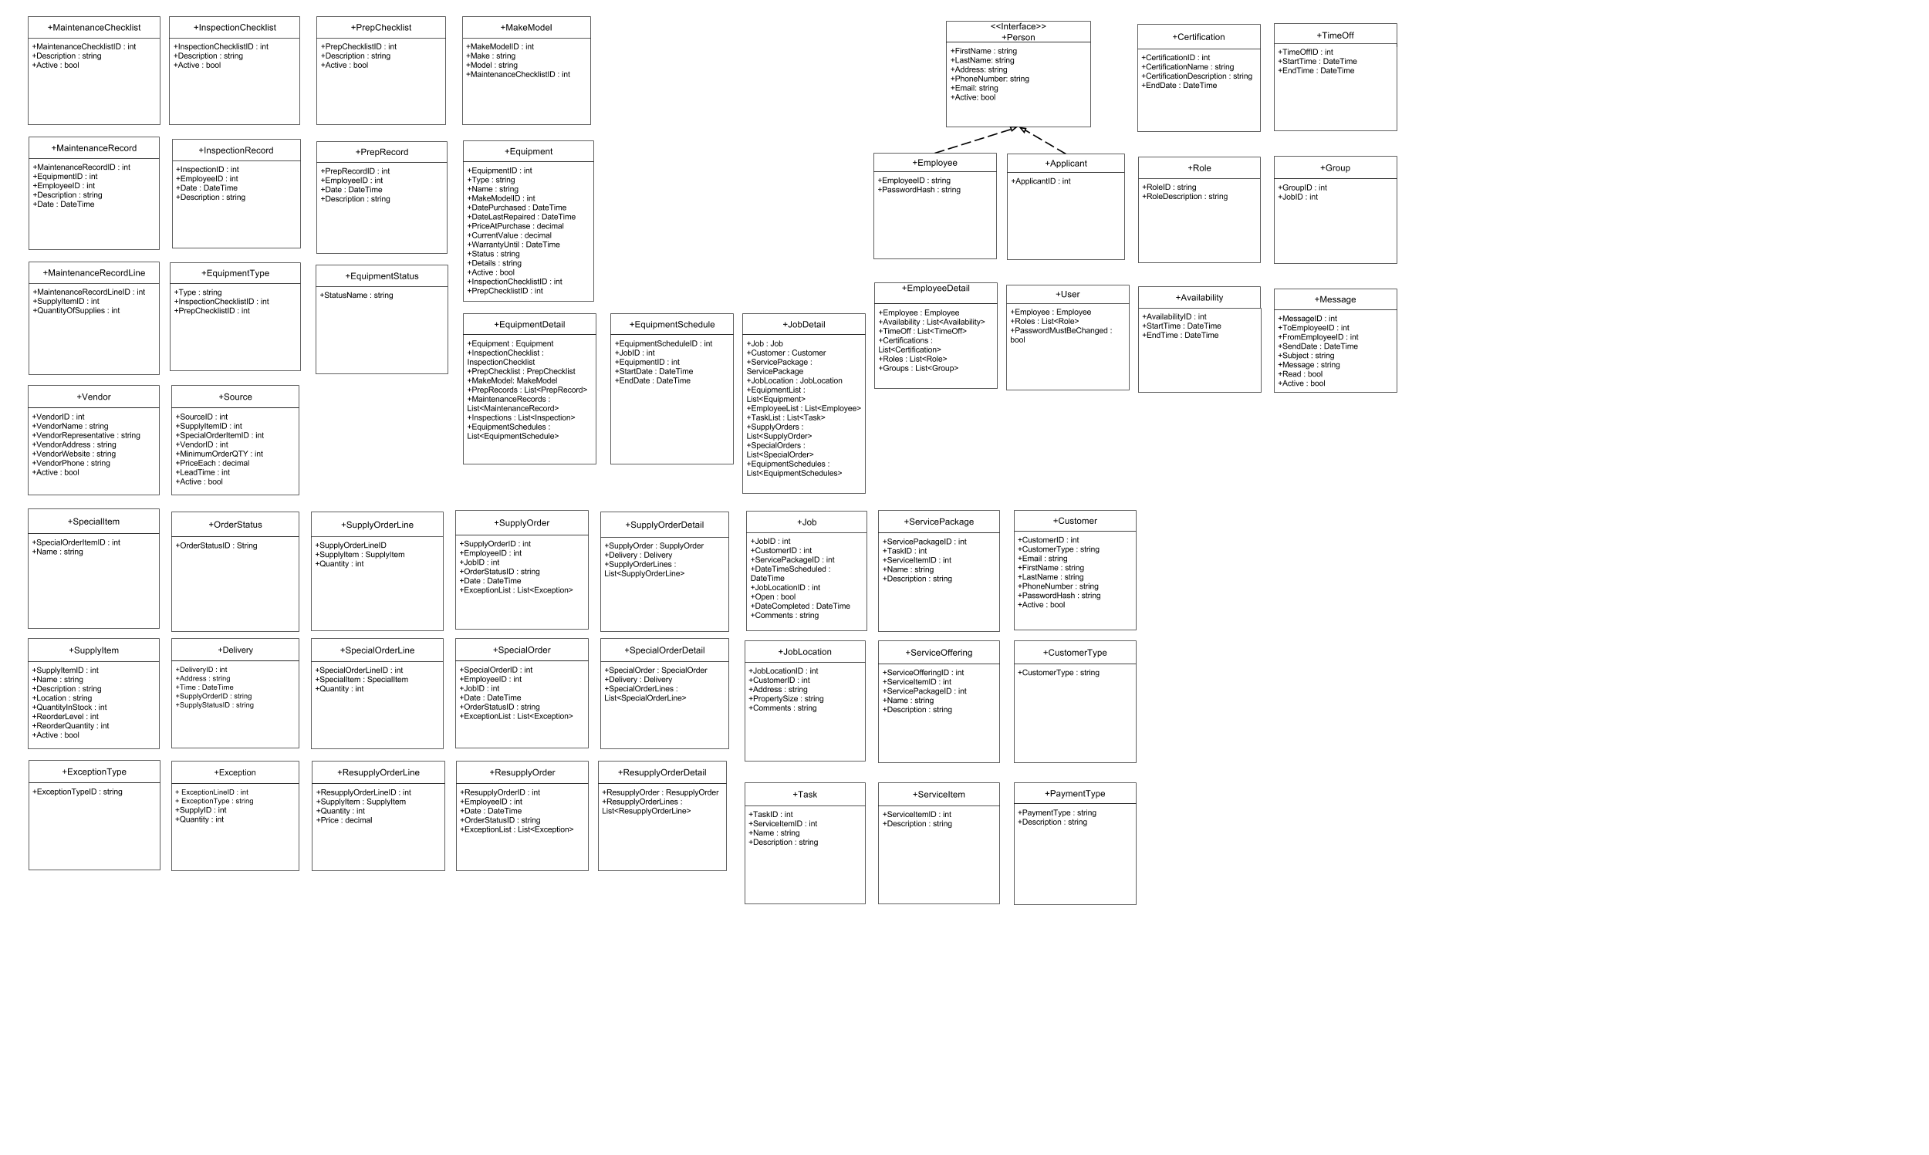

## Data Access Classes

### Supply Management

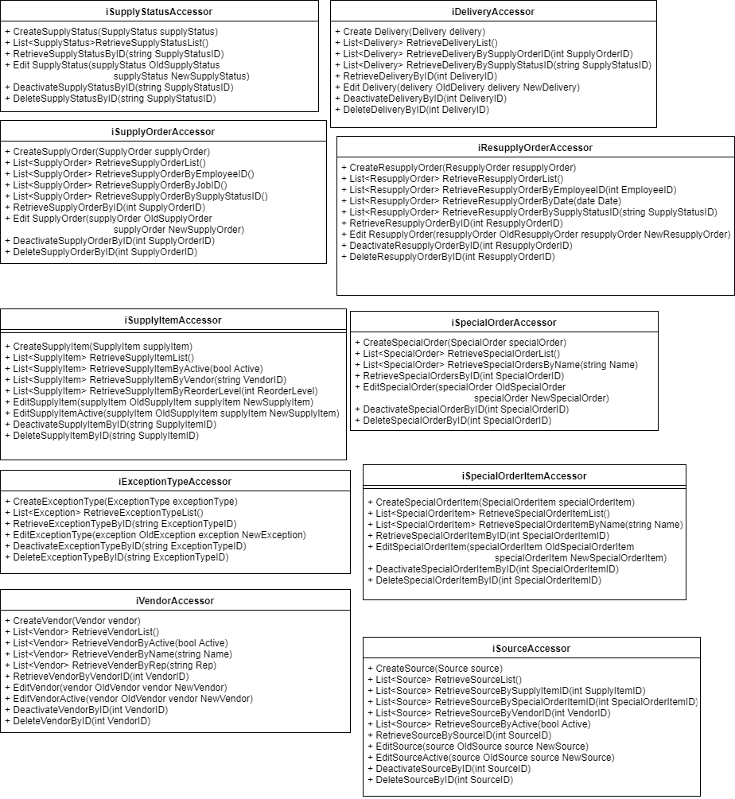

### Equipment Management

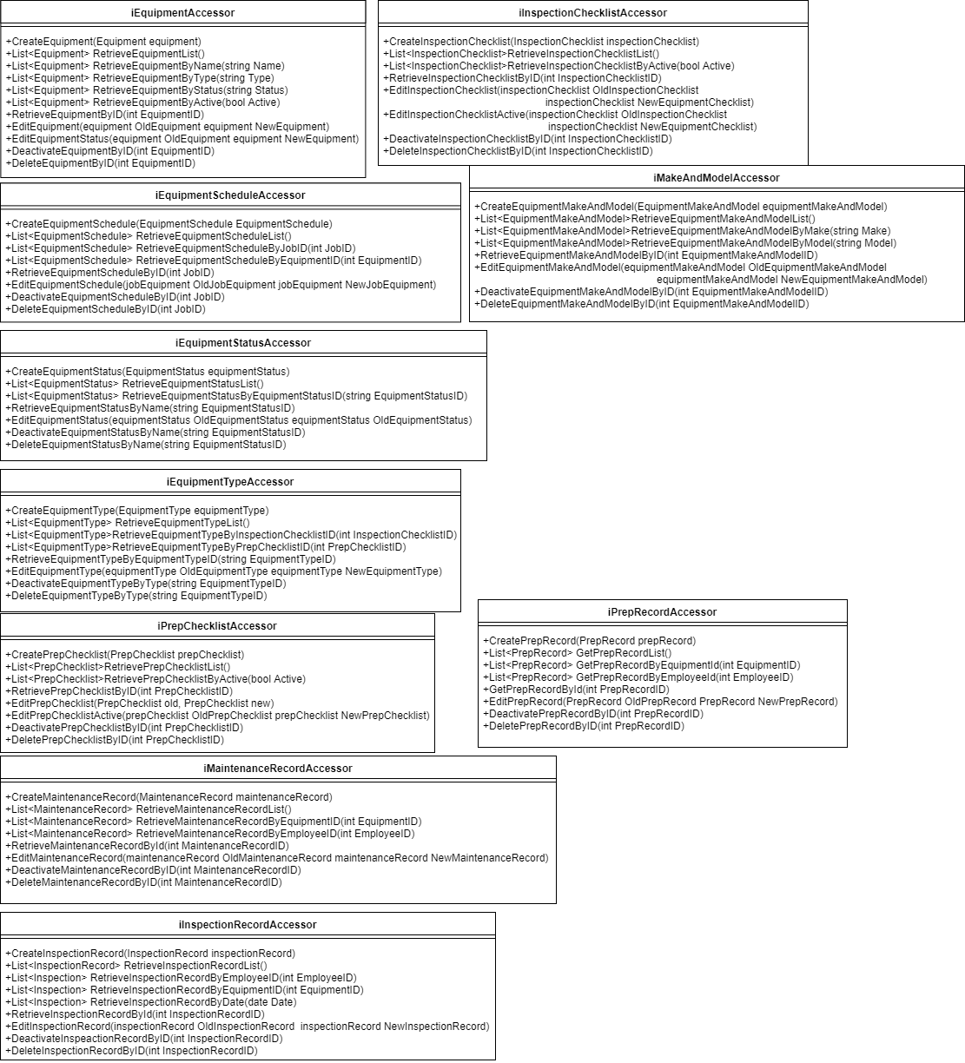

### 

### Job Scheduling

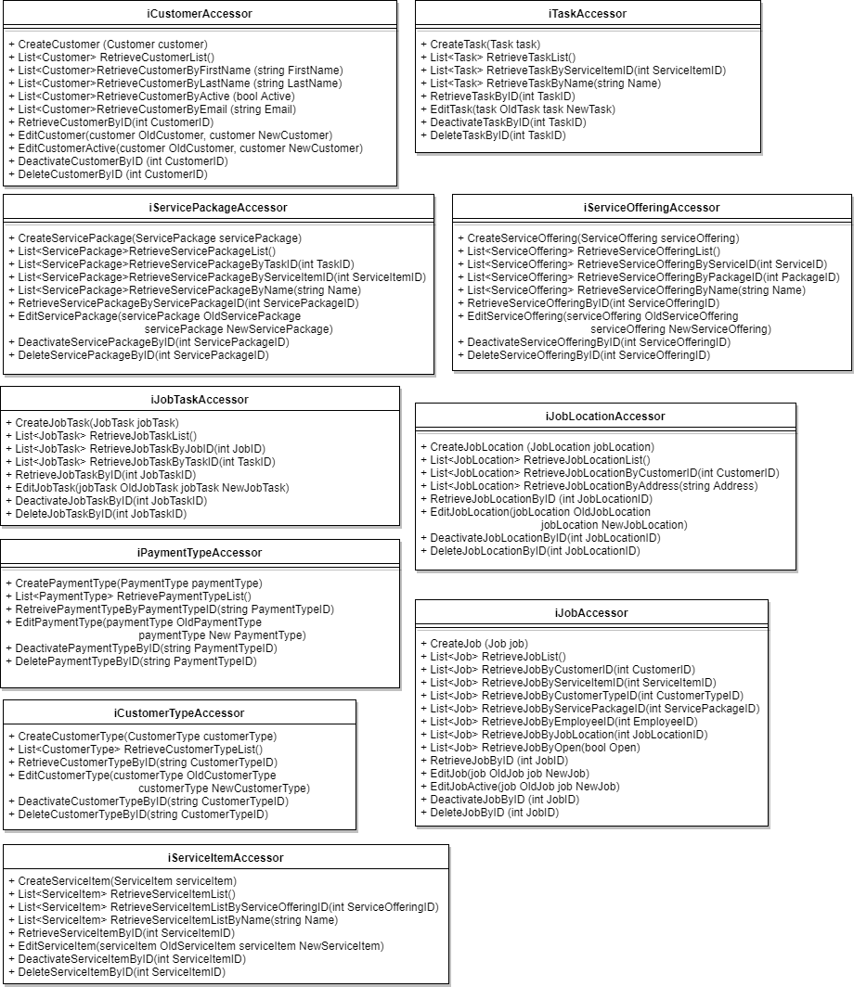

### Labor Scheduling

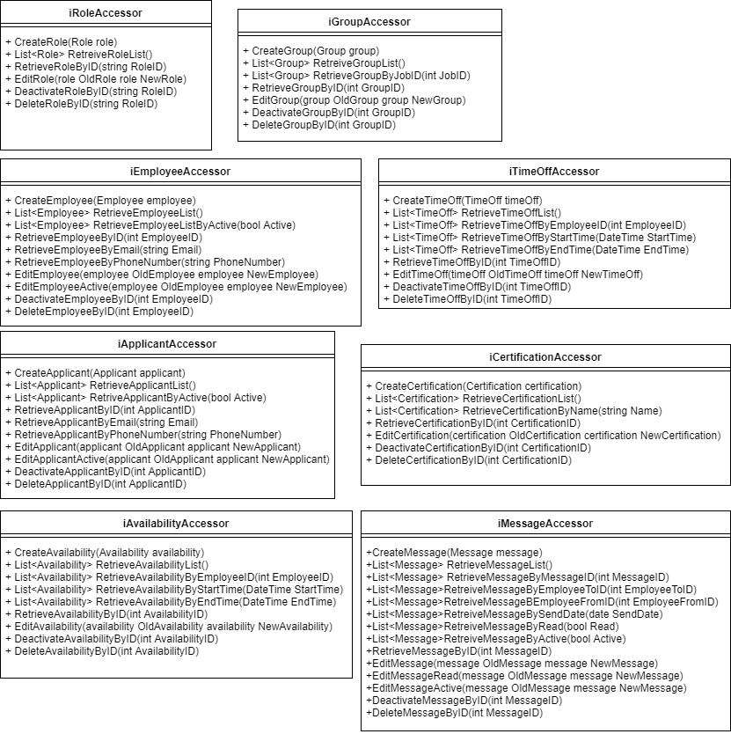

## E-R Diagram

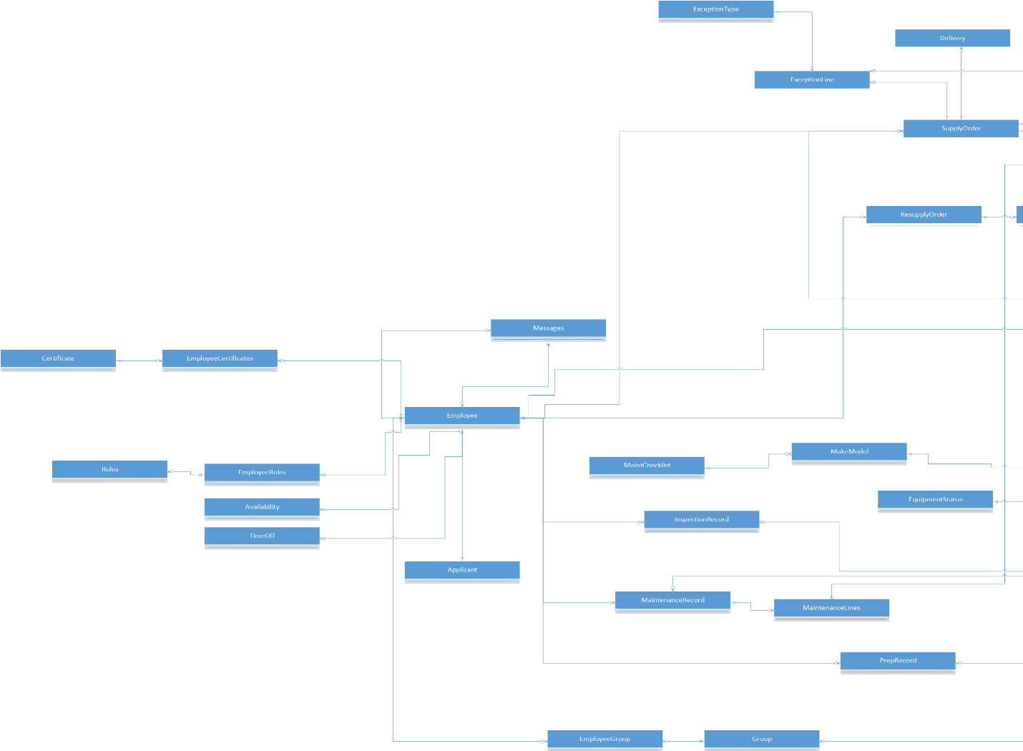

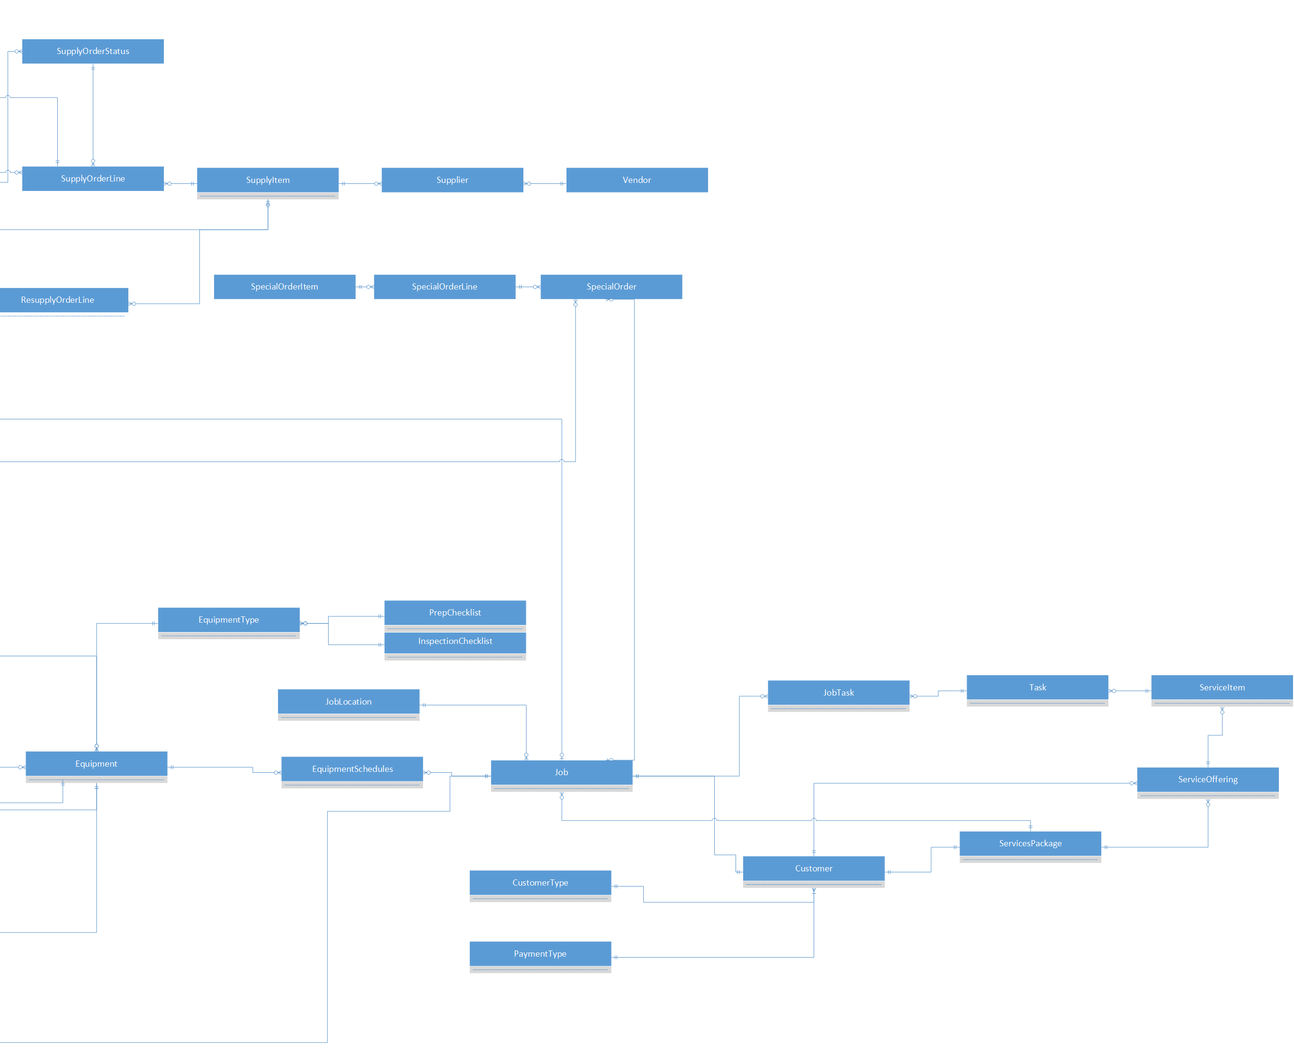

## Data Dictionary

|  |  |  |  |  |  |  |  |  |  |  |  |  |  |
| --- | --- | --- | --- | --- | --- | --- | --- | --- | --- | --- | --- | --- | --- |
| **JOB** |  |  |  |  |  |  |  |  |  |  |  |  |  |
|  |  |  |  |  |  |  |  |  |  |  |  |  |  |
| **Customer** |  |  |  |  |  |  |  |  |  |  |  |  |  |
| Field Name | Data Type | ID | Starting Value | Increment | Null | Default | Primary Key | Foreign Key | Reference Table | Reference Field | Unique | Index | Comments |
| CustomerID | int | yes | 1000000 | 1 | NOT NULL | N/A | yes | N/A | N/A | N/A | yes | yes | Primary key for customers |
| CustomerTypeID | nvarchar (100) | N/A | N/A | N/A | NOT NULL | N/A | N/A | yes | CustomerType | CustomerTypeID | N/A | N/A | The type of the customer |
| Email | nvarchar (100) | N/A | N/A | N/A | NOT NULL | N/A | N/A | N/A | N/A | N/A | yes | N/A | Customer email |
| FirstName | nvarchar (100) | N/A | N/A | N/A | NOT NULL | N/A | N/A | N/A | N/A | N/A | N/A | yes | The first name of the customer |
| LastName | nvarchar (100) | N/A | N/A | N/A | NOT NULL | N/A | N/A | N/A | N/A | N/A | N/A | yes | The last name of the customer |
| PhoneNumber | nvarchar (15) | N/A | N/A | N/A | NOT NULL | N/A | N/A | N/A | N/A | N/A | N/A | N/A | The phone number of the customer |
| PasswordHash | nvarchar (100) | N/A | N/A | N/A | NOT NULL | 9c9064c59f1ffa2e174ee754d2979be80dd30db552ec03e7e327e9b1a4bd594e' | N/A | N/A | N/A | N/A | N/A | N/A | The customer's password |
| Active | bit | N/A | N/A | N/A | NOT NULL | 1 | N/A | N/A | N/A | N/A | N/A | N/A | Shows if the customer is active |
|  |  |  |  |  |  |  |  |  |  |  |  |  |  |
|  |  |  |  |  |  |  |  |  |  |  |  |  |  |
| **CustomerType** |  |  |  |  |  |  |  |  |  |  |  |  |  |
| Field Name | Data Type | ID | Starting Value | Increment | Null | Default | Primary Key | Foreign Key | Reference Table | Reference Field | Unique | Index | Comments |
| CustomerTypeID | nvarchar(100) | N/A | N/A | N/A | NOT NULL | N/A | yes | N/A | N/A | N/A | N/A | N/A | The type of the customer |
|  |  |  |  |  |  |  |  |  |  |  |  |  |  |
|  |  |  |  |  |  |  |  |  |  |  |  |  |  |
| **ServicePackage** |  |  |  |  |  |  |  |  |  |  |  |  |  |
| Field Name | Data Type | ID | Starting Value | Increment | Null | Default | Primary Key | Foreign Key | Reference Table | Reference Field | Unique | Index | Comments |
| ServicePackageID | int | yes | 1000000 | 1 | NOT NULL | N/A | yes | N/A | N/A | N/A | yes | yes | Primary key for packages |
| TaskID | int | N/A | N/A | N/A | NOT NULL | N/A | N/A | yes | Task | TaskID | N/A | N/A | Foreign key for tasks |
| ServiceItemID | int | N/A | N/A | N/A | NOT NULL | N/A | N/A | yes | ServiceItem | ServiceItemID | N/A | N/A | Foreign key for service |
| Name | nvarchar (100) | N/A | N/A | N/A | NOT NULL | N/A | N/A | N/A | N/A | N/A | N/A | N/A | The name of the package |
| Description | nvarchar (1000) | N/A | N/A | N/A | NOT NULL | N/A | N/A | N/A | N/A | N/A | N/A | N/A | The description of the package |
|  |  |  |  |  |  |  |  |  |  |  |  |  |  |
|  |  |  |  |  |  |  |  |  |  |  |  |  |  |
| **Job** |  |  |  |  |  |  |  |  |  |  |  |  |  |
| Field Name | Data Type | ID | Starting Value | Increment | Null | Default | Primary Key | Foreign Key | Reference Table | Reference Field | Unique | Index | Comments |
| JobID | int | yes | 1000000 | 1 | NOT NULL | N/A | yes | N/A | N/A | N/A | yes | yes | the id of the job |
| ServiceItemID | int | N/A | N/A | N/A | NOT NULL | N/A | N/A | yes | ServiceItem | ServiceItemID | N/A | N/A | Service ID foreign key |
| CustomerID | int | N/A | N/A | N/A | NOT NULL | N/A | N/A | yes | Customer | CustomerID | N/A | N/A | Primary key for Customer Type table |
| ServicePackageID | int | N/A | N/A | N/A | NOT NULL | N/A | N/A | yes | ServicePackage | ServicePackageID | N/A | N/A | The service package selected for the job |
| DateTimeScheduled | DateTime | N/A | N/A | N/A | NOT NULL | N/A | N/A | N/A | N/A | N/A | N/A | N/A | date the job is scheduled for |
| EmployeeID | int | N/A | N/A | N/A | NOT NULL | N/A | N/A | yes | Employee | EmployeeID | N/A | N/A | id of the employee who scheduled the job |
| JobLocationID | int | N/A | N/A | N/A | NOT NULL | N/A | N/A | yes | JobLocation | JobLocationID | N/A | N/A | the location of the job |
| JobTaskID | int | N/A | N/A | N/A | NOT NULL | N/A | N/A | yes | JobTask | JobTaskID | N/A | N/A | the list of job tasks |
| Active | bit | N/A | N/A | N/A | NOT NULL | 1 | N/A | N/A | N/A | N/A | N/A | N/A | whether the job is open or not |
| DateCompleted | DateTime | N/A | N/A | N/A | NULL? | N/A | N/A | N/A | N/A | N/A | N/A | N/A | the date the job was completed |
| Comments | nvarchar(1000) | N/A | N/A | N/A | NOT NULL | N/A | N/A | N/A | N/A | N/A | N/A | N/A | any additional comments on the job itself |
|  |  |  |  |  |  |  |  |  |  |  |  |  |  |
|  |  |  |  |  |  |  |  |  |  |  |  |  |  |
| **Task** |  |  |  |  |  |  |  |  |  |  |  |  |  |
| Field Name | Data Type | ID | Starting Value | Increment | Null | Default | Primary Key | Foreign Key | Reference Table | Reference Field | Unique | Index | Comments |
| TaskID | int | yes | 1000000 | 1 | NOT NULL | N/A | yes | N/A | N/A | N/A | N/A | yes | the id number of the task |
| ServiceItemID | int | N/A | N/A | N/A | NOT NULL | N/A | N/A | yes | ServiceItem | ServiceItemID | N/A | N/A | Service ID foreign key |
| Name | nvarchar(100) | N/A | N/A | N/A | NOT NULL | N/A | N/A | N/A | N/A | N/A | N/A | N/A | The name of the task |
| Description | nvarchar (1000) | N/A | N/A | N/A | NULL? | N/A | N/A | N/A | N/A | N/A | N/A | N/A | The description of the service offering |
|  |  |  |  |  |  |  |  |  |  |  |  |  |  |
|  |  |  |  |  |  |  |  |  |  |  |  |  |  |
| **ServiceOffering** |  |  |  |  |  |  |  |  |  |  |  |  |  |
| Field Name | Data Type | ID | Starting Value | Increment | Null | Default | Primary Key | Foreign Key | Reference Table | Reference Field | Unique | Index | Comments |
| ServiceOfferingID | int | yes | 1000000 | 1 | NOT NULL | N/A | yes | N/A | N/A | N/A | yes | yes | The primary key for service offerings |
| ServicePackageID | int | N/A | N/A | N/A | NOT NULL | N/A | N/A | yes | Package | PackageID | N/A | N/A | The foreign key for packages |
| Name | nvarchar (100) | N/A | N/A | N/A | NOT NULL | N/A | N/A | N/A | N/A | N/A | N/A | N/A | The name of the service offering |
| Description | nvarchar (1000) | N/A | N/A | N/A | NULL? | N/A | N/A | N/A | N/A | N/A | N/A | N/A | The description of the service offering |
|  |  |  |  |  |  |  |  |  |  |  |  |  |  |
|  |  |  |  |  |  |  |  |  |  |  |  |  |  |
| **ServiceItem** |  |  |  |  |  |  |  |  |  |  |  |  |  |
| Field Name | Data Type | ID | Starting Value | Increment | Null | Default | Primary Key | Foreign Key | Reference Table | Reference Field | Unique | Index | Comments |
| ServiceItemID | int | yes | 1000000 | 1 | NOT NULL | N/A | yes | N/A | N/A | N/A | yes | yes | The service ID |
| ServiceOfferingID | int | N/A | N/A | N/A | NOT NULL | N/A | N/A | yes | ServiceOffering | ServiceOfferingID | N/A | yes | The ID for the service offering the item belongs to |
| Name | nvarchar (100) | N/A | N/A | N/A | NOT NULL | N/A | N/A | N/A | N/A | N/A | N/A | N/A | The name of the service item |
| Description | nvarchar (1000) | N/A | N/A | N/A | NOT NULL | N/A | N/A | N/A | N/A | N/A | N/A | N/A | Description of the service |
|  |  |  |  |  |  |  |  |  |  |  |  |  |  |
|  |  |  |  |  |  |  |  |  |  |  |  |  |  |
| **PaymentType** |  |  |  |  |  |  |  |  |  |  |  |  |  |
| Field Name | Data Type | ID | Starting Value | Increment | Null | Default | Primary Key | Foreign Key | Reference Table | Reference Field | Unique | Index | Comments |
| PaymentTypeID | nvarchar (100) | N/A | N/A | N/A | NOT NULL | N/A | yes | N/A | N/A | N/A | N/A | N/A | the type of payment |
| Description | nvarchar (1000) | N/A | N/A | N/A | NOT NULL | N/A | N/A | N/A | N/A | N/A | N/A | N/A | description of the pament type |
|  |  |  |  |  |  |  |  |  |  |  |  |  |  |
|  |  |  |  |  |  |  |  |  |  |  |  |  |  |
| **JobTask** |  |  |  |  |  |  |  |  |  |  |  |  |  |
| Field Name | Data Type | ID | Starting Value | Increment | Null | Default | Primary Key | Foreign Key | Reference Table | Reference Field | Unique | Index | Comments |
| JobID | int | N/A | N/A | N/A | NOT NULL | N/A | N/A | yes | Job | JobID | N/A | N/A | The job the the task is assigned to |
| TaskID | int | N/A | N/A | N/A | NOT NULL | N/A | N/A | yes | Task | TaskID | N/A | N/A | the id of the task |
| JobTaskID | int | yes | 1000000 | 1 | NOT NULL | N/A | yes | N/A | N/A | N/A | N/A | yes | the list of job tasks |
|  |  |  |  |  |  |  |  |  |  |  |  |  |  |
|  |  |  |  |  |  |  |  |  |  |  |  |  |  |
|  |  |  |  |  |  |  |  |  |  |  |  |  |  |
| **JobLocation** |  |  |  |  |  |  |  |  |  |  |  |  |  |
| Field Name | Data Type | ID | Starting Value | Increment | Null | Default | Primary Key | Foreign Key | Reference Table | Reference Field | Unique | Index | Comments |
| JobLocationID | int | yes | 1000000 | 1 | NOT NULL | N/A | yes | N/A | N/A | N/A | N/A | yes | id of the location |
| CustomerID | int | N/A | N/A | N/A | NOT NULL | N/A | N/A | yes | Customer | CustomerID | N/A | N/A | the id of the customer asssociated with the location |
| Address | nvarchar(250) | N/A | N/A | N/A | NOT NULL | N/A | N/A | N/A | N/A | N/A | N/A | N/A | the address of the location |
| PropertySize | nvarchar(100) | N/A | N/A | N/A | NOT NULL | N/A | N/A | N/A | N/A | N/A | N/A | N/A | the size of the property |
| Comments | nvarchar(1000) | N/A | N/A | N/A | NULL? | N/A | N/A | N/A | N/A | N/A | N/A | N/A | any additonal comments on te location |
|  |  |  |  |  |  |  |  |  |  |  |  |  |  |
|  |  |  |  |  |  |  |  |  |  |  |  |  |  |
| **EQUIPMENT** |  |  |  |  |  |  |  |  |  |  |  |  |  |
|  |  |  |  |  |  |  |  |  |  |  |  |  |  |
| **PrepChecklist** |  |  |  |  |  |  |  |  |  |  |  |  | The checklists are a list of repair/maintenance/prep requirements to determine if a piece of equipment is available considered ready |
| FieldName | DataType | Identity? | StartingValue | Increment | Null? | Default? | PK? | FK? | ReferencedTable | ReferencedField | Unique? | Indexed? | Comments |
| PrepChecklistID | int | yes | 1000000 | 1 | NOT NULL | N/A | yes | N/A | N/A | N/A | N/A | yes | The ID for the checklist. |
| Description | nvarchar(1000) | N/A | N/A | N/A | NOT NULL | N/A | N/A | N/A | N/A | N/A | N/A | N/A | List of requirements for the item. |
| Active | bit | N/A | N/A | N/A | NOT NULL | 1 | N/A | N/A | N/A | N/A | N/A | N/A | Whether or not the checklist is still being used. |
|  |  |  |  |  |  |  |  |  |  |  |  |  |  |
|  |  |  |  |  |  |  |  |  |  |  |  |  |  |
| **InspectionChecklist** |  |  |  |  |  |  |  |  |  |  |  |  |  |
| FieldName | DataType | Identity? | StartingValue | Increment | Null? | Default? | PK? | FK? | ReferencedTable | ReferencedField | Unique? | Indexed? | Comments |
| InspectionChecklistID | int | yes | 1000000 | 1 | NOT NULL | N/A | yes | N/A | N/A | N/A | N/A | yes | The ID for the checklist. |
| Description | nvarchar(1000) | N/A | N/A | N/A | NOT NULL | N/A | N/A | N/A | N/A | N/A | N/A | N/A | List of requirements for the item. |
| Active | bit | N/A | N/A | N/A | NOT NULL | 1 | N/A | N/A | N/A | N/A | N/A | N/A | Whether or not the checklist is still being used. |
|  |  |  |  |  |  |  |  |  |  |  |  |  |  |
|  |  |  |  |  |  |  |  |  |  |  |  |  |  |
| **MaintenanceChecklist** |  |  |  |  |  |  |  |  |  |  |  |  |  |
| FieldName | DataType | Identity? | StartingValue | Increment | Null? | Default? | PK? | FK? | ReferencedTable | ReferencedField | Unique? | Indexed? | Comments |
| MaintenanceChecklistID | int | yes | 1000000 | 1 | NOT NULL | N/A | yes | N/A | N/A | N/A | N/A | yes | The ID for the checklist. |
| Description | nvarchar(1000) | N/A | N/A | N/A | NOT NULL | N/A | N/A | N/A | N/A | N/A | N/A | N/A | List of requirements for the item. |
| Active | bit | N/A | N/A | N/A | NOT NULL | 1 | no | no | N/A | N/A | N/A | N/A | Whether or not the checklist is still being used. |
|  |  |  |  |  |  |  |  |  |  |  |  |  |  |
|  |  |  |  |  |  |  |  |  |  |  |  |  |  |
| **MakeModel** |  |  |  |  |  |  |  |  |  |  |  |  |  |
| FieldName | DataType | Identity? | StartingValue | Increment | Null? | Default? | PK? | FK? | ReferencedTable | ReferencedField | Unique? | Indexed? | Comments |
| MakeModelID | int | yes | 1000000 | 1 | NOT NULL | N/A | yes | N/A | N/A | N/A | N/A | yes | The ID for the Make and Model. |
| Make | nvarchar(100) | N/A | N/A | N/A | NOT NULL | N/A | N/A | N/A | N/A | N/A | N/A | N/A | The manufacturer |
| Model | nvarchar(100) | N/A | N/A | N/A | NOT NULL | N/A | N/A | N/A | N/A | N/A | N/A | N/A | The model of the piece of equipment. |
| MaintenanceChecklistID | int | N/A | N/A | N/A | NULL? | N/A | N/A | yes | MaintenanceChecklist | MaintenanceChecklistID | N/A | N/A | The ID of the checklist associated with the Make and Model. |
|  |  |  |  |  |  |  |  |  |  |  |  |  |  |
|  |  |  |  |  |  |  |  |  |  |  |  |  |  |
| **EquipmentType** |  |  |  |  |  |  |  |  |  |  |  |  |  |
| FieldName | DataType | Identity? | StartingValue | Increment | Null? | Default? | PK? | FK? | ReferencedTable | ReferencedField | Unique? | Indexed? | Comments |
| EquipmentTypeID | nvarchar(100) | N/A | N/A | N/A | NOT NULL | N/A | yes | N/A | N/A | N/A | N/A | yes | The generalized type of equipment. |
| InspectionChecklistID | int | N/A | N/A | N/A | NULL? | N/A | N/A | yes | InspectionChecklist | InspectionChecklistID | N/A | N/A | The checklist ID associated with this type of equipment. |
| PrepChecklistID | int | N/A | N/A | N/A | NULL? | N/A | N/A | yes | PrepChecklist | PrepChecklistID | N/A | N/A | The checklist ID associated with this type of equipment. |
|  |  |  |  |  |  |  |  |  |  |  |  |  |  |
|  |  |  |  |  |  |  |  |  |  |  |  |  |  |
| **Equipment** |  |  |  |  |  |  |  |  |  |  |  |  |  |
| FieldName | DataType | Identity? | StartingValue | Increment | Null? | Default? | PK? | FK? | ReferencedTable | ReferencedField | Unique? | Indexed? | Comments |
| EquipmentID | int | yes | 1000000 | 1 | NOT NULL | N/A | yes | N/A | N/A | N/A | N/A | N/A | The automatically assigned ID for a piece of equipment. |
| EquipmentTypeID | nvarchar(100) | N/A | N/A | N/A | NOT NULL | N/A | N/A | yes | EquipmentType | EquipmentTypeID | N/A | yes | The generalized type of equipment. |
| Name | nvarchar(100) | N/A | N/A | N/A | NOT NULL | N/A | N/A | N/A | N/A | N/A | N/A | N/A | The name of the piece of equipment. |
| MakeModelID | int | N/A | N/A | N/A | NOT NULL | N/A | N/A | yes | MakeModel | MakeModelID | N/A | N/A | The make and model ID number. |
| DatePurchased | date | N/A | N/A | N/A | NOT NULL | N/A | N/A | N/A | N/A | N/A | N/A | N/A | Date the equipment was bought. |
| DateLastRepaired | date | N/A | N/A | N/A | NULL? | N/A | N/A | N/A | N/A | N/A | N/A | N/A | Date the equipment was last repaired |
| PriceAtPurchase | money | N/A | N/A | N/A | NOT NULL | N/A | N/A | N/A | N/A | N/A | N/A | N/A | Price of the equipment when initally purchased |
| CurrentValue | money | N/A | N/A | N/A | NOT NULL | N/A | N/A | N/A | N/A | N/A | N/A | N/A | Price of the equipment last time it was assessed |
| WarrantyUntil | date | N/A | N/A | N/A | NULL? | N/A | N/A | N/A | N/A | N/A | N/A | N/A | Date the warranty expires |
| EquipmentStatusID | nvarchar(100) | N/A | N/A | N/A | NOT NULL | N/A | N/A | Yes | Status | EquipmentStatusID | N/A | Yes | The current status of the equipment. |
| EquipmentDetails | nvarchar(1000) | N/A | N/A | N/A | NOT NULL | N/A | N/A | N/A | N/A | N/A | N/A | N/A | Extra details that are specific to the type of equipment, such as mileage. |
| Active | bit | N/A | N/A | N/A | NOT NULL | 1 | N/A | N/A | N/A | N/A | N/A | N/A | Checking if the equipment is still valid to be used on jobs or not. |
|  |  |  |  |  |  |  |  |  |  |  |  |  |  |
|  |  |  |  |  |  |  |  |  |  |  |  |  |  |
| **EquipmentSchedule** |  |  |  |  |  |  |  |  |  |  |  |  | A join table for Equipment and Jobs. |
| FieldName | DataType | Identity? | StartingValue | Increment | Null? | Default? | PK? | FK? | ReferencedTable | ReferencedField | Unique? | Indexed? | Comments |
| EquipmentScheduleID | int | yes | 1000000 | 1 | NOT NULL | N/A | yes | N/A | N/A | N/A | N/A | N/A | The ID for the schedule |
| JobID | int | N/A | N/A | N/A | NOT NULL | N/A | N/A | yes | Job | JobID | N/A | N/A | The ID for the job the equipment is scheduled for. |
| EquipmentID | int | N/A | N/A | N/A | NOT NULL | N/A | N/A | yes | Equipment | EquipmentID | N/A | N/A | The ID of the equipment that the job is requesting. |
| StartDate | dateTime | N/A | N/A | N/A | NOT NULL | N/A | N/A | N/A | N/A | N/A | N/A | N/A | The start date of when the equipment is needed. |
| EndDate | dateTime | N/A | N/A | N/A | NOT NULL | N/A | N/A | N/A | N/A | N/A | N/A | N/A | The end date of when the equipment is needed. |
|  |  |  |  |  |  |  |  |  |  |  |  |  |  |
|  |  |  |  |  |  |  |  |  |  |  |  |  |  |
| **EquipmentStatus** |  |  |  |  |  |  |  |  |  |  |  |  |  |
| FieldName | DataType | Identity? | StartingValue | Increment | Null? | Default? | PK? | FK? | ReferencedTable | ReferencedField | Unique? | Indexed? | Comments |
| EquipmentStatusID | nvarchar(100) | no | N/A | N/A | NOT NULL | no | yes | no | N/A | N/A | no | N/A | What the status is (needs prep/needs repairs/needs maintenance) |
|  |  |  |  |  |  |  |  |  |  |  |  |  |  |
|  |  |  |  |  |  |  |  |  |  |  |  |  |  |
| **MaintenanceRecord** |  |  |  |  |  |  |  |  |  |  |  |  |  |
| FieldName | DataType | Identity? | StartingValue | Increment | Null? | Default? | PK? | FK? | ReferencedTable | ReferencedField | Unique? | Indexed? | Comments |
| MaintenanceRecordID | int | yes | 1000000 | 1 | NOT NULL | N/A | yes | N/A | N/A | N/A | yes | N/A | The ID of the maintenance record. |
| EquipmentID | int | N/A | N/A | N/A | NOT NULL | N/A | N/A | yes | Equipment | EquipmentID | N/A | N/A | The equipment ID that the record is associated with. |
| EmployeeID | int | N/A | N/A | N/A | NOT NULL | N/A | N/A | yes | Employee | EmployeeID | N/A | N/A | The employee who made the maintenance. |
| Description | nvarchar(1000) | N/A | N/A | N/A | NOT NULL | N/A | N/A | N/A | N/A | N/A | N/A | N/A | Description of how the maintenance went |
| Date | date | N/A | N/A | N/A | NOT NULL | N/A | N/A | N/A | N/A | N/A | N/A | N/A | The date the maintenance was performed |
|  |  |  |  |  |  |  |  |  |  |  |  |  |  |
|  |  |  |  |  |  |  |  |  |  |  |  |  |  |
| **InspectionRecord** |  |  |  |  |  |  |  |  |  |  |  |  |  |
| FieldName | DataType | Identity? | StartingValue | Increment | Null? | Default? | PK? | FK? | ReferencedTable | ReferencedField | Unique? | Indexed? | Comments |
| InspectionRecordID | int | yes | 1000000 | 1 | NOT NULL | N/A | yes | N/A | N/A | N/A | yes | N/A | The ID for the inspection record |
| EquipmentID | int | N/A | N/A | N/A | NOT NULL | N/A | N/A | yes | Equipment | EquipmentID | N/A | N/A | The equipment ID the record is associated with. |
| EmployeeID | int | N/A | N/A | N/A | NOT NULL | N/A | N/A | yes | Employee | EmployeeID | N/A | N/A | The employee who made the inspection. |
| Description | nvarchar(1000) | N/A | N/A | N/A | NOT NULL | N/A | N/A | N/A | N/A | N/A | N/A | N/A | Description of how the inspection went |
| Date | date | N/A | N/A | N/A | NOT NULL | N/A | N/A | N/A | N/A | N/A | N/A | N/A | The date the inspection was performed |
|  |  |  |  |  |  |  |  |  |  |  |  |  |  |
|  |  |  |  |  |  |  |  |  |  |  |  |  |  |
| **PrepRecord** |  |  |  |  |  |  |  |  |  |  |  |  |  |
| FieldName | DataType | Identity? | StartingValue | Increment | Null? | Default? | PK? | FK? | ReferencedTable | ReferencedField | Unique? | Indexed? | Comments |
| PrepRecordID | int | yes | 1000000 | 1 | NOT NULL | N/A | yes | N/A | N/A | N/A | N/A | N/A | The ID for the prep record |
| EquipmentID | int | no | N/A | N/A | NOT NULL | N/A | N/A | yes | Equipment | EquipmentID | N/A | N/A | The equipment ID the record is associated with. |
| EmployeeID | int | no | N/A | N/A | NOT NULL | N/A | N/A | yes | Employee | EmployeeID | N/A | N/A | The employee who complete prepping the equipment. |
| Description | nvarchar(1000) | no | N/A | N/A | NOT NULL | N/A | N/A | N/A | N/A | N/A | N/A | N/A | Description of how the preperation went |
| Date | date | no | N/A | N/A | NOT NULL | N/A | N/A | N/A | N/A | N/A | N/A | N/A | The date the prep was performed |
|  |  |  |  |  |  |  |  |  |  |  |  |  |  |
|  |  |  |  |  |  |  |  |  |  |  |  |  |  |
| **Message** |  |  |  |  |  |  |  |  |  |  |  |  |  |
| FieldName | DataType | Identity? | StartingValue | Increment | Null? | Default? | PK? | FK? | ReferencedTable | ReferencedField | Unique? | Indexed? | Comments |
| MessageID | int | yes | 1000000 | 1 | NOT NULL | N/A | yes | N/A | N/A | N/A | N/A | yes | The ID for the message. |
| ToEmployeeID | int | N/A | N/A | N/A | NOT NULL | N/A | N/A | yes | Employee | EmployeeID | N/A | yes | The employee this is directed to. |
| FromEmployeeID | int | N/A | N/A | N/A | NOT NULL | N/A | N/A | yes | Employee | EmployeeID | N/A | yes | The employee this message is from. |
| SendDate | date | N/A | N/A | N/A | NOT NULL | N/A | N/A | N/A | N/A | N/A | N/A | N/A | The date the message was sent. |
| Subject | nvarchar(100) | N/A | N/A | N/A | NOT NULL | N/A | N/A | N/A | N/A | N/A | N/A | yes | The subject line of the message. |
| Message | nvarchar(1000) | N/A | N/A | N/A | NOT NULL | N/A | N/A | N/A | N/A | N/A | N/A | N/A | The content of the message. |
| Read | bit | N/A | N/A | N/A | NOT NULL | 0 | N/A | N/A | N/A | N/A | N/A | N/A | Whether the message has been opened or not. |
| Active | bit | N/A | N/A | N/A | NOT NULL | 1 | N/A | N/A | N/A | N/A | N/A | N/A | Whether or not the message is deactivated. |
|  |  |  |  |  |  |  |  |  |  |  |  |  |  |
|  |  |  |  |  |  |  |  |  |  |  |  |  |  |
| **MaintenanceLine** |  |  |  |  |  |  |  |  |  |  |  |  |  |
| FieldName | DataType | Identity? | StartingValue | Increment | Null? | Default? | PK? | FK? | ReferencedTable | ReferencedField | Unique? | Indexed? | Comments |
| MaintenanceLineID | int | yes | 1000000 | 1 | NOT NULL | N/A | yes | N/A | N/A | N/A | N/A | N/A | The ID for the maintenance lines |
| MaintenanceRecordID | int | N/A | N/A | N/A | NOT NULL | N/A | N/A | yes | MaintenanceRecord | MaintenanceRecordID | N/A | N/A | The maintenance record associated with this line. |
| SupplyItemID | int | N/A | N/A | N/A | NOT NULL | N/A | N/A | yes | SupplyItem | SupplyItemID | N/A | N/A | The ID of the supply item used that needs to be replaced. |
| QuantityOfSupplies | int | N/A | N/A | N/A | NOT NULL | N/A | N/A | N/A | N/A | N/A | N/A | N/A | The number of supplies needed. |
|  |  |  |  |  |  |  |  |  |  |  |  |  |  |
|  |  |  |  |  |  |  |  |  |  |  |  |  |  |
| **SUPPLY** |  |  |  |  |  |  |  |  |  |  |  |  |  |
|  |  |  |  |  |  |  |  |  |  |  |  |  |  |
| **SupplyItem** |  |  |  |  |  |  |  |  |  |  |  |  |  |
| Field Name | Data Type | Identity? | Starting Value | Increment | NULL? | Default? | Primary Key? | Foreign Key? | Referenced Table | Referenced Field | Unique? | Indexed? | Comments |
| SupplyItemID | int | yes | 1000000 | 1 | NOT NULL | N/A | yes | N/A | N/A | N/A | N/A | yes | the ID for the supply |
| Name | nvarchar(100) | N/A | N/A | N/A | NOT NULL | N/A | N/A | N/A | N/A | N/A | N/A | yes | the name of the supply |
| Description | nvarchar (1000) | N/A | N/A | N/A | NOT NULL | N/A | N/A | N/A | N/A | N/A | N/A | N/A | Desciption of supply |
| Location | nvarchar(100) | N/A | N/A | N/A | NULL? | N/A | N/A | N/A | N/A | N/A | N/A | N/A | the location of the supply in the warehouse |
| QuantityInStock | int | N/A | N/A | N/A | NOT NULL | 0 | N/A | N/A | N/A | N/A | N/A | N/A | the quantity of the supply in stock |
| ReorderLevel | int | N/A | N/A | N/A | NOT NULL | 0 | N/A | N/A | N/A | N/A | N/A | N/A | the lowest the stock can go before it should be reordered |
| ReorderQuanity | int | N/A | N/A | N/A | NOT NULL | 0 | N/A | N/A | N/A | N/A | N/A | N/A | Reorder quantity |
| Active | bit | N/A | N/A | N/A | NOT NULL | 1 | N/A | N/A | N/A | N/A | N/A | N/A | active or deactive |
|  |  |  |  |  |  |  |  |  |  |  |  |  |  |
|  |  |  |  |  |  |  |  |  |  |  |  |  |  |
| **Vendor** |  |  |  |  |  |  |  |  |  |  |  |  |  |
| Field Name | Data Type | Identity? | Starting Value | Increment | NULL? | Default? | Primary Key? | Foreign Key? | Referenced Table | Referenced Field | Unique? | Indexed? | Comments |
| VendorID | int | yes | 1000000 | 1 | NOT NULL | N/A | yes | N/A | N/A | N/A | N/A | yes | the ID of the vendor |
| Name | nvarchar(100) | N/A | N/A | N/A | NOT NULL | N/A | N/A | N/A | N/A | N/A | N/A | yes | The name of the vendor |
| Rep | nvarchar(100) | N/A | N/A | N/A | NOT NULL | N/A | N/A | N/A | N/A | N/A | N/A | N/A | Vendor contact person |
| Address | nvarchar(250) | N/A | N/A | N/A | NOT NULL | N/A | N/A | N/A | N/A | N/A | N/A | N/A | The address of the vendor |
| Website | nvarchar(250) | N/A | N/A | N/A | NULL? | N/A | N/A | N/A | N/A | N/A | N/A | N/A | The website of the vendor |
| Phone | nvarchar(15) | N/A | N/A | N/A | NOT NULL | N/A | N/A | N/A | N/A | N/A | N/A | N/A | Vendor phone number |
| Active | bit | N/A | N/A | N/A | NOT NULL | 1 | N/A | N/A | N/A | N/A | N/A | N/A | Whether or not the vendor is still active |
|  |  |  |  |  |  |  |  |  |  |  |  |  |  |
| **Source** |  |  |  |  |  |  |  |  |  |  |  |  |  |
| Field Name | Data Type | Identity? | Starting Value | Increment | NULL? | Default? | Primary Key? | Foreign Key? | Referenced Table | Referenced Field | Unique? | Indexed? | Comments |
| SourceID | int | yes | 1000000 | 1 | NOT NULL | N/A | yes | N/A | N/A | N/A | N/A | yes | ID of the source |
| SupplyItemID | int | N/A | N/A | N/A | NULL? | N/A | N/A | yes | Supply | SupplyID | N/A | yes | the ID of the supply |
| SpecialOrdertemID | int | N/A | N/A | N/A | NULL? | N/A | N/A | yes | SpecialOrderItem | SpecialOrderItemID | N/A | N/A | The ID of the special supply item |
| VendorID | int | N/A | N/A | N/A | NOT NULL | N/A | N/A | yes | Vendor | VendorID | N/A | yes | the ID of the vendor |
| MinimumOrderQTY | int | N/A | N/A | N/A | NOT NULL | 1 | N/A | N/A | N/A | N/A | N/A | N/A | The minimum number of the supply that can be ordered |
| PriceEach | money | N/A | N/A | N/A | NOT NULL | 0 | N/A | N/A | N/A | N/A | N/A | N/A | the price of the supply the last time it was ordered |
| LeadTime | int | N/A | N/A | N/A | NOT NULL | N/A | N/A | N/A | N/A | N/A | N/A | N/A | time to get supply in days |
| Active | bit | N/A | N/A | N/A | NOT NULL | 1 | N/A | N/A | N/A | N/A | N/A | N/A | whether or not the vendor still carries the supply |
|  |  |  |  |  |  |  |  |  |  |  |  |  |  |
| **SupplyStatus** |  |  |  |  |  |  |  |  |  |  |  |  |  |
| Field Name | Data Type | Identity? | Starting Value | Increment | NULL? | Default? | Primary Key? | Foreign Key? | Referenced Table | Referenced Field | Unique? | Indexed? | Comments |
| SupplyStatusID | nvarchar(100) | N/A | N/A | N/A | NOT NULL | N/A | yes | N/A | N/A | N/A | N/A | yes | The current status of the order |
|  |  |  |  |  |  |  |  |  |  |  |  |  |  |
|  |  |  |  |  |  |  |  |  |  |  |  |  |  |
| **ExceptionLine** |  |  |  |  |  |  |  |  |  |  |  |  |  |
| Field Name | Data Type | Identity? | Starting Value | Increment | NULL? | Default? | Primary Key? | Foreign Key? | Referenced Table | Referenced Field | Unique? | Indexed? | Comments |
| ExceptionLineID | int | yes | 1000000 | 1 | NOT NULL | N/A | yes | N/A | N/A | N/A | N/A | N/A | The name of the supply that was received |
| SupplyOrderID | int | N/A | N/A | N/A | NULL? | N/A | N/A | yes | SupplyOrder | SupplyOrderID | N/A | N/A | The ID from supply order, if thats where the exception is coming from. |
| ResupplyOrderID | int | N/A | N/A | N/A | NULL? | N/A | N/A | yes | SpecialOrder | SpecialOrderID | N/A | N/A | The ID from resupply order, if thats where the exception is coming from. |
| SpecialOrderID | int | N/A | N/A | N/A | NULL? | N/A | N/A | yes | ResupplyOrder | ResupplyOrderID | N/A | N/A | The ID from special supply order, if thats where the exception is coming from. |
| ExceptionTypeID | nvarchar(100) | N/A | N/A | N/A | NOT NULL | N/A | N/A | N/A | ExceptionType | ExceptionTypeID | N/A | N/A | The type of exception |
| Quantity | int | N/A | N/A | N/A | NOT NULL | N/A | N/A | N/A | N/A | N/A | N/A | N/A | The amount of the wrong supply given |
|  |  |  |  |  |  |  |  |  |  |  |  |  |  |
|  |  |  |  |  |  |  |  |  |  |  |  |  |  |
| **ExceptionType** |  |  |  |  |  |  |  |  |  |  |  |  |  |
| Field Name | Data Type | Identity? | Starting Value | Increment | NULL? | Default? | Primary Key? | Foreign Key? | Referenced Table | Referenced Field | Unique? | Indexed? | Comments |
| ExceptionTypeID | nvarchar(100) | N/A | N/A | N/A | NOT NULL | N/A | yes | N/A | N/A | N/A | N/A | N/A | the type of exception |
|  |  |  |  |  |  |  |  |  |  |  |  |  |  |
|  |  |  |  |  |  |  |  |  |  |  |  |  |  |
| **SupplyOrder** |  |  |  |  |  |  |  |  |  |  |  |  |  |
| Field Name | Data Type | Identity? | Starting Value | Increment | NULL? | Default? | Primary Key? | Foreign Key? | Referenced Table | Referenced Field | Unique? | Indexed? | Comments |
| SupplyOrderID | int | yes | 1000000 | 1 | NOT NULL | N/A | yes | N/A | N/A | N/A | N/A | N/A | ID of the resupply order |
| EmployeeID | int | N/A | N/A | N/A | NOT NULL | N/A | N/A | yes | Employee | EmployeeID | N/A | N/A | The employee who ordered it. |
| JobID | int | N/A | N/A | N/A | NULL? | N/A | N/A | yes | Job | JobID | N/A | N/A | The job ID associated with the supply request. |
| SupplyStatusID | int | N/A | N/A | N/A | NOT NULL | N/A | N/A | yes | SupplyOrderStatus | SupplyOrderStatusID | N/A | N/A | the status of the line |
| Date | date | N/A | N/A | N/A | NOT NULL | N/A | N/A | N/A | N/A | N/A | N/A | N/A | The Date the order was made |
|  |  |  |  |  |  |  |  |  |  |  |  |  |  |
|  |  |  |  |  |  |  |  |  |  |  |  |  |  |
| **Delivery** |  |  |  |  |  |  |  |  |  |  |  |  |  |
| Field Name | Data Type | Identity? | Starting Value | Increment | NULL? | Default? | Primary Key? | Foreign Key? | Referenced Table | Referenced Field | Unique? | Indexed? | Comments |
| DeliveryID | int | yes | 1000000 | 1 | NOT NULL | N/A | yes | N/A | N/A | N/A | N/A | N/A | ID for delivery |
| Address | nvarchar(250) | N/A | N/A | N/A | NOT NULL | N/A | N/A | N/A | N/A | N/A | N/A | N/A | Location of delivery, may be different than customer |
| Time | DateTime | N/A | N/A | N/A | NOT NULL | N/A | N/A | N/A | N/A | N/A | N/A | N/A | time of delivery |
| SupplyOrderID | int | N/A | N/A | N/A | NOT NULL | N/A | N/A | yes | Supply Order | SupplyOrderID | N/A | N/A | Id for supplies going out for delivery |
| SupplyStatusID | nvarchar(100) | N/A | N/A | N/A | NOT NULL | N/A | N/A | yes | SupplyStatus | SupplyStatusID | N/A | N/A | The current status of the delivery supplies |
|  |  |  |  |  |  |  |  |  |  |  |  |  |  |
|  |  |  |  |  |  |  |  |  |  |  |  |  |  |
| **SupplyOrderLine** |  |  |  |  |  |  |  |  |  |  |  |  |  |
| Field Name | Data Type | Identity? | Starting Value | Increment | NULL? | Default? | Primary Key? | Foreign Key? | Referenced Table | Referenced Field | Unique? | Indexed? | Comments |
| SupplyOrderLineID | int | yes | 1000000 | 1 | NOT NULL | N/A | yes | N/A | N/A | N/A | N/A | yes | The Id for the order line |
| SupplyItemID | int | N/A | N/A | N/A | NULL? | N/A | N/A | yes | SpecialOrderItem | SpecialOrderItemID | N/A | N/A | the id for the supply item |
| Quantity | int | N/A | N/A | N/A | NOT NULL | N/A | N/A | N/A | N/A | N/A | N/A | N/A | The quantity ordered special item in the order |
| SupplyOrderID | int | N/A | N/A | N/A | NOT NULL | N/A | N/A | Yes | SupplyOrder | SupplyOrderID | N/A | N/A | ID of the supply order |
|  |  |  |  |  |  |  |  |  |  |  |  |  |  |
|  |  |  |  |  |  |  |  |  |  |  |  |  |  |
| **SpecialOrderItem** |  |  |  |  |  |  |  |  |  |  |  |  |  |
| Field Name | Data Type | Identity? | Starting Value | Increment | NULL? | Default? | Primary Key? | Foreign Key? | Referenced Table | Referenced Field | Unique? | Indexed? | Comments |
| SpecialOrderItemID | int | yes | 1000000 | 1 | NOT NULL | N/A | yes | N/A | N/A | N/A | N/A | yes | The ID of the special order item |
| Name | nvarchar(100) | N/A | N/A | N/A | NOT NULL | N/A | N/A | N/A | N/A | N/A | N/A | N/A | The Name of the special order Item |
|  |  |  |  |  |  |  |  |  |  |  |  |  |  |
|  |  |  |  |  |  |  |  |  |  |  |  |  |  |
| **SpecialOrderLine** |  |  |  |  |  |  |  |  |  |  |  |  |  |
| Field Name | Data Type | Identity? | Starting Value | Increment | NULL? | Default? | Primary Key? | Foreign Key? | Referenced Table | Referenced Field | Unique? | Indexed? | Comments |
| SpecialOrderLineID | int | yes | 1000000 | 1 | NOT NULL | N/A | yes | N/A | N/A | N/A | N/A | yes | The ID of the special order line |
| SpecialOrderItemID | int | N/A | N/A | N/A | NOT NULL | N/A | N/A | yes | SpecialOrder | SpecialOrderID | N/A | N/A | The ID of the special order item |
| Quantity | int | N/A | N/A | N/A | NOT NULL | N/A | N/A | N/A | N/A | N/A | N/A | N/A | The quantity ordered special item in the order |
|  |  |  |  |  |  |  |  |  |  |  |  |  |  |
|  |  |  |  |  |  |  |  |  |  |  |  |  |  |
| **SpecialOrder** |  |  |  |  |  |  |  |  |  |  |  |  |  |
| Field Name | Data Type | Identity? | Starting Value | Increment | NULL? | Default? | Primary Key? | Foreign Key? | Referenced Table | Referenced Field | Unique? | Indexed? | Comments |
| SpecialOrderID | int | yes | 1000000 | 1 | NOT NULL | N/A | yes | N/A | N/A | N/A | N/A | N/A | The order number for the special order. |
| EmployeeID | int | N/A | N/A | N/A | NOT NULL | N/A | N/A | yes | Employee | EmployeeID | N/A | N/A | The employee that ordered |
| JobID | int | N/A | N/A | N/A | NULL? | N/A | N/A | yes | Job | JobID | N/A | N/A | The job for which the special order is for. |
| Date | date | N/A | N/A | N/A | NOT NULL | N/A | N/A | N/A | N/A | N/A | N/A | N/A | The Date the order was made |
| SupplyStatusID | nvarchar(100) | N/A | N/A | N/A | NOT NULL | N/A | N/A | yes | Status | StatusID | N/A | yes | The status of the special order |
|  |  |  |  |  |  |  |  |  |  |  |  |  |  |
|  |  |  |  |  |  |  |  |  |  |  |  |  |  |
| **ResupplyOrder** |  |  |  |  |  |  |  |  |  |  |  |  |  |
| Field Name | Data Type | Identity? | Starting Value | Increment | NULL? | Default? | Primary Key? | Foreign Key? | Referenced Table | Referenced Field | Unique? | Indexed? | Comments |
| ResupplyOrderID | int | yes | 1000000 | 1 | NOT NULL | N/A | yes | N/A | N/A | N/A | N/A | N/A | The ID of the resupply order |
| EmployeeID | int | N/A | N/A | N/A | NOT NULL | N/A | N/A | yes | Employee | EmployeeID | N/A | N/A | The employee that authorized the resupply |
| Date | date | N/A | N/A | N/A | NOT NULL | N/A | N/A | N/A | N/A | N/A | N/A | N/A | The Date the order was made |
| SupplyStatusID | nvarchar(100) | N/A | N/A | N/A | NOT NULL | N/A | N/A | yes | Status | StatusID | N/A | yes | The status of the order |
|  |  |  |  |  |  |  |  |  |  |  |  |  |  |
|  |  |  |  |  |  |  |  |  |  |  |  |  |  |
|  |  |  |  |  |  |  |  |  |  |  |  |  |  |
| **ResupplyOrderLine** |  |  |  |  |  |  |  |  |  |  |  |  |  |
| Field Name | Data Type | Identity? | Starting Value | Increment | NULL? | Default? | Primary Key? | Foreign Key? | Referenced Table | Referenced Field | Unique? | Indexed? | Comments |
| ResupplyOrderLineID | int | yes | 1000000 | 1 | NOT NULL | N/A | yes | N/A | N/A | N/A | N/A | N/A | The ID of the resupply order line |
| ResupplyOrderID | int | N/A | N/A | N/A | NOT NULL | N/A | N/A | yes | ResupplyOrder | ResupplyOrderID | N/A | N/A | The ID of the resupply order associated with the line. |
| SupplyItemID | int | N/A | N/A | N/A | NOT NULL | N/A | N/A | yes | SupplyItem | SupplyItemID | N/A | N/A | The ID of the item being ordered. |
| Quantity | int | N/A | N/A | N/A | NOT NULL | N/A | N/A | N/A | N/A | N/A | N/A | N/A | The quantity of items ordered |
| Price | money | N/A | N/A | N/A | NOT NULL | N/A | N/A | N/A | N/A | N/A | N/A | N/A | The price of item ordered |
|  |  |  |  |  |  |  |  |  |  |  |  |  |  |
|  |  |  |  |  |  |  |  |  |  |  |  |  |  |
| **LABOR** |  |  |  |  |  |  |  |  |  |  |  |  |  |
|  |  |  |  |  |  |  |  |  |  |  |  |  |  |
| **Employees** |  |  |  |  |  |  |  |  |  |  |  |  |  |
| Field Name | Data Type | Identity? | Starting Value | Increment | NULL? | Defualt? | PK? | FK? | Reference Table | Reference Field | Unique? | Indexed? | Comments |
| EmployeeID | int | yes | 1000000 | 1 | NOT NULL | N/A | yes | N/A | N/A | N/A | yes | yes | The ID of the Employee |
| FirstName | nvarchar(100) | N/A | N/A | N/A | NOT NULL | N/A | N/A | N/A | N/A | N/A | N/A | yes | The Employee's First Name |
| LastName | nvarchar(100) | N/A | N/A | N/A | NOT NULL | N/A | N/A | N/A | N/A | N/A | N/A | yes | The Employee's Last Name |
| Address | nvarchar(250) | N/A | N/A | N/A | NOT NULL | N/A | N/A | N/A | N/A | N/A | N/A | N/A | The Employee's Address |
| PhoneNumber | nvarchar(15) | N/A | N/A | N/A | NOT NULL | N/A | N/A | N/A | N/A | N/A | N/A | N/A | Phone number |
| Email | nvarchar(100) | N/A | N/A | N/A | NOT NULL | N/A | N/A | N/A | N/A | N/A | N/A | N/A | Email for access to login |
| PasswordHash | nvarchar(100) | N/A | N/A | N/A | NOT NULL | 9c9064c59f1ffa2e174ee754d2979be80dd30db552ec03e7e327e9b1a4bd594e' | N/A | N/A | N/A | N/A | N/A | N/A | Password for login / password hash 'newuser' |
| Active | bit | N/A | N/A | N/A | NOT NULL | 1 | N/A | N/A | N/A | N/A | N/A | N/A | Active employee |
|  |  |  |  |  |  |  |  |  |  |  |  |  |  |
|  |  |  |  |  |  |  |  |  |  |  |  |  |  |
| **EmployeeRoles** |  |  |  |  |  |  |  |  |  |  |  |  |  |
| Field Name | Data Type | Identity? | Starting Value | Increment | NULL? | Defualt? | PK? | FK? | Reference Table | Reference Field | Unique? | Indexed? | Comments |
| EmployeeID | int | N/A | N/A | N/A | NOT NULL | N/A | yes | yes | Employee | EmployeeID | yes | N/A | The id of the employee, composite key |
| RoleID | nvarchar (100) | N/A | N/A | N/A | NOT NULL | N/A | yes | yes | Roles | RoleID | N/A | yes | the Id of the role, composite key |
|  |  |  |  |  |  |  |  |  |  |  |  |  |  |
|  |  |  |  |  |  |  |  |  |  |  |  |  |  |
| **Roles** |  |  |  |  |  |  |  |  |  |  |  |  |  |
| Field Name | Data Type | Identity? | Starting Value | Increment | NULL? | Default? | PK? | FK? | Reference Table | Reference Field | Unique? | Indexed? | Comments |
| RoleID | nvarchar (100) | N/A | N/A | N/A | NOT NULL | N/A | yes | N/A | N/A | N/A | N/A | yes | ID for role, role name |
| Description | nvarchar (1000) | N/A | N/A | N/A | NOT NULL | N/A | N/A | N/A | N/A | N/A | N/A | N/A | Description of role |
|  |  |  |  |  |  |  |  |  |  |  |  |  |  |
|  |  |  |  |  |  |  |  |  |  |  |  |  |  |
| **Group** |  |  |  |  |  |  |  |  |  |  |  |  |  |
| Field Name | Data Type | Identity? | Starting Value | Increment | NULL? | Defualt? | PK? | FK? | Reference Table | Reference Field | Unique? | Indexed? | Comments |
| GroupID | int | yes | 1000000 | 1 | NOT NULL | N/A | yes | N/A | N/A | N/A | N/A | yes | id for labor group |
| JobID | int | N/A | N/A | N/A | NOT NULL | N/A | N/A | yes | Jobs | JobID | N/A | N/A | from jobs table, for fk |
|  |  |  |  |  |  |  |  |  |  |  |  |  |  |
|  |  |  |  |  |  |  |  |  |  |  |  |  |  |
| **EmployeeGroup** |  |  |  |  |  |  |  |  |  |  |  |  |  |
| Field Name | Data Type | Identity? | Starting Value | Increment | NULL? | Defualt? | PK? | FK? | Reference Table | Reference Field | Unique? | Indexed? | Comments |
| GroupID | int | N/A | N/A | N/A | NOT NULL | N/A | yes | yes | Group | GroupID | N/A | N/A | ID for labor group, composite key |
| EmployeeID | int | N/A | N/A | N/A | NOT NULL | N/A | yes | yes | Employee | EmployeeID | N/A | N/A | ID for Employee, compsite key |
|  |  |  |  |  |  |  |  |  |  |  |  |  |  |
|  |  |  |  |  |  |  |  |  |  |  |  |  |  |
| **EmployeeCertification** |  |  |  |  |  |  |  |  |  |  |  |  |  |
| Field Name | Data Type | Identity? | Starting Value | Increment | NULL? | Defualt? | PK? | FK? | Reference Table | Reference Field | Unique? | Indexed? | Comments |
| CertificationID | int | N/A | N/A | N/A | NOT NULL | N/A | yes | yes | Certifications | CertificationID | N/A | N/A | id for certification, composite key |
| EmployeeID | int | N/A | N/A | N/A | NOT NULL | N/A | yes | yes | Employee | EmployeeID | N/A | N/A | id for employee, composite key |
| EndDate | DateTime | N/A | N/A | N/A | NOT NULL | N/A | N/A | N/A | N/A | N/A | N/A | N/A | end date of certication |
|  |  |  |  |  |  |  |  |  |  |  |  |  |  |
|  |  |  |  |  |  |  |  |  |  |  |  |  |  |
| **Certifications** |  |  |  |  |  |  |  |  |  |  |  |  |  |
| Field Name | Data Type | Identity? | Starting Value | Increment | NULL? | Default | PK? | FK? | Reference Table | Reference Field | Unique? | Indexed? | Comments |
| CertificationID | int | yes | 1000000 | 1 | NOT NULL | N/A | yes | N/A | N/A | N/A | yes | yes | Id for cerificaiton |
| Name | nvarchar(100) | N/A | N/A | N/A | NOT NULL | N/A | N/A | N/A | N/A | N/A | N/A | yes | Name of certifcation |
| Description | nvarchar(1000) | N/A | N/A | N/A | NOT NULL | N/A | N/A | N/A | N/A | N/A | N/A | N/A | description of certification |
|  |  |  |  |  |  |  |  |  |  |  |  |  |  |
|  |  |  |  |  |  |  |  |  |  |  |  |  |  |
| **Applicant** |  |  |  |  |  |  |  |  |  |  |  |  |  |
| Field Name | Data Type | Identity? | Starting Value | Increment | NULL? | Defualt? | PK? | FK? | Reference Table | Reference Field | Unique? | Indexed? | Comments |
| ApplicantID | int | yes | 1000000 | 1 | NOT NULL | N/A | yes | N/A | N/A | N/A | yes | yes | The ID of the Applicant |
| FirstName | nvarchar(100) | N/A | N/A | N/A | NOT NULL | N/A | N/A | N/A | N/A | N/A | N/A | yes | The applicant's First Name |
| LastName | nvarchar(100) | N/A | N/A | N/A | NOT NULL | N/A | N/A | N/A | N/A | N/A | N/A | yes | The applicant's Last Name |
| Address | nvarchar(250) | N/A | N/A | N/A | NOT NULL | N/A | N/A | N/A | N/A | N/A | N/A | N/A | The applicant's Address |
| PhoneNumber | nvarchar(15) | N/A | N/A | N/A | NOT NULL | N/A | N/A | N/A | N/A | N/A | N/A | N/A | Phone number |
| Email | nvarchar(100) | N/A | N/A | N/A | NOT NULL | N/A | N/A | N/A | N/A | N/A | N/A | N/A | Email for access to login |
| Active | bit | N/A | N/A | N/A | NOT NULL | 1 | N/A | N/A | N/A | N/A | N/A | N/A | Active applicant |
|  |  |  |  |  |  |  |  |  |  |  |  |  |  |
|  |  |  |  |  |  |  |  |  |  |  |  |  |  |
| **Availability** |  |  |  |  |  |  |  |  |  |  |  |  |  |
| Field Name | Data Type | Identity? | Starting Value | Increment | NULL? | Defualt? | PK? | FK? | Reference Table | Reference Field | Unique? | Indexed? | Comments |
| AvailabilityID | int | yes | 1000000 | 1 | NOT NULL | N/A | yes | N/A | N/A | N/A | N/A | yes | ID of Availability |
| EmployeeID | int | N/A | N/A | N/A | NOT NULL | N/A | yes | yes | Employee | EmployeeID | N/A | N/A | ID of employee |
| StartTime | DATETIME | N/A | N/A | N/A | NOT NULL | N/A | N/A | N/A | N/A | N/A | N/A | N/A | Start time of availability |
| EndTime | DATETIME | N/A | N/A | N/A | NOT NULL | N/A | N/A | N/A | N/A | N/A | N/A | N/A | end time of availability |
|  |  |  |  |  |  |  |  |  |  |  |  |  |  |
|  |  |  |  |  |  |  |  |  |  |  |  |  |  |
| **TimeOff** |  |  |  |  |  |  |  |  |  |  |  |  |  |
| Field Name | Data Type | Identity? | Starting Value | Increment | NULL? | Defualt? | PK? | FK? | Reference Table | Reference Field | Unique? | Indexed? | Comments |
| TimeOffID | int | yes | 1000000 | 1 | NOT NULL | N/A | yes | N/A | N/A | N/A | N/A | yes | Id for time off |
| EmployeeID | int | N/A | N/A | N/A | NOT NULL | N/A | yes | yes | Employee | EmployeeID | N/A | N/A | ID for employee |
| StartTime | DATETIME | N/A | N/A | N/A | NOT NULL | N/A | N/A | N/A | N/A | N/A | N/A | N/A | Start time of requested time off |
| EndTime | DATETIME | N/A | N/A | N/A | NOT NULL | N/A | N/A | N/A | N/A | N/A | N/A | N/A | End time of requested time off |
|  |  |  |  |  |  |  |  |  |  |  |  |  |  |
|  |  |  |  |  |  |  |  |  |  |  |  |  |  |
| **Message** |  |  |  |  |  |  |  |  |  |  |  |  |  |
| FieldName | DataType | Identity? | StartingValue | Increment | Null? | Default? | PK? | FK? | ReferencedTable | ReferencedField | Unique? | Indexed? | Comments |
| MessageID | int | yes | 1000000 | 1 | NOT NULL | N/A | yes | N/A | N/A | N/A | N/A | yes | The ID for the message. |
| ToEmployeeID | int | N/A | N/A | N/A | NOT NULL | N/A | N/A | yes | Employee | EmployeeID | N/A | yes | The employee this is directed to. |
| FromEmployeeID | int | N/A | N/A | N/A | NOT NULL | N/A | N/A | yes | Employee | EmployeeID | N/A | yes | The employee this message is from. |
| SendDate | date | N/A | N/A | N/A | NOT NULL | N/A | N/A | N/A | N/A | N/A | N/A | N/A | The date the message was sent. |
| Subject | nvarchar(100) | N/A | N/A | N/A | NOT NULL | N/A | N/A | N/A | N/A | N/A | N/A | yes | The subject line of the message. |
| Message | nvarchar(1000) | N/A | N/A | N/A | NOT NULL | N/A | N/A | N/A | N/A | N/A | N/A | N/A | The content of the message. |
| Read | bit | N/A | N/A | N/A | NOT NULL | 0 | N/A | N/A | N/A | N/A | N/A | N/A | Whether the message has been opened or not. |
| Active | bit | N/A | N/A | N/A | NOT NULL | 1 | N/A | N/A | N/A | N/A | N/A | N/A | Whether or not the message is deactivated. |

# Additional Functional Models

## Data Flow Diagrams

### Supply ManagementC:\Users\nh229u22\Downloads\DataFlow\DataFlow\DeliveryManager.pngC:\Users\nh229u22\Downloads\DataFlow\DataFlow\Exception Manager.pngC:\Users\nh229u22\Downloads\DataFlow\DataFlow\ResupplyOrderManager.pngC:\Users\nh229u22\Downloads\DataFlow\DataFlow\SourceManager.pngC:\Users\nh229u22\Downloads\DataFlow\DataFlow\SpecialOrderItemManager.pngC:\Users\nh229u22\Downloads\DataFlow\DataFlow\SpecialOrderManager.pngC:\Users\nh229u22\Downloads\DataFlow\DataFlow\SupplyItemManager.pngC:\Users\nh229u22\Downloads\DataFlow\DataFlow\SupplyOrderManager.pngC:\Users\nh229u22\Downloads\DataFlow\DataFlow\SupplyStatusManager.pngC:\Users\nh229u22\Downloads\DataFlow\DataFlow\VendorManager.png

### Equipment Management

### Job Scheduling

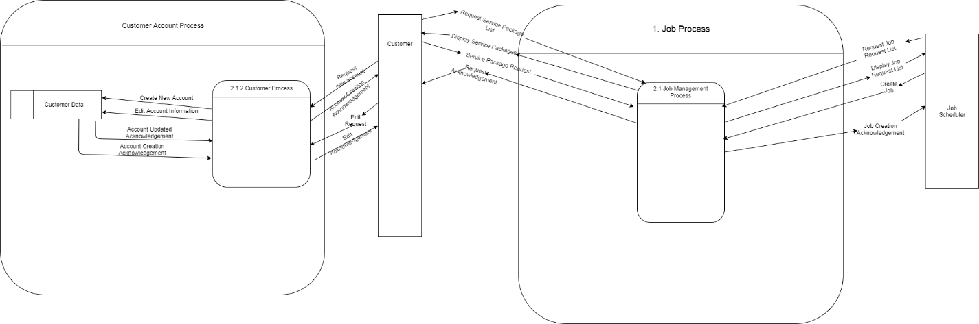

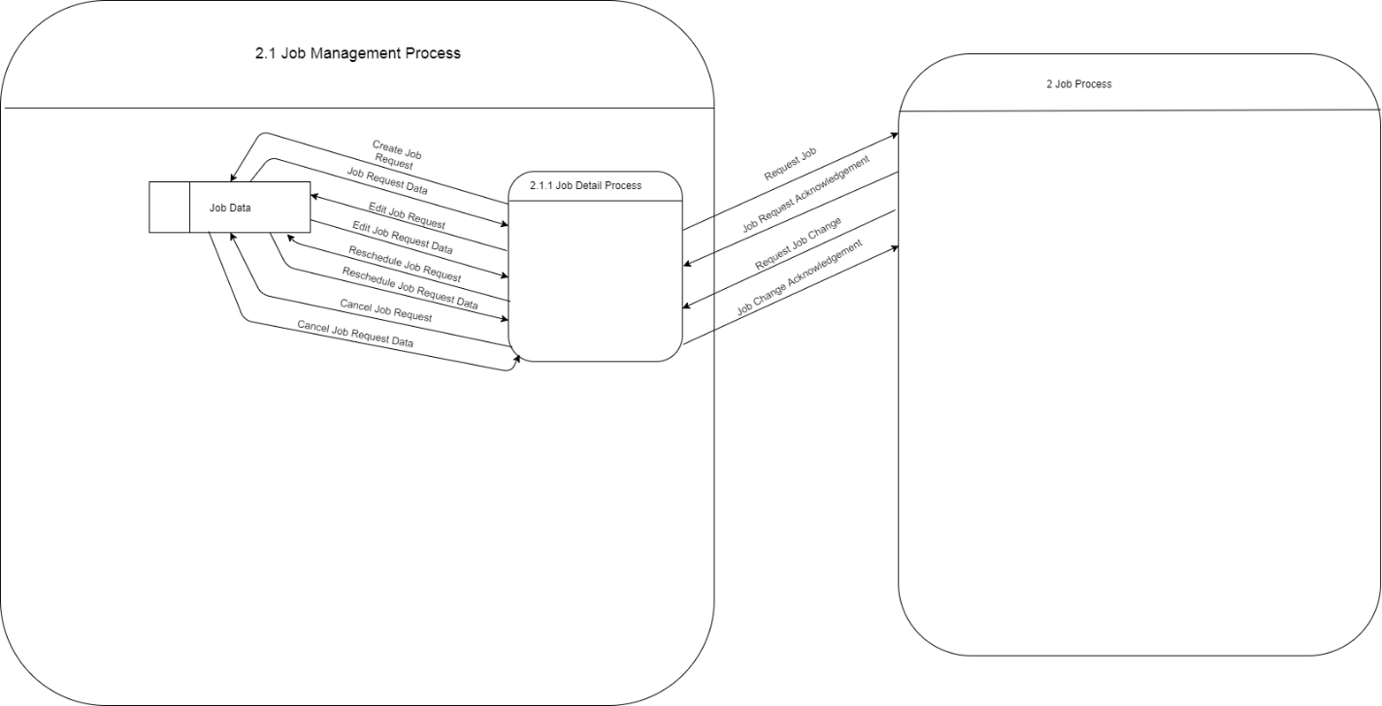

### Labor Scheduling

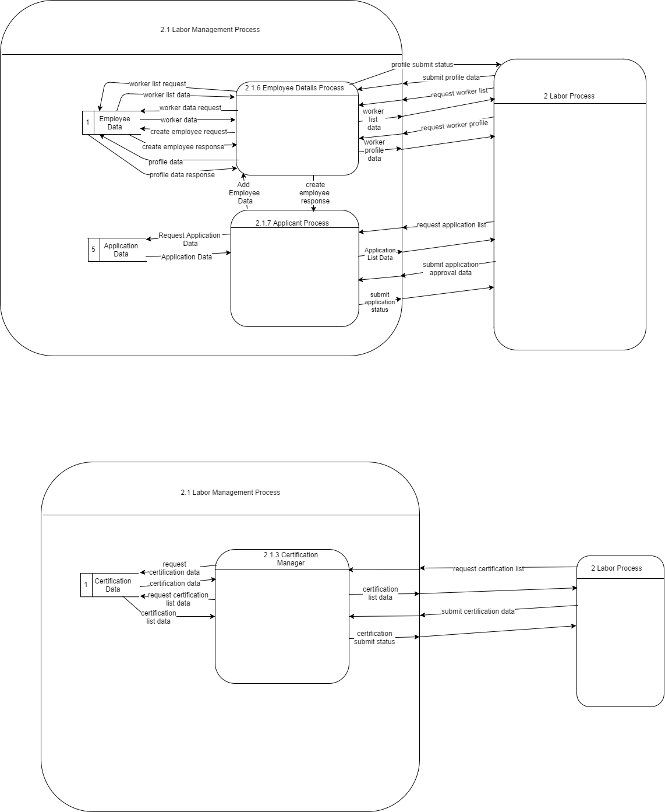

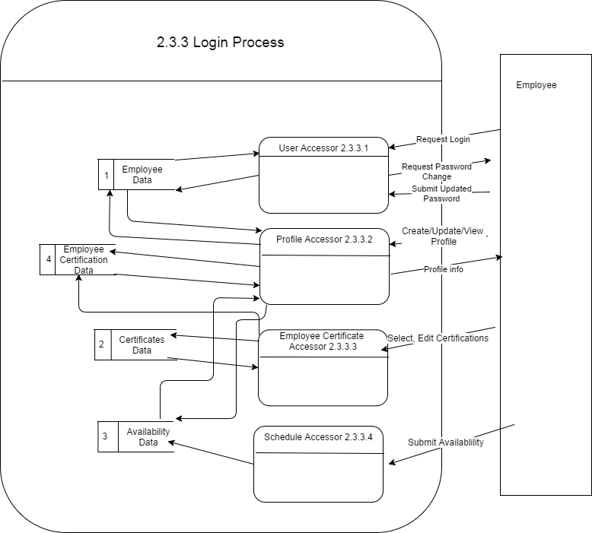

## Use Case Diagrams

### Supply Management

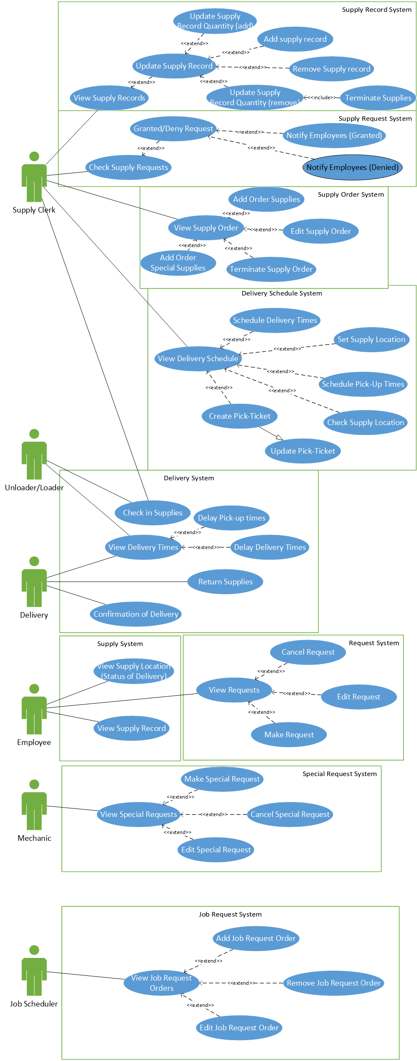

### Equipment Management

#### Inventory

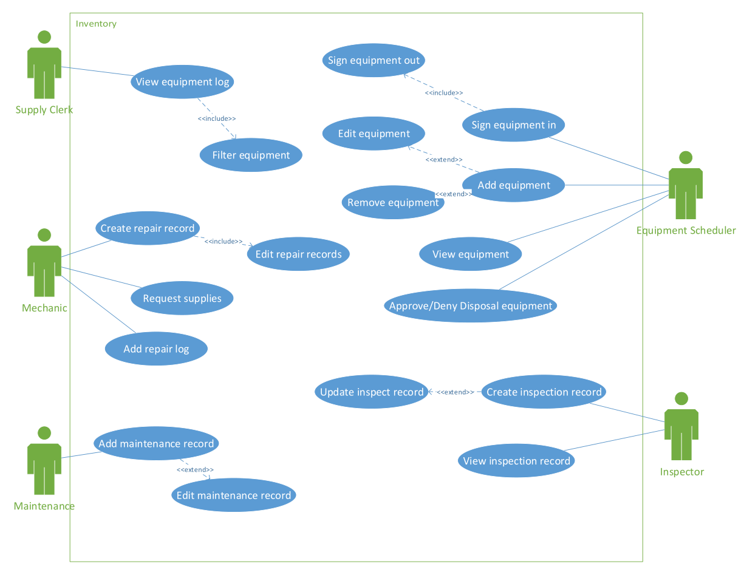

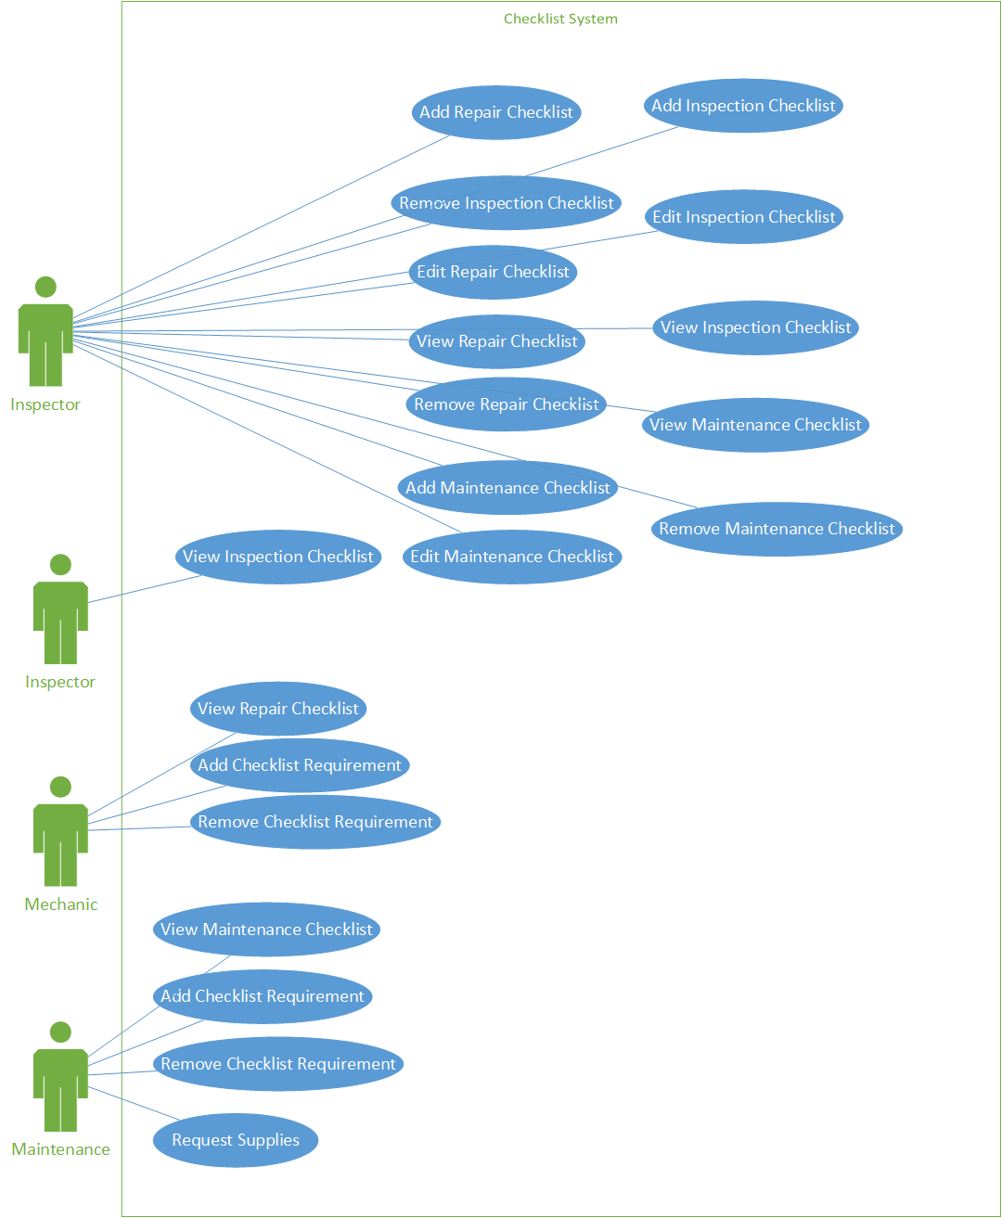

#### Work Queue System

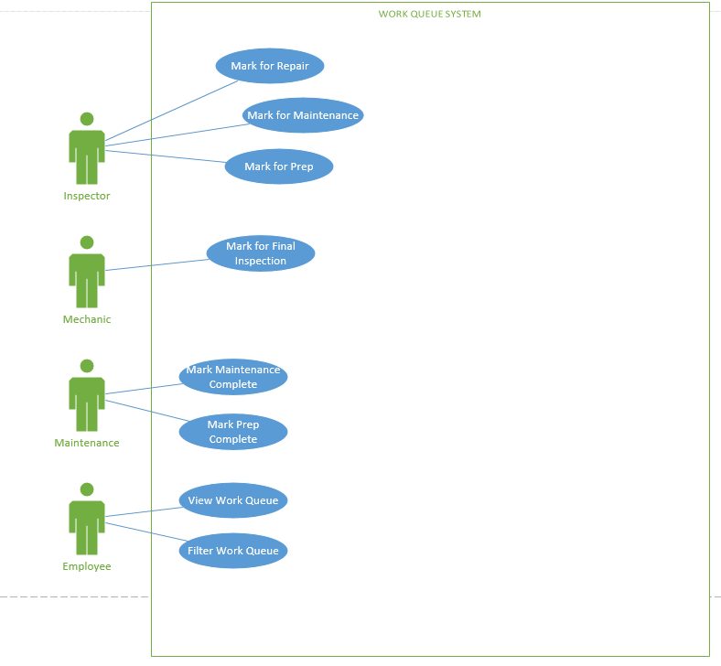

### Job Scheduling

#### Create Job and Request Job

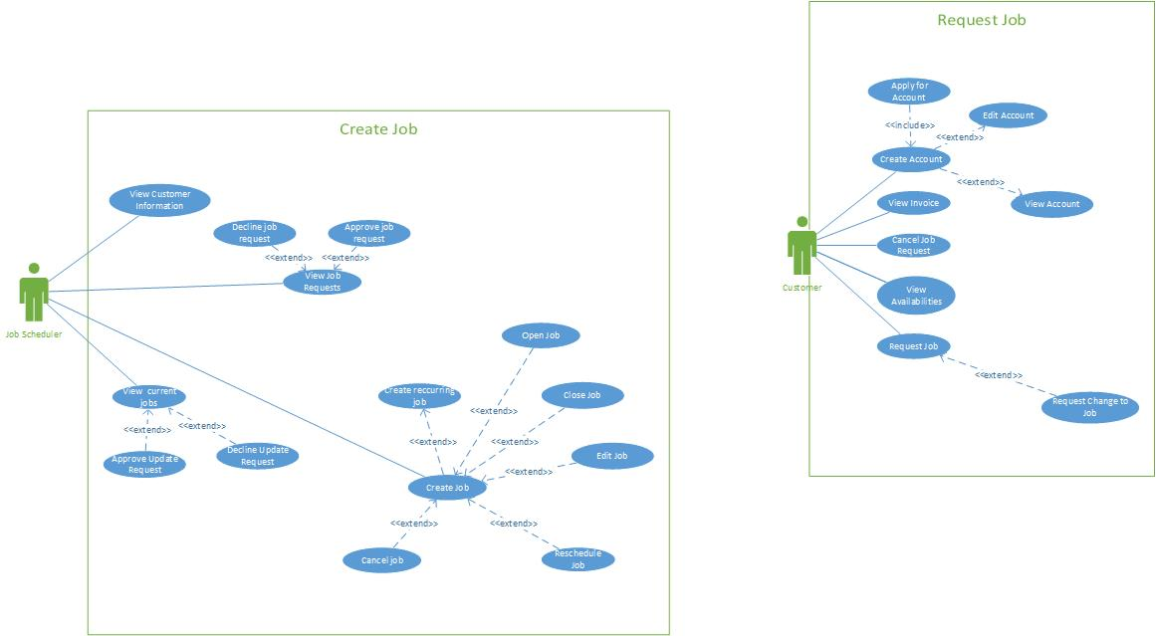

### Labor Scheduling

#### Labor Schedule System

#### https://lh6.googleusercontent.com/5BBbI0vuE9LZGCiAI1ve8T0HRYYX3ToHPljXoq8DuNRcDM21lZDLUAchTyDfk7KrqPRbVkBNzAUKj1yVzX2y69Dua_UAVbdv9bRG7d95UvbdxmgFZafB0B_2VuN2Z4xO425GIMAtEmployee Logging System and Employee Self-Service System

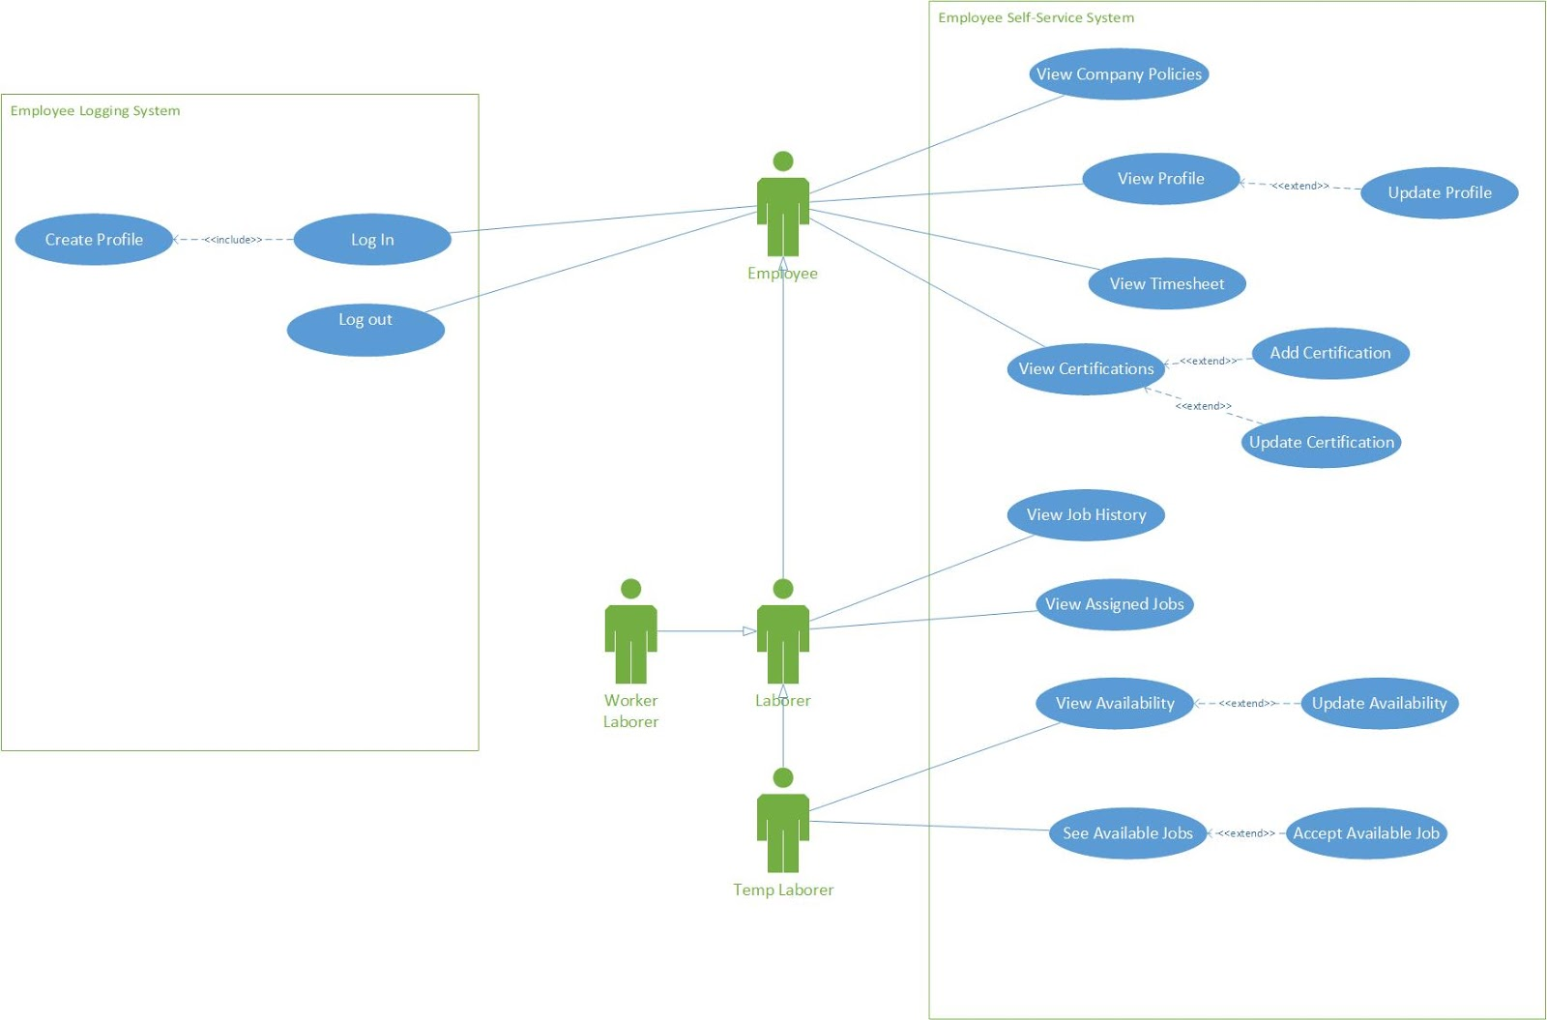

#### Employee Management

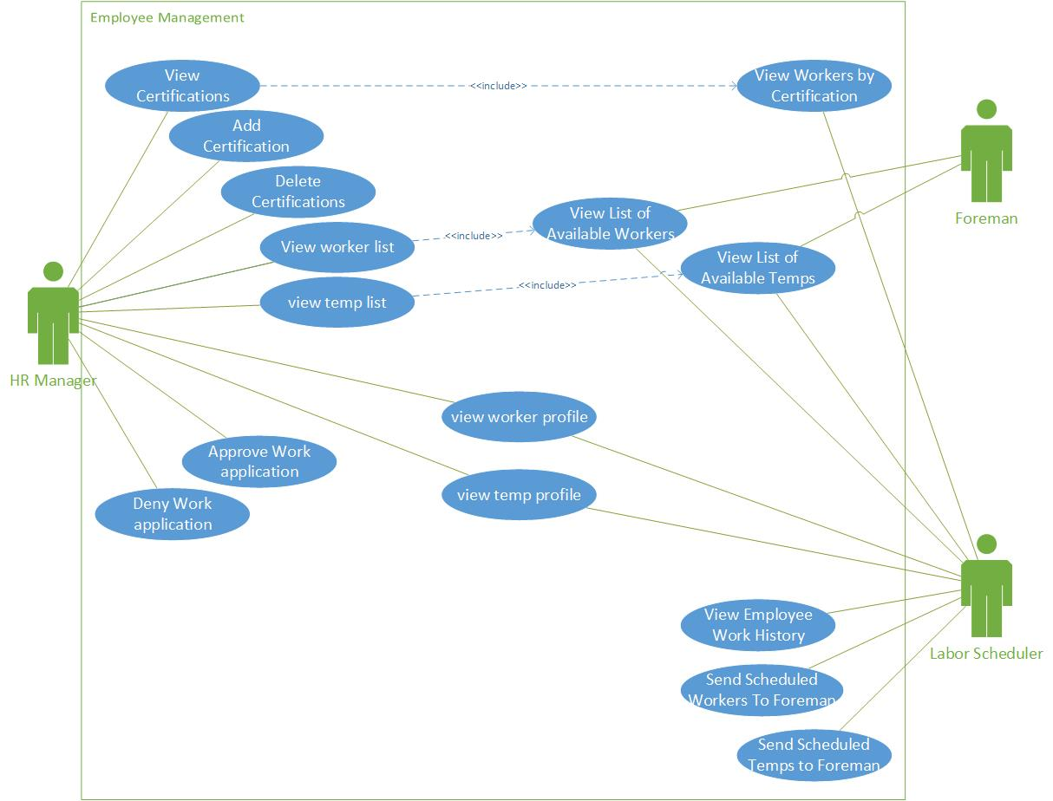

#### Job Site Management

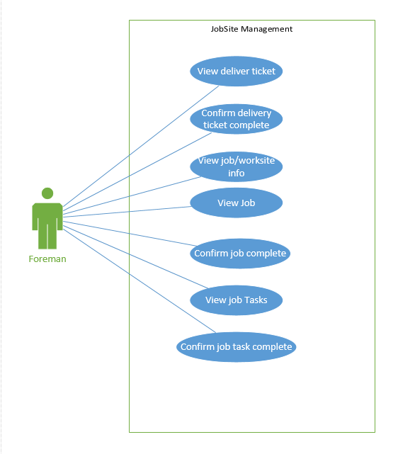

## Activity Diagrams

### Supply Scheduling

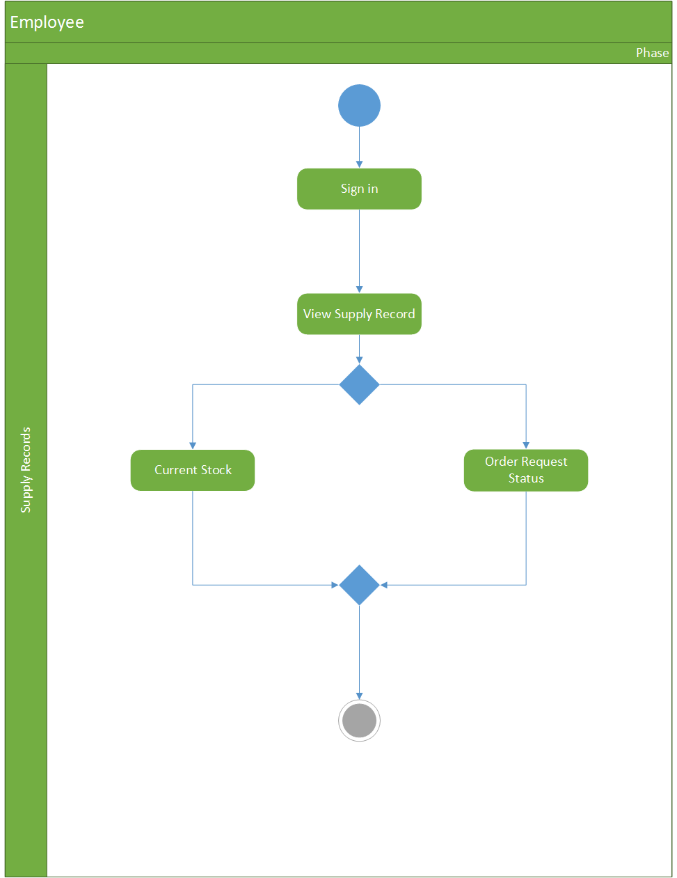

### Job Scheduling

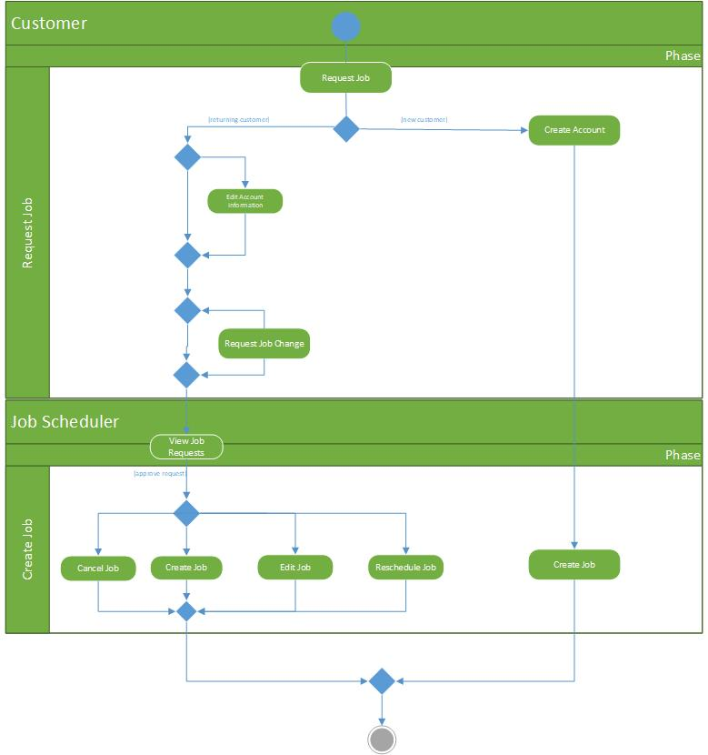

# Formal Use Cases

## Supply Management

|  |  |  |  |  |
| --- | --- | --- | --- | --- |
| **Use Case ID:** | 10001 | | | |
| **Use Case Name:** | View supply record | | | |
| **Created By:** | Noah Davison | | **Last Updated By:** | Noah Davison |
| **Date Created:** | 09-28-2017 | | **Last Revision Date:** | 09-29-2017 |
| **Actors:** | | Supply Clerk | | |
| **Description:** | | The supply record should be able to view the supply record so he knows what we have in inventory | | |
| **Trigger:** | | The supply clerk wants to know what we have in inventory | | |
| **Preconditions:** | |  | | |
| **Postconditions:** | | 1.      The supply clerk receives an inventory record | | |
| **Normal Flow:** | | 1.     Supply clerk clicks on view supply in record  2.     Supply clerk is displayed with options to search and sort the inventory record  3.     System validates if supply clerk is authorized to view the supply record  4.     System outputs supply record  5.     System allows supply clerk to change the search query, or close the supply record | | |
| **Alternative Flows:** | | 3a. If the system decides in section 3 that the user is not authorized to view the supply record  1.   System will tell the user that he is not authorized to view the supply record  2.   Use case goes back to step 2 of normal flow | | |
| **Exceptions:** | | 2a.   In step 2 of the normal flow, if the customer enters an invalid PIN  1.      Transaction is disapproved  2.      Message to customer to re-enter PIN  3.      Customer enters correct PIN  4.      Use Case resumes on step 3 of normal flow | | |
| **Includes:** | |  | | |
| **Frequency of Use:** | | 5 times per day? | | |
| **Special Requirements:** | |  | | |
| **Assumptions:** | | The user is logged into an account | | |
| **Notes and Issues:** | |  | | |
|  | | | | |

|  |  |  |  |  |
| --- | --- | --- | --- | --- |
| **Use Case ID:** | 10002 | | | |
| **Use Case Name:** | Remove supply record | | | |
| **Created By:** | Noah Davison | | **Last Updated By:** | Noah Davison |
| **Date Created:** | 09-28-2017 | | **Last Revision Date:** | 09-29-2017 |
| **Actors:** | | Supply clerk | | |
| **Description:** | | The supply clerk should be able to remove an item from the supply record | | |
| **Trigger:** | | The supply clerk needs to remove something from the supply record, most likely due to an error | | |
| **Preconditions:** | | 1.      The user is viewing the supply record | | |
| **Postconditions:** | | 1.      The item the supply clerk specified is removed from the record  2.      A record of the item being removed is created | | |
| **Normal Flow:** | | 1.      Supply clerk views the supply record  2.      Supply clerk has button options next to record to remove from records  3.      Supply clerk clicks the button  4.      System prompts the user if they are sure  5.      Supply clerk clicks yes  6.      The item is removed from records | | |
| **Alternative Flows:** | | 4a. If the supply clerk clicks “no”  1.The use case restarts from step 2 | | |
| **Exceptions:** | | No exceptions | | |
| **Includes:** | | View supply record | | |
| **Frequency of Use:** | | Once a month | | |
| **Special Requirements:** | |  | | |
| **Assumptions:** | | The user is logged in | | |
| **Notes and Issues:** | |  | | |

|  |  |  |  |  |  |  |  |
| --- | --- | --- | --- | --- | --- | --- | --- |
| **Use Case ID:** | UC-003 | | | | | | |
| **Use Case Name:** | Add supply record | | | | | | |
| **Created By:** | Noah Davison | | | | **Last Updated By:** | | Noah Davison |
| **Date Created:** | 09-28-2017 | | | | **Last Revision Date:** | | 09-28-2017 |
| **Actors:** | | | Supply clerk | | | | |
| **Description:** | | | The supply clerk can add an item to the inventory | | | | |
| **Trigger:** | | | The company gets a new supply item | | | | |
| **Preconditions:** | | | **1.      The user is viewing the supply record** | | | | |
| **Postconditions:** | | | 1.      A new item is added to the supply record  2.      A record of the item being added is created | | | | |
| **Normal Flow:** | | | 1.      System displays a button to add to the supply record while the user is viewing the supply record  2.      User clicks the button  3.      System asks for the name and relevant information about the supply  4.      The system checks if all the fields have been filled out  5.      The user clicks a button to add it to the records  6.      The supply is added to the records | | | | |
| **Alternative Flows:** | | | 4a. In step 4 of the use case if not all fields are filled out  1.      The add to record button is grayed out and unclickable  2.      The user finished filling the fields  3.      The button becomes clickable | | | | |
| **Exceptions:** | | | 3a. In step 3 of the use case the user inputs an invalid character  1.      The system greys out the add to records button and notifies the user where the invalid character is  2.      The user fixes the invalid character  3.      The system resumes where it left off | | | | |
| **Includes:** | | | View supply record | | | | |
| **Frequency of Use:** | | | A few times a week | | | | |
| **Special Requirements:** | | |  | | | | |
| **Assumptions:** | | | The user is logged in | | | | |
| **Notes and Issues:** | | |  | | | | |
| **Use Case ID:** | UC-004 | | | | | | |
| **Use Case Name:** | Update the supply record(add) | | | | | | |
| **Created By:** | Noah Davison | | | **Last Updated By:** | | Noah Davison | |
| **Date Created:** | 09-28-2017 | | | **Last Revision Date:** | | 09-28-2017 | |
| **Actors:** | | Supply clerk | | | | | |
| **Description:** | | Function to add to the quantity of an item in inventory | | | | | |
| **Trigger:** | | New supplies are received | | | | | |
| **Preconditions:** | | **The user is viewing the supply record** | | | | | |
| **Postconditions:** | | 1.      Items in inventories quantities are increased | | | | | |
| **Normal Flow:** | | 1.      System displays a button to increase the quantity of an item next to an item while the user is viewing the supply record  2.      The system prompts the user to input how much to increase the quantity by  3.      The system records the change in records  4.      The system increases the quantity of the item | | | | | |
| **Alternative Flows:** | | 2a. In step 2 if the user does not want to add to the quantity  1.      The system has a button to cancel the record change  2.      The use case starts over from step 1 | | | | | |
| **Exceptions:** | | No exceptions | | | | | |
| **Includes:** | | View supply record | | | | | |
| **Frequency of Use:** | | A few times a week | | | | | |
| **Special Requirements:** | |  | | | | | |
| **Assumptions:** | | The user is logged in | | | | | |
| **Notes and Issues:** | |  | | | | | |

|  |  |  |  |  |  |  |
| --- | --- | --- | --- | --- | --- | --- |
| **Use Case ID:** | UC-005 | | | | | |
| **Use Case Name:** | Update the supply record(remove) | | | | | |
| **Created By:** | Noah Davison | | | | **Last Updated By:** | Noah Davison |
| **Date Created:** | 09-28-2017 | | | | **Last Revision Date:** | 09-28-2017 |
| **Actors:** | | | Supply clerk | | | |
| **Description:** | | | Function  to decrease the quantity of an item in inventory | | | |
| **Trigger:** | | | Supplies are taken out | | | |
| **Preconditions:** | | | **The user is viewing the supply record** | | | |
| **Postconditions:** | | | Items in inventories quantities are decreased | | | |
| **Normal Flow:** | | | 1.      System displays a button to decrease the quantity of an item next to an item while the user is viewing the supply record  2.      The system prompts the user to input how much to decrease the quantity by  3.      The system records the change in records  4.      The system decreases the quantity of the item | | | |
| **Alternative Flows:** | | | 2a. In step 2 if the user does not want to remove from the quantity  1.      The system has a button to cancel the record change  2.      The use case starts over from step 1 | | | |
| **Exceptions:** | | | No exceptions | | | |
| **Includes:** | | | View supply record | | | |
| **Frequency of Use:** | | | A few times a week | | | |
| **Special Requirements:** | | |  | | | |
| **Assumptions:** | | | The use is logged in | | | |
| **Notes and Issues:** | | |  | | | |
| **Use Case ID:** | | UC-006 | | | | |
| **Use Case Name:** | | Update supply record | | | | |
| **Created By:** | | Noah Davison | | | **Last Updated By:** | Noah Davison |
| **Date Created:** | | 09-28-2017 | | | **Last Revision Date:** | 09-29-2017 |
| **Actors:** | | | | Supply clerk | | |
| **Description:** | | | | The supply clerk can update an item in the inventory | | |
| **Trigger:** | | | | There is an error in the data about a supply item, or it needs to be changed for some other reason | | |
| **Preconditions:** | | | | **1.      The user is viewing the supply record** | | |
| **Postconditions:** | | | | 1.      The item in the database is updated | | |
| **Normal Flow:** | | | | 1.      The user double clicks on a changeable value  2.      The system opens a prompt asking the user what to change the value to  4.      The user types in the new value and clicks save  5.      The supply item is updated in the records | | |
| **Alternative Flows:** | | | | 2a. In step 2 of the use case the user decides to not update the supply record  1.      The user clicks the cancel button  2.      The use case ends | | |
| **Exceptions:** | | | | No exceptions | | |
| **Includes:** | | | | View supply record | | |
| **Frequency of Use:** | | | | A few times a week | | |
| **Special Requirements:** | | | |  | | |
| **Assumptions:** | | | | The user is logged in  The user can’t input an invalid value type | | |
| **Notes and Issues:** | | | |  | | |

|  |  |  |  |  |
| --- | --- | --- | --- | --- |
| **Use Case ID:** | UC-008 | | | |
| **Use Case Name:** | Check supply requests | | | |
| **Created By:** | Noah Davison | | **Last Updated By:** | Noah Davison |
| **Date Created:** | 09-28-2017 | | **Last Revision Date:** | 09-29-2017 |
| **Actors:** | | Supply clerk | | |
| **Description:** | | Determine if new supplies are needed so that we can keep on top of supply demand | | |
| **Trigger:** | | The supply clerk wants to check if new supplies are needed | | |
| **Preconditions:** | | **1.      The user is viewing the supply record**  **2.      There are supply requests** | | |
| **Postconditions:** | |  | | |
| **Normal Flow:** | | 1.      The user clicks on a button to view supply requests while viewing the supply requests  2.      The system displays supply requests to the user  3.      The user closes the supply requests viewer | | |
| **Alternative Flows:** | | No alternative flow | | |
| **Exceptions:** | | No exceptions | | |
| **Includes:** | | View supply record | | |
| **Frequency of Use:** | | A few times a day | | |
| **Special Requirements:** | |  | | |
| **Assumptions:** | | The user is logged in | | |
| **Notes and Issues:** | |  | | |

|  |  |  |  |  |
| --- | --- | --- | --- | --- |
| **Use Case ID:** | UC-009 | | | |
| **Use Case Name:** | Notify Employee(granted) | | | |
| **Created By:** | Noah Davison | | **Last Updated By:** | Noah Davison |
| **Date Created:** | 09-28-2017 | | **Last Revision Date:** | 09-29-2017 |
| **Actors:** | | Supply clerk | | |
| **Description:** | | Notify the employee the supply request was granted | | |
| **Trigger:** | | The supply clerk wants to approve a supply request | | |
| **Preconditions:** | | **1.      The supply clerk is viewing the supply requests** | | |
| **Postconditions:** | | The user is viewing the supply record | | |
| **Normal Flow:** | | 1.      The user clicks on a button next to the supply request to grant it  2.      The system prompts the user if he is sure he wants to grant the request  3.      The program sends an email to the requester saying that the supply request was granted | | |
| **Alternative Flows:** | | No alternative flow | | |
| **Exceptions:** | | No exceptions | | |
| **Includes:** | | View supply record  Check supply requests | | |
| **Frequency of Use:** | | A few times a day | | |
| **Special Requirements:** | |  | | |
| **Assumptions:** | | The user is logged in | | |
| **Notes and Issues:** | |  | | |

|  |  |  |  |  |
| --- | --- | --- | --- | --- |
| **Use Case ID:** | UC-010 | | | |
| **Use Case Name:** | Notify Employee(denied) | | | |
| **Created By:** | Noah Davison | | **Last Updated By:** | Noah Davison |
| **Date Created:** | 09-28-2017 | | **Last Revision Date:** | 10-05-2017 |
| **Actors:** | | Supply clerk | | |
| **Description:** | | Notify the employee the supply request was granted | | |
| **Trigger:** | | The supply clerk wants to approve a supply request | | |
| **Preconditions:** | | **The user is viewing the supply requests** | | |
| **Postconditions:** | |  | | |
| **Normal Flow:** | | 1.      The user clicks on a button next to the supply request to deny it  2.      The system prompts the user if he is sure he wants to deny the request  3.      The program sends an email to the requester saying that the supply request was denied | | |
| **Alternative Flows:** | | No alternative flow | | |
| **Exceptions:** | | No exceptions | | |
| **Includes:** | | View supply record  Check supply requests | | |
| **Frequency of Use:** | | A few times a day | | |
| **Special Requirements:** | |  | | |
| **Assumptions:** | | The user is logged in | | |
| **Notes and Issues:** | |  | | |

|  |  |  |  |  |
| --- | --- | --- | --- | --- |
| **Use Case ID:** | UC-15 | | | |
| **Use Case Name:** | Add Order Supplies | | | |
| **Created By:** | Jacob Conley | | **Last Updated By:** | Jacob Conley |
| **Date Created:** | 9/28/2017 | | **Last Revision Date:** | 9/29/2017 |
| **Actors:** | | Supply Clerk | | |
| **Description:** | | Create a new order for supplies when supplies are running low | | |
| **Trigger:** | | Supplies are too low to keep up with demand | | |
| **Preconditions:** | | 1. User is viewing orders | | |
| **Postconditions:** | | 1. New order created 2. User is returned to the view orders screen | | |
| **Normal Flow:** | | 1. System shows orders and buttons 2. User clicks button to add new order 3. System shows form to add new order 4. User fills out form and clicks create button 5. System shows a message saying order created 6. System returns to the view orders page | | |
| **Alternative Flows:** | | 4a. User does not want to add new order anymore   1. User Clicks button to cancel create new order 2. System shows message saying order cancelled 3. System returns to view orders page | | |
| **Exceptions:** | | nothing | | |
| **Includes:** | |  | | |
| **Frequency of Use:** | | on demand | | |
| **Special Requirements:** | |  | | |
| **Assumptions:** | | User is logged in and has the right role | | |
| **Notes and Issues:** | |  | | |

|  |  |  |  |  |
| --- | --- | --- | --- | --- |
| **Use Case ID:** | UC-16 | | | |
| **Use Case Name:** | Add Order Special Supplies | | | |
| **Created By:** | Jacob Conley | | **Last Updated By:** | Jacob Conley |
| **Date Created:** | 9/28/2017 | | **Last Revision Date:** | 9/29/2017 |
| **Actors:** | | Supply Clerk | | |
| **Description:** | | Create a new order for special supplies when the mechanic is in need of supplies that are not kept on hand | | |
| **Trigger:** | | Mechanic reports that a part is needed for a piece of equipment that is not kept on hand | | |
| **Preconditions:** | | 1. **Supply Clerk received special request for a part** 2. **User is viewing orders** | | |
| **Postconditions:** | | 1. New order created 2. User is returned to the view orders screen | | |
| **Normal Flow:** | | 1. System shows orders and buttons 2. User clicks button to add new order 3. System shows form to add new order 4. User fills out form and clicks create button 5. System shows a message saying order created 6. System returns to the view orders page | | |
| **Alternative Flows:** | | 4a. User clicked the wrong button   1. User clicks cancel order button 2. System shows message saying order cancelled 3. System returns to view orders page | | |
| **Exceptions:** | | No exceptions | | |
| **Includes:** | |  | | |
| **Frequency of Use:** | | On demand | | |
| **Special Requirements:** | |  | | |
| **Assumptions:** | | User is logged in and has the right role | | |
| **Notes and Issues:** | |  | | |

|  |  |  |  |  |
| --- | --- | --- | --- | --- |
| **Use Case ID:** | UC-17 | | | |
| **Use Case Name:** | Edit Supply Order | | | |
| **Created By:** | Jacob Conley | | **Last Updated By:** | Jacob Conley |
| **Date Created:** | 9/28/2017 | | **Last Revision Date:** | 10/02/2017 |
| **Actors:** | | Supply Clerk | | |
| **Description:** | | Change the amount of supplies to be ordered in case a larger amount of supplies will be needed or less for a particular reason | | |
| **Trigger:** | | The Supply clerk is notified of a decrease/increase of demand for a product | | |
| **Preconditions:** | | 1. **User is viewing supply orders** | | |
| **Postconditions:** | | 1. Number of items ordered lowered or increased 2. User is returned to view supply orders page | | |
| **Normal Flow:** | | 1. System shows orders and buttons 2. User clicks button to edit order 3. System shows form to edit existing order 4. User fills out form and clicks change button 5. System shows a message saying order changed 6. System returns to the view orders page | | |
| **Alternative Flows:** | | 4a. User does not want to add new order anymore   1. User Clicks button to cancel create new order 2. System shows message saying order cancelled 3. System returns to view orders page | | |
| **Exceptions:** | | No exceptions | | |
| **Includes:** | |  | | |
| **Frequency of Use:** | | On demand | | |
| **Special Requirements:** | |  | | |
| **Assumptions:** | | User is logged in and has the right role and has need to change the current orders. | | |
| **Notes and Issues:** | |  | | |

|  |  |  |  |  |
| --- | --- | --- | --- | --- |
| **Use Case ID:** | UC-18 | | | |
| **Use Case Name:** | View Supply Order | | | |
| **Created By:** | Jacob Conley | | **Last Updated By:** | Jacob Conley |
| **Date Created:** | 9/28/2017 | | **Last Revision Date:** | 10/02/2017 |
| **Actors:** | | Supply Clerk | | |
| **Description:** | | View the supplies that are going to be ordered to check whether anything on the list should be changed | | |
| **Trigger:** | | Changes are needed to be made to an existing supply order or a new order must be created | | |
| **Preconditions:** | | **User is wanting to create a new order or edit old ones** | | |
| **Postconditions:** | | 1. User can see all current orders 2. User can add new orders 3. User can edit existing orders | | |
| **Normal Flow:** | | 1. System displays tabs of job roles 2. User clicks tab to view orders | | |
| **Alternative Flows:** | | No alternative flow | | |
| **Exceptions:** | | No exceptions | | |
| **Includes:** | | Terminate Supply Order  Edit Supply Order  Add Order Special Supplies  Add Order Supplies | | |
| **Frequency of Use:** | | 3 times a day | | |
| **Special Requirements:** | |  | | |
| **Assumptions:** | | User is logged in and has the right role | | |
| **Notes and Issues:** | |  | | |

|  |  |  |  |  |
| --- | --- | --- | --- | --- |
| **Use Case ID:** | UC-19 | | | |
| **Use Case Name:** | Terminate Supply Order | | | |
| **Created By:** | Jacob Conley | | **Last Updated By:** | Jacob Conley |
| **Date Created:** | 9/28/2017 | | **Last Revision Date:** | 10/02/2017 |
| **Actors:** | | Supply Clerk | | |
| **Description:** | | Delete an order that is unnecessary in the case that items that were thought to be unwanted after an order has been placed | | |
| **Trigger:** | | Supply clerk was notified that the supplies ordered would be unnecessary due to a large decrease in demand at this time. | | |
| **Preconditions:** | | 1. **Supply clerk was notified of a large decrease in demand on an item to be ordered** 2. **User is viewing supply orders** | | |
| **Postconditions:** | | 1. Supply order is removed 2. User is returned to view supply orders page | | |
| **Normal Flow:** | | 1. System shows orders and buttons 2. User selects an existing order and clicks button to delete order 3. System displays question asking if the user is sure about the decision 4. User selects yes to delete order 5. System returns to view orders and order is removed | | |
| **Alternative Flows:** | | 4a user is notified of a change and order is necessary   1. User chooses no to not delete order 2. System returns to view orders   4b. User did not mean to click button   1. User chooses no to not delete order 2. System returns to view orders | | |
| **Exceptions:** | | No exceptions | | |
| **Includes:** | |  | | |
| **Frequency of Use:** | | On demand | | |
| **Special Requirements:** | |  | | |
| **Assumptions:** | | User is logged in and has the right role | | |
| **Notes and Issues:** | |  | | |

|  |  |  |  |  |
| --- | --- | --- | --- | --- |
| **Use Case ID:** | UC-20 | | | |
| **Use Case Name:** | Terminate Supplies | | | |
| **Created By:** | Jacob Conley | | **Last Updated By:** | Jacob Conley |
| **Date Created:** | 9/28/2017 | | **Last Revision Date:** | 10/04/2017 |
| **Actors:** | | Supply Clerk | | |
| **Description:** | | Remove supplies from stock in the system that are no longer being used | | |
| **Trigger:** | | Supplies on the shelf that are no longer being used | | |
| **Preconditions:** | | 1. **Supply Clerk went through supplies to check if any supplies are not being used** 2. **Supply Clerk found old supplies and is removing them from stock** 3. **Supply Clerk is viewing supplies** | | |
| **Postconditions:** | | 1. Supply item is removed from the system 2. Supply clerk is returned to viewing supplies | | |
| **Normal Flow:** | | 1. System is showing supplies stock and buttons 2. User clicks supply item and clicks button terminate supplies 3. System shows message remove from stock 4. User clicks remove supplies 5. System returns to viewing supplies and displays message saying supplies supply removed | | |
| **Alternative Flows:** | | 4a User clicked terminate supply, doesn’t need to though   1. User clicks cancel 2. System returns to viewing supplies | | |
| **Exceptions:** | | No exceptions | | |
| **Includes:** | |  | | |
| **Frequency of Use:** | | On demand | | |
| **Special Requirements:** | |  | | |
| **Assumptions:** | | User is logged in and has the right role | | |
| **Notes and Issues:** | |  | | |

|  |  |  |  |  |
| --- | --- | --- | --- | --- |
| **Use Case ID:** | UC-21 | | | |
| **Use Case Name:** | Check Supply Location | | | |
| **Created By:** | Jacob Conley | | **Last Updated By:** | Jacob Conley |
| **Date Created:** | 9/28/2017 | | **Last Revision Date:** | 10/04/2017 |
| **Actors:** | | Supply Clerk | | |
| **Description:** | | Check the system for the location of supplies, so that all supplies can be placed where they are supposed to be or removed from that location | | |
| **Trigger:** | | Supply clerk needs to find the place to put the supplies that were ordered or returned to the warehouse | | |
| **Preconditions:** | | 1. **User wants to view locations of supplies** | | |
| **Postconditions:** | | 1. User can see the location of supplies 2. User can change the location of supplies 3. User can add a location for new supplies | | |
| **Normal Flow:** | | 1. System displays tabs of job roles 2. User clicks tab for supply locations | | |
| **Alternative Flows:** | | No alternative flow | | |
| **Exceptions:** | | No exceptions | | |
| **Includes:** | | Set Supply Location | | |
| **Frequency of Use:** | | Several times daily | | |
| **Special Requirements:** | |  | | |
| **Assumptions:** | | User is logged in and has the right role | | |
| **Notes and Issues:** | |  | | |

|  |  |  |  |  |
| --- | --- | --- | --- | --- |
| **Use Case ID:** | UC-22 | | | |
| **Use Case Name:** | Set Supply Location | | | |
| **Created By:** | Jacob Conley | | **Last Updated By:** | Jacob Conley |
| **Date Created:** | 9/28/2017 | | **Last Revision Date:** | 10/04/2017 |
| **Actors:** | | Supply Clerk | | |
| **Description:** | | Set the location of a new item in inventory that had not been set yet when orders have been received. | | |
| **Trigger:** | | New supplies yet to be seen in the warehouse were ordered and need to have a location to be set for them | | |
| **Preconditions:** | | 1. **Supply Clerk had new order come in with new items not on record** 2. **Supply Clerk is viewing supply locations** | | |
| **Postconditions:** | | 1. Supply location has been set 2. User is returned to viewing supply locations | | |
| **Normal Flow:** | | 1. System is showing supply locations and buttons 2. User clicks add new supply location button 3. System displays form to add new location for a certain supply 4. User fills out form and clicks submit 5. System returns to view supply locations and displays message saying new location has been added | | |
| **Alternative Flows:** | | 4a User mistakenly added new location   1. User clicks button to cancel new location 2. System shows message saying new location cancelled 3. System returns to viewing supply locations | | |
| **Exceptions:** | | No alternative flow | | |
| **Includes:** | |  | | |
| **Frequency of Use:** | | On demand | | |
| **Special Requirements:** | |  | | |
| **Assumptions:** | | Is logged in and has the right role | | |
| **Notes and Issues:** | |  | | |

|  |  |  |  |  |
| --- | --- | --- | --- | --- |
| **Use Case ID:** | UC-41 | | | |
| **Use Case Name:** | view department order quests | | | |
| **Created By:** | Marshall Sejkora | | **Last Updated By:** | Marshall Sejkora |
| **Date Created:** | 9/28/2017 | | **Last Revision Date:** | 9/29/2017 |
| **Actors:** | | Employee | | |
| **Description:** | | view unfilled orders you have made to the supply department | | |
| **Trigger:** | | Want to see unfilled orders you have made to the supply department | | |
| **Preconditions:** | | 1. Must be an Employee | | |
| **Postconditions:** | |  | | |
| **Normal Flow:** | | 1. Employee clicks “view special part orders” 2. Click an order to view details | | |
| **Alternative Flows:** | | No alternative flow | | |
| **Exceptions:** | | No exceptions | | |
| **Includes:** | | Edit special part order | | |
| **Frequency of Use:** | | daily | | |
| **Special Requirements:** | |  | | |
| **Assumptions:** | | Is logged in and has the right role | | |
| **Notes and Issues:** | |  | | |

|  |  |  |  |  |
| --- | --- | --- | --- | --- |
| **Use Case ID:** | UC-42 | | | |
| **Use Case Name:** | Edit special part order | | | |
| **Created By:** | Marshall Sejkora | | **Last Updated By:** | Marshall Sejkora |
| **Date Created:** | 9/28/2017 | | **Last Revision Date:** | 9/29/2017 |
| **Actors:** | | Mechanic | | |
| **Description:** | | edit unfilled orders you have made for special parts from the supply department | | |
| **Trigger:** | | Want to edit unfilled orders you have made for special parts from the supply department for some reason | | |
| **Preconditions:** | | 1. Must be the same mechanic that placed order or a superior | | |
| **Postconditions:** | | 1. Changes special part order | | |
| **Normal Flow:** | | 1. Mechanic clicks “view special part orders” 2. Mechanic clicks “view edit special part orders” | | |
| **Alternative Flow** | | No alternative flow | | |
| **Exceptions:** | | No exceptions | | |
| **Includes:** | |  | | |
| **Frequency of Use:** | | When necessary | | |
| **Special Requirements:** | |  | | |
| **Assumptions:** | | Is logged in and has the right role | | |
| **Notes and Issues:** | |  | | |

|  |  |  |  |  |
| --- | --- | --- | --- | --- |
| **Use Case ID:** | UC-43 | | | |
| **Use Case Name:** | Special part order | | | |
| **Created By:** | Marshall Sejkora | | **Last Updated By:** | Marshall Sejkora |
| **Date Created:** | 9/28/2017 | | **Last Revision Date:** | 9/29/2017 |
| **Actors:** | | Mechanic | | |
| **Description:** | | make a special parts order from the supply department | | |
| **Trigger:** | | Want to make a special parts order from the supply department so equipment can be fixed | | |
| **Preconditions:** | | 1. Must be a Mechanic | | |
| **Postconditions:** | | 1. Special part order sent to supply department | | |
| **Normal Flow:** | | 1. Mechanic clicks “order special part” | | |
| **Alternative Flows:** | | No alternative flow | | |
| **Exceptions:** | | No exceptions | | |
| **Includes:** | |  | | |
| **Frequency of Use:** | | On demand | | |
| **Special Requirements:** | |  | | |
| **Assumptions:** | | Is logged in and has the right role | | |
| **Notes and Issues:** | |  | | |

|  |  |  |  |  |
| --- | --- | --- | --- | --- |
| **Use Case ID:** | UC-44 | | | |
| **Use Case Name:** | Cancel Special part order | | | |
| **Created By:** | Marshall Sejkora | | **Last Updated By:** | Marshall Sejkora |
| **Date Created:** | 9/28/2017 | | **Last Revision Date:** | 9/29/2017 |
| **Actors:** | | Mechanic | | |
| **Description:** | | Cancel unfilled orders you have made for special parts from the supply department | | |
| **Trigger:** | | want to Cancel unfilled orders you have made for special parts from the supply department for any reason | | |
| **Preconditions:** | | 1. Must be the same mechanic that placed order or a superior | | |
| **Postconditions:** | | 1. The special part order is Canceled | | |
| **Normal Flow:** | | 1. Mechanic clicks “view cancel special part orders” | | |
| **Alternative Flow** | | No alternative flow | | |
| **Exceptions:** | | No exceptions | | |
| **Includes:** | |  | | |
| **Frequency of Use:** | | On demand | | |
| **Special Requirements:** | |  | | |
| **Assumptions:** | | Is logged in and has the right role | | |
| **Notes and Issues:** | |  | | |

|  |  |  |  |  |
| --- | --- | --- | --- | --- |
| **Use Case ID:** | UC-45 | | | |
| **Use Case Name:** | View Special part order | | | |
| **Created By:** | Marshall Sejkora | | **Last Updated By:** | Marshall Sejkora |
| **Date Created:** | 9/28/2017 | | **Last Revision Date:** | 9/29/2017 |
| **Actors:** | | Mechanic | | |
| **Description:** | | view unfilled orders you have made for special parts from the supply department | | |
| **Trigger:** | | Want to view unfilled orders you have made for special parts from the supply department for any reason | | |
| **Preconditions:** | | 1. Is a Mechanic | | |
| **Postconditions:** | | 1. List of Special part orders is displayed | | |
| **Normal Flow:** | | 1. Mechanic clicks “view special part orders” 2. Click an order to view details | | |
| **Alternative Flows:** | | No alternative flow | | |
| **Exceptions:** | | No exceptions | | |
| **Includes:** | |  | | |
| **Frequency of Use:** | | daily | | |
| **Special Requirements:** | |  | | |
| **Assumptions:** | | Is logged in and has the right role | | |
| **Notes and Issues:** | |  | | |

|  |  |  |  |  |
| --- | --- | --- | --- | --- |
| **Use Case ID:** | UC-46 | | | |
| **Use Case Name:** | Make a Supply order for jobs | | | |
| **Created By:** | Marshall Sejkora | | **Last Updated By:** | Marshall Sejkora |
| **Date Created:** | 9/28/2017 | | **Last Revision Date:** | 9/29/2017 |
| **Actors:** | | Job Scheduler | | |
| **Description:** | | make a supply order to the supply department for a job | | |
| **Trigger:** | | Want to make a supply order to the supply department for a job so a job can be accomplished | | |
| **Preconditions:** | | 1. Job is valid | | |
| **Postconditions:** | | 1. Job supply order sent to supply department | | |
| **Normal Flow:** | | 1. Job Scheduler clicks “view job supply orders” 2. Click Make new job supply order 3. Make order 4. Confirm order | | |
| **Alternative Flows:** | | 4.a.Cancel new order | | |
| **Exceptions:** | | No exceptions | | |
| **Includes:** | |  | | |
| **Frequency of Use:** | | daily | | |
| **Special Requirements:** | |  | | |
| **Assumptions:** | |  | | |
| **Notes and Issues:** | |  | | |

|  |  |  |  |  |
| --- | --- | --- | --- | --- |
| **Use Case ID:** | UC-47 | | | |
| **Use Case Name:** | Edit a Supply order for jobs | | | |
| **Created By:** | Marshall Sejkora | | **Last Updated By:** | Marshall Sejkora |
| **Date Created:** | 9/28/2017 | | **Last Revision Date:** | 9/29/2017 |
| **Actors:** | | Job Scheduler | | |
| **Description:** | | Edit a supply order to the supply department for a job | | |
| **Trigger:** | | Want to Edit a supply order to the supply department for a job for any reason | | |
| **Preconditions:** | | 1. Must be the Job Scheduler that scheduled it originally | | |
| **Postconditions:** | | 1. Job supply order is changed | | |
| **Normal Flow:** | | 1. Job Scheduler clicks “view job supply orders” 2. Click an order to view details 3. Click edit order 4. Edit order 5. Click confirm change | | |
| **Alternative Flows:** | | 5.a.Cancel order change | | |
| **Exceptions:** | | No exceptions | | |
| **Includes:** | |  | | |
| **Frequency of Use:** | | On demand | | |
| **Special Requirements:** | |  | | |
| **Assumptions:** | | Is logged in and has the right role | | |
| **Notes and Issues:** | |  | | |

|  |  |  |  |  |
| --- | --- | --- | --- | --- |
| **Use Case ID:** | UC-48 | | | |
| **Use Case Name:** | Cancel a Supply order for jobs | | | |
| **Created By:** | Marshall Sejkora | | **Last Updated By:** | Marshall Sejkora |
| **Date Created:** | 9/28/2017 | | **Last Revision Date:** | 9/29/2017 |
| **Actors:** | | Job Scheduler | | |
| **Description:** | | Remove a supply order to the supply department for a job | | |
| **Trigger:** | | Want to Remove a supply order to the supply department for a job for any reason | | |
| **Preconditions:** | | 1. Must be the Job Scheduler that scheduled it originally | | |
| **Postconditions:** | | 1. Job supply order is canceled | | |
| **Normal Flow:** | | 1. Job Scheduler clicks “view job supply orders” 2. Click an order to view details 3. Click cancel order 4. Verify cancel 5. Verify user | | |
| **Alternative Flows:** | | No alternative flow | | |
| **Exceptions:** | | No exceptions | | |
| **Includes:** | |  | | |
| **Frequency of Use:** | | On demand | | |
| **Special Requirements:** | |  | | |
| **Assumptions:** | | Is logged in and has the right role | | |
| **Notes and Issues:** | |  | | |

|  |  |  |  |  |
| --- | --- | --- | --- | --- |
| **Use Case ID:** | UC-49 | | | |
| **Use Case Name:** | View Supply orders for jobs | | | |
| **Created By:** | Marshall Sejkora | | **Last Updated By:** | Marshall Sejkora |
| **Date Created:** | 9/28/2017 | | **Last Revision Date:** | 9/29/2017 |
| **Actors:** | | Job Scheduler | | |
| **Description:** | | View the supply orders to the supply department for jobs | | |
| **Trigger:** | | Want to View the supply orders to the supply department for jobs for any reason | | |
| **Preconditions:** | | 1. Job is submitted | | |
| **Postconditions:** | | 1. Job Supply orders are displayed | | |
| **Normal Flow:** | | 1. Job Scheduler clicks “view job supply orders” 2. Click an order to view details | | |
| **Alternative Flows:** | | No alternative flow | | |
| **Exceptions:** | | No exceptions | | |
| **Includes:** | |  | | |
| **Frequency of Use:** | | daily | | |
| **Special Requirements:** | |  | | |
| **Assumptions:** | | Is logged in and has the right role | | |
| **Notes and Issues:** | |  | | |

|  |  |  |  |  |
| --- | --- | --- | --- | --- |
| **Use Case ID:** | UC-32 | | | |
| **Use Case Name:** | Delay pick-up times | | | |
| **Created By:** | Jayden Tollefson | | **Last Updated By:** | Jayden Tollefson |
| **Date Created:** | 09-28-2017 | | **Last Revision Date:** | 10-06-2017 |
| **Actors:** | | Delivery | | |
| **Description:** | | Delay the pick-up times so the deliverer can get where they need to be on time | | |
| **Trigger:** | | The delivery driver gets stuck and cannot make it in time | | |
| **Preconditions:** | | 1. **Delivery driver must have a good reason to be late** | | |
| **Postconditions:** | | 1. Pick-up time set back | | |
| **Normal Flow:** | | 1. User views pickup times  2. System displays pickup times and button to delay  3. User clicks delay button  4. System displays form to change pickup times  5. User fills out form and clicks the change/delay button  6. System shows message saying “The pickup has been delayed” | | |
| **Alternative Flows:** | | 4a. In step 5 of the normal flow, if the user realizes he has enough time to make the delivery   1. User can click a button labeled cancel | | |
| **Exceptions:** | | No exceptions | | |
| **Includes:** | | View pickup times | | |
| **Frequency of Use:** | | On demand | | |
| **Special Requirements:** | |  | | |
| **Assumptions:** | | Is logged in and has the right role | | |
| **Notes and Issues:** | |  | | |

|  |  |  |  |  |
| --- | --- | --- | --- | --- |
| **Use Case ID:** | UC-33 | | | |
| **Use Case Name:** | Delay delivery times | | | |
| **Created By:** | Jayden Tollefson | | **Last Updated By:** | Jayden Tollefson |
| **Date Created:** | 09-28-2017 | | **Last Revision Date:** | 10-06-2017 |
| **Actors:** | | Delivery | | |
| **Description:** | | The delivery times get delayed because the delivery driver is stuck somewhere | | |
| **Trigger:** | | The delivery driver gets delayed due to traffic, weather, or some kind of accident | | |
| **Preconditions:** | | 1. **Delivery driver must have a good reason to be late** | | |
| **Postconditions:** | | 1. Delivery time set back | | |
| **Normal Flow:** | | 1. User views delivery times  2. System displays delivery times and button to delay  3. User clicks delay button  4. System displays form to change delivery times  5. User fills out form and clicks the change/delay button  6. System shows message saying “The delivery has been delayed” | | |
| **Alternative Flows:** | | 4a. In step 5 of the normal flow, if the user realizes he has enough time to make the delivery   1. User can click a button labeled cancel | | |
| **Exceptions:** | | No exceptions | | |
| **Includes:** | | View delivery times | | |
| **Frequency of Use:** | | On demand | | |
| **Special Requirements:** | |  | | |
| **Assumptions:** | | Is logged in and has the right role | | |
| **Notes and Issues:** | |  | | |

|  |  |  |  |  |
| --- | --- | --- | --- | --- |
| **Use Case ID:** | UC-34 | | | |
| **Use Case Name:** | Return supplies | | | |
| **Created By:** | Jayden Tollefson | | **Last Updated By:** | Jayden Tollefson |
| **Date Created:** | 09-28-2017 | | **Last Revision Date:** | 10-06-2017 |
| **Actors:** | | Delivery | | |
| **Description:** | | The delivery driver returns items that either are not working, or if the order was canceled | | |
| **Trigger:** | | The delivery driver returns to the warehouse with items that should be in use | | |
| **Preconditions:** | | 1. **Item must be damaged, broken, or be on a canceled order** | | |
| **Postconditions:** | | 1. Item gets fixed or put directly back where it belongs | | |
| **Normal Flow:** | | 1. User view deliveries 2. System shows current deliveries and radio buttons for reasons why the delivery supplies would be back 3. User selects appropriate radio button 4. User hits submit button 5. System displays message saying “Item status changed” | | |
| **Alternative Flows:** | | No alternative flow | | |
| **Exceptions:** | | No exceptions | | |
| **Includes:** | |  | | |
| **Frequency of Use:** | | On Demand | | |
| **Special Requirements:** | |  | | |
| **Assumptions:** | | Is logged in and has the right role | | |
| **Notes and Issues:** | |  | | |

|  |  |  |  |  |
| --- | --- | --- | --- | --- |
| **Use Case ID:** | UC-35 | | | |
| **Use Case Name:** | Confirmation of delivery | | | |
| **Created By:** | Jayden Tollefson | | **Last Updated By:** | Jayden Tollefson |
| **Date Created:** | 09-28-2017 | | **Last Revision Date:** | 10-06-2017 |
| **Actors:** | | Delivery | | |
| **Description:** | | The delivery driver lets the store know that certain items have been delivered | | |
| **Trigger:** | | The delivery driver makes it to their destination and delivers the items | | |
| **Preconditions:** | | 1. **The delivery driver makes it to their destination with all of the items** | | |
| **Postconditions:** | | 1. Management knows that the delivery has been made | | |
| **Normal Flow:** | | 1. User views current deliveries 2. System displays the current deliveries and a delivered button 3. User clicks the delivered button 4. System displays message saying “ Delivery has successfully been delivered.“ | | |
| **Alternative Flows:** | | No alternative flow | | |
| **Exceptions:** | | No exceptions | | |
| **Includes:** | |  | | |
| **Frequency of Use:** | | Every Day | | |
| **Special Requirements:** | |  | | |
| **Assumptions:** | | Is logged in and has the right role | | |
| **Notes and Issues:** | |  | | |

|  |  |  |  |  |
| --- | --- | --- | --- | --- |
| **Use Case ID:** | UC-36 | | | |
| **Use Case Name:** | View supply record | | | |
| **Created By:** | Jayden Tollefson | | **Last Updated By:** | Jayden Tollefson |
| **Date Created:** | 09-28-2017 | | **Last Revision Date:** | 10-06-2017 |
| **Actors:** | | Employee | | |
| **Description:** | | Employees can see what supplies are in stock | | |
| **Trigger:** | | Employees need an item and want to know if the store has any on hand | | |
| **Preconditions:** | |  | | |
| **Postconditions:** | | 1. Employees get to see what the store has in stock | | |
| **Normal Flow:** | | 1. User clicks “view supply records” | | |
| **Alternative Flows:** | | No alternative flow | | |
| **Exceptions:** | | No exceptions | | |
| **Includes:** | |  | | |
| **Frequency of Use:** | | Every Day | | |
| **Special Requirements:** | |  | | |
| **Assumptions:** | | Is logged in and has the right role | | |
| **Notes and Issues:** | |  | | |

|  |  |  |  |  |
| --- | --- | --- | --- | --- |
| **Use Case ID:** | UC-37 | | | |
| **Use Case Name:** | View supply location (status of delivery) | | | |
| **Created By:** | Jayden Tollefson | | **Last Updated By:** | Jayden Tollefson |
| **Date Created:** | 09-28-2017 | | **Last Revision Date:** | 10-06-2017 |
| **Actors:** | | Employee | | |
| **Description:** | | Employees can see where supplies are located or if some are being delivered to the warehouse | | |
| **Trigger:** | | Employees need to find a certain item and don’t know exactly where it is | | |
| **Preconditions:** | |  | | |
| **Postconditions:** | | 1. Employees see where supplies are located in the warehouse | | |
| **Normal Flow:** | | 1. User clicks “view supply location” | | |
| **Alternative Flows:** | | No alternative flow | | |
| **Exceptions:** | | No exceptions | | |
| **Includes:** | |  | | |
| **Frequency of Use:** | | Every Day | | |
| **Special Requirements:** | |  | | |
| **Assumptions:** | | Is logged in and has the right role | | |
| **Notes and Issues:** | |  | | |

|  |  |  |  |  |
| --- | --- | --- | --- | --- |
| **Use Case ID:** | UC-38 | | | |
| **Use Case Name:** | Make Request | | | |
| **Created By:** | Jayden Tollefson | | **Last Updated By:** | Jayden Tollefson |
| **Date Created:** | 09-28-2017 | | **Last Revision Date:** | 10-06-2017 |
| **Actors:** | | Employee | | |
| **Description:** | | An employee wants to make a request | | |
| **Trigger:** | | An employee realizes  they need an item that the store doesn’t have | | |
| **Preconditions:** | |  | | |
| **Postconditions:** | | 1. The request is sent to the supply clerk | | |
| **Normal Flow:** | | 1. User opens “supply requests” 2. System displays all basic requests made and a button that says ‘make’ 3. User click the ‘make’ button 4. System pulls up a request paper for the user to fill out 5. User fills out request paper and hits submit 6. System displays message saying “Request made.” | | |
| **Alternative Flows:** | | 4a. In step 5 of the normal flow, if the user realizes they don’t need to make the request   1. User can click a button labeled cancel | | |
| **Exceptions:** | | No exceptions | | |
| **Includes:** | | View supply request | | |
| **Frequency of Use:** | | On Demand | | |
| **Special Requirements:** | |  | | |
| **Assumptions:** | | Is a valid employee | | |
| **Notes and Issues:** | |  | | |

|  |  |  |  |  |
| --- | --- | --- | --- | --- |
| **Use Case ID:** | UC-39 | | | |
| **Use Case Name:** | Edit request | | | |
| **Created By:** | Jayden Tollefson | | **Last Updated By:** | Jayden Tollefson |
| **Date Created:** | 09-28-2017 | | **Last Revision Date:** | 10-06-2017 |
| **Actors:** | | Employee | | |
| **Description:** | | Employees can make changes to the requests that they sent if it hasn’t already been granted by the supply clerk | | |
| **Trigger:** | | Employees realise that they ordered too much or too little of the item | | |
| **Preconditions:** | | 1. **User must have made the request** 2. **Request must not have already been granted by the supply clerk** | | |
| **Postconditions:** | | 1. The request is edited with the correct info | | |
| **Normal Flow:** | | 1. User opens “supply requests” 2. System displays all basic requests made by the current user as well as a button labeled Edit 3. User clicks the button labeled Edit that is next to the request they want to change 4. System displays the request they want to edit 5. User makes the changes needed and hits the button labeled Apply 6. Displays a message saying “Your changes have been saved” | | |
| **Alternative Flows:** | | 4a. In line 5 of the normal flow, if the user realizes that they are editing the wrong request   1. User clicks a button labeled cancel 2. Return user to step 2   4b. In line 3 of the normal flow, if the user realises that their request doesn’t need any editing   1. User clicks a button labeled cancel | | |
| **Exceptions:** | | No exceptions | | |
| **Includes:** | | View supply request | | |
| **Frequency of Use:** | | On Demand | | |
| **Special Requirements:** | |  | | |
| **Assumptions:** | | Is a valid employee | | |
| **Notes and Issues:** | |  | | |

|  |  |  |  |  |
| --- | --- | --- | --- | --- |
| **Use Case ID:** | UC-40 | | | |
| **Use Case Name:** | Cancel Request | | | |
| **Created By:** | Jayden Tollefson | | **Last Updated By:** | Jayden Tollefson |
| **Date Created:** | 09-28-2017 | | **Last Revision Date:** | 10-06-2017 |
| **Actors:** | | Employee | | |
| **Description:** | | Employees can cancel requests they made if the request is no longer needed, as long as it hasn’t already been granted by the supply clerk | | |
| **Trigger:** | | Employee realizes they don’t need the item or that the company already has the item on hand | | |
| **Preconditions:** | | 1. **User must have made the request** 2. **Request must not have already been granted by the supply clerk** | | |
| **Postconditions:** | | 1. The request gets deleted from the database | | |
| **Normal Flow:** | | 1. User opens “supply requests” 2. System displays all basic requests made by the current user and a button that says ‘delete’ 3. User clicks the ‘delete’ button next to the request they want to delete 4. System pops up a message box asking the user to make sure that they want to delete the specific request 5. User clicks the button that says yes 6. System displays message saying “Request has been successfully deleted.” | | |
| **Alternative Flows:** | | 4a. In line 5 of the normal flow, user could have realized that the request he was trying to delete was the wrong one   1. User hits a button that says no 2. Return to step 2   4b. In line 3 of the normal flow, user could realise that they don’t need to delete any requests   1. User hits a button that says cancel | | |
| **Exceptions:** | | No exceptions | | |
| **Includes:** | | View supply request | | |
| **Frequency of Use:** | | On Demand | | |
| **Special Requirements:** | |  | | |
| **Assumptions:** | | Is a valid employee | | |
| **Notes and Issues:** | |  | | |

|  |  |  |  |  |
| --- | --- | --- | --- | --- |
| **Use Case ID:** | UC-23 | | | |
| **Use Case Name:** | Schedule delivery times | | | |
| **Created By:** | Travis Ryan | | **Last Updated By:** | Jayden Tollefson |
| **Date Created:** | 10-01-2017 | | **Last Revision Date:** | 12-3-2017 |
| **Actors:** | | Supply Clerk | | |
| **Description:** | | Schedule the incoming delivery of supplies as needed | | |
| **Trigger:** | | Store clerk clicks on schedule delivery | | |
| **Preconditions:** | | The Store clerk has been logged on | | |
| **Postconditions:** | | Delivery time is added to schedule | | |
| **Normal Flow:** | | 1.   Inputs what is to be on the delivery  2.   Selects the time for delivery by date and time  3.   Add any descriptions necessary for the delivery  4.   Confirmation to submit the delivery information to delivery schedule | | |
| **Alternative Flows:** | | No alternative flow | | |
| **Exceptions:** | | No exceptions | | |
| **Includes:** | |  | | |
| **Frequency of Use:** | | daily | | |
| **Special Requirements:** | |  | | |
| **Assumptions:** | |  | | |
| **Notes and Issues:** | |  | | |

|  |  |  |  |  |
| --- | --- | --- | --- | --- |
| **Use Case ID:** | UC-24 | | | |
| **Use Case Name:** | Schedule pickup times | | | |
| **Created By:** | Travis Ryan | | **Last Updated By:** | Jayden Tollefson |
| **Date Created:** | 10-1-2017 | | **Last Revision Date:** | 12-3-2017 |
| **Actors:** | | Supply Clerk | | |
| **Description:** | | Add scheduled pick-up time for supplies | | |
| **Trigger:** | | Clicked to add a pick up time | | |
| **Preconditions:** | | Supply Clerk logged in | | |
| **Postconditions:** | | Pick up time added to the schedule | | |
| **Normal Flow:** | | 1.   Selects time for pick up  2.   Add any description/notes for the pickup  3.   Confirmation button to submit the pick up to the schedule. | | |
| **Alternative Flows:** | | No alternative flow | | |
| **Exceptions:** | | No exceptions | | |
| **Includes:** | |  | | |
| **Frequency of Use:** | | daily | | |
| **Special Requirements:** | |  | | |
| **Assumptions:** | |  | | |
| **Notes and Issues:** | |  | | |

|  |  |  |  |  |
| --- | --- | --- | --- | --- |
| **Use Case ID:** | UC-25 | | | |
| **Use Case Name:** | Create a Pick-Ticket | | | |
| **Created By:** | Travis Ryan | | **Last Updated By:** | Jayden Tollefson |
| **Date Created:** | 10-1-2017 | | **Last Revision Date:** | 12-3-2017 |
| **Actors:** | | Supply Clerk | | |
| **Description:** | | Create an Itemized pick-ticket for an order for supplies to be taken out | | |
| **Trigger:** | | Clicked on add a pick-ticket for an order | | |
| **Preconditions:** | | Pick up time created | | |
| **Postconditions:** | | Pick-Ticket created and added | | |
| **Normal Flow:** | | 1.   Add supply items to the ticket  2.   Set amount of each items  3.   Submit the ticket to be completed | | |
| **Alternative Flows:** | | 4a. In step 3 of the normal flow, if the user realizes they don’t need the item   1. User can click a button labeled cancel | | |
| **Exceptions:** | | No exceptions | | |
| **Includes:** | |  | | |
| **Frequency of Use:** | | daily | | |
| **Special Requirements:** | |  | | |
| **Assumptions:** | |  | | |
| **Notes and Issues:** | |  | | |

|  |  |  |  |  |
| --- | --- | --- | --- | --- |
| **Use Case ID:** | UC-26 | | | |
| **Use Case Name:** | Update Pick Ticket | | | |
| **Created By:** | Travis Ryan | | **Last Updated By:** | Jayden Tollefson |
| **Date Created:** | 10-2-2017 | | **Last Revision Date:** | 12-3-2017 |
| **Actors:** | | Supply Clerk | | |
| **Description:** | | Update a Ticket | | |
| **Trigger:** | | Supply Clerk views the ticket and clicks an update button | | |
| **Preconditions:** | | A pick ticket has been created | | |
| **Postconditions:** | | Alterations saved to the ticket | | |
| **Normal Flow:** | | 1.   Allow to add items to a ticket  2.   Change amounts of supplies on a ticket  3.   Delete items from the ticket  4.   Submit changes to be saved to the ticket | | |
| **Alternative Flows:** | | 4a. In step 4 of the normal flow, if the user realizes they don’t need to make the changes to the ticket   1. User can click a button labeled cancel | | |
| **Exceptions:** | | No exceptions | | |
| **Includes:** | |  | | |
| **Frequency of Use:** | | On demand | | |
| **Special Requirements:** | |  | | |
| **Assumptions:** | |  | | |
| **Notes and Issues:** | |  | | |

|  |  |  |  |  |  |  |  |
| --- | --- | --- | --- | --- | --- | --- | --- |
| **Use Case ID:** | UC-27 | | | | | | |
| **Use Case Name:** | Check in Supplies | | | | | | |
| **Created By:** | Travis Ryan | | | **Last Updated By:** | | Jayden Tollefson | |
| **Date Created:** | 10-2-2017 | | | **Last Revision Date:** | | 12-3-2017 | |
| **Actors:** | | Supply Clerk, Unloader | | | | | |
| **Description:** | | Add and increase quantity amount of Incoming supplies | | | | | |
| **Trigger:** | | User clicks into check in supply | | | | | |
| **Preconditions:** | |  | | | | | |
| **Postconditions:** | |  | | | | | |
| **Normal Flow:** | | 1.   Enter in supply item information  2.   Enter in amount of what is being checked in  3.   Add to a list of checked in items  4.   Submit the items to be checked into the inventory | | | | | |
| **Alternative Flows:** | | No alternative flow | | | | | |
| **Exceptions:** | | No exceptions | | | | | |
| **Includes:** | |  | | | | | |
| **Frequency of Use:** | | daily | | | | | |
| **Special Requirements:** | |  | | | | | |
| **Assumptions:** | |  | | | | | |
| **Notes and Issues:** | |  | | | | | |
| **Use Case ID:** | UC-28 | | | | | |
| **Use Case Name:** | View Pick-up Times | | | | | |
| **Created By:** | Travis Ryan | | **Last Updated By:** | | Jayden Tollefson | |
| **Date Created:** | 10-3-2017 | | **Last Revision Date:** | | 12-3-2017 | |
| **Actors:** | | Unloader, Loader | | | | |
| **Description:** | | View pick up time | | | | |
| **Trigger:** | | User clicks to view upcoming pick up times | | | | |
| **Preconditions:** | | Pick up times and pick ticket created | | | | |
| **Postconditions:** | |  | | | | |
| **Normal Flow:** | | 1.User can see the list of upcoming Pick up times. | | | | |
| **Alternative Flows:** | | No alternative flow | | | | |
| **Exceptions:** | | No exceptions | | | | |
| **Includes:** | |  | | | | |
| **Frequency of Use:** | | daily | | | | |
| **Special Requirements:** | |  | | | | |
| **Assumptions:** | |  | | | | |
| **Notes and Issues:** | |  | | | | |

|  |  |  |  |  |
| --- | --- | --- | --- | --- |
| **Use Case ID:** | UC-29 | | | |
| **Use Case Name:** | View Supplies to take out | | | |
| **Created By:** | Travis Ryan | | **Last Updated By:** | Jayden Tollefson |
| **Date Created:** | 10-3-2017 | | **Last Revision Date:** | 12-3-2017 |
| **Actors:** | | Unloader/Loader | | |
| **Description:** | | Views what supplies need to be taken out to be delivered to other departments | | |
| **Trigger:** | | Views the pick ticket to see what supplies need picked up | | |
| **Preconditions:** | | Pick ticket created | | |
| **Postconditions:** | |  | | |
| **Normal Flow:** | | 1.      User selects upcoming pick ticket  2.      Sees list of supplies need to be taken out | | |
| **Alternative Flows:** | | No alternative flow | | |
| **Exceptions:** | | No exceptions | | |
| **Includes:** | |  | | |
| **Frequency of Use:** | | daily | | |
| **Special Requirements:** | |  | | |
| **Assumptions:** | |  | | |
| **Notes and Issues:** | |  | | |
|  |  |  |  |  |

|  |  |  |  |  |
| --- | --- | --- | --- | --- |
| **Use Case ID:** | UC-30 | | | |
| **Use Case Name:** | Take Out Supplies | | | |
| **Created By:** | Travis Ryan | | **Last Updated By:** | Jacob Conley |
| **Date Created:** | 10-3-2017 | | **Last Revision Date:** | 12-1-2017 |
| **Actors:** | | Unloader, Loader | | |
| **Description:** | | Take supplies from pick ticket to other departments | | |
| **Trigger:** | | Clicks to complete pick ticket to be taken out | | |
| **Preconditions:** | | Pick ticket created | | |
| **Postconditions:** | | Pick ticket marked as completed and no longer seen on upcoming. | | |
| **Normal Flow:** | | 1.      Views list of pick tickets to be taken out.  2.      Selects current ticket  3.      Confirmation button that its been completed | | |
| **Alternative Flows:** | | 2a. user could have realized that the pick ticket chosen was the wrong one.   1. System displays current supply to remove 2. User chooses cancel pick. 3. System returns to step 1 | | |
| **Exceptions:** | | No exceptions | | |
| **Includes:** | |  | | |
| **Frequency of Use:** | | Daily | | |
| **Special Requirements:** | |  | | |
| **Assumptions:** | |  | | |
| **Notes and Issues:** | |  | | |

|  |  |  |  |  |
| --- | --- | --- | --- | --- |
| **Use Case ID:** | UC-31 | | | |
| **Use Case Name:** | View Delivery Times | | | |
| **Created By:** | Travis Ryan | | **Last Updated By:** | Jacob Conley |
| **Date Created:** | 10-3-2017 | | **Last Revision Date:** | 12-1-2017 |
| **Actors:** | | Unloader, Loader, Delivery | | |
| **Description:** | | View the list of upcoming deliveries to unload from trucks | | |
| **Trigger:** | | Selects Deliveries | | |
| **Preconditions:** | | Delivery times created | | |
| **Postconditions:** | |  | | |
| **Normal Flow:** | | 1. User sees the list of deliveries  2. Can see when the delivery will be and what is coming in | | |
| **Alternative Flows:** | | No alternative flow | | |
| **Exceptions:** | | No exceptions | | |
| **Includes:** | |  | | |
| **Frequency of Use:** | | daily | | |
| **Special Requirements:** | |  | | |
| **Assumptions:** | | Signed in as loader, unloader, or delivery | | |
| **Notes and Issues:** | |  | | |

## Equipment Management

|  |  |  |  |  |
| --- | --- | --- | --- | --- |
| **Use Case ID:** |  | | | |
| **Use Case Name:** | Add maintenance record | | | |
| **Created By:** | Sam Dramstad | | **Last Updated By:** | Sam Dramstad |
| **Date Created:** | 9/22/17 | | **Last Revision Date:** | 9/22/17 |
| **Actors:** | | Maintenance employees | | |
| **Description:** | | Maintenance employees will want to create new records to store all relevant information. | | |
| **Trigger:** | | Equipment being brought in to be repaired. | | |
| **Preconditions:** | | 1.      Must have a valid equipment ID | | |
| **Postconditions:** | | 1.      The equipment record is created. | | |
| **Normal Flow:** | | 1. System offers choices. 2. User selects Add record. 3. System generates a record ID. 4. System prompts for information about the record, using Edit maintenance record functions. 5. System saves record under it’s new ID. 6. User finishes and exits system. | | |
| **Alternative Flows:** | |  | | |
| **Exceptions:** | | 1.      Incorrect permissions.  2.      Invalid equipment ID. | | |
| **Includes:** | | Edit maintenance record (would share many of the same functions) | | |
| **Frequency of Use:** | | Once for every time equipment needs maintenance. | | |
| **Special Requirements:** | |  | | |
| **Assumptions:** | | The user is logged in a maintenance account. | | |
| **Notes and Issues:** | |  | | |

|  |  |  |  |  |
| --- | --- | --- | --- | --- |
| **Use Case ID:** |  | | | |
| **Use Case Name:** | Edit maintenance record | | | |
| **Created By:** | Sam Dramstad | | **Last Updated By:** |  |
| **Date Created:** | 9/22/17 | | **Last Revision Date:** |  |
| **Actors:** | | Maintenance | | |
| **Description:** | | Editing a record to update it with new information or to fix mistakes. | | |
| **Trigger:** | | 1.      Employee wants to update the record with more information  2.      Employee wants to correct a mistake. | | |
| **Preconditions:** | | 1.      Must select which maintenance record to edit. | | |
| **Postconditions:** | | 1.      The equipment record is updated. | | |
| **Normal Flow:** | | 1. System offers choices 2. User selects edit maintenance record 3. System prompts for maintenance record ID 4. User inputs a valid record ID 5. System show editing tools for that record 6. User edits and then saves changes. 7. User exits system | | |
| **Alternative Flows:** | |  | | |
| **Exceptions:** | | 1.      User inputs an incorrect employee ID  2.      User inputs an incorrect maintenance record ID | | |
| **Includes:** | |  | | |
| **Frequency of Use:** | | Very often, at least 1 time per maintenance session. | | |
| **Special Requirements:** | |  | | |
| **Assumptions:** | | Assumes that the user knows the record ID. | | |
| **Notes and Issues:** | |  | | |

|  |  |  |  |  |  |
| --- | --- | --- | --- | --- | --- |
|  |  |  | |  |  |
| **Use Case ID:** | [Repeat for multiple use cases] | | | | | |
| **Use Case Name:** | View maintenance checklist | | | | | |
| **Created By:** | Sam Dramstad | | **Last Updated By:** | | |  |
| **Date Created:** | 9/22/17 | | **Last Revision Date:** | | |  |
| **Actors:** | | Maintenance | | | | |
| **Description:** | | Maintenance would want to view their checklist to see what is required with a job. | | | | |
| **Trigger:** | | An employee wants to view the checklist. | | | | |
| **Preconditions:** | | 1. The checklist exists. | | | | |
| **Postconditions:** | | 1.      Employee has accessed the current maintenance checklist | | | | |
| **Normal Flow:** | | 1. Systems offers choices 2. User selects View Checklist 3. System displays checklist 4. User exits System | | | | |
| **Alternative Flows:** | |  | | | | |
| **Exceptions:** | | 1.      User inputs an incorrect employee ID.  2.      No maintenance checklist has been made. | | | | |
| **Includes:** | |  | | | | |
| **Frequency of Use:** | | Often, especially when new staff are hired. | | | | |
| **Special Requirements:** | |  | | | | |
| **Assumptions:** | |  | | | | |
| **Notes and Issues:** | |  | | | | |

|  |  |  |  |  |
| --- | --- | --- | --- | --- |
|  |  |  |  |  |

|  |  |  |  |
| --- | --- | --- | --- |
| **Use Case ID:** | [Repeat for multiple use cases] | | |
| **Use Case Name:** | Edit checklist requirement | | |
| **Created By:** | Sam Dramstad | **Last Updated By:** |  |
| **Date Created:** | 9/22/17 | **Last Revision Date:** |  |
| **Actors:** | Maintenance | | |
| **Description:** | Adding or removing requirements to the checklist as needed by changing business rules. | | |
| **Trigger:** | A new rule is implemented that changes the requirements for something to be considered properly maintained. | | |
| **Preconditions:** |  | | |
| **Postconditions:** | 1.      The checklist is updated with different requirements. | | |
| **Normal Flow:** | 1. System offers choices 2. User selects Edit Maintenance Checklist 3. System prompts for input 4. User chooses to either add, edit, or remove a checklist item. 5. User does so, leading to one of two paths. 6. User exits system. | | |
| **Alternative Flows:** | 5a.The flow for adding an item   1. User creates the description for the requirement. 2. User adds the requirement to the total list, at any point they want to.   5b. The flow for editing/removing a checklist item.   1. User is given a list showing all items they can edit. 2. User selects which item they want to edit, given them an edit menu 3. User can choose to update the requirement itself, or delete the requirement | | |
| **Exceptions:** | 1.      User inputs an incorrect employee ID.  2.      No maintenance checklist has been made. | | |
| **Includes:** |  | | |
| **Frequency of Use:** | Rarely, it’s not often that requirements will change. | | |
| **Special Requirements:** |  | | |
| **Assumptions:** |  | | |
| **Notes and Issues:** |  | | |

|  |  |  |  |  |
| --- | --- | --- | --- | --- |
| **Use Case ID:** | [Repeat for multiple use cases] | | | |
| **Use Case Name:** | Mark maintenance complete | | | |
| **Created By:** | Sam Dramstad | | **Last Updated By:** |  |
| **Date Created:** | 9/25/17 | | **Last Revision Date:** |  |
| **Actors:** | | Maintenance | | |
| **Description:** | | Allows a user to mark an equipment’s maintenance complete. | | |
| **Trigger:** | | Maintenance finishes the maintenance work on a piece of equipment, making it ready to be used. | | |
| **Preconditions:** | | 1.      A piece of equipment that has had the maintenance checklist run through on it. | | |
| **Postconditions:** | | 1.      The equipment is listed on file as having its maintenance work complete. | | |
| **Normal Flow:** | | 1. System offers choices. 2. The user chooses Mark Maintenance Complete 3. System asks for an equipment ID 4. User enters equipment ID 5. System marks the equipment associated with the ID to be maintained 6. User exits system | | |
| **Alternative Flows:** | |  | | |
| **Exceptions:** | | An incorrect equipment ID would cause a failure. | | |
| **Includes:** | |  | | |
| **Frequency of Use:** | | Often, at the end of every successful maintenance operation. | | |
| **Special Requirements:** | |  | | |
| **Assumptions:** | |  | | |
| **Notes and Issues:** | |  | | |

|  |  |  |  |  |
| --- | --- | --- | --- | --- |
| **Use Case ID:** | [Repeat for multiple use cases] | | | |
| **Use Case Name:** | Add maintenance record | | | |
| **Created By:** | Sam Dramstad | | **Last Updated By:** |  |
| **Date Created:** | 9/22/17 | | **Last Revision Date:** |  |
| **Actors:** | | Maintenance employees | | |
| **Description:** | | Maintenance employees will want to create new records to store all relevant information. | | |
| **Trigger:** | | Equipment being brought in to be repaired. | | |
| **Preconditions:** | | 1.      Must have a valid equipment ID | | |
| **Postconditions:** | | 1.      The equipment record is created. | | |
| **Normal Flow:** | | 1. System offers choices. 2. User selects Add record. 3. System generates a record ID. 4. System prompts for information about the record, using Edit maintenance record functions. 5. System saves record under it’s new ID. 6. User finishes and exits system. | | |
| **Alternative Flows:** | |  | | |
| **Exceptions:** | | 1.      Incorrect permissions.  2.      Invalid equipment ID. | | |
| **Includes:** | | Edit maintenance record (would share many of the same functions) | | |
| **Frequency of Use:** | | Very often, every time equipment needs to have basic maintenance done. | | |
| **Special Requirements:** | |  | | |
| **Assumptions:** | |  | | |
| **Notes and Issues:** | |  | | |

|  |  |  |  |  |
| --- | --- | --- | --- | --- |
| **Use Case ID:** | [Repeat for multiple use cases] | | | |
| **Use Case Name:** | Edit maintenance record | | | |
| **Created By:** | Sam Dramstad | | **Last Updated By:** |  |
| **Date Created:** | 9/22/17 | | **Last Revision Date:** |  |
| **Actors:** | | Maintenance | | |
| **Description:** | | Editing a record to update it with new information or to fix mistakes. | | |
| **Trigger:** | | 1.      Employee wants to update the record with more information  2.      Employee wants to correct a mistake. | | |
| **Preconditions:** | | 1.      Must select which maintenance record to edit. | | |
| **Postconditions:** | | 1.      The equipment record is updated. | | |
| **Normal Flow:** | | 1. System offers choices 2. User selects edit maintenance record 3. System prompts for maintenance record ID 4. User inputs a valid record ID 5. System show editing tools for that record 6. User edits and then saves changes. 7. User exits system | | |
| **Alternative Flows:** | |  | | |
| **Exceptions:** | | 1.      User inputs an incorrect employee ID  2.      User inputs an incorrect maintenance record ID | | |
| **Includes:** | |  | | |
| **Frequency of Use:** | |  | | |
| **Special Requirements:** | |  | | |
| **Assumptions:** | | Assumes that the user knows the record ID. | | |
| **Notes and Issues:** | |  | | |

|  |  |  |  |  |
| --- | --- | --- | --- | --- |
| **Use Case ID:** | [Repeat for multiple use cases] | | | |
| **Use Case Name:** | View maintenance checklist | | | |
| **Created By:** | Sam Dramstad | | **Last Updated By:** |  |
| **Date Created:** | 9/22/17 | | **Last Revision Date:** |  |
| **Actors:** | | Maintenance | | |
| **Description:** | | Maintenance would want to view their checklist to see what is required with a job. | | |
| **Trigger:** | | An employee wants to view the checklist. | | |
| **Preconditions:** | |  | | |
| **Postconditions:** | | 1.      Employee has accessed the current maintenance checklist | | |
| **Normal Flow:** | | 1. Systems offers choices 2. User selects View Checklist 3. System displays checklist 4. User exits System | | |
| **Alternative Flows:** | |  | | |
| **Exceptions:** | | 1.      User inputs an incorrect employee ID.  2.      No maintenance checklist has been made. | | |
| **Includes:** | |  | | |
| **Frequency of Use:** | |  | | |
| **Special Requirements:** | |  | | |
| **Assumptions:** | |  | | |
| **Notes and Issues:** | |  | | |

|  |  |  |  |
| --- | --- | --- | --- |
| **Use Case ID:** | [Repeat for multiple use cases] | | |
| **Use Case Name:** | Add checklist requirement | | |
| **Created By:** | Sam Dramstad | **Last Updated By:** |  |
| **Date Created:** | 9/22/17 | **Last Revision Date:** |  |
| **Actors:** | Maintenance | | |
| **Description:** | Adding requirements to the checklist as needed by changing business rules. | | |
| **Trigger:** | A new rule is implemented that changes the requirements for something to be considered properly maintained. | | |
| **Preconditions:** |  | | |
| **Postconditions:** | 1.      The checklist is updated with additional requirements. | | |
| **Normal Flow:** | 1. User enters their employee ID 2. System validates to check permissions 3. System offers choices 4. User selects add to checklist 5. System prompts for input 6. User enters new checklist requirements 7. User exits system. | | |
| **Alternative Flows:** |  | | |
| **Exceptions:** | 1.      User inputs an incorrect employee ID.  2.      No maintenance checklist has been made. | | |
| **Includes:** |  | | |
| **Frequency of Use:** |  | | |
| **Special Requirements:** |  | | |
| **Assumptions:** |  | | |
| **Notes and Issues:** |  | | |

|  |  |  |  |  |
| --- | --- | --- | --- | --- |
|  |  |  |  |  |

|  |  |  |  |  |
| --- | --- | --- | --- | --- |
| **Use Case ID:** | [Repeat for multiple use cases] | | | |
| **Use Case Name:** | Remove checklist requirement | | | |
| **Created By:** | Sam Dramstad | | **Last Updated By:** |  |
| **Date Created:** | 9/23/17 | | **Last Revision Date:** |  |
| **Actors:** | | Maintenance | | |
| **Description:** | | Allows maintenance to remove requirements from the checklist. | | |
| **Trigger:** | | A rule has changed that removes a requirement. | | |
| **Preconditions:** | | 1. There must at least be one checklist requirement. | | |
| **Postconditions:** | | 1.      A requirement is removed from the checklist. | | |
| **Normal Flow:** | | 1.      System offers choices.  2.      User selects remove from checklist.  3.      System asks which item to remove.  4.      User selects an item to remove.  5.      System saves changes.  6.      User exits system. | | |
| **Alternative Flows:** | |  | | |
| **Exceptions:** | | 1.      User inputs an incorrect employee ID.  2.      No maintenance checklist has been made. | | |
| **Includes:** | |  | | |
| **Frequency of Use:** | |  | | |
| **Special Requirements:** | |  | | |
| **Assumptions:** | |  | | |
| **Notes and Issues:** | |  | | |
|  |  |  |  |  |

|  |  |  |  |  |
| --- | --- | --- | --- | --- |
| **Use Case ID:** | [Repeat for multiple use cases] | | | |
| **Use Case Name:** | Request supplies | | | |
| **Created By:** | Sam Dramstad | | **Last Updated By:** |  |
| **Date Created:** | 9/23/17 | | **Last Revision Date:** |  |
| **Actors:** | | Maintenance | | |
| **Description:** | | Maintenance makes a request to the supply division to get some more tools/supplies for maintenance work. | | |
| **Trigger:** | | Maintenance requires more supplies. | | |
| **Preconditions:** | |  | | |
| **Postconditions:** | | 1.      The supply division gets a request and can either approve or deny the request.  2.      Eventually, the maintenance division gets the supplies it needs. | | |
| **Normal Flow:** | | 1.      System offers choices.  2.      User selects Request Supplies  3.      System prompts for a description of the supplies needed, or a supply ID if that’s known.  4.      User enters that information.  5.      System sends the request over.  6.      User exits system. | | |
| **Alternative Flows:** | |  | | |
| **Exceptions:** | |  | | |
| **Includes:** | |  | | |
| **Frequency of Use:** | |  | | |
| **Special Requirements:** | |  | | |
| **Assumptions:** | |  | | |
| **Notes and Issues:** | |  | | |

|  |  |  |  |  |
| --- | --- | --- | --- | --- |
| **Use Case ID:** | [Repeat for multiple use cases] | | | |
| **Use Case Name:** | Mark maintenance complete | | | |
| **Created By:** | Sam Dramstad | | **Last Updated By:** |  |
| **Date Created:** | 9/25/17 | | **Last Revision Date:** |  |
| **Actors:** | | Maintenance | | |
| **Description:** | | Allows a user to mark an equipment’s maintenance complete. | | |
| **Trigger:** | | Maintenance finishes the maintenance work on a piece of equipment, making it ready to be used. | | |
| **Preconditions:** | | **1.**      **A piece of equipment has had the maintenance checklist run through on it.** | | |
| **Postconditions:** | | 1.      The equipment is listed on file as having its maintenance work complete. | | |
| **Normal Flow:** | | 1.      System offers choices.  2.      The user chooses Mark Maintenance Complete  3.      System asks for an equipment ID  4.      User enters equipment ID  5.      System marks the equipment associated with the ID to be maintained  6.      User exits system | | |
| **Alternative Flows:** | |  | | |
| **Exceptions:** | |  | | |
| **Includes:** | |  | | |
| **Frequency of Use:** | |  | | |
| **Special Requirements:** | |  | | |
| **Assumptions:** | |  | | |
| **Notes and Issues:** | |  | | |

|  |  |  |  |  |
| --- | --- | --- | --- | --- |
| **Use Case ID:** | [Repeat for multiple use cases] | | | |
| **Use Case Name:** | Mark prep complete | | | |
| **Created By:** | Sam Dramstad | | **Last Updated By:** |  |
| **Date Created:** | 9/29/17 | | **Last Revision Date:** |  |
| **Actors:** | | Maintenance | | |
| **Description:** | | Mark’s a piece of equipment as prepped and ready to be used for work. | | |
| **Trigger:** | | Maintenance finishes the prep work on a piece of equipment, making it ready to be used. | | |
| **Preconditions:** | | 1.      A piece of equipment has had the prepwork checklist run through on it. | | |
| **Postconditions:** | | 1.      The equipment is listed on file as having its prep work complete. | | |
| **Normal Flow:** | | 1.      System offers choices.  2.      The user chooses Mark Prepwork Complete  3.      System asks for an equipment ID  4.      User enters equipment ID  5.      System marks the equipment associated with the ID to be prepped.  6.      User exits system | | |
| **Alternative Flows:** | |  | | |
| **Exceptions:** | |  | | |
| **Includes:** | |  | | |
| **Frequency of Use:** | |  | | |
| **Special Requirements:** | |  | | |
| **Assumptions:** | |  | | |
| **Notes and Issues:** | |  | | |

|  |  |  |  |  |
| --- | --- | --- | --- | --- |
| **Use Case ID:** | [Repeat for multiple use cases] | | | |
| **Use Case Name:** | View Equipment Log | | | |
| **Created By:** | Sam Dramstad | | **Last Updated By:** |  |
| **Date Created:** | 9/29/17 | | **Last Revision Date:** |  |
| **Actors:** | | Supply Clerk | | |
| **Description:** | | View a list of all equipment to check their status and other information. | | |
| **Trigger:** | | Any situation where the supply clerk needs information on equipment log. | | |
| **Preconditions:** | |  | | |
| **Postconditions:** | | 1.      A full list of all equipment still listed as active is shown. | | |
| **Normal Flow:** | | 1.      System offers choices.  2.      The user chooses to view the Equipment Log.  3.      System shows the list of active equipment.  4.      The user views it.  5.      The user can filter information if they’d like.  6.      The user exits the system. | | |
| **Alternative Flows:** | |  | | |
| **Exceptions:** | |  | | |
| **Includes:** | | Filter Equipment Log | | |
| **Frequency of Use:** | |  | | |
| **Special Requirements:** | |  | | |
| **Assumptions:** | |  | | |
| **Notes and Issues:** | |  | | |

|  |  |  |  |  |
| --- | --- | --- | --- | --- |
| **Use Case ID:** | [Repeat for multiple use cases] | | | |
| **Use Case Name:** | Filter Equipment Log | | | |
| **Created By:** | Sam Dramstad | | **Last Updated By:** |  |
| **Date Created:** | 9/29/17 | | **Last Revision Date:** |  |
| **Actors:** | | Supply Clerk | | |
| **Description:** | |  | | |
| **Trigger:** | | Everytime a user searching through the equipment log wants to narrow their search. | | |
| **Preconditions:** | | 1. An equipment log exists | | |
| **Postconditions:** | | The user is given a filtered list to view. | | |
| **Normal Flow:** | | 1. User begins the search through the equipment log. 2. User selects filters to sort through the log more efficiently. 3. System filters through records, showing only objects that match the filters selected. | | |
| **Alternative Flows:** | |  | | |
| **Exceptions:** | |  | | |
| **Includes:** | |  | | |
| **Frequency of Use:** | | Often, whenever someone is searching with the equipment log. | | |
| **Special Requirements:** | |  | | |
| **Assumptions:** | |  | | |
| **Notes and Issues:** | |  | | |

|  |  |  |  |  |
| --- | --- | --- | --- | --- |
| Use Case ID: | [Repeat for multiple use cases] | | | |
| **Use Case Name:** | Send internal message | | | |
| **Created By:** | Sam Dramstad | | **Last Updated By:** |  |
| **Date Created:** | 9/29/17 | | **Last Revision Date:** |  |
| **Actors:** | | Any employee | | |
| **Description:** | | Sends a message to another employee. | | |
| **Trigger:** | | When a user wants to communicate with another employee. | | |
| **Preconditions:** | | User accesses the internal messaging system. | | |
| **Postconditions:** | | A message is sent to the other user. | | |
| **Normal Flow:** | | 1. User choose a recipient for the message. 2. User writes their message. 3. User clicks send. 4. Message arrives to recipient. | | |
| **Alternative Flows:** | |  | | |
| **Exceptions:** | |  | | |
| **Includes:** | |  | | |
| **Frequency of Use:** | | Very often, for internal communication. | | |
| **Special Requirements:** | |  | | |
| **Assumptions:** | |  | | |
| **Notes and Issues:** | |  | | |

|  |  |  |  |  |
| --- | --- | --- | --- | --- |
| **Use Case ID:** | [Repeat for multiple use cases] | | | |
| **Use Case Name:** | Reply to internal message | | | |
| **Created By:** | Sam Dramstad | | **Last Updated By:** |  |
| **Date Created:** | 9/29/17 | | **Last Revision Date:** |  |
| **Actors:** | | Any employee | | |
| **Description:** | | Reply to someone’s IM, skipping a few steps. | | |
| **Trigger:** | | An internal message is received. | | |
| **Preconditions:** | | Another user has sent you a message, and the user accesses the IM functions. | | |
| **Postconditions:** | | The message is sent to the other user. | | |
| **Normal Flow:** | | 1.User clicks “Reply to IM”  2.The recipient field is automatically filled out with the correct info.  3.User writes a message.  4.User clicks send.  5.Recipient receives message. | | |
| **Alternative Flows:** | | 3a.The user closes the messagebox. | | |
| **Exceptions:** | |  | | |
| **Includes:** | |  | | |
| **Frequency of Use:** | |  | | |
| **Special Requirements:** | |  | | |
| **Assumptions:** | |  | | |
| **Notes and Issues:** | |  | | |

|  |  |  |  |  |
| --- | --- | --- | --- | --- |
| **Use Case ID:** | [Repeat for multiple use cases] | | | |
| **Use Case Name:** | View list of Messages | | | |
| **Created By:** | Sam Dramstad | | **Last Updated By:** |  |
| **Date Created:** | 9/29/17 | | **Last Revision Date:** |  |
| **Actors:** | | All employees | | |
| **Description:** | | View a list of internal messages | | |
| **Trigger:** | | The user wishes to view their IMs. | | |
| **Preconditions:** | | The user accesses their IM list. | | |
| **Postconditions:** | | The user can see their list of IMs. | | |
| **Normal Flow:** | | 1. User clicks on Internal Message list. 2. The IM list is shown to the user. | | |
| **Alternative Flows:** | |  | | |
| **Exceptions:** | |  | | |
| **Includes:** | |  | | |
| **Frequency of Use:** | | Often. | | |
| **Special Requirements:** | |  | | |
| **Assumptions:** | |  | | |
| **Notes and Issues:** | |  | | |

|  |  |  |  |  |
| --- | --- | --- | --- | --- |
| **Use Case ID:** | [Repeat for multiple use cases] | | | |
| **Use Case Name:** | View internal messages | | | |
| **Created By:** | Sam Dramstad | | **Last Updated By:** |  |
| **Date Created:** | 9/29/17 | | **Last Revision Date:** |  |
| **Actors:** | | Employee | | |
| **Description:** | | View an individual internal message | | |
| **Trigger:** | | While in the IM list, click on an individual message. | | |
| **Preconditions:** | | On the IM list screen. | | |
| **Postconditions:** | | Viewing an IM. | | |
| **Normal Flow:** | | 1. User clicks on a specific IM message. 2. The system displays the contents of the message. | | |
| **Alternative Flows:** | |  | | |
| **Exceptions:** | |  | | |
| **Includes:** | |  | | |
| **Frequency of Use:** | |  | | |
| **Special Requirements:** | |  | | |
| **Assumptions:** | |  | | |
| **Notes and Issues:** | |  | | |

|  |  |  |  |  |
| --- | --- | --- | --- | --- |
| **Use Case Name:** | Delete Internal Message | | | |
| **Created By:** | Sam Dramstad | | **Last Updated By:** |  |
| **Date Created:** | 9/29/17 | | **Last Revision Date:** |  |
| **Actors:** | | All employees | | |
| **Description:** | | Deletes a specific internal message. | | |
| **Trigger:** | | The user wants to delete an IM. | | |
| **Preconditions:** | | The user has an IM from another employee. | | |
| **Postconditions:** | | The user has removed an IM. | | |
| **Normal Flow:** | | 1. The user selects an IM. 2. The user selects the option “Delete” 3. The system prompts for confirmation “Are you sure you want to delete this?” 4. The user selects yes, and the IM is deleted. | | |
| **Alternative Flows:** | | 4b. The user selects no. The system goes back to the list. | | |
| **Exceptions:** | |  | | |
| **Includes:** | |  | | |
| **Frequency of Use:** | |  | | |
| **Special Requirements:** | |  | | |
| **Assumptions:** | |  | | |
| **Notes and Issues:** | |  | | |

|  |  |  |  |  |
| --- | --- | --- | --- | --- |
| **Use Case Name:** | View work queue | | | |
| **Created By:** | Sam Dramstad | | **Last Updated By:** |  |
| **Date Created:** | 9/29/17 | | **Last Revision Date:** |  |
| **Actors:** | | All employees | | |
| **Description:** | | View a queue of all required work assigned to the employee. | | |
| **Trigger:** | | The user wants to view their work queue. | | |
| **Preconditions:** | | The user has work assigned to them. | | |
| **Postconditions:** | | The user can view the work assigned to them. | | |
| **Normal Flow:** | | 1. The user selects the View Work Queue option. 2. The system displays a list of all work that is assigned to them. | | |
| **Alternative Flows:** | |  | | |
| **Exceptions:** | |  | | |
| **Includes:** | |  | | |
| **Frequency of Use:** | |  | | |
| **Special Requirements:** | |  | | |
| **Assumptions:** | |  | | |
| **Notes and Issues:** | |  | | |

|  |  |  |  |  |
| --- | --- | --- | --- | --- |
| **Use Case Name:** | Filter work queue | | | |
| **Created By:** | Sam Dramstad | | **Last Updated By:** |  |
| **Date Created:** | 9/29/17 | | **Last Revision Date:** |  |
| **Actors:** | | All employees | | |
| **Description:** | | Filter through a work queue to better search through it. | | |
| **Trigger:** | | The user attempts to search through their work queue. | | |
| **Preconditions:** | | The user has work in their queue. | | |
| **Postconditions:** | | The user’s work queue is filtered to to show only what the user selected they wanted to see. | | |
| **Normal Flow:** | | 1. The user accesses their work queue, displaying a list of all their work assigned. 2. The user selects from the available filters to sort the list. 3. The system sorts the list to their specifications. 4. The user can then view the sorted list. | | |
| **Alternative Flows:** | |  | | |
| **Exceptions:** | |  | | |
| **Includes:** | |  | | |
| **Frequency of Use:** | |  | | |
| **Special Requirements:** | |  | | |
| **Assumptions:** | |  | | |
| **Notes and Issues:** | |  | | |

|  |  |  |  |  |
| --- | --- | --- | --- | --- |
| **Use Case ID:** | [Repeat for multiple use cases] | | | |
| **Use Case Name:** | View inspection records | | | |
| **Created By:** | Sam Dramstad | | **Last Updated By:** |  |
| **Date Created:** | 9/22/17 | | **Last Revision Date:** |  |
| **Actors:** | | Inspector | | |
| **Description:** | | Inspector would want to view the records of their inspections. | | |
| **Trigger:** | | An inspector wants to view the records. | | |
| **Preconditions:** | | The inspection records exist. | | |
| **Postconditions:** | | The inspector has accessed and viewed the records. | | |
| **Normal Flow:** | | 1. System prompts the user for input. 2. User selects View Inspection Records 3. System gets the tables and shows the list of inspection records. 4. User can then close when done. | | |
| **Alternative Flows:** | |  | | |
| **Exceptions:** | | 1.      User inputs an incorrect employee ID.  2.      No inspection records have been created.. | | |
| **Includes:** | |  | | |
| **Frequency of Use:** | | As needed by the inspector, to review equipment records. | | |
| **Special Requirements:** | |  | | |
| **Assumptions:** | |  | | |
| **Notes and Issues:** | |  | | |

|  |  |  |  |  |
| --- | --- | --- | --- | --- |
| **Use Case Name:** | View inspection checklist | | | |
| **Created By:** | Sam Dramstad | | **Last Updated By:** |  |
| **Date Created:** | 10/27/17 | | **Last Revision Date:** |  |
| **Actors:** | | Inspector | | |
| **Description:** | | View the checklist of requirements for an inspection to be considered done. | | |
| **Trigger:** | | The inspector wants to review what the checklist for a specific piece of equipment is. | | |
| **Preconditions:** | | 1. The inspector is logged in. | | |
| **Postconditions:** | | The user can view the checklist. | | |
| **Normal Flow:** | | 1. System prompts user for input. 2. User selects Checklist tab. 3. User chooses to view the inspection Checklist. 4. System displays the inspection checklist. 5. User can exit after completion. | | |
| **Alternative Flows:** | |  | | |
| **Exceptions:** | |  | | |
| **Includes:** | |  | | |
| **Frequency of Use:** | | As needed, by inspector. | | |
| **Special Requirements:** | |  | | |
| **Assumptions:** | |  | | |
| **Notes and Issues:** | |  | | |

|  |  |  |  |  |
| --- | --- | --- | --- | --- |
| **Use Case Name:** | Mark for repair | | | |
| **Created By:** | Sam Dramstad | | **Last Updated By:** |  |
| **Date Created:** | 10/27/17 | | **Last Revision Date:** |  |
| **Actors:** | | Inspector | | |
| **Description:** | | Mark equipment as needing to be repaired. | | |
| **Trigger:** | | The inspector has inspected an item and believes it needs to be repaired. | | |
| **Preconditions:** | | 1. The inspector has previously checked on a piece of a equipment. 2. The equipment is damaged enough to require a repair. | | |
| **Postconditions:** | | 1. The equipment is marked for repair, adding it to the mechanic’s work queue. | | |
| **Normal Flow:** | | 1. System prompts user for input. 2. Inspector chooses to view the Mark Equipment tab. 3. Selects the equipment he wants to mark from a list. 4. Press the button for “Mark for Repair”. 5. User exits. | | |
| **Alternative Flows:** | |  | | |
| **Exceptions:** | |  | | |
| **Includes:** | |  | | |
| **Frequency of Use:** | | As often as equipment gets damaged. | | |
| **Special Requirements:** | |  | | |
| **Assumptions:** | |  | | |
| **Notes and Issues:** | |  | | |

|  |  |  |  |  |
| --- | --- | --- | --- | --- |
| **Use Case Name:** | Request Equipment Disposal | | | |
| **Created By:** | Sam Dramstad | | **Last Updated By:** |  |
| **Date Created:** | 10/27/17 | | **Last Revision Date:** |  |
| **Actors:** | | Mechanic | | |
| **Description:** | | Marks an equipment to add it to the disposal queue. | | |
| **Trigger:** | | A piece of equipment is assessed as damaged beyond the point of repair | | |
| **Preconditions:** | | 1. The mechanic has examined a damaged piece of equipment | | |
| **Postconditions:** | | 1. The equipment is marked and sent to the equipment scheduler for them to deal with it. | | |
| **Normal Flow:** | | 1. System prompts user for input. 2. User selects the Equipment Management tab. 3. User selects the desired piece of equipment from a list. 4. User selects Mark for Disposal. 5. The user logs off. | | |
| **Alternative Flows:** | |  | | |
| **Exceptions:** | |  | | |
| **Includes:** | |  | | |
| **Frequency of Use:** | | Rarely, equipment being damaged beyond repair shouldn’t be happening often. | | |
| **Special Requirements:** | |  | | |
| **Assumptions:** | | There is at least one item in the equipment list. | | |
| **Notes and Issues:** | |  | | |

|  |  |  |  |  |
| --- | --- | --- | --- | --- |
| **Use Case Name:** | Edit repair records | | | |
| **Created By:** | Sam Dramstad | | **Last Updated By:** |  |
| **Date Created:** | 10/27/17 | | **Last Revision Date:** |  |
| **Actors:** | | Mechanic | | |
| **Description:** | | Edit the repair records to update or change them. | | |
| **Trigger:** | | The mechanic wants to update the record with an explanation of what was done during repairs. | | |
| **Preconditions:** | |  | | |
| **Postconditions:** | |  | | |
| **Normal Flow:** | |  | | |
| **Alternative Flows:** | |  | | |
| **Exceptions:** | |  | | |
| **Includes:** | |  | | |
| **Frequency of Use:** | |  | | |
| **Special Requirements:** | |  | | |
| **Assumptions:** | |  | | |
| **Notes and Issues:** | |  | | |

|  |  |  |  |
| --- | --- | --- | --- |
| **Use Case ID:** | [Repeat for multiple use cases] | | |
| **Use Case Name:** | View Repair Checklist | | |
| **Created By:** | Dan Cable | Last Updated By: | Dan Cable |
| **Date Created:** | 2017/09/29 | Last Revision Date: | 2017/09/29 |
| **Actors:** | Equipment Scheduler | | |
| **Description:** | The Equipment Scheduler will need to view the repair checklists to make sure the repairs being done are necessary. | | |
| **Trigger:** | The Equipment Scheduler wants to view the checklist. | | |
| **Preconditions:** |  | | |
| **Postconditions:** | The Equipment Scheduler viewed the checklist. | | |
| **Normal Flow:** | 1.           User selects View Checklist  2.           System displays checklist | | |
| **Alternative Flows:** |  | | |
| **Exceptions:** | 1.      The Repair checklist has not been created. | | |
| **Includes:** |  | | |
| **Frequency of Use:** |  | | |
| **Special Requirements:** |  | | |
| **Assumptions:** |  | | |
| **Notes and Issues:** |  | | |

|  |  |  |  |
| --- | --- | --- | --- |
| **Use Case ID:** | [Repeat for multiple use cases] | | |
| **Use Case Name:** | Remove Repair Checklist | | |
| **Created By:** | Dan Cable | Last Updated By: | Dan Cable |
| **Date Created:** | 2017/09/29 | Last Revision Date: | 2017/09/29 |
| **Actors:** | Equipment Scheduler | | |
| **Description:** | As the Equipment Scheduler I would need to remove a repair checklist in order to remove unnecessary items from the list | | |
| **Trigger:** | A checklist needs to be removed | | |
| **Preconditions:** | A checklist has already been created | | |
| **Postconditions:** | A checklist has been removed | | |
| **Normal Flow:** | 1.      User selects a checklist to view  2.      User selects checklist items to remove  3.      Checklist items are removed | | |
| **Alternative Flows:** |  | | |
| **Exceptions:** | A checklist has not been created | | |
| **Includes:** |  | | |
| **Frequency of Use:** |  | | |
| **Special Requirements:** |  | | |
| **Assumptions:** |  | | |
| **Notes and Issues:** |  | | |

|  |  |  |  |
| --- | --- | --- | --- |
| **Use Case ID:** | [Repeat for multiple use cases] | | |
| **Use Case Name:** | Add Maintenance Checklist | | |
| **Created By:** | Dan Cable | Last Updated By: | Dan Cable |
| **Date Created:** | 2017/09/29 | Last Revision Date: | 2017/09/29 |
| **Actors:** | Equipment Scheduler | | |
| **Description:** | As an Equipment Scheduler I would need to add a maintenance checklist in order to add a checklist for the maintenance team to work off of | | |
| **Trigger:** | A checklist needs to be created | | |
| **Preconditions:** |  | | |
| **Postconditions:** | A checklist has been created | | |
| **Normal Flow:** | 1.      User views checklists  2.      User creates checklist  3.      User adds checklist items | | |
| **Alternative Flows:** |  | | |
| **Exceptions:** |  | | |
| **Includes:** |  | | |
| **Frequency of Use:** |  | | |
| **Special Requirements:** |  | | |
| **Assumptions:** |  | | |
| **Notes and Issues:** |  | | |

|  |  |  |  |
| --- | --- | --- | --- |
| **Use Case ID:** | [Repeat for multiple use cases] | | |
| **Use Case Name:** | Edit Maintenance Checklist | | |
| **Created By:** | Dan Cable | Last Updated By: | Dan Cable |
| **Date Created:** | 2017/09/29 | Last Revision Date: | 2017/09/29 |
| **Actors:** | Equipment Scheduler | | |
| **Description:** | As an Equipment Scheduler I would need to edit a maintenance checklist in order to edit/update the checklist | | |
| **Trigger:** | A checklist needs to be edited | | |
| **Preconditions:** | A checklist has been created | | |
| **Postconditions:** | A checklist has been updated | | |
| **Normal Flow:** | User would view a checklist  User would select checklist items to be updated  User would update an item | | |
| **Alternative Flows:** |  | | |
| **Exceptions:** | A checklist has not been created | | |
| **Includes:** |  | | |
| **Frequency of Use:** |  | | |
| **Special Requirements:** |  | | |
| **Assumptions:** |  | | |
| **Notes and Issues:** |  | | |

|  |  |  |  |
| --- | --- | --- | --- |
| **Use Case ID:** | [Repeat for multiple use cases] | | |
| **Use Case Name:** | View Maintenance Checklist | | |
| **Created By:** | Dan Cable | Last Updated By: | Dan Cable |
| **Date Created:** | 2017/09/29 | Last Revision Date: | 2017/09/29 |
| **Actors:** | Equipment Scheduler | | |
| **Description:** | As an Equipment Scheduler I would need to view the maintenance checklist in order to make sure the items are necessary | | |
| **Trigger:** | A checklist needs to be viewed | | |
| **Preconditions:** | A checklist has already been created | | |
| **Postconditions:** | A checklist was viewed | | |
| **Normal Flow:** | User selects a checklist to be viewed  User views a checklist | | |
| **Alternative Flows:** |  | | |
| **Exceptions:** | A checklist has not been created | | |
| **Includes:** |  | | |
| **Frequency of Use:** |  | | |
| **Special Requirements:** |  | | |
| **Assumptions:** |  | | |
| **Notes and Issues:** |  | | |

|  |  |  |  |
| --- | --- | --- | --- |
| **Use Case ID:** | [Repeat for multiple use cases] | | |
| **Use Case Name:** | Remove Maintenance Checklist | | |
| **Created By:** | Dan Cable | Last Updated By: | Dan Cable |
| **Date Created:** | 2017/09/29 | Last Revision Date: | 2017/09/29 |
| **Actors:** | Equipment Scheduler | | |
| **Description:** | As the Equipment Scheduler I would need to remove maintenance checklist items in order to make sure the maintenance team is doing the correct job | | |
| **Trigger:** | A checklist needs removed | | |
| **Preconditions:** | A checklist has already been created | | |
| **Postconditions:** | A checklist has been removed | | |
| **Normal Flow:** | 1.      User would view a checklist  2.      User would remove a checklist  3.      A checklist would be removed | | |
| **Alternative Flows:** |  | | |
| **Exceptions:** | A checklist has not been created | | |
| **Includes:** |  | | |
| **Frequency of Use:** |  | | |
| **Special Requirements:** |  | | |
| **Assumptions:** |  | | |
| **Notes and Issues:** |  | | |

|  |  |  |  |
| --- | --- | --- | --- |
| **Use Case ID:** | [Repeat for multiple use cases] | | |
| **Use Case Name:** | Add Inspection Checklist | | |
| **Created By:** | Dan Cable | Last Updated By: | Dan Cable |
| **Date Created:** | 2017/09/29 | Last Revision Date: | 2017/09/29 |
| **Actors:** | Equipment Scheduler | | |
| **Description:** | As the Equipment Scheduler I would need to add the inspection checklist in order to make sure the inspector is inspecting the right things | | |
| **Trigger:** | A checklist would need to be created | | |
| **Preconditions:** |  | | |
| **Postconditions:** | A checklist is created | | |
| **Normal Flow:** | 1.      User creates checklist  2.      User adds checklist items  3.      User completes checklist creation | | |
| **Alternative Flows:** |  | | |
| **Exceptions:** |  | | |
| **Includes:** |  | | |
| **Frequency of Use:** |  | | |
| **Special Requirements:** |  | | |
| **Assumptions:** |  | | |
| **Notes and Issues:** |  | | |

|  |  |  |  |
| --- | --- | --- | --- |
| **Use Case ID:** | [Repeat for multiple use cases] | | |
| **Use Case Name:** | Edit Inspection Checklist | | |
| **Created By:** | Dan Cable | Last Updated By: | Dan Cable |
| **Date Created:** | 2017/09/29 | Last Revision Date: | 2017/09/29 |
| **Actors:** | Equipment Scheduler | | |
| **Description:** | As the Equipment Scheduler, I would need to edit the inspection checklist in order to update/fix the checklist | | |
| **Trigger:** | The Equipment Scheduler would need to edit the inspection checklist. | | |
| **Preconditions:** | An inspection checklist has already been created | | |
| **Postconditions:** | The checklist was updated | | |
| **Normal Flow:** | 1.      User would view the checklist  2.      User would select which item to edit  3.      User would edit the selected record | | |
| **Alternative Flows:** |  | | |
| **Exceptions:** | Checklist has not been created | | |
| **Includes:** |  | | |
| **Frequency of Use:** |  | | |
| **Special Requirements:** |  | | |
| **Assumptions:** |  | | |
| **Notes and Issues:** |  | | |

|  |  |  |  |
| --- | --- | --- | --- |
| **Use Case ID:** | [Repeat for multiple use cases] | | |
| **Use Case Name:** | View Inspection Checklist | | |
| **Created By:** | Dan Cable | Last Updated By: | Dan Cable |
| **Date Created:** | 2017/09/29 | Last Revision Date: | 2017/09/29 |
| **Actors:** | Equipment Scheduler | | |
| **Description:** | As the Equipment Scheduler, I would need to view inspection checklist in order to make sure the list is accurate. | | |
| **Trigger:** | The Equipment Scheduler wants to view the checklist | | |
| **Preconditions:** | A checklist has already been created | | |
| **Postconditions:** | The checklist was viewed | | |
| **Normal Flow:** | 1.      User would view the checklist | | |
| **Alternative Flows:** |  | | |
| **Exceptions:** | A checklist was not available to view | | |
| **Includes:** |  | | |
| **Frequency of Use:** |  | | |
| **Special Requirements:** |  | | |
| **Assumptions:** |  | | |
| **Notes and Issues:** |  | | |

|  |  |  |  |
| --- | --- | --- | --- |
| **Use Case ID:** | [Repeat for multiple use cases] | | |
| **Use Case Name:** | Remove Inspection Checklist | | |
| **Created By:** | Dan Cable | Last Updated By: | Dan Cable |
| **Date Created:** | 2017/09/29 | Last Revision Date: | 2017/09/29 |
| **Actors:** | Equipment Scheduler | | |
| **Description:** | As an Equipment Scheduler I would need to deactivate an inspection checklist if there were unnecessary items that needed inspected | | |
| **Trigger:** | Equipment Scheduler removes unnecessary checklist items | | |
| **Preconditions:** | A checklist would need to already be created | | |
| **Postconditions:** | A checklist item would be removed | | |
| **Normal Flow:** | 1.      User would view the checklist  2.      User would select which item they want removed  2.      3. User would remove item | | |
| **Alternative Flows:** |  | | |
| **Exceptions:** | There is no checklist to remove | | |
| **Includes:** |  | | |
| **Frequency of Use:** | When the user would want to remove a checklist item | | |
| **Special Requirements:** |  | | |
| **Assumptions:** |  | | |
| **Notes and Issues:** |  | | |

|  |  |  |  |
| --- | --- | --- | --- |
| **Use Case ID:** | [Repeat for multiple use cases] | | |
| **Use Case Name:** | Approve Equipment Disposal | | |
| **Created By:** | Dan Cable | Last Updated By: | Dan Cable |
| **Date Created:** | 2017/09/29 | Last Revision Date: | 2017/09/29 |
| **Actors:** | Equipment Scheduler | | |
| **Description:** | As an Equipment Scheduler I need to approve equipment disposal in order to remove old or beyond-repair equipment from inventory | | |
| **Trigger:** | Mechanic sent a request to Equipment Scheduler to dispose a piece of equipment | | |
| **Preconditions:** | Mechanic determined it needed to be disposed of | | |
| **Postconditions:** | Equipment is removed from inventory | | |
| **Normal Flow:** | 1.      User would accept disposal request if proper information was provided  2.      System sends message to Mechanic with information from Equipment Scheduler | | |
| **Alternative Flows:** |  | | |
| **Exceptions:** | No signature from Accounting  No reason for disposal  No disposal method | | |
| **Includes:** |  | | |
| **Frequency of Use:** | Once every time a piece of equipment is requested to be disposed of | | |
| **Special Requirements:** |  | | |
| **Assumptions:** |  | | |
| **Notes and Issues:** |  | | |

|  |  |  |  |
| --- | --- | --- | --- |
| **Use Case ID:** | [Repeat for multiple use cases] | | |
| **Use Case Name:** | Deny Equipment Disposal | | |
| **Created By:** | Dan Cable | Last Updated By: | Dan Cable |
| **Date Created:** | 2017/09/29 | Last Revision Date: | 2017/09/29 |
| **Actors:** | Equipment Scheduler | | |
| **Description:** | As an Equipment Scheduler I need to deny equipment disposal request if request is missing information | | |
| **Trigger:** | Mechanic sent a request to Equipment Scheduler to dispose a piece of equipment | | |
| **Preconditions:** | Mechanic determined equipment could not be repaired or maintained | | |
| **Postconditions:** | Equipment is sent back to Mechanic to provide proper information or fix based on updated request | | |
| **Normal Flow:** | 1.      Request is sent from Mechanic to Equipment Scheduler to dispose of equipment  2.      User will deny request with reasons why  3.      System will send message back to Mechanic with information from Equipment Scheduler | | |
| **Alternative Flows:** |  | | |
| **Exceptions:** | No signature from Accounting | | |
| **Includes:** |  | | |
| **Frequency of Use:** | Once every time a piece of equipment is requested to be disposed of | | |
| **Special Requirements:** |  | | |
| **Assumptions:** |  | | |
| **Notes and Issues:** |  | | |

|  |  |  |  |
| --- | --- | --- | --- |
| **Use Case ID:** | [Repeat for multiple use cases] | | |
| **Use Case Name:** | Mark equipment for maintenance | | |
| **Created By:** | Dan Cable | Last Updated By: | Dan Cable |
| **Date Created:** | 2017/09/29 | Last Revision Date: | 2017/09/29 |
| **Actors:** | Inspector | | |
| **Description:** | As an Inspector I would need to mark equipment for maintenance so the equipment could be maintained so it could become ready for the next job | | |
| **Trigger:** | Equipment brought back from jobs that would need to be maintained | | |
| **Preconditions:** | Equipment was checked-in from a job | | |
| **Postconditions:** | Equipment would show up in the maintenance queue to be maintained | | |
| **Normal Flow:** | 1.      User inspects the equipment  2.      User determines the status of the equipment  3.      User marks the equipment for maintenance | | |
| **Alternative Flows:** |  | | |
| **Exceptions:** |  | | |
| **Includes:** |  | | |
| **Frequency of Use:** | Once every time a piece of equipment needs to be maintained | | |
| **Special Requirements:** |  | | |
| **Assumptions:** |  | | |
| **Notes and Issues:** |  | | |

|  |  |  |  |
| --- | --- | --- | --- |
| **Use Case ID:** | [Repeat for multiple use cases] | | |
| **Use Case Name:** | Mark for prep | | |
| **Created By:** | Dan Cable | Last Updated By: | Dan Cable |
| **Date Created:** | 2017/09/29 | Last Revision Date: | 2017/09/29 |
| **Actors:** | Inspector | | |
| **Description:** | As an Inspector I would need to mark equipment that needs prepped so the maintenance team could maintain the equipment | | |
| **Trigger:** | Equipment brought back from a job that needs prepped | | |
| **Preconditions:** | Equipment was previously used for a job | | |
| **Postconditions:** | Equipment would show up in the maintenance queue to be prepped | | |
| **Normal Flow:** | 1.      User inspects the equipment  2.      User determines the status of the equipment  3.      User marks the equipment for prep | | |
| **Alternative Flows:** |  | | |
| **Exceptions:** |  | | |
| **Includes:** |  | | |
| **Frequency of Use:** | Once every time a piece of equipment needs to be sent to prep. | | |
| **Special Requirements:** |  | | |
| **Assumptions:** |  | | |
| **Notes and Issues:** |  | | |

|  |  |  |  |
| --- | --- | --- | --- |
| **Use Case ID:** | [Repeat for multiple use cases] | | |
| **Use Case Name:** | Edit Inspection Record | | |
| **Created By:** | Dan Cable | Last Updated By: | Dan Cable |
| **Date Created:** | 9/29/17 | Last Revision Date: | 2017/09/29 |
| **Actors:** | Inspector | | |
| **Description:** | As an Inspector I need to edit inspection records in order to fix their mistakes or add information that was missed. | | |
| **Trigger:** | The inspector needed to update an existing inspection record. | | |
| **Preconditions:** | There would need to be a record already created | | |
| **Postconditions:** | A record would be edited | | |
| **Normal Flow:** | 1.      User would need to view the list of inspection records  2.      User would select which record they wanted to update  3.      User would update the record | | |
| **Alternative Flows:** |  | | |
| **Exceptions:** |  | | |
| **Includes:** | View Inspection Records | | |
| **Frequency of Use:** | This will be used if an inspection record would need updated | | |
| **Special Requirements:** |  | | |
| **Assumptions:** |  | | |
| **Notes and Issues:** |  | | |

|  |  |  |  |  |
| --- | --- | --- | --- | --- |
| **Use Case ID:** | [Repeat for multiple use cases] | | | |
| **Use Case Name:** | Add reservation schedule | | | |
| **Created By:** | James McPherson | | **Last Updated By:** |  |
| **Date Created:** | 9/29/17 | | **Last Revision Date:** |  |
| **Actors:** | | Equipment Scheduler | | |
| **Description:** | | Equipment is marked as scheduled for a job in the database | | |
| **Trigger:** | | The equipment scheduler schedules equipment for a job | | |
| **Preconditions:** | | 1.      Equipment can’t already be scheduled for the time specified by the job | | |
| **Postconditions:** | | 1.      The equipment destination and time is stored in the database | | |
| **Normal Flow:** | | 1. User selects a job from a list 2. User selects equipment from a list 3. User clicks a button to schedule the selected equipment for the selected job | | |
| **Alternative Flows:** | |  | | |
| **Exceptions:** | | 3a. In step 3 of the normal flow, if the equipment has already been scheduled for a job at the specified time  1.      An error message is displayed explaining that the equipment is already scheduled | | |
| **Includes:** | | View reservation schedules | | |
| **Frequency of Use:** | | Once every time a job requests equipment | | |
| **Special Requirements:** | |  | | |
| **Assumptions:** | |  | | |
| **Notes and Issues:** | |  | | |
|  |  |  |  |  |

|  |  |  |  |  |
| --- | --- | --- | --- | --- |
| **Use Case ID:** | [Repeat for multiple use cases] | | | |
| **Use Case Name:** | Edit reservation schedule | | | |
| **Created By:** | James McPherson | | **Last Updated By:** |  |
| **Date Created:** | 10/06/17 | | **Last Revision Date:** |  |
| **Actors:** | | Equipment Scheduler | | |
| **Description:** | | Equipment schedule dates are modified | | |
| **Trigger:** | | The equipment scheduler changes an equipment schedule | | |
| **Preconditions:** | | 1.      Equipment can’t already be scheduled for the new time | | |
| **Postconditions:** | | 1.      The reservation schedule is changed accordingly | | |
| **Normal Flow:** | | 1. User selects a job from a list 2. User selects equipment from a list 3. User clicks a button to reschedule the selected equipment for the selected job | | |
| **Alternative Flows:** | |  | | |
| **Exceptions:** | | 3a. In step 3 of the normal flow, if the equipment has already been scheduled for a job at the specified time  1.      An error message is displayed explaining that the equipment is already scheduled | | |
| **Includes:** | | View reservation schedules | | |
| **Frequency of Use:** | | Once every time a job is rescheduled | | |
| **Special Requirements:** | |  | | |
| **Assumptions:** | |  | | |
| **Notes and Issues:** | |  | | |
|  |  |  |  |  |

|  |  |  |  |  |
| --- | --- | --- | --- | --- |
| **Use Case ID:** | [Repeat for multiple use cases] | | | |
| **Use Case Name:** | Remove reservation schedule | | | |
| **Created By:** | James McPherson | | **Last Updated By:** |  |
| **Date Created:** | 10/06/17 | | **Last Revision Date:** |  |
| **Actors:** | | Equipment Scheduler | | |
| **Description:** | | An equipment schedule | | |
| **Trigger:** | | The equipment scheduler removes a reservation schedule | | |
| **Preconditions:** | | 1.      The schedule must exist | | |
| **Postconditions:** | | 1.      The equipment is removed | | |
| **Normal Flow:** | | 1. The user selects a job from a list 2. The user selects equipment from a list 3. The user clicks a button to remove that equipment’s schedule for that job | | |
| **Alternative Flows:** | |  | | |
| **Exceptions:** | |  | | |
| **Includes:** | | View reservation schedules | | |
| **Frequency of Use:** | | Once every time a schedule needs to be removed | | |
| **Special Requirements:** | |  | | |
| **Assumptions:** | |  | | |
| **Notes and Issues:** | |  | | |
|  |  |  |  |  |

|  |  |  |  |  |
| --- | --- | --- | --- | --- |
| **Use Case ID:** | [Repeat for multiple use cases] | | | |
| **Use Case Name:** | View reservation schedules | | | |
| **Created By:** | James McPherson | | **Last Updated By:** |  |
| **Date Created:** | 10/06/17 | | **Last Revision Date:** |  |
| **Actors:** | | Equipment Scheduler | | |
| **Description:** | | A list of equipment schedules is shown | | |
| **Trigger:** | | Equipment or a job is selected | | |
| **Preconditions:** | |  | | |
| **Postconditions:** | | A list of equipment schedules is shown | | |
| **Normal Flow:** | | 1. The user selects a job from a list 2. A list of equipment scheduled for that job is shown 3. The user selects equipment from a list of equipment 4. A list of schedules is shown for that equipment | | |
| **Alternative Flows:** | |  | | |
| **Exceptions:** | |  | | |
| **Includes:** | |  | | |
| **Frequency of Use:** | | Every time equipment schedules need to be added/removed/edited | | |
| **Special Requirements:** | |  | | |
| **Assumptions:** | |  | | |
| **Notes and Issues:** | |  | | |
|  |  |  |  |  |

|  |  |  |  |  |
| --- | --- | --- | --- | --- |
| **Use Case ID:** | [Repeat for multiple use cases] | | | |
| **Use Case Name:** | Add equipment | | | |
| **Created By:** | James McPherson | | **Last Updated By:** |  |
| **Date Created:** | 10/06/17 | | **Last Revision Date:** |  |
| **Actors:** | | Equipment Scheduler | | |
| **Description:** | | Equipment is added to the database | | |
| **Trigger:** | | New equipment is acquired | | |
| **Preconditions:** | |  | | |
| **Postconditions:** | | A new equipment entry is added to the database | | |
| **Normal Flow:** | | 1. The user clicks an “Add Equipment” button 2. The user enters the equipment’s information 3. The user clicks a button to finalize the addition | | |
| **Alternative Flows:** | |  | | |
| **Exceptions:** | |  | | |
| **Includes:** | | View equipment | | |
| **Frequency of Use:** | | Every time equipment is acquired | | |
| **Special Requirements:** | |  | | |
| **Assumptions:** | |  | | |
| **Notes and Issues:** | |  | | |
|  |  |  |  |  |

|  |  |  |  |  |
| --- | --- | --- | --- | --- |
| **Use Case ID:** | [Repeat for multiple use cases] | | | |
| **Use Case Name:** | Edit equipment | | | |
| **Created By:** | James McPherson | | **Last Updated By:** |  |
| **Date Created:** | 10/06/17 | | **Last Revision Date:** |  |
| **Actors:** | | Equipment Scheduler | | |
| **Description:** | | Equipment details are edited | | |
| **Trigger:** | | An error is discovered in the equipment’s details | | |
| **Preconditions:** | |  | | |
| **Postconditions:** | | The details of the equipment are changed | | |
| **Normal Flow:** | | 1. The user selects equipment from a list 2. The user clicks an edit button 3. The user enters the changes to be made 4. The user clicks a button to finalize the changes | | |
| **Alternative Flows:** | |  | | |
| **Exceptions:** | |  | | |
| **Includes:** | | View equipment | | |
| **Frequency of Use:** | | Every time an error is discovered in equipment details | | |
| **Special Requirements:** | |  | | |
| **Assumptions:** | |  | | |
| **Notes and Issues:** | |  | | |
|  |  |  |  |  |

|  |  |  |  |  |
| --- | --- | --- | --- | --- |
| **Use Case ID:** | [Repeat for multiple use cases] | | | |
| **Use Case Name:** | View equipment | | | |
| **Created By:** | James McPherson | | **Last Updated By:** |  |
| **Date Created:** | 10/06/17 | | **Last Revision Date:** |  |
| **Actors:** | | Equipment Scheduler | | |
| **Description:** | | A list of equipment is shown | | |
| **Trigger:** | | The equipment pane is shown | | |
| **Preconditions:** | |  | | |
| **Postconditions:** | | A list of equipment is displayed on screen | | |
| **Normal Flow:** | | 1. The user clicks the equipment tab 2. A list of equipment is shown 3. The user clicks a job in the job pane 4. A list of available equipment is shown | | |
| **Alternative Flows:** | |  | | |
| **Exceptions:** | |  | | |
| **Includes:** | |  | | |
| **Frequency of Use:** | | Every time equipment needs to be added/edited/removed | | |
| **Special Requirements:** | |  | | |
| **Assumptions:** | |  | | |
| **Notes and Issues:** | |  | | |
|  |  |  |  |  |

|  |  |  |  |  |
| --- | --- | --- | --- | --- |
| **Use Case ID:** | [Repeat for multiple use cases] | | | |
| **Use Case Name:** | Remove equipment | | | |
| **Created By:** | James McPherson | | **Last Updated By:** |  |
| **Date Created:** | 10/06/17 | | **Last Revision Date:** |  |
| **Actors:** | | Equipment Scheduler | | |
| **Description:** | | Equipment is removed from the database | | |
| **Trigger:** | | Equipment is disposed of | | |
| **Preconditions:** | | The equipment must exist | | |
| **Postconditions:** | | The equipment is removed | | |
| **Normal Flow:** | | 1. The user selects equipment from a list 2. The user clicks a remove button 3. The equipment is removed from the view | | |
| **Alternative Flows:** | |  | | |
| **Exceptions:** | |  | | |
| **Includes:** | | View equipment | | |
| **Frequency of Use:** | | Every time equipment is disposed of | | |
| **Special Requirements:** | |  | | |
| **Assumptions:** | |  | | |
| **Notes and Issues:** | |  | | |
|  |  |  |  |  |

|  |  |  |  |  |
| --- | --- | --- | --- | --- |
| **Use Case ID:** | [Repeat for multiple use cases] | | | |
| **Use Case Name:** | Add repair checklist | | | |
| **Created By:** | James McPherson | | **Last Updated By:** |  |
| **Date Created:** | 10/06/17 | | **Last Revision Date:** |  |
| **Actors:** | | Equipment Scheduler | | |
| **Description:** | | A repair checklist is added for use by mechanics | | |
| **Trigger:** | | A new set of instructions for repairing a certain part of certain equipment is discovered | | |
| **Preconditions:** | |  | | |
| **Postconditions:** | | The checklist must be added | | |
| **Normal Flow:** | | 1. The user clicks “Add Checklist” 2. The user enters checklist details including steps 3. The user clicks a button to finalize the new checklist | | |
| **Alternative Flows:** | |  | | |
| **Exceptions:** | |  | | |
| **Includes:** | | View repair checklists | | |
| **Frequency of Use:** | | Every time a new way to repair equipment is discovered | | |
| **Special Requirements:** | |  | | |
| **Assumptions:** | |  | | |
| **Notes and Issues:** | |  | | |
|  |  |  |  |  |

|  |  |  |  |  |
| --- | --- | --- | --- | --- |
| **Use Case ID:** | [Repeat for multiple use cases] | | | |
| **Use Case Name:** | Edit repair checklist | | | |
| **Created By:** | James McPherson | | **Last Updated By:** |  |
| **Date Created:** | 10/06/17 | | **Last Revision Date:** |  |
| **Actors:** | | Equipment Scheduler, Mechanic | | |
| **Description:** | | The details of a repair checklist are changed | | |
| **Trigger:** | | An error in a checklist is discovered or a new step needs to be added | | |
| **Preconditions:** | |  | | |
| **Postconditions:** | | The changes are made to the checklist | | |
| **Normal Flow:** | | 1. The user selects a checklist from a list of checklists 2. The user clicks an “Edit Checklist” button 3. The user changes the checklist details 4. The user clicks a button to finalize the changes | | |
| **Alternative Flows:** | |  | | |
| **Exceptions:** | |  | | |
| **Includes:** | | View repair checklists | | |
| **Frequency of Use:** | | Every time a checklist needs to be changed | | |
| **Special Requirements:** | |  | | |
| **Assumptions:** | |  | | |
| **Notes and Issues:** | |  | | |
|  |  |  |  |  |

|  |  |  |  |  |
| --- | --- | --- | --- | --- |
| **Use Case ID:** | [Repeat for multiple use cases] | | | |
| **Use Case Name:** | View repair checklists | | | |
| **Created By:** | James McPherson | | **Last Updated By:** |  |
| **Date Created:** | 10/06/17 | | **Last Revision Date:** |  |
| **Actors:** | | Equipment Scheduler, Mechanic | | |
| **Description:** | | A list of repair checklists is shown | | |
| **Trigger:** | | A mechanic needs to repair equipment or change a repair checklist | | |
| **Preconditions:** | |  | | |
| **Postconditions:** | | A list of repair checklists is shown | | |
| **Normal Flow:** | | 1. The user clicks the “Repair Checklists” tab 2. A list of repair checklists is shown | | |
| **Alternative Flows:** | |  | | |
| **Exceptions:** | |  | | |
| **Includes:** | |  | | |
| **Frequency of Use:** | | Every time a repair checklist needs to be added/edited/removed | | |
| **Special Requirements:** | |  | | |
| **Assumptions:** | |  | | |
| **Notes and Issues:** | |  | | |
|  |  |  |  |  |

|  |  |  |  |  |
| --- | --- | --- | --- | --- |
| **Use Case ID:** | [Repeat for multiple use cases] | | | |
| **Use Case Name:** | Remove disposal request | | | |
| **Created By:** | James McPherson | | **Last Updated By:** |  |
| **Date Created:** | 10/27/17 | | **Last Revision Date:** |  |
| **Actors:** | | Mechanic | | |
| **Description:** | | A disposal request is removed | | |
| **Trigger:** | | A mechanic makes an accidental disposal request | | |
| **Preconditions:** | |  | | |
| **Postconditions:** | | The disposal request is removed | | |
| **Normal Flow:** | | 1. The user selects a disposal request from a list 2. The user clicks a button to remove the disposal request | | |
| **Alternative Flows:** | |  | | |
| **Exceptions:** | |  | | |
| **Includes:** | |  | | |
| **Frequency of Use:** | | Every time a mechanic makes an accidental disposal request | | |
| **Special Requirements:** | |  | | |
| **Assumptions:** | |  | | |
| **Notes and Issues:** | |  | | |
|  |  |  |  |  |

|  |  |  |  |  |
| --- | --- | --- | --- | --- |
| **Use Case ID:** | [Repeat for multiple use cases] | | | |
| **Use Case Name:** | Create repair record | | | |
| **Created By:** | James McPherson | | **Last Updated By:** |  |
| **Date Created:** | 10/27/17 | | **Last Revision Date:** |  |
| **Actors:** | | Mechanic | | |
| **Description:** | | A repair record is created | | |
| **Trigger:** | | A mechanic begins repairing a piece of equipment | | |
| **Preconditions:** | |  | | |
| **Postconditions:** | | A repair record is created | | |
| **Normal Flow:** | | 1. The user clicks a button to add a repair entry, and no repair record exists 2. The system creates the record and adds an entry to it | | |
| **Alternative Flows:** | |  | | |
| **Exceptions:** | |  | | |
| **Includes:** | |  | | |
| **Frequency of Use:** | | Every time repairs are started for a piece of equipment | | |
| **Special Requirements:** | |  | | |
| **Assumptions:** | |  | | |
| **Notes and Issues:** | |  | | |
|  |  |  |  |  |

|  |  |  |  |  |
| --- | --- | --- | --- | --- |
| **Use Case ID:** | [Repeat for multiple use cases] | | | |
| **Use Case Name:** | Log repair | | | |
| **Created By:** | James McPherson | | **Last Updated By:** |  |
| **Date Created:** | 10/27/17 | | **Last Revision Date:** |  |
| **Actors:** | | Mechanic | | |
| **Description:** | | A repair entry is added to a repair record | | |
| **Trigger:** | | A mechanic begins repairing a piece of equipment | | |
| **Preconditions:** | |  | | |
| **Postconditions:** | | A repair entry is added to a repair record | | |
| **Normal Flow:** | | 1. The user clicks a button to add a repair entry 2. The system adds the entry to an existing repair record | | |
| **Alternative Flows:** | |  | | |
| **Exceptions:** | |  | | |
| **Includes:** | |  | | |
| **Frequency of Use:** | | Every time a mechanic fixes a part of a piece of equipment | | |
| **Special Requirements:** | |  | | |
| **Assumptions:** | |  | | |
| **Notes and Issues:** | |  | | |
|  |  |  |  |  |

|  |  |  |  |  |
| --- | --- | --- | --- | --- |
| **Use Case ID:** | [Repeat for multiple use cases] | | | |
| **Use Case Name:** | Mark for final inspection | | | |
| **Created By:** | James McPherson | | **Last Updated By:** |  |
| **Date Created:** | 10/27/17 | | **Last Revision Date:** |  |
| **Actors:** | | Mechanic | | |
| **Description:** | | A repaired piece of equipment is marked for final inspection | | |
| **Trigger:** | | A mechanic finishes repairing a piece of equipment | | |
| **Preconditions:** | |  | | |
| **Postconditions:** | | The equipment is marked as needing inspection | | |
| **Normal Flow:** | | 1. The user clicks a button to close out a repair record when an equipment has no more repairs to be done 2. The equipment is marked as needing inspection | | |
| **Alternative Flows:** | |  | | |
| **Exceptions:** | |  | | |
| **Includes:** | |  | | |
| **Frequency of Use:** | | Every time repairs are finished for a piece of equipment | | |
| **Special Requirements:** | |  | | |
| **Assumptions:** | |  | | |
| **Notes and Issues:** | |  | | |
|  |  |  |  |  |

## Job Scheduling

|  |  |  |  |  |
| --- | --- | --- | --- | --- |
| **Use Case ID:** | 1201 | | | |
| **Use Case Name:** | Filter Available Equipment | | | |
| **Created By:** | ShilinXiong | | **Last Updated By:** |  |
| **Date Created:** | 09/28/2017 | | **Last Revision Date:** |  |
| **Actors:** | | Equipment Schedule | | |
| **Description:** | | The use case describes  how Customer can add a filter for Equipment | | |
| **Trigger:** | | The User filter or research the available Equipment to the Cart | | |
| **Preconditions:** | | The Customer visits the Equipment page in their own account | | |
| **Postconditions:** | | The Customer can search and add the equipment  And add the equipment in their own Wishlist. | | |
| **Normal Flow:** | | 1. The Customer login their account 2. The Customer visit the search the equipment category 3. The Customer click the equipment 4. The Customer click the filter button 5. The Customer select equipment from the available filter options 6. The Customer click apply filter 7. If the equipment is not available and The Customer add the equipment to Wishlist. | | |
| **Alternative Flows:** | | If no available equipment that show the filter criteria are found,  The Customer is show with message “No Available equipment” | | |
| **Exceptions:** | |  | | |
| **Includes:** | | N/A | | |
| **Frequency of Use:** | |  | | |
| **Special Requirements:** | | If no available equipment that show the filter criteria are found,  The Customer is show with message “No Available equipment” | | |
| **Assumptions:** | | N/A | | |
| **Notes and Issues:** | | In the | | |

|  |  |  |  |  |
| --- | --- | --- | --- | --- |
| **Use Case ID:** | 1202 | | | |
| **Use Case Name:** | View the Equipment Detail | | | |
| **Created By:** | ShilinXiong | | **Last Updated By:** |  |
| **Date Created:** | 09/28/2017 | | **Last Revision Date:** |  |
| **Actors:** | | Equipment Schedule | | |
| **Description:** | | This use case describes how Customer view the Equipment detail | | |
| **Trigger:** | | The Customers are able to view the information about the equipment include:  How to use the equipment.  How long the equipment’s will be available  How much cost to rent. | | |
| **Preconditions:** | | The Customer need logged in their own account. | | |
| **Postconditions:** | | The Customer should view the equipment detail. | | |
| **Normal Flow:** | | 1.The Customer should enter the search page.  2. The Customer should see the list of equipment detail  3. The Customer should choose the detail  4. The Customer should click the “Close” button or “Main menu” button. | | |
| **Alternative Flows:** | | N/A | | |
| **Exceptions:** | | The Customer should see the list of available equipment detail | | |
| **Includes:** | | N/A | | |
| **Frequency of Use:** | |  | | |
| **Special Requirements:** | |  | | |
| **Assumptions:** | |  | | |
| **Notes and Issues:** | |  | | |

|  |  |  |  |  |
| --- | --- | --- | --- | --- |
| **Use Case ID:** | 1203 | | | |
| **Use Case Name:** | Submit the Equipment | | | |
| **Created By:** | ShilinXiong | | **Last Updated By:** |  |
| **Date Created:** | 09/28/2017 | | **Last Revision Date:** |  |
| **Actors:** | | Equipment Schedule | | |
| **Description:** | | This use case to allows customer submit the equipment | | |
| **Trigger:** | | The User submit the equipment to the Cart | | |
| **Preconditions:** | | The Customer should request the logged in their account | | |
| **Post conditions:** | | The Customer should create the own equipment list and submit the list | | |
| **Normal Flow:** | | 1. The Customer log into their own account 2. The Customer click on account and navigate to “My Account” 3. The Customer click the cart 4. The Customer view the list of equipment 5. The Customer select the equipment which available 6. The Customer click “Save” button | | |
| **Alternative Flows:** | | The Customer should return Submit page and resubmit the equipment | | |
| **Exceptions:** | | N/A | | |
| **Includes:** | | N/A | | |
| **Frequency of Use:** | | N/A | | |
| **Special Requirements:** | | N/A | | |
| **Assumptions:** | | N/A | | |
| **Notes and Issues:** | | N/A | | |

|  |  |  |  |  |
| --- | --- | --- | --- | --- |
| **Use Case ID:** | 1204 | | | |
| **Use Case Name:** | Add the Equipment to Cart | | | |
| **Created By:** | ShilinXiong | | **Last Updated By:** |  |
| **Date Created:** | 09/28/2017 | | **Last Revision Date:** |  |
| **Actors:** | | Equipment Schedule | | |
| **Description:** | | This use case to allows customer add more equipment | | |
| **Trigger:** | | User is current view the items in wish list and add new Equipment to the Cart | | |
| **Preconditions:** | | The User Log in  User is in wish list | | |
| **Postconditions:** | | Selected items sent to the cart | | |
| **Normal Flow:** | | 1.Customer logs into their account  2.Customer Navigates to “My account”  3.Customer Navigates to “Equipment Schedule”  4.Customer selects add Equipment to Cart  5. Customer select done | | |
| **Alternative Flows:** | | N/A | | |
| **Exceptions:** | | If the equipment is not variable, Customer can select the Wishlist for the equipment they need. | | |
| **Includes:** | | N/A | | |
| **Frequency of Use:** | | The customer need add the equipment. | | |
| **Special Requirements:** | | The new equipment need go through the equipment schedule. | | |
| **Assumptions:** | | The Wishlist should update for other customer. | | |
| **Notes and Issues:** | | N/A | | |

|  |  |  |  |  |
| --- | --- | --- | --- | --- |
| **Use Case ID:** | 1205 | | | |
| **Use Case Name:** | View the Equipment in the Cart | | | |
| **Created By:** | ShilinXiong | | **Last Updated By:** |  |
| **Date Created:** | 09/28/2017 | | **Last Revision Date:** |  |
| **Actors:** | | Equipment Schedule | | |
| **Description:** | | This use case to allows customer View quantity equipment | | |
| **Trigger:** | | User is current view the items in wish list and add new Equipment to the Cart | | |
| **Preconditions:** | | View the Equipment in the cart | | |
| **Postconditions:** | | The Customer should receive the equipment information and available equipment schedule. | | |
| **Normal Flow:** | | 1. The Equipment Manage should logged in The Customer account. 2. The Customer should click the list of the equipment 3. The Customer should | | |
| **Alternative Flows:** | | The Customer will see the detail of the only submit order | | |
| **Exceptions:** | | The Customer can choose the see the archived orders | | |
| **Includes:** | | N/A | | |
| **Frequency of Use:** | | N/A | | |
| **Special Requirements:** | | N/A | | |
| **Assumptions:** | | N/A | | |
| **Notes and Issues:** | | N/A | | |

|  |  |  |  |  |
| --- | --- | --- | --- | --- |
| **Use Case ID:** | 1206 | | | |
| **Use Case Name:** | Update the Equipment in the Cart | | | |
| **Created By:** | ShilinXiong | | **Last Updated By:** |  |
| **Date Created:** | 09/28/2017 | | **Last Revision Date:** |  |
| **Actors:** | | Equipment Schedule | | |
| **Description:** | | This use case to allows customer update the cart items | | |
| **Trigger:** | | Allow the customer to update , add, remove or delete the Equipment from the Cart | | |
| **Preconditions:** | | The Customer need logged in and update the equipment in the cart | | |
| **Postconditions:** | | The Customer update the list of equipment | | |
| **Normal Flow:** | | 1. The Customer should log in their own account 2. The Customer should select the update button 3. The Customer should add the new available the equipment in the cart 4. The Customer should bring up the all the equipment in update page 5. The Customer should save the update statues. | | |
| **Alternative Flows:** | | The Customer select the update button before save all equipment | | |
| **Exceptions:** | | Should not be save before exiting page. | | |
| **Includes:** | | N/A | | |
| **Frequency of Use:** | | N/A | | |
| **Special Requirements:** | | N/A | | |
| **Assumptions:** | |  | | |
| **Notes and Issues:** | |  | | |

|  |  |  |  |  |
| --- | --- | --- | --- | --- |
| **Use Case ID:** | 1207 | | | |
| **Use Case Name:** | Submit the Order | | | |
| **Created By:** | ShilinXiong | | **Last Updated By:** |  |
| **Date Created:** | 09/28/2017 | | **Last Revision Date:** |  |
| **Actors:** | | Equipment Schedule | | |
| **Description:** | | This use case to submit the order | | |
| **Trigger:** | | Allow to the customer to submit the order and check the order detail. | | |
| **Preconditions:** | | The Customer should be log in the their account | | |
| **Postconditions:** | | Order should be confirmed. | | |
| **Normal Flow:** | | 1. The Customer log into their own account 2. The Customer click on account and navigate to “My Account” 3. The Customer click the cart 4. The Customer view the list of equipment 5. The Customer select the equipment which available 6. The Customer click “Save” button | | |
| **Alternative Flows:** | | N/A | | |
| **Exceptions:** | | N/A | | |
| **Includes:** | | N/A | | |
| **Frequency of Use:** | | N/A | | |
| **Special Requirements:** | | N/A | | |
| **Assumptions:** | | N/A | | |
| **Notes and Issues:** | | N/A | | |

|  |  |  |  |  |
| --- | --- | --- | --- | --- |
| **Use Case ID:** | 1208 | | | |
| **Use Case Name:** | Track Order | | | |
| **Created By:** | ShilinXiong | | **Last Updated By:** |  |
| **Date Created:** | 09/28/2017 | | **Last Revision Date:** |  |
| **Actors:** | | Equipment Schedule | | |
| **Description:** | | The use case describes  how Customer can track order for Equipment | | |
| **Trigger:** | | Allow the customer track the order detail | | |
| **Preconditions:** | | The Customer should be log in  The Order should be active | | |
| **Postconditions:** | | The Customer should view the detail of order | | |
| **Normal Flow:** | | 1.The Customer should navigate to “Order list” page.  2. The Customer should select order list  3. The Customer select the track order page  4. The Customer should view the detail of track order. | | |
| **Alternative Flows:** | |  | | |
| **Exceptions:** | |  | | |
| **Includes:** | |  | | |
| **Frequency of Use:** | | N/A | | |
| **Special Requirements:** | |  | | |
| **Assumptions:** | | N/A | | |
| **Notes and Issues:** | | The track order detail must include:   1. Mail carrier 2. Date order 3. Customer information | | |

|  |  |  |  |  |
| --- | --- | --- | --- | --- |
| **Use Case ID:** | 1201 | | | |
| **Use Case Name:** | Filter Available Equipment | | | |
| **Created By:** | ShilinXiong | | **Last Updated By:** |  |
| **Date Created:** | 09/28/2017 | | **Last Revision Date:** |  |
| **Actors:** | | Equipment Schedule | | |
| **Description:** | | The use case describes  how Customer can add a filter for Equipment | | |
| **Trigger:** | | The User filter or research the available Equipment to the Cart | | |
| **Preconditions:** | | The Customer visits the Equipment page in their own account | | |
| **Postconditions:** | | The Customer can search and add the equipment  And add the equipment in their own Wishlist. | | |
| **Normal Flow:** | | 1. The Customer login their account 2. The Customer visit the search the equipment category 3. The Customer click the equipment 4. The Customer click the filter button 5. The Customer select equipment from the available filter options 6. The Customer click apply filter 7. If the equipment is not available and The Customer add the equipment to Wishlist. | | |
| **Alternative Flows:** | | If no available equipment that show the filter criteria are found,  The Customer is show with message “No Available equipment” | | |
| **Exceptions:** | |  | | |
| **Includes:** | | N/A | | |
| **Frequency of Use:** | |  | | |
| **Special Requirements:** | | If no available equipment that show the filter criteria are found,  The Customer is show with message “No Available equipment” | | |
| **Assumptions:** | | N/A | | |
| **Notes and Issues:** | | In the | | |

|  |  |  |  |  |
| --- | --- | --- | --- | --- |
| **Use Case ID:** | 1202 | | | |
| **Use Case Name:** | View the Equipment Detail | | | |
| **Created By:** | ShilinXiong | | **Last Updated By:** |  |
| **Date Created:** | 09/28/2017 | | **Last Revision Date:** |  |
| **Actors:** | | Equipment Schedule | | |
| **Description:** | | This use case describes how Customer view the Equipment detail | | |
| **Trigger:** | | The Customers are able to view the information about the equipment include:  How to use the equipment.  How long the equipment’s will be available  How much cost to rent. | | |
| **Preconditions:** | | The Customer need logged in their own account. | | |
| **Postconditions:** | | The Customer should view the equipment detail. | | |
| **Normal Flow:** | | 1.The Customer should enter the search page.  2. The Customer should see the list of equipment detail  3. The Customer should choose the detail  4. The Customer should click the “Close” button or “Main menu” button. | | |
| **Alternative Flows:** | | N/A | | |
| **Exceptions:** | | The Customer should see the list of available equipment detail | | |
| **Includes:** | | N/A | | |
| **Frequency of Use:** | |  | | |
| **Special Requirements:** | |  | | |
| **Assumptions:** | |  | | |
| **Notes and Issues:** | |  | | |

|  |  |  |  |  |
| --- | --- | --- | --- | --- |
| **Use Case ID:** | 1203 | | | |
| **Use Case Name:** | Submit the Equipment | | | |
| **Created By:** | ShilinXiong | | **Last Updated By:** |  |
| **Date Created:** | 09/28/2017 | | **Last Revision Date:** |  |
| **Actors:** | | Equipment Schedule | | |
| **Description:** | | This use case to allows customer submit the equipment | | |
| **Trigger:** | | The User submit the equipment to the Cart | | |
| **Preconditions:** | | The Customer should request the logged in their account | | |
| **Post conditions:** | | The Customer should create the own equipment list and submit the list | | |
| **Normal Flow:** | | 1. The Customer log into their own account 2. The Customer click on account and navigate to “My Account” 3. The Customer click the cart 4. The Customer view the list of equipment 5. The Customer select the equipment which available 6. The Customer click “Save” button | | |
| **Alternative Flows:** | | The Customer should return Submit page and resubmit the equipment | | |
| **Exceptions:** | | N/A | | |
| **Includes:** | | N/A | | |
| **Frequency of Use:** | | N/A | | |
| **Special Requirements:** | | N/A | | |
| **Assumptions:** | | N/A | | |
| **Notes and Issues:** | | N/A | | |

|  |  |  |  |  |
| --- | --- | --- | --- | --- |
| **Use Case ID:** | 1204 | | | |
| **Use Case Name:** | Add the Equipment to Cart | | | |
| **Created By:** | ShilinXiong | | **Last Updated By:** |  |
| **Date Created:** | 09/28/2017 | | **Last Revision Date:** |  |
| **Actors:** | | Equipment Schedule | | |
| **Description:** | | This use case to allows customer add more equipment | | |
| **Trigger:** | | User is current view the items in wish list and add new Equipment to the Cart | | |
| **Preconditions:** | | The User Log in  User is in wish list | | |
| **Postconditions:** | | Selected items sent to the cart | | |
| **Normal Flow:** | | 1.Customer logs into their account  2.Customer Navigates to “My account”  3.Customer Navigates to “Equipment Schedule”  4.Customer selects add Equipment to Cart  5. Customer select done | | |
| **Alternative Flows:** | | N/A | | |
| **Exceptions:** | | If the equipment is not variable, Customer can select the Wishlist for the equipment they need. | | |
| **Includes:** | | N/A | | |
| **Frequency of Use:** | | The customer need add the equipment. | | |
| **Special Requirements:** | | The new equipment need go through the equipment schedule. | | |
| **Assumptions:** | | The Wishlist should update for other customer. | | |
| **Notes and Issues:** | | N/A | | |

|  |  |  |  |  |
| --- | --- | --- | --- | --- |
| **Use Case ID:** | 1205 | | | |
| **Use Case Name:** | View the Equipment in the Cart | | | |
| **Created By:** | ShilinXiong | | **Last Updated By:** |  |
| **Date Created:** | 09/28/2017 | | **Last Revision Date:** |  |
| **Actors:** | | Equipment Schedule | | |
| **Description:** | | This use case to allows customer View quantity equipment | | |
| **Trigger:** | | User is current view the items in wish list and add new Equipment to the Cart | | |
| **Preconditions:** | | View the Equipment in the cart | | |
| **Postconditions:** | | The Customer should receive the equipment information and available equipment schedule. | | |
| **Normal Flow:** | | 1. The Equipment Manage should logged in The Customer account. 2. The Customer should click the list of the equipment 3. The Customer should | | |
| **Alternative Flows:** | | The Customer will see the detail of the only submit order | | |
| **Exceptions:** | | The Customer can choose the see the archived orders | | |
| **Includes:** | | N/A | | |
| **Frequency of Use:** | | N/A | | |
| **Special Requirements:** | | N/A | | |
| **Assumptions:** | | N/A | | |
| **Notes and Issues:** | | N/A | | |

|  |  |  |  |  |
| --- | --- | --- | --- | --- |
| **Use Case ID:** | 1206 | | | |
| **Use Case Name:** | Update the Equipment in the Cart | | | |
| **Created By:** | ShilinXiong | | **Last Updated By:** |  |
| **Date Created:** | 09/28/2017 | | **Last Revision Date:** |  |
| **Actors:** | | Equipment Schedule | | |
| **Description:** | | This use case to allows customer update the cart items | | |
| **Trigger:** | | Allow the customer to update , add, remove or delete the Equipment from the Cart | | |
| **Preconditions:** | | The Customer need logged in and update the equipment in the cart | | |
| **Postconditions:** | | The Customer update the list of equipment | | |
| **Normal Flow:** | | 1. The Customer should log in their own account 2. The Customer should select the update button 3. The Customer should add the new available the equipment in the cart 4. The Customer should bring up the all the equipment in update page 5. The Customer should save the update statues. | | |
| **Alternative Flows:** | | The Customer select the update button before save all equipment | | |
| **Exceptions:** | | Should not be save before exiting page. | | |
| **Includes:** | | N/A | | |
| **Frequency of Use:** | | N/A | | |
| **Special Requirements:** | | N/A | | |
| **Assumptions:** | |  | | |
| **Notes and Issues:** | |  | | |

|  |  |  |  |  |
| --- | --- | --- | --- | --- |
| **Use Case ID:** | 1207 | | | |
| **Use Case Name:** | Submit the Order | | | |
| **Created By:** | ShilinXiong | | **Last Updated By:** |  |
| **Date Created:** | 09/28/2017 | | **Last Revision Date:** |  |
| **Actors:** | | Equipment Schedule | | |
| **Description:** | | This use case to submit the order | | |
| **Trigger:** | | Allow to the customer to submit the order and check the order detail. | | |
| **Preconditions:** | | The Customer should be log in the their account | | |
| **Postconditions:** | | Order should be confirmed. | | |
| **Normal Flow:** | | 1. The Customer log into their own account 2. The Customer click on account and navigate to “My Account” 3. The Customer click the cart 4. The Customer view the list of equipment 5. The Customer select the equipment which available 6. The Customer click “Save” button | | |
| **Alternative Flows:** | | N/A | | |
| **Exceptions:** | | N/A | | |
| **Includes:** | | N/A | | |
| **Frequency of Use:** | | N/A | | |
| **Special Requirements:** | | N/A | | |
| **Assumptions:** | | N/A | | |
| **Notes and Issues:** | | N/A | | |

|  |  |  |  |  |
| --- | --- | --- | --- | --- |
| **Use Case ID:** | 1208 | | | |
| **Use Case Name:** | Track Order | | | |
| **Created By:** | ShilinXiong | | **Last Updated By:** |  |
| **Date Created:** | 09/28/2017 | | **Last Revision Date:** |  |
| **Actors:** | | Equipment Schedule | | |
| **Description:** | | The use case describes  how Customer can track order for Equipment | | |
| **Trigger:** | | Allow the customer track the order detail | | |
| **Preconditions:** | | The Customer should be log in  The Order should be active | | |
| **Postconditions:** | | The Customer should view the detail of order | | |
| **Normal Flow:** | | 1.The Customer should navigate to “Order list” page.  2. The Customer should select order list  3. The Customer select the track order page  4. The Customer should view the detail of track order. | | |
| **Alternative Flows:** | |  | | |
| **Exceptions:** | |  | | |
| **Includes:** | |  | | |
| **Frequency of Use:** | | N/A | | |
| **Special Requirements:** | |  | | |
| **Assumptions:** | | N/A | | |
| **Notes and Issues:** | | The track order detail must include:   1. Mail carrier 2. Date order 3. Customer information | | |

|  |  |  |  |  |
| --- | --- | --- | --- | --- |
| **Use Case ID:** | 48 | | | |
| **Use Case Name:** | Create Package | | | |
| **Created By:** | John Miller | | **Last Updated By:** |  |
| **Date Created:** | 2017/11/09 | | **Last Revision Date:** | 11/17/17 |
| **Actors:** | | Job Scheduler | | |
| **Description:** | | This use case describes how a package is created. | | |
| **Trigger:** | | The Job Scheduler needs to make a package of services for customers. | | |
| **Preconditions:** | |  | | |
| **Postconditions:** | | 1. The Package is available for customers to choose from the website. | | |
| **Normal Flow:** | | 1. The Job Scheduler chooses services necessary for the package 2. The Job Scheduler adds the selected services to a list to make up the package. 3. The Job Scheduler confirms that the list is correct and the package is created. | | |
| **Alternative Flows:** | |  | | |
| **Exceptions:** | |  | | |
| **Includes:** | | -Use Case #49: Delete Package  -Use Case #50: Edit Package  -Use Case #51: Add Package  -Use Case #52: Remove Package | | |
| **Frequency of Use:** | |  | | |
| **Special Requirements:** | |  | | |
| **Assumptions:** | |  | | |
| **Notes and Issues:** | | None | | |

|  |  |  |  |  |
| --- | --- | --- | --- | --- |
| **Use Case ID:** | 50 | | | |
| **Use Case Name:** | Edit Package | | | |
| **Created By:** | John Miller | | **Last Updated By:** |  |
| **Date Created:** | 2017/11/09 | | **Last Revision Date:** | 11/17/17 |
| **Actors:** | | Job Scheduler | | |
| **Description:** | | This use case describes how a package can be edited by a Job Scheduler | | |
| **Trigger:** | | The Job Scheduler needs to make changes to an existing package. | | |
| **Preconditions:** | | 1. The package has been created successfully. | | |
| **Postconditions:** | | 1. The changes made by the Job Scheduler have been applied to the package. | | |
| **Normal Flow:** | | 1. The Job Scheduler selects an existing package. 2. The Job Scheduler opens the package and makes changes. 3. The Job Scheduler is prompted to confirm that the changes are correct. 4. The edits are applied to the package | | |
| **Alternative Flows:** | |  | | |
| **Exceptions:** | |  | | |
| **Includes:** | | -Use Case #48: Create Package  -Use Case #50: Edit Package  -Use Case #51: Add Package  -Use Case #52: Remove Package | | |
| **Frequency of Use:** | |  | | |
| **Special Requirements:** | |  | | |
| **Assumptions:** | |  | | |
| **Notes and Issues:** | | None | | |

|  |  |  |  |  |
| --- | --- | --- | --- | --- |
| **Use Case ID:** | 49 | | | |
| **Use Case Name:** | Delete Package | | | |
| **Created By:** | John Miller | | **Last Updated By:** |  |
| **Date Created:** | 2017/11/09 | | **Last Revision Date:** | 11/17/17 |
| **Actors:** | | Job Scheduler | | |
| **Description:** | | This use case describes how a package can be deleted by a Job Scheduler | | |
| **Trigger:** | | The Job Scheduler needs delete an existing package. | | |
| **Preconditions:** | | 1. The package has been created successfully. | | |
| **Postconditions:** | | 1. The package is deleted and removed from all lists within the system. | | |
| **Normal Flow:** | | 1. The Job Scheduler selects an existing package. 2. The Job Scheduler selects an option to delete the package. 3. The Job Scheduler is prompted to confirm that the package should be deleted. 4. The package is deleted from the system. | | |
| **Alternative Flows:** | |  | | |
| **Exceptions:** | |  | | |
| **Includes:** | | -Use Case #48: Create Package | | |
| **Frequency of Use:** | |  | | |
| **Special Requirements:** | |  | | |
| **Assumptions:** | |  | | |
| **Notes and Issues:** | | None | | |

|  |  |  |  |  |
| --- | --- | --- | --- | --- |
| **Use Case ID:** | 51 | | | |
| **Use Case Name:** | Add Package to Job | | | |
| **Created By:** | John Miller | | **Last Updated By:** |  |
| **Date Created:** | 2017/11/09 | | **Last Revision Date:** | 11/17/17 |
| **Actors:** | | Job Scheduler | | |
| **Description:** | | This use case describes how a package can be added to a job. | | |
| **Trigger:** | | A job exists or is being created and needs a package added to it. | | |
| **Preconditions:** | | 1. There is a job that needs a package added to it. | | |
| **Postconditions:** | | 1. The package has been added to the job | | |
| **Normal Flow:** | | 1. The Job Scheduler opens a job. 2. The Job Scheduler selects an option to add a package. 3. The Job Scheduler selects the package to be added. 4. The job scheduler is prompted to confirm that the package is to be added to the job. 5. The package is added to the job | | |
| **Alternative Flows:** | |  | | |
| **Exceptions:** | |  | | |
| **Includes:** | | -Use Case #48: Create Package  -Use Case #52: Remove Package | | |
| **Frequency of Use:** | |  | | |
| **Special Requirements:** | |  | | |
| **Assumptions:** | |  | | |
| **Notes and Issues:** | | None | | |

|  |  |  |  |  |
| --- | --- | --- | --- | --- |
| **Use Case ID:** | 52 | | | |
| **Use Case Name:** | Remove Package from Job | | | |
| **Created By:** | John Miller | | **Last Updated By:** |  |
| **Date Created:** | 2017/11/09 | | **Last Revision Date:** | 11/17/17 |
| **Actors:** | | Job Scheduler | | |
| **Description:** | | This use case describes how a package can be removed from a job. | | |
| **Trigger:** | | A job with a package exists and needs to have that package removed. | | |
| **Preconditions:** | | 1. There is a job that needs a package removed from it. | | |
| **Postconditions:** | | 1. The package has been removed from the job | | |
| **Normal Flow:** | | 1. The Job Scheduler opens a job. 2. The Job Scheduler selects a package from a list of packages applied to that job. 3. The Job Scheduler selects the package to be removed. 4. The job scheduler is prompted to confirm that the package is to be removed from the job. 5. The package is removed from the job | | |
| **Alternative Flows:** | |  | | |
| **Exceptions:** | |  | | |
| **Includes:** | | -Use Case #48: Create Package  -Use Case #51: Add Package to Job | | |
| **Frequency of Use:** | |  | | |
| **Special Requirements:** | |  | | |
| **Assumptions:** | |  | | |
| **Notes and Issues:** | | None | | |

|  |  |  |  |  |
| --- | --- | --- | --- | --- |
| **Use Case ID:** | 48 | | | |
| **Use Case Name:** | Create Package | | | |
| **Created By:** | John Miller | | **Last Updated By:** |  |
| **Date Created:** | 2017/11/09 | | **Last Revision Date:** | 11/17/17 |
| **Actors:** | | Job Scheduler | | |
| **Description:** | | This use case describes how a package is created. | | |
| **Trigger:** | | The Job Scheduler needs to make a package of services for customers. | | |
| **Preconditions:** | |  | | |
| **Postconditions:** | | 1. The Package is available for customers to choose from the website. | | |
| **Normal Flow:** | | 1. The Job Scheduler chooses services necessary for the package 2. The Job Scheduler adds the selected services to a list to make up the package. 3. The Job Scheduler confirms that the list is correct and the package is created. | | |
| **Alternative Flows:** | |  | | |
| **Exceptions:** | |  | | |
| **Includes:** | | -Use Case #49: Delete Package  -Use Case #50: Edit Package  -Use Case #51: Add Package  -Use Case #52: Remove Package | | |
| **Frequency of Use:** | |  | | |
| **Special Requirements:** | |  | | |
| **Assumptions:** | |  | | |
| **Notes and Issues:** | | None | | |

|  |  |  |  |  |
| --- | --- | --- | --- | --- |
| **Use Case ID:** | 50 | | | |
| **Use Case Name:** | Edit Package | | | |
| **Created By:** | John Miller | | **Last Updated By:** |  |
| **Date Created:** | 2017/11/09 | | **Last Revision Date:** | 11/17/17 |
| **Actors:** | | Job Scheduler | | |
| **Description:** | | This use case describes how a package can be edited by a Job Scheduler | | |
| **Trigger:** | | The Job Scheduler needs to make changes to an existing package. | | |
| **Preconditions:** | | 1. The package has been created successfully. | | |
| **Postconditions:** | | 1. The changes made by the Job Scheduler have been applied to the package. | | |
| **Normal Flow:** | | 1. The Job Scheduler selects an existing package. 2. The Job Scheduler opens the package and makes changes. 3. The Job Scheduler is prompted to confirm that the changes are correct. 4. The edits are applied to the package | | |
| **Alternative Flows:** | |  | | |
| **Exceptions:** | |  | | |
| **Includes:** | | -Use Case #48: Create Package  -Use Case #50: Edit Package  -Use Case #51: Add Package  -Use Case #52: Remove Package | | |
| **Frequency of Use:** | |  | | |
| **Special Requirements:** | |  | | |
| **Assumptions:** | |  | | |
| **Notes and Issues:** | | None | | |

|  |  |  |  |  |
| --- | --- | --- | --- | --- |
| **Use Case ID:** | 49 | | | |
| **Use Case Name:** | Delete Package | | | |
| **Created By:** | John Miller | | **Last Updated By:** |  |
| **Date Created:** | 2017/11/09 | | **Last Revision Date:** | 11/17/17 |
| **Actors:** | | Job Scheduler | | |
| **Description:** | | This use case describes how a package can be deleted by a Job Scheduler | | |
| **Trigger:** | | The Job Scheduler needs delete an existing package. | | |
| **Preconditions:** | | 1. The package has been created successfully. | | |
| **Postconditions:** | | 1. The package is deleted and removed from all lists within the system. | | |
| **Normal Flow:** | | 1. The Job Scheduler selects an existing package. 2. The Job Scheduler selects an option to delete the package. 3. The Job Scheduler is prompted to confirm that the package should be deleted. 4. The package is deleted from the system. | | |
| **Alternative Flows:** | |  | | |
| **Exceptions:** | |  | | |
| **Includes:** | | -Use Case #48: Create Package | | |
| **Frequency of Use:** | |  | | |
| **Special Requirements:** | |  | | |
| **Assumptions:** | |  | | |
| **Notes and Issues:** | | None | | |

|  |  |  |  |  |
| --- | --- | --- | --- | --- |
| **Use Case ID:** | 51 | | | |
| **Use Case Name:** | Add Package to Job | | | |
| **Created By:** | John Miller | | **Last Updated By:** |  |
| **Date Created:** | 2017/11/09 | | **Last Revision Date:** | 11/17/17 |
| **Actors:** | | Job Scheduler | | |
| **Description:** | | This use case describes how a package can be added to a job. | | |
| **Trigger:** | | A job exists or is being created and needs a package added to it. | | |
| **Preconditions:** | | 1. There is a job that needs a package added to it. | | |
| **Postconditions:** | | 1. The package has been added to the job | | |
| **Normal Flow:** | | 1. The Job Scheduler opens a job. 2. The Job Scheduler selects an option to add a package. 3. The Job Scheduler selects the package to be added. 4. The job scheduler is prompted to confirm that the package is to be added to the job. 5. The package is added to the job | | |
| **Alternative Flows:** | |  | | |
| **Exceptions:** | |  | | |
| **Includes:** | | -Use Case #48: Create Package  -Use Case #52: Remove Package | | |
| **Frequency of Use:** | |  | | |
| **Special Requirements:** | |  | | |
| **Assumptions:** | |  | | |
| **Notes and Issues:** | | None | | |

|  |  |  |  |  |
| --- | --- | --- | --- | --- |
| **Use Case ID:** | 52 | | | |
| **Use Case Name:** | Remove Package from Job | | | |
| **Created By:** | John Miller | | **Last Updated By:** |  |
| **Date Created:** | 2017/11/09 | | **Last Revision Date:** | 11/17/17 |
| **Actors:** | | Job Scheduler | | |
| **Description:** | | This use case describes how a package can be removed from a job. | | |
| **Trigger:** | | A job with a package exists and needs to have that package removed. | | |
| **Preconditions:** | | 1. There is a job that needs a package removed from it. | | |
| **Postconditions:** | | 1. The package has been removed from the job | | |
| **Normal Flow:** | | 1. The Job Scheduler opens a job. 2. The Job Scheduler selects a package from a list of packages applied to that job. 3. The Job Scheduler selects the package to be removed. 4. The job scheduler is prompted to confirm that the package is to be removed from the job. 5. The package is removed from the job | | |
| **Alternative Flows:** | |  | | |
| **Exceptions:** | |  | | |
| **Includes:** | | -Use Case #48: Create Package  -Use Case #51: Add Package to Job | | |
| **Frequency of Use:** | |  | | |
| **Special Requirements:** | |  | | |
| **Assumptions:** | |  | | |
| **Notes and Issues:** | | None | | |

|  |  |  |  |  |
| --- | --- | --- | --- | --- |
| **Use Case ID:** | [Repeat for multiple use cases] | | | |
| **Use Case Name:** | Search Available Day | | | |
| **Created By:** | Mike Mason | | **Last Updated By:** | Mike Mason |
| **Date Created:** | 9/27/2017 | | **Last Revision Date:** | 9/27/2017 |
| **Actors:** | | Delivery Scheduler | | |
| **Description:** | | This use case describes how we search for available days for delivery. | | |
| **Trigger:** | | After logging in and selecting an option to search available delivery days, the Delivery Scheduler is asked for parameters of the search. | | |
| **Preconditions:** | | Delivery scheduler is logged into system. | | |
| **Postconditions:** | | Search results are displayed. | | |
| **Normal Flow:** | | 1. The Delivery Scheduler signs into their account. 2. The Delivery Scheduler selects the option for searching for available delivery days. 3. The Delivery Scheduler selects parameters for their search. 4. The Delivery Scheduler is shown a list of delivery days that are available. | | |
| **Alternative Flows:** | |  | | |
| **Exceptions:** | | None | | |
| **Includes:** | | View Available Day | | |
| **Frequency of Use:** | | High | | |
| **Special Requirements:** | | None | | |
| **Assumptions:** | | None | | |
| **Notes and Issues:** | | None | | |

|  |  |  |  |  |
| --- | --- | --- | --- | --- |
| **Use Case ID:** | [Repeat for multiple use cases] | | | |
| **Use Case Name:** | Filter Available Day | | | |
| **Created By:** | Mike Mason | | **Last Updated By:** | Mike Mason |
| **Date Created:** | 9/27/2017 | | **Last Revision Date:** | 9/27/2017 |
| **Actors:** | | Delivery Scheduler | | |
| **Description:** | | This use case describes how we can filter the list of available days for delivery. | | |
| **Trigger:** | | After logging in and selecting an option to search available delivery days, the Delivery Scheduler is asked for parameters of the search, search results are displayed and the Delivery Scheduler selects an option to filter the results. | | |
| **Preconditions:** | | Delivery scheduler is logged into system, prompted for search criteria, search criteria was entered. | | |
| **Postconditions:** | | Filtered search results are displayed. | | |
| **Normal Flow:** | | 1. The Delivery Scheduler signs into their account. 2. The Delivery Scheduler selects the option for searching for available delivery days. 3. The Delivery Scheduler selects parameters for their search. 4. The Delivery Scheduler is shown a list of delivery days that are available. 5. The Delivery Scheduler selects an option to filter the search results. 6. The Delivery Scheduler is shown a list of filtered delivery days that are available. | | |
| **Alternative Flows:** | |  | | |
| **Exceptions:** | | None | | |
| **Includes:** | | View Available Day | | |
| **Frequency of Use:** | | Low | | |
| **Special Requirements:** | | None | | |
| **Assumptions:** | | None | | |
| **Notes and Issues:** | | None | | |

|  |  |  |  |  |
| --- | --- | --- | --- | --- |
| **Use Case ID:** | [Repeat for multiple use cases] | | | |
| **Use Case Name:** | View Available Day | | | |
| **Created By:** | Mike Mason | | **Last Updated By:** | Mike Mason |
| **Date Created:** | 9/27/2017 | | **Last Revision Date:** | 9/27/2017 |
| **Actors:** | | Delivery Scheduler | | |
| **Description:** | | This use case describes how we can view the details of a selected available day. | | |
| **Trigger:** | | After logging in and selecting an option to search available delivery days, the Delivery Scheduler is asked for parameters of the search, search results are displayed and the Delivery Scheduler selects an option to filter the results. | | |
| **Preconditions:** | | Delivery scheduler is logged into system, prompted for search criteria, search criteria was entered, a list of available days matching the search criteria is displayed. | | |
| **Postconditions:** | | Selected available day is displayed. | | |
| **Normal Flow:** | | 1. The Delivery Scheduler signs into their account. 2. The Delivery Scheduler selects the option for searching for available delivery days. 3. The Delivery Scheduler selects parameters for their search. 4. The Delivery Scheduler is shown a list of delivery days that are available. 5. The Delivery Scheduler selects a delivery day to view details. | | |
| **Alternative Flows:** | | 1. The Delivery Scheduler signs into their account. 2. The Delivery Scheduler selects the option for searching for available delivery days. 3. The Delivery Scheduler selects parameters for their search. 4. The Delivery Scheduler is shown a list of delivery days that are available. 5. The Delivery Scheduler filters the list of delivery days that are available.   The Delivery Scheduler selects a delivery day to view details. | | |
| **Exceptions:** | | None | | |
| **Includes:** | | Submit Available Day | | |
| **Frequency of Use:** | | Low | | |
| **Special Requirements:** | | None | | |
| **Assumptions:** | | None | | |
| **Notes and Issues:** | | None | | |

|  |  |  |  |  |
| --- | --- | --- | --- | --- |
| **Use Case ID:** | [Repeat for multiple use cases] | | | |
| **Use Case Name:** | Submit the Available Delivery Day | | | |
| **Created By:** | Mike Mason | | **Last Updated By:** | Mike Mason |
| **Date Created:** | 9/27/2017 | | **Last Revision Date:** | 9/27/2017 |
| **Actors:** | | Delivery Scheduler | | |
| **Description:** | | This use case shows how we can submit the available day for delivery to the customer. | | |
| **Trigger:** | | After logging in and selecting an option to search available delivery days, the Delivery Scheduler is asked for parameters of the search, the search results are shown and the Delivery Scheduler selects a particular day to view, then the Delivery Scheduler selects the day to submit for delivery. | | |
| **Preconditions:** | | Delivery scheduler is logged into system, prompted for search criteria, search criteria was entered, a list of available days matching the search criteria is displayed, an available day is selected. | | |
| **Postconditions:** | | Available delivery day is scheduled. | | |
| **Normal Flow:** | | 1. The Delivery Scheduler signs into their account. 2. The Delivery Scheduler selects the option for searching for available delivery days. 3. The Delivery Scheduler selects parameters for their search. 4. The Delivery Scheduler is shown a list of delivery days that are available. 5. The Delivery Scheduler selects an available day to view details. 6. The Delivery Scheduler submits the selected day for delivery. | | |
| **Alternative Flows:** | | 1. The Delivery Scheduler signs into their account. 2. The Delivery Scheduler selects the option for searching for available delivery days. 3. The Delivery Scheduler selects parameters for their search. 4. The Delivery Scheduler is shown a list of delivery days that are available. 5. The Delivery Scheduler selects an available day to view details. 6. The Delivery Scheduler cancels the selected available day. 7. The Delivery Scheduler selects a different available day to view. 8. The Delivery Scheduler submits the selected day for delivery. | | |
| **Exceptions:** | | None | | |
| **Includes:** | | None | | |
| **Frequency of Use:** | | Low | | |
| **Special Requirements:** | | None | | |
| **Assumptions:** | | None | | |
| **Notes and Issues:** | | None | | |

|  |  |  |  |  |
| --- | --- | --- | --- | --- |
| **Use Case ID:** | [Repeat for multiple use cases] | | | |
| **Use Case Name:** | Track Order | | | |
| **Created By:** | Mike Mason | | **Last Updated By:** | Mike Mason |
| **Date Created:** | 9/27/2017 | | **Last Revision Date:** | 9/27/2017 |
| **Actors:** | | Delivery Scheduler | | |
| **Description:** | | This use case shows how we can track the order for delivery to the customer. | | |
| **Trigger:** | | The customer or Delivery Scheduler wants to track the progress of the delivery. | | |
| **Preconditions:** | | Delivery Scheduler is logged into system. | | |
| **Postconditions:** | | Order tracking information is displayed. | | |
| **Normal Flow:** | | 1. The Delivery Scheduler signs into their account. 2. The Delivery Scheduler selects the option for tracking orders. 3. The Delivery Scheduler is shown delivery tracking information. | | |
| **Alternative Flows:** | |  | | |
| **Exceptions:** | | None | | |
| **Includes:** | | None | | |
| **Frequency of Use:** | | High | | |
| **Special Requirements:** | | None | | |
| **Assumptions:** | | None | | |
| **Notes and Issues:** | | None | | |

|  |  |  |  |  |
| --- | --- | --- | --- | --- |
| **Use Case ID:** | [Repeat for multiple use cases] | | | |
| **Use Case Name:** | Search Available Equipment | | | |
| **Created By:** | Mike Mason | | **Last Updated By:** | Mike Mason |
| **Date Created:** | 9/27/2017 | | **Last Revision Date:** | 9/27/2017 |
| **Actors:** | | Equipment Scheduler | | |
| **Description:** | | This use case describes how we search for available equipment. | | |
| **Trigger:** | | After logging in and selecting an option to search available equipment, the Equipment Scheduler is asked for parameters of the search. | | |
| **Preconditions:** | | Equipment scheduler is logged into system. | | |
| **Postconditions:** | | Search results are displayed. | | |
| **Normal Flow:** | | 1. The Equipment Scheduler signs into their account. 2. The Equipment Scheduler selects the option for searching for available delivery days. 3. The Equipment Scheduler selects parameters for their search. 4. The Equipment Scheduler is shown a list of delivery days that are available. | | |
| **Alternative Flows:** | |  | | |
| **Exceptions:** | | None | | |
| **Includes:** | | View Equipment Detail | | |
| **Frequency of Use:** | | High | | |
| **Special Requirements:** | | None | | |
| **Assumptions:** | | None | | |
| **Notes and Issues:** | | None | | |

|  |  |  |  |  |
| --- | --- | --- | --- | --- |
| **Use Case ID:** | 16 | | | |
| **Use Case Name:** | View Availability | | | |
| **Created By:** | John Miller | | **Last Updated By:** |  |
| **Date Created:** | 2017/09/29 | | **Last Revision Date:** |  |
| **Actors:** | | Customer | | |
| **Description:** | | Customers are able to view open time slots so that they can make scheduling decisions. | | |
| **Trigger:** | | After logging in, the customer selects the “View Availability” option from a menu. | | |
| **Preconditions:** | | 1. A customer must have created an account. 2. A customer must have signed into their account. | | |
| **Postconditions:** | |  | | |
| **Normal Flow:** | | 1. The customer signs into their personal account. 2. The Customer selects the option to view availability. | | |
| **Alternative Flows:** | | 1. If the customer has not created an account and is unable to sign in to the system, they are sent to the “create a new customer account” menu. | | |
| **Exceptions:** | |  | | |
| **Includes:** | |  | | |
| **Frequency of Use:** | | This use-case will be used every time a customer decides to view the equipment rental business’ availability. | | |
| **Special Requirements:** | |  | | |
| **Assumptions:** | |  | | |
| **Notes and Issues:** | |  | | |

|  |  |  |  |  |
| --- | --- | --- | --- | --- |
| **Use Case ID:** | 17 | | | |
| **Use Case Name:** | Create a New Account | | | |
| **Created By:** | John Miller | | **Last Updated By:** |  |
| **Date Created:** | 2017/09/29 | | **Last Revision Date:** |  |
| **Actors:** | | Customer | | |
| **Description:** | | Customers are able to create a new account for signing into the system and requesting jobs, making updates, etc. | | |
| **Trigger:** | | At the log in screen, the customer selects an option to create a new account. | | |
| **Preconditions:** | |  | | |
| **Postconditions:** | | 1. After creating a new account, the customer is taken to the sign in screen to sign in with their new account information. | | |
| **Normal Flow:** | |  | | |
| **Alternative Flows:** | |  | | |
| **Exceptions:** | | 1. The customer is not able to create a duplicate username. | | |
| **Includes:** | |  | | |
| **Frequency of Use:** | | This use-case will be used by a customer the first time they decide to sign into the system. | | |
| **Special Requirements:** | |  | | |
| **Assumptions:** | |  | | |
| **Notes and Issues:** | |  | | |

|  |  |  |  |  |
| --- | --- | --- | --- | --- |
| **Use Case ID:** | 18 | | | |
| **Use Case Name:** | Request Job Cancellation | | | |
| **Created By:** | John Miller | | **Last Updated By:** |  |
| **Date Created:** | 2017/09/29 | | **Last Revision Date:** |  |
| **Actors:** | | Customer | | |
| **Description:** | | Customers are able to submit job cancellation requests for jobs they’ve previously scheduled. | | |
| **Trigger:** | | After logging in and selecting an option to view a list of their currently-scheduled jobs, the customer selects an option to cancel a particular job. | | |
| **Preconditions:** | | 1. Customer is logged into an existing customer account. | | |
| **Postconditions:** | | 1. After submitting the job cancellation request, it is sent to the Job Scheduler for review. | | |
| **Normal Flow:** | | 1. The customer signs into their personal account. 2. The customer selects an option to view a list of their scheduled jobs. 3. The customer selects an option to make changes to a particular job. 4. The job change request is sent to the Job Scheduler for review. | | |
| **Alternative Flows:** | |  | | |
| **Exceptions:** | |  | | |
| **Includes:** | | 1. Sign in menu 2. Customer’s personal job list | | |
| **Frequency of Use:** | | This use-case will be used by a customer the every time they decide to make changes to a job they’ve previously scheduled. | | |
| **Special Requirements:** | |  | | |
| **Assumptions:** | |  | | |
| **Notes and Issues:** | |  | | |

|  |  |  |  |  |
| --- | --- | --- | --- | --- |
| **Use Case ID:** | 19 | | | |
| **Use Case Name:** | Request Job Scheduling Change | | | |
| **Created By:** | John Miller | | **Last Updated By:** |  |
| **Date Created:** | 2017/09/29 | | **Last Revision Date:** |  |
| **Actors:** | | Customer | | |
| **Description:** | | Customers are able to submit job change requests for jobs they’ve previously scheduled to the Job Scheduler. | | |
| **Trigger:** | | After logging in and selecting an option to view a list of their currently-scheduled jobs, the customer selects an option to make changes to a particular job. | | |
| **Preconditions:** | | 1. Customer is logged into an existing customer account. 2. Customer is viewing a list of their currently-scheduled jobs. | | |
| **Postconditions:** | | 1. After submitting the job change request, it is sent to the Job Scheduler for review. | | |
| **Normal Flow:** | | 1. The customer signs into their personal account. 2. The customer selects an option to view a list of their scheduled jobs. 3. The customer selects an option to make changes to a particular job 4. The job change request is sent to the Job Scheduler for review. | | |
| **Alternative Flows:** | |  | | |
| **Exceptions:** | |  | | |
| **Includes:** | | 1. Sign in menu 2. Customer’s personal job list | | |
| **Frequency of Use:** | | This use-case will be used by a customer the every time they decide to make changes to a job they’ve previously scheduled. | | |
| **Special Requirements:** | |  | | |
| **Assumptions:** | |  | | |
| **Notes and Issues:** | |  | | |

|  |  |  |  |  |
| --- | --- | --- | --- | --- |
| **Use Case ID:** | 20 | | | |
| **Use Case Name:** | Edit Personal Account Information | | | |
| **Created By:** | John Miller | | **Last Updated By:** |  |
| **Date Created:** | 2017/09/29 | | **Last Revision Date:** |  |
| **Actors:** | | Customer | | |
| **Description:** | | Customers are able to make changes to their personal account information | | |
| **Trigger:** | | After logging into the system and selecting an option to view their account information, the customer selects an option to make edits to that information. | | |
| **Preconditions:** | | 1. Customer is logged in to an existing account. 2. Customer is at the “View Account Information” screen/menu. 3. After making changes to their account, the customer is asked to verify the changes before they are saved permanently. | | |
| **Postconditions:** | | 1. Updates the customer has made to their account are saved for use by other actors with access to them within the system. | | |
| **Normal Flow:** | | 1. The customer signs into their personal account. 2. The customer selects an option to view their personal account information. 3. The customer makes their edits to their account information. 4. They system asks the customer to verify that the changes they’ve made are correct. 5. The changes are saved to the system. | | |
| **Alternative Flows:** | |  | | |
| **Exceptions:** | |  | | |
| **Includes:** | | 1. Sign in menu 2. Customer’s personal account information screen/menu | | |
| **Frequency of Use:** | | This use-case will be used by a customer the every time they decide to make changes to their personal account information. | | |
| **Special Requirements:** | |  | | |
| **Assumptions:** | |  | | |
| **Notes and Issues:** | |  | | |

|  |  |  |  |  |
| --- | --- | --- | --- | --- |
| **Use Case ID:** | 21 | | | |
| **Use Case Name:** | View Personal Account Information | | | |
| **Created By:** | John Miller | | **Last Updated By:** |  |
| **Date Created:** | 2017/09/29 | | **Last Revision Date:** |  |
| **Actors:** | | Customer | | |
| **Description:** | | Customers are able to view their personal account information. | | |
| **Trigger:** | | After logging into the system the customer selects an option to view their current personal account information. | | |
| **Preconditions:** | | 1. Customer is logged in to an existing account. | | |
| **Postconditions:** | |  | | |
| **Normal Flow:** | | 1. The customer signs into their personal account. 2. The customer selects an option to view their personal account information. 3. The customer is taken to a screen/menu showing their currently-saved information. | | |
| **Alternative Flows:** | |  | | |
| **Exceptions:** | |  | | |
| **Includes:** | | 1. Sign in menu 2. Customer’s personal account information screen/menu | | |
| **Frequency of Use:** | | This use-case will be used by a customer the every time they decide to view their currently-saved personal information. | | |
| **Special Requirements:** | |  | | |
| **Assumptions:** | |  | | |
| **Notes and Issues:** | |  | | |

|  |  |  |  |  |
| --- | --- | --- | --- | --- |
| **Use Case ID:** | 22 | | | |
| **Use Case Name:** | Request New Job Creation | | | |
| **Created By:** | John Miller | | **Last Updated By:** |  |
| **Date Created:** | 2017/09/29 | | **Last Revision Date:** |  |
| **Actors:** | | Customer | | |
| **Description:** | | Customers are able to submit new job creation requests for jobs to the Job Scheduler. | | |
| **Trigger:** | | After logging in, the customer selects the option to request a new job. | | |
| **Preconditions:** | | 1. A customer must have created an account. 2. A customer must have signed into their account. | | |
| **Postconditions:** | | 1. A message is sent to the customer about the job being requested. 2. A message is sent to the Job Scheduler with the customer’s request. | | |
| **Normal Flow:** | | 1. The customer signs into their personal account. 2. The Customer views the availability of the business 3. The Customer selects the option to request a new job 4. A message with the customer’s request is sent to the Job Scheduler. | | |
| **Alternative Flows:** | | 1. If the customer has not created an account and is unable to sign in to the system, they are sent to the “create a new account” menu. | | |
| **Exceptions:** | |  | | |
| **Includes:** | |  | | |
| **Frequency of Use:** | | This use-case will be used every time a customer decides to request a new job. | | |
| **Special Requirements:** | |  | | |
| **Assumptions:** | |  | | |
| **Notes and Issues:** | |  | | |

|  |  |  |  |  |
| --- | --- | --- | --- | --- |
| **Use Case ID:** | 23 | | | |
| **Use Case Name:** | View Invoice for a Job | | | |
| **Created By:** | John Miller | | **Last Updated By:** |  |
| **Date Created:** | 2017/09/29 | | **Last Revision Date:** |  |
| **Actors:** | | Customer | | |
| **Description:** | | Customers are able to view invoices for their completed jobs. | | |
| **Trigger:** | | After logging in, the customer selects the option to view an invoice for one of their completed jobs. | | |
| **Preconditions:** | | 1. A customer must have created an account. 2. A customer must have signed into their account. 3. A customer must have completed jobs in the system. (Invoices are generated after a job has been completed.) | | |
| **Postconditions:** | |  | | |
| **Normal Flow:** | | 1. The customer signs into their personal account. 2. The Customer selects the option to view their list of completed jobs. 3. The Customer selects the option to view an invoice for a particular job. | | |
| **Alternative Flows:** | | 1. If the customer has not created an account and is unable to sign in to the system, they are sent to the “create a new account” menu. | | |
| **Exceptions:** | |  | | |
| **Includes:** | |  | | |
| **Frequency of Use:** | | This use-case will be used every time a customer decides to view an invoice for a completed job. | | |
| **Special Requirements:** | |  | | |
| **Assumptions:** | |  | | |
| **Notes and Issues:** | |  | | |

|  |  |  |  |  |
| --- | --- | --- | --- | --- |
| **Use Case ID:** | 24 | | | |
| **Use Case Name:** | View Job Information | | | |
| **Created By:** | John Miller | | **Last Updated By:** |  |
| **Date Created:** | 2017/10/05 | | **Last Revision Date:** |  |
| **Actors:** | | Foreman | | |
| **Description:** | | The Foreman for a job is able to view information for jobs they have already been assigned to. | | |
| **Trigger:** | | After logging in, the Foreman is able to select “View Job” from their list of currently assigned jobs. | | |
| **Preconditions:** | | 1. A Foreman must have an active account. 2. A Foreman must have signed into their account. | | |
| **Postconditions:** | |  | | |
| **Normal Flow:** | | 1. The Foreman Selects an option to view his/her currently assigned jobs. 2. The Foreman selects an option to view the details of a particular job. | | |
| **Alternative Flows:** | | 1. If the Foreman does not have an active account in the system, or is otherwise unable to sign in, they are prompted to contact their supervisor. | | |
| **Exceptions:** | |  | | |
| **Includes:** | |  | | |
| **Frequency of Use:** | | This use-case will be used every time a Foreman decides to view job information regarding one of their currently assigned jobs. | | |
| **Special Requirements:** | |  | | |
| **Assumptions:** | |  | | |
| **Notes and Issues:** | |  | | |

|  |  |  |  |  |
| --- | --- | --- | --- | --- |
| **Use Case ID:** | 25 | | | |
| **Use Case Name:** | Request Job Reschedule | | | |
| **Created By:** | John Miller | | **Last Updated By:** |  |
| **Date Created:** | 2017/10/05 | | **Last Revision Date:** |  |
| **Actors:** | | Foreman | | |
| **Description:** | | The Foreman for a job is able to request that the Job Scheduler Reschedule a job. | | |
| **Trigger:** | | After logging in, the Foreman is able to select “Reschedule Job” from their list of currently assigned jobs. | | |
| **Preconditions:** | | 1. A Foreman must have an active account. 2. A Foreman must have signed into their account. | | |
| **Postconditions:** | | 1. The Foreman’s job schedule change request is sent to the Job Scheduler for approval. | | |
| **Normal Flow:** | | 1. The Foreman selects an option to view a list of their currently assigned jobs. 2. The Foreman selects an option to request schedule changes for a particular job. 3. The Foreman is presented with a form with the jobs current information, and is able send a message with details about what changes need to be made and why. 4. The Foreman submits the message with their schedule change request to the Job Scheduler. | | |
| **Alternative Flows:** | | 1. If the Foreman does not have an active account in the system, or is otherwise unable to sign in, they are prompted to contact their supervisor. | | |
| **Exceptions:** | |  | | |
| **Includes:** | |  | | |
| **Frequency of Use:** | | This use-case will be used every time a Foreman decides that a job needs to be rescheduled. | | |
| **Special Requirements:** | |  | | |
| **Assumptions:** | |  | | |
| **Notes and Issues:** | |  | | |

|  |  |  |  |  |
| --- | --- | --- | --- | --- |
| **Use Case ID:** | 18 | | | |
| **Use Case Name:** | Apply for Commercial Account | | | |
| **Created By:** | John Miller | | **Last Updated By:** |  |
| **Date Created:** | 2017/10/20 | | **Last Revision Date:** |  |
| **Actors:** | | Customer (Business) | | |
| **Description:** | | The customer is able to apply for a commercial account. | | |
| **Trigger:** | | The customer fills out information on the Request Commercial Account web page. | | |
| **Preconditions:** | | 1. A customer must have created sign in information and logged into the website. | | |
| **Postconditions:** | | 1. The customer’s commercial account creation request, which includes their billing information, is sent to ********* for approval. | | |
| **Normal Flow:** | | 1. The customer selects the tab to create a commercial account 2. The customer fills out the information on the form, and presses Payment Information button. 3. Customer is taken to Payment Information page, fills out and submits their payment information. 4. The customer’s account information is sent to **** for approval. | | |
| **Alternative Flows:** | | 1. If the customer doesn’t fill out a required field and presses submit, they will be prompted to enter the information and re-submit | | |
| **Exceptions:** | |  | | |
| **Includes:** | |  | | |
| **Frequency of Use:** | | This use-case will be used every time a customer decides to apply for a commercial account. | | |
| **Special Requirements:** | |  | | |
| **Assumptions:** | |  | | |
| **Notes and Issues:** | |  | | |

|  |  |  |  |  |
| --- | --- | --- | --- | --- |
| **Use Case ID:** | UC-0.1 | | | |
| **Use Case Name:** | Approve Update Request | | | |
| **Created By:** | Jacob Slaubaugh | | **Last Updated By:** | 9/28/2017 |
| **Date Created:** | 9/28/2017 | | **Last Revision Date:** |  |
| **Actors:** | | Job Scheduler | | |
| **Description:** | | Allows the job scheduler to approve a job update request. | | |
| **Trigger:** | | When a customer or employee requests something to be changed about the job, it sends a request to the job scheduler so that he can decide to approve it or not. | | |
| **Preconditions:** | | 1. The customer or employee must have an account 2. The job to be changed must be active | | |
| **Postconditions:** | | 1. The job scheduler approves the job. 2. Changes are scheduled and everyone’s account updates to the changes | | |
| **Normal Flow:** | | 1. Job scheduler signs into account 2. Views current update requests 3. Check criteria for update request 4. Approves the requests 5. Updates/changes are made to the system 6. Job scheduler signs out | | |
| **Alternative Flows:** | | 1. The update request is cancelled 2. Request is taken down from the list of requests | | |
| **Exceptions:** | | 1. The request is denied 2. The job scheduler gives alternate requests | | |
| **Includes:** | | None | | |
| **Frequency of Use:** | | Could be used up to 50 times a day. | | |
| **Special Requirements:** | | None | | |
| **Assumptions:** | | None | | |
| **Notes and Issues:** | | None | | |

|  |  |  |  |  |
| --- | --- | --- | --- | --- |
| **Use Case ID:** | UC-0.1 | | | |
| **Use Case Name:** | Decline Update Request | | | |
| **Created By:** | Jacob Slaubaugh | | **Last Updated By:** | 9/28/2017 |
| **Date Created:** | 9/28/2017 | | **Last Revision Date:** |  |
| **Actors:** | | Job Scheduler | | |
| **Description:** | | Allows the job scheduler to decline a job update request. | | |
| **Trigger:** | | When a customer or employee requests something to be changed about the job. The job scheduler reviews the request and decides to decline it. | | |
| **Preconditions:** | | 1. Customer or employee must have accounts 2. The request does not meet requirements | | |
| **Postconditions:** | | 1. The job scheduler declines the request 2. A message is sent to the customer or employee | | |
| **Normal Flow:** | | 1. Job scheduler signs into account 2. Views current update requests 3. Check criteria for update request 4. Declines requests that don’t meet criteria 5. Sends a message to the requester 6. Job scheduler signs out | | |
| **Alternative Flows:** | | 1. The update request is cancelled 2. Request is taken down from the list of requests | | |
| **Exceptions:** | | 1. Job scheduler declines and deletes request 2. Job scheduler give alternate options | | |
| **Includes:** | | None | | |
| **Frequency of Use:** | | could be used up to 50 times a day. | | |
| **Special Requirements:** | | None | | |
| **Assumptions:** | | None | | |
| **Notes and Issues:** | | None | | |

|  |  |  |  |  |
| --- | --- | --- | --- | --- |
| **Use Case ID:** | UC-0.1 | | | |
| **Use Case Name:** | View Customer Information | | | |
| **Created By:** | Jacob Slaubaugh | | **Last Updated By:** | 9/28/2017 |
| **Date Created:** | 9/28/2017 | | **Last Revision Date:** |  |
| **Actors:** | | Job Scheduler | | |
| **Description:** | | This allows the job scheduler to view customer information for various reasons. | | |
| **Trigger:** | | When the job scheduler decides they need to look up a certain piece of information on a certain customer. | | |
| **Preconditions:** | | 1. The customer must be in the system 2. Job scheduler must know customer id 3. The job scheduler can only look up something that he has access to | | |
| **Postconditions:** | | 1. The job scheduler acquires the information needed | | |
| **Normal Flow:** | | 1. The job scheduler signs into account 2. He searches for a customer by id 3. Views info that he has access for 4. Signs out of account | | |
| **Alternative Flows:** | | 1. Job scheduler is declined access for viewing customer info 2. Job scheduler is logged out | | |
| **Exceptions:** | | 1. The job scheduler gains access to the customer information 2. The job scheduler is denied access to the customer information | | |
| **Includes:** | | None | | |
| **Frequency of Use:** | | If the job scheduler needs to view customer info, could be used a couple times a day. | | |
| **Special Requirements:** | | None | | |
| **Assumptions:** | | None | | |
| **Notes and Issues:** | | None | | |

|  |  |  |  |  |
| --- | --- | --- | --- | --- |
| **Use Case ID:** | UC-0.1 | | | |
| **Use Case Name:** | View Current Jobs | | | |
| **Created By:** | Jacob Slaubaugh | | **Last Updated By:** | 9/28/2017 |
| **Date Created:** | 9/28/2017 | | **Last Revision Date:** |  |
| **Actors:** | | Job Scheduler | | |
| **Description:** | | Shows the job scheduler a list of current jobs to see what’s in progress. | | |
| **Trigger:** | | The job scheduler will sign into his account and click on the current jobs button. | | |
| **Preconditions:** | | 1. The job scheduler must sign in 2. Jobs must be active to show up | | |
| **Postconditions:** | | 1. Job scheduler views current job 2. Job scheduler signs out of account | | |
| **Normal Flow:** | | 1. Job scheduler signs into account 2. Clicks on current jobs 3. Views the ongoing jobs 4. Signs out of account | | |
| **Alternative Flows:** | | 1. Access is denied for viewing jobs 2. User is logged out. | | |
| **Exceptions:** | | None | | |
| **Includes:** | | None | | |
| **Frequency of Use:** | | To make sure people are on schedule this could be used a lot. | | |
| **Special Requirements:** | | None | | |
| **Assumptions:** | | None | | |
| **Notes and Issues:** | | None | | |

|  |  |  |  |  |
| --- | --- | --- | --- | --- |
| **Use Case ID:** | UC-0.1 | | | |
| **Use Case Name:** | Reschedule Jobs | | | |
| **Created By:** | Jacob Slaubaugh | | **Last Updated By:** | 9/28/2017 |
| **Date Created:** | 9/28/2017 | | **Last Revision Date:** |  |
| **Actors:** | | Job Scheduler | | |
| **Description:** | | The job scheduler is allowed to reschedule a job. | | |
| **Trigger:** | | When the job scheduler decides the job needs to be rescheduled. Either because of the employee or because of the customer. | | |
| **Preconditions:** | | 1. The job scheduler must be signed in 2. The current job must be active | | |
| **Postconditions:** | | 1. The job is rescheduled 2. Updates/changes are sent to everyone’s accounts | | |
| **Normal Flow:** | | 1. Job scheduler signs into account 2. Clicks on reschedule 3. Searches for the job that needs to be rescheduled 4. Finds a different time to reschedule that meets criteria 5. Applies the change and updates are sent to accounts 6. Job scheduler signs out | | |
| **Alternative Flows:** | | 1. The job is cancelled. | | |
| **Exceptions:** | | 1. The job cannot be found 2. Rescheduling a job does not meet criteria | | |
| **Includes:** | | None | | |
| **Frequency of Use:** | | This won’t be used as much. | | |
| **Special Requirements:** | | None | | |
| **Assumptions:** | | None | | |
| **Notes and Issues:** | | None | | |

|  |  |  |  |  |
| --- | --- | --- | --- | --- |
| **Use Case ID:** | UC-0.1 | | | |
| **Use Case Name:** | View Schedule | | | |
| **Created By:** | Jacob Slaubaugh | | **Last Updated By:** | 9/28/2017 |
| **Date Created:** | 9/28/2017 | | **Last Revision Date:** |  |
| **Actors:** | | Any User | | |
| **Description:** | | Any user can login and view the work schedule | | |
| **Trigger:** | | You have to login and click on the view schedule link for the case to be triggered and show the current schedule | | |
| **Preconditions:** | | 1. User must be an active account to be able to view schedule 2. There must be an active job to view the schedule | | |
| **Postconditions:** | | 1. User is allowed to view the job schedule 2. Gives user options to download or request change | | |
| **Normal Flow:** | | 1. User signs in 2. Select view current schedule 3. Has the option to download or request change 4. User signs out of account | | |
| **Alternative Flows:** | | 1. The User downloads the account 2. User opens download in excel to view 3. User request change 4. Fills out form for change 5. Submits change form and returns to the view schedule page | | |
| **Exceptions:** | | 1. User is not active and is denied access 2. Redirected to an application page or homepage | | |
| **Includes:** | | None | | |
| **Frequency of Use:** | | At least 100 times a week by multiple users. | | |
| **Special Requirements:** | | Anyone should be able to view the schedule | | |
| **Assumptions:** | | None | | |
| **Notes and Issues:** | | None | | |

|  |  |  |  |  |
| --- | --- | --- | --- | --- |
| **Use Case ID:** | UC-0.1 | | | |
| **Use Case Name:** | View Jobs | | | |
| **Created By:** | Jacob Slaubaugh | | **Last Updated By:** | 9/28/2017 |
| **Date Created:** | 9/28/2017 | | **Last Revision Date:** |  |
| **Actors:** | | Any User | | |
| **Description:** | | Allows any user to view a specific job that is currently active | | |
| **Trigger:** | | The user logins into their account and searches for a specific job by enter the job id. | | |
| **Preconditions:** | | 1. The job must be active 2. The user must be active | | |
| **Postconditions:** | | 1. The user is able to view the specific job 2. The user is given the option to download or request change | | |
| **Normal Flow:** | | 1. The user logins into their active account 2. Clicks on current jobs 3. Searches for a specific job by the id 4. User is give the option to download or request change 5. User logs out of account | | |
| **Alternative Flows:** | | 1. The user downloads the job. 2. Opens it up on a different format and saves it to their device 3. User clicks on request change 4. Fills out form to change 5. Form is submitted and user is taken back to view job | | |
| **Exceptions:** | | 1. User is denied access to view jobs 2. User is denied access to change or download | | |
| **Includes:** | | None | | |
| **Frequency of Use:** | | About 50 times a week by multiple users | | |
| **Special Requirements:** | | Anyone should be able to view the jobs. | | |
| **Assumptions:** | | None | | |
| **Notes and Issues:** | | None | | |

## Labor Scheduling

|  |  |  |  |  |
| --- | --- | --- | --- | --- |
| **Use Case ID:** | 1.2.1 | | | |
| **Use Case Name:** | View Company Policies | | | |
| **Created By:** | Zachary Hall | | **Last Updated By:** |  |
| **Date Created:** | 9/28/17 | | **Last Revision Date:** |  |
| **Actors:** | | Employee | | |
| **Description:** | | The reason for being able to view the company policies is so the employee can review and understand the policies of the company. | | |
| **Trigger:** | | An employee wants to view the company policies. | | |
| **Preconditions:** | |  | | |
| **Postconditions:** | |  | | |
| **Normal Flow:** | | 1.     Employee clicks on the Company Policies menu option from the Employee Services tab  2.     System displays the company policies document to the Employee to view in a new screen.  3.     Employee views the document.  4.     Employee closes the document.  5.     Employee is taken back to the Employee Services screen. | | |
| **Alternative Flows:** | | 2a. If employee is using the website/mobile application  1.     The System opens the document in a different browser tab, not closing the previous tab.  2.     Employee views the browser tab and the document contained within.  3.     Employee is allowed to switch between tabs at any point.  4.     Employee closes the browser tab containing the document.  2b. If Employee is using the desktop application.  1.     The System opens the document in another window.  2.     Employee views the window and the document within.  3.     Employee is allowed to return to the Employee Services window at any point without closing the document window.  4.     Employee closes the document window. | | |
| **Exceptions:** | | ·         Employee logs out at any point in the process, and is returned to the Log In screen/page  ·         Employee closes all windows at any time and is logged out automatically. | | |
| **Includes:** | |  | | |
| **Frequency of Use:** | | 3 times a month | | |
| **Special Requirements:** | |  | | |
| **Assumptions:** | |  | | |
|  |  |  |  |  |

|  |  |  |  |  |
| --- | --- | --- | --- | --- |
| **Use Case ID:** | 2.2.1 | | | |
| **Use Case Name:** | Update Profile | | | |
| **Created By:** | Zachary Hall | | **Last Updated By:** |  |
| **Date Created:** | 9/28/17 | | **Last Revision Date:** |  |
| **Actors:** | | Employee | | |
| **Description:** | | The purpose of this use case is to allow the employee to update or read their employee profile | | |
| **Trigger:** | | The Employee wants to view or update elements of their user profile | | |
| **Preconditions:** | | **The employee knows the information they need to update** | | |
| **Postconditions:** | | ·         Employees profile information is updated in the System.  ·         The employees profile information becomes unedittable again | | |
| **Normal Flow:** | | 1.     Employee clicks on the Employee Services tab  2.     The System opens a workspace containing a panel where the employees current information is viewed and an option to Update the Employees information is seen  3.     Employee clicks on the Update button  4.     The System lets the elements representing the Employee’s information become editable.  5.     The Employee edits what they want changed.  6.     The Employee clicks the Submit button.  7.     The System validates the information the Employee submitted  8.     The System prompts the Employee that their changes have been submitted.  9.     The Employee either closes the screen or presses the Exit button to end the process | | |
| **Alternative Flows:** | | 4a. The Employee wants to change their password  1.     The Change Password button becomes clickable  2.     The Employee clicks on the Change Password button  3.     The System opens a small window with inputs for old password, new password, and to repeat the new password.  4.     The Employee enters the information and clicks the submit button  5.     The System validates the information.  6.     The System prompts the user that the password was changed successfully.  7.     The Employee confirms the prompt  8.     The System returns the Employee to the Update Profile screen.  9.     Process resumes at step 3. | | |
| **Exceptions:** | | 3a. If the System finds the Employee entered data to be invalid  1.     The System prompts the Employee which elements are invalid  2.     The process starts again at step 2 | | |
| **Includes:** | | View Profile | | |
| **Frequency of Use:** | | 3 times a day. | | |
| **Special Requirements:** | |  | | |
| **Assumptions:** | |  | | |
| **Notes and Issues:** | |  | | |
|  |  |  |  |  |

|  |  |  |  |  |
| --- | --- | --- | --- | --- |
| **Use Case ID:** | [Repeat for multiple use cases] | | | |
| **Use Case Name:** | View Profile | | | |
| **Created By:** | Zachary Hall | | **Last Updated By:** |  |
| **Date Created:** | 10/1/17 | | **Last Revision Date:** |  |
| **Actors:** | | Employee | | |
| **Description:** | | Describes how an employee can view their profile information | | |
| **Trigger:** | | Employee wants to make sure their profile information is correct. | | |
| **Preconditions:** | |  | | |
| **Postconditions:** | |  | | |
| **Normal Flow:** | | 1.     Employee clicks on Employee Services tab  2.     The System opens a screen containing all the Employee’s basic information  3.     The Employee views the information on the screen.  4.     The Employee either closes the screen or presses the Exit button to end the process | | |
| **Alternative Flows:** | |  | | |
| **Exceptions:** | |  | | |
| **Includes:** | |  | | |
| **Frequency of Use:** | |  | | |
| **Special Requirements:** | |  | | |
| **Assumptions:** | |  | | |
| **Notes and Issues:** | |  | | |
|  |  |  |  |  |

|  |  |  |  |  |
| --- | --- | --- | --- | --- |
| **Use Case ID:** | 1.2.3 | | | |
| **Use Case Name:** | Create Profile | | | |
| **Created By:** | Zachary Hall | | **Last Updated By:** |  |
| **Date Created:** | 9/28/17 | | **Last Revision Date:** |  |
| **Actors:** | | Employee | | |
| **Description:** | | The reason for this use case is for an employee to be able to create a profile for themselves if they do not have one. | | |
| **Trigger:** | | The Employee does not have a profile and needs to create one. | | |
| **Preconditions:** | | ·         **The Employee is a new employee who has their log in information, but hasn’t had a profile created for them yet.** | | |
| **Postconditions:** | | ·         A profile is saved for the Employee  ·         The Employee can now see and interact with the rest of the system | | |
| **Normal Flow:** | | 1.     The Employee logs in.  2.     The System prompts the Employee that they do not have a profile created yet, and must have one if they are to continue.  3.     The Employee accepts the prompt.  4.     The System sends the user to another window containing a form to enter in profile information  5.     The Employee enters valid information into all presented form fields  6.     The Employee presses Submit Profile button  7.     The System validates the information  8.     The System prompts user that information is valid.  9.     Employee accepts the System’s prompt  10.  System sends user back to Employee Services menu. | | |
| **Alternative Flows:** | |  | | |
| **Exceptions:** | | 3a. Employee declines prompt  1.     The System takes them back to the log in page.  5a. Employee enters invalid data  1.     Employee presses Submit Profile button.  2.     The System validates the information.  3.     System prompts Employee that certain fields were invalid  4.     The Employee accepts prompt  5.     The System resets all invalid fields  6.     The process starts again at step 3. | | |
| **Includes:** | |  | | |
| **Frequency of Use:** | | Once a day | | |
| **Special Requirements:** | |  | | |
| **Assumptions:** | |  | | |
| **Notes and Issues:** | |  | | |
|  |  |  |  |  |

|  |  |  |  |  |
| --- | --- | --- | --- | --- |
| **Use Case ID:** | 1.2.4 | | | |
| **Use Case Name:** | View Timesheet | | | |
| **Created By:** | Zachary Hall | | **Last Updated By:** |  |
| **Date Created:** | 9/28/17 | | **Last Revision Date:** |  |
| **Actors:** | | Employee | | |
| **Description:** | | The purpose of this use case is so that the Employee can view how many hours they worked during the current pay-period | | |
| **Trigger:** | | The Employee wishes to view and/or print their personal timesheet. | | |
| **Preconditions:** | | **The Employee has worked an number of hours in the current pay period** | | |
| **Postconditions:** | |  | | |
| **Normal Flow:** | | 1.     The Employee clicks on the View Timesheet option in the Employee Services menu  2.     The System opens a document in another window that represents the Employee’s hours worked for the current pay period.  3.     The Employee Views the timesheet document.  4.     Employee is allowed to return to the Employee Services window at any point without closing the document window.  5.     The Employee clicks the close button or exits out of the document window. | | |
| **Alternative Flows:** | | 3a. If the employee wishes to print the timesheet  1.     The Employee clicks the Print button in the document window.  2.     The System prompts the Employee for print settings  3.     The Employee enters print settings  4.     The Employee submits the print settings  5.     The System sends the document out to be printed.  6.     Resume process on step 3. | | |
| **Exceptions:** | |  | | |
| **Includes:** | |  | | |
| **Frequency of Use:** | | N times a day, where n is the number of employees. | | |
| **Special Requirements:** | |  | | |
| **Assumptions:** | |  | | |
| **Notes and Issues:** | |  | | |
|  |  |  |  |  |

|  |  |  |  |  |
| --- | --- | --- | --- | --- |
| **Use Case ID:** | 1.2.5 | | | |
| **Use Case Name:** | View Certifications | | | |
| **Created By:** | Zachary Hall | | **Last Updated By:** |  |
| **Date Created:** | 9/28/17 | | **Last Revision Date:** |  |
| **Actors:** | | Employees | | |
| **Description:** | | This use case describes how an Employee can view their certifications and their details | | |
| **Trigger:** | | An Employee wishes to see if their certifications and details are correct. | | |
| **Preconditions:** | |  | | |
| **Postconditions:** | |  | | |
| **Normal Flow:** | | 1.     The Employee clicks on the View Certification option in the Employee Services menu  2.     The System brings the Employee to another window where a listing of their current certifications can be viewed, and there are options for adding, updating and deleting certifications.  3.     The Employee views the list of certifications.  4.     The Employee can click on a certification from the list and it’s full details can be seen in a text area on the same window.  5.     The Employee hits the Close button or exits out of the window  6.     The System brings them back to the Employee Services menu | | |
| **Alternative Flows:** | |  | | |
| **Exceptions:** | |  | | |
| **Includes:** | |  | | |
| **Frequency of Use:** | | Multiple times a week | | |
| **Special Requirements:** | |  | | |
| **Assumptions:** | |  | | |
| **Notes and Issues:** | |  | | |
|  |  |  |  |  |

|  |  |  |  |  |
| --- | --- | --- | --- | --- |
| **Use Case ID:** | [Repeat for multiple use cases] | | | |
| **Use Case Name:** | Add Certification | | | |
| **Created By:** | Zachary Hall | | **Last Updated By:** |  |
| **Date Created:** | 10/1/17 | | **Last Revision Date:** |  |
| **Actors:** | | Employee | | |
| **Description:** | | This use case describes how an employee can add a certification. | | |
| **Trigger:** | | An Employee was just trained and certified, and needs their certification recorded. | | |
| **Preconditions:** | | ·         **The certification they are trying to add is already in the system.**  ·         **The Employee has all the necessary information to go with it.** | | |
| **Postconditions:** | | ·         A certification is associated with the Employee in the System | | |
| **Normal Flow:** | | 1.     The Employee clicks on the Manage Certification option in the Employee Services menu  2.     The System brings the Employee to another window where a listing of their current certifications can be viewed.  3.     The Employee clicks on the add certification button.  4.     The System opens a form in another window containing all the necessary fields for the Employee to enter in information about the certification  5.     The Employee enters valid information into all necessary fields  6.     The Employee submits the form.  7.     The System validates the information  8.     The System prompts the Employee that the information was valid and the certification has been added.  9.     The Employee accepts the prompt  10.  The System returns the Employee back to the viewing certifications window  11.  Process resumes on step 3. | | |
| **Alternative Flows:** | |  | | |
| **Exceptions:** | | 7a. If the System finds the information to be invalid  1.     The System prompts the Employee that certain fields are invalid  2.     The Employee accepts the prompt  3.     The System removes what the Employee entered for those fields  4.     The Employee edits invalid fields.  5.     Process resumes on step 4 | | |
| **Includes:** | | View Certifications | | |
| **Frequency of Use:** | |  | | |
| **Special Requirements:** | |  | | |
| **Assumptions:** | |  | | |
| **Notes and Issues:** | |  | | |
|  |  |  |  |  |

|  |  |  |  |  |
| --- | --- | --- | --- | --- |
| **Use Case ID:** | 8.2.1 | | | |
| **Use Case Name:** | Update Certification | | | |
| **Created By:** | Zachary Hall | | **Last Updated By:** |  |
| **Date Created:** | 10/6/17 | | **Last Revision Date:** |  |
| **Actors:** | | Employee | | |
| **Description:** | | Describes how an employee can update their certification information with the system | | |
| **Trigger:** | | An Employee just renewed their certification and needs it updated in the system | | |
| **Preconditions:** | | ·         **Employee has all necessary information in order to update the certification** | | |
| **Postconditions:** | | ·         The System updates the employee certification information | | |
| **Normal Flow:** | | 1.     The Employee clicks on the Manage Certification option in the Employee Services menu  2.     The System brings the Employee to another window where a listing of their current certifications can be viewed.  3.     The Employee selects the certification they want to update from the list of certifications  4.     The System makes the Update button clickable  5.     The Employee clicks on the Update button  6.     The System opens a form in another window, with all the fields that are editable.  7.     The Employee edits the fields they wish to edit with valid information  8.     The Employee submits the form.  9.     The System validates the information.  10.  The System prompts the Employee that the information was valid and the certification was updated.  11.  The Employee confirms the prompt  The System takes them back to the Manage Certifications screen. | | |
| **Alternative Flows:** | |  | | |
| **Exceptions:** | | 9a. If the Employee updated the form with invalid information  1.     The System prompts the Employee that certain fields are invalid  2.     The Employee confirms the prompt.  3.     Process resumes on step 7 | | |
| **Includes:** | | View Certifications | | |
| **Frequency of Use:** | |  | | |
| **Special Requirements:** | |  | | |
| **Assumptions:** | |  | | |
| **Notes and Issues:** | |  | | |
|  |  |  |  |  |

|  |  |  |  |  |
| --- | --- | --- | --- | --- |
| **Use Case ID:** | 1.2.6 | | | |
| **Use Case Name:** | View Job History | | | |
| **Created By:** | Zachary Hall | | **Last Updated By:** |  |
| **Date Created:** | 9/28/17 | | **Last Revision Date:** |  |
| **Actors:** | | Temp Laborer  Worker Laborer | | |
| **Description:** | | This use case allows a laborer or a foreman to view their Job History | | |
| **Trigger:** | | A laborer wants to see their job history so that they can prove they are qualified for a raise or another position. | | |
| **Preconditions:** | | ·         **The Laborer is logged in.**  ·         **The Laborer is on the Employee Services menu.** | | |
| **Postconditions:** | |  | | |
| **Normal Flow:** | | 1.     The Laborer clicks on the Job History option in the Employee Services menu  2.     The System opens the job history workspace that lists all the past jobs the laborer has worked  3.     The Laborer views the document.  4.     The laborer can select a job from the list and details about the job will propagate in the details workspace. | | |
| **Alternative Flows:** | |  | | |
| **Exceptions:** | |  | | |
| **Includes:** | |  | | |
| **Frequency of Use:** | | 3 times a day. | | |
| **Special Requirements:** | |  | | |
| **Assumptions:** | |  | | |
| **Notes and Issues:** | |  | | |
|  |  |  |  |  |

|  |  |  |  |  |
| --- | --- | --- | --- | --- |
| **Use Case ID:** |  | | | |
| **Use Case Name:** | View Availability | | | |
| **Created By:** | Zachary Hall | | **Last Updated By:** |  |
| **Date Created:** | 10/10/17 | | **Last Revision Date:** |  |
| **Actors:** | | Temp Laborer | | |
| **Description:** | | Describes how a temp laborer can view when they are available to work | | |
| **Trigger:** | | The Temp Laborer needs to view their availability so they know if they need to change it or not. | | |
| **Preconditions:** | |  | | |
| **Postconditions:** | |  | | |
| **Normal Flow:** | | 1) Temp clicks on the Manage Availability tab in the work space  2) System opens the Availability workspace where there is a weekly calendar that shows their availability for each day of the week.  3) Temp views this calendar  4) Temp clicks on any other tab or exits to end the process | | |
| **Alternative Flows:** | |  | | |
| **Exceptions:** | |  | | |
| **Includes:** | |  | | |
| **Frequency of Use:** | | N times a day where N is the number of Temps | | |
| **Special Requirements:** | |  | | |
| **Assumptions:** | |  | | |
| **Notes and Issues:** | |  | | |
|  |  |  |  |  |

|  |  |  |  |  |
| --- | --- | --- | --- | --- |
| **Use Case ID:** |  | | | |
| **Use Case Name:** | Update Availability | | | |
| **Created By:** | Zachary Hall | | **Last Updated By:** |  |
| **Date Created:** | 10/10/17 | | **Last Revision Date:** |  |
| **Actors:** | | Temp Laborer | | |
| **Description:** | | Describes how the Temp Laborer can update their availability to the current state of when they can work | | |
| **Trigger:** | | The temp laborer has new obligations outside of the company some days of the week and needs to change their available times they are able to work in order to reflect this. | | |
| **Preconditions:** | | **The temp laborer knows what times they are or are not available to presently work.** | | |
| **Postconditions:** | | The system is updated with the temp laborers new availability schedule. | | |
| **Normal Flow:** | | 1.     The Temp Laborer clicks on the Manage Availability tab  2.     The System opens a window with an availability form which has all the Temp Laborer’s availabilities.  3.     The Temp Laborer clicks the Update button on the Manage Availability window.  4.     The System opens the cells in the availability table to be selectable.  5.     The Temp Laborer clicks on the highlighted cell they wish to take availability away from or click on unhighlighted cells to add availability.  6.     The System toggles availability in that cell.  7.     Repeat steps 3 and 4 as necessary  8.     The Temp Laborer clicks the Submit button on the availability form.  9.     The System checks if the Temp Laborer made any changes.  10.  The System prompts the Temp that the system was updated with the current availabilities.  11.  The System makes the cells un-selectable again. | | |
| **Alternative Flows:** | |  | | |
| **Exceptions:** | |  | | |
| **Includes:** | | View Availability | | |
| **Frequency of Use:** | |  | | |
| **Special Requirements:** | |  | | |
| **Assumptions:** | |  | | |
| **Notes and Issues:** | |  | | |
|  |  |  |  |  |

|  |  |  |  |  |
| --- | --- | --- | --- | --- |
| **Use Case ID:** | [Repeat for multiple use cases] | | | |
| **Use Case Name:** | View Available Jobs | | | |
| **Created By:** | Zachary Hall | | **Last Updated By:** |  |
| **Date Created:** | 10/10/17 | | **Last Revision Date:** |  |
| **Actors:** | | Temp Laborer | | |
| **Description:** | | Describes how a temp labor can view jobs that are in need of labor | | |
| **Trigger:** | | The Temp Laborer is looking for work wants to view a list of jobs that are in need of labor so that they can potentially work on that job.  Alternatively, the temp laborer was alerted via the automatic alerting system via text/email that there are available jobs that they can accept. | | |
| **Preconditions:** | |  | | |
| **Postconditions:** | |  | | |
| **Normal Flow:** | | 1.      The Temp Laborer clicks on the Available Jobs tab in the Employee Services menu  2.     The System opens the available jobs workspace where there is a list of jobs available to the temp, and a button to accept job.  3.     The Temp Laborer views the list.  4.     The Temp can click on any of the jobs in the list.  5.     The accept job button becomes clickable and the details workspace is propagated with details about the specific job.  6.     The Temp Laborer exits the program or switches to another tab to end the process. | | |
| **Alternative Flows:** | |  | | |
| **Exceptions:** | |  | | |
| **Includes:** | |  | | |
| **Frequency of Use:** | |  | | |
| **Special Requirements:** | |  | | |
| **Assumptions:** | |  | | |
| **Notes and Issues:** | |  | | |
|  |  |  |  |  |

|  |  |  |  |  |
| --- | --- | --- | --- | --- |
| **Use Case ID:** | [Repeat for multiple use cases] | | | |
| **Use Case Name:** | Accept Available Job | | | |
| **Created By:** | Zachary Hall | | **Last Updated By:** |  |
| **Date Created:** | 10/10/17 | | **Last Revision Date:** |  |
| **Actors:** | | Temp Laborer | | |
| **Description:** | | Describes how the Temp laborer can accept jobs that are available for them to join. | | |
| **Trigger:** | | The Temp Laborer has been alerted that there is a new job that is available and they wish to be added to the job | | |
| **Preconditions:** | | **The temp laborer knows which job they would like to be added to.** | | |
| **Postconditions:** | | The temp laborer is added to the group assigned the job | | |
| **Normal Flow:** | | 1.     The Temp Laborer clicks on the Available Jobs tab in the Employee Services menu  2.     The System opens the available jobs workspace where there is a list of jobs available to the temp, and a button to accept job.  3.     The Temp Laborer views the list.  4.     The Temp clicks on the job in the job list that they want to be added to  5.     The accept job button becomes clickable and the details workspace is propagated with details about the specific job.  6.     The temp makes sure that that is the job they want to be assigned to and clicks the accept job button.  7.     The system prompts the user with a dialog box asking if they are sure they want to be assigned to the job they selected.  8.     The Temp accepts the dialog box.  9.     The System alerts the temp that they have been added to the group assigned to that job.  10.  The Temp accepts the dialog box  11.  The Temp Laborer exits the program or switches to another tab to end the process. | | |
| **Alternative Flows:** | | 8a) The temp declines the dialog box.  1) The process starts again at step 4. | | |
| **Exceptions:** | |  | | |
| **Includes:** | | View Available Jobs | | |
| **Frequency of Use:** | |  | | |
| **Special Requirements:** | |  | | |
| **Assumptions:** | |  | | |
| **Notes and Issues:** | |  | | |
|  |  |  |  |  |

|  |  |  |  |  |
| --- | --- | --- | --- | --- |
| **Use Case ID:** |  | | | |
| **Use Case Name:** | View Assigned Jobs | | | |
| **Created By:** | Zachary Hall | | **Last Updated By:** |  |
| **Date Created:** | 10/10/17 | | **Last Revision Date:** |  |
| **Actors:** | | Laborers | | |
| **Description:** | | Describes how a laborer can view what jobs they are assigned to. | | |
| **Trigger:** | | Laborer wants to see what jobs they are assigned to and the details of those jobs so they can prepare for the job. | | |
| **Preconditions:** | | **The laborer has jobs that they are assigned to.** | | |
| **Postconditions:** | |  | | |
| **Normal Flow:** | | 1) The laborer sets focus to the jobs list that is on the left hand side of the window.  2) The laborer views the list of jobs, which are color coded: green colored jobs are jobs that they are assigned to. The laborer can sort the job list by assigned jobs by using the drop-down filter menu above the jobs list workspace.  3) The laborer can click on any of the available jobs in the jobs list and the detail workspace will be propagated by details associated with that job for them to view.  4) The laborer exits the program or begins another process to end this process. | | |
| **Alternative Flows:** | |  | | |
| **Exceptions:** | |  | | |
| **Includes:** | |  | | |
| **Frequency of Use:** | |  | | |
| **Special Requirements:** | |  | | |
| **Assumptions:** | |  | | |
| **Notes and Issues:** | |  | | |
|  |  |  |  |  |

|  |  |  |  |  |
| --- | --- | --- | --- | --- |
| **Use Case ID:** | 2.2.1 | | | |
| **Use Case Name:** | Employee Log In | | | |
| **Created By:** | Zachary Hall | | **Last Updated By:** |  |
| **Date Created:** | 9/28/17 | | **Last Revision Date:** |  |
| **Actors:** | | Employee | | |
| **Description:** | | The employee must be able to log in to the system in order to interact with functions of the business. | | |
| **Trigger:** | | Employee needs to log in to perform a function with the system. | | |
| **Preconditions:** | | ·         **Employee has been set up in the system.**  ·         **Employee knows their username and password.**  ·         **The employee has opened the desktop app or the website and is on the log in page for Employees.** | | |
| **Postconditions:** | | ·         The Employee can only see pages/windows that their role has access to in the Main Menu. | | |
| **Normal Flow:** | | 1.     The Employee enters their username into the username text field.  2.     The Employee enters their password into the text field.  3.     The Employee clicks the Log In button.  4.     The System validates their information and gives them access to the main menu. | | |
| **Alternative Flows:** | |  | | |
| **Exceptions:** | | 4a. If the employee entered the wrong information.  1.     System gives the Employee appropriate error dialog box.  2.     Employee clicks out of dialog box  3.     System empties username and password textboxes of text.  4.     Process begins again at step 1. | | |
| **Includes:** | |  | | |
| **Frequency of Use:** | | N times a day, where N is the number of times employees log into the system | | |
| **Special Requirements:** | |  | | |
| **Assumptions:** | |  | | |
| **Notes and Issues:** | |  | | |
|  |  |  |  |  |

|  |  |  |  |  |
| --- | --- | --- | --- | --- |
| **Use Case ID:** |  | | | |
| **Use Case Name:** | Log out | | | |
| **Created By:** | Zachary Hall | | **Last Updated By:** |  |
| **Date Created:** | 10/10/17 | | **Last Revision Date:** |  |
| **Actors:** | | Employee | | |
| **Description:** | | Describes how the employee can log out of the system | | |
| **Trigger:** | | The Employee is done with what they need to do in the system and wish to log out. | | |
| **Preconditions:** | |  | | |
| **Postconditions:** | | The user is logged out of the system. All workspaces become unselectable to the employee until they log in again. | | |
| **Normal Flow:** | | 1) The Employee clicks the logout button.  2) System logs them out. | | |
| **Alternative Flows:** | |  | | |
| **Exceptions:** | |  | | |
| **Includes:** | |  | | |
| **Frequency of Use:** | | N times a day, where N is the number of times an employee logs in. | | |
| **Special Requirements:** | |  | | |
| **Assumptions:** | |  | | |
| **Notes and Issues:** | |  | | |
|  |  |  |  |  |

|  |  |  |  |  |
| --- | --- | --- | --- | --- |
| **Use Case ID:** |  | | | |
| **Use Case Name:** | **Assign foreman to group** | | | |
| **Created By:** | Weston Olund | | **Last Updated By:** |  |
| **Date Created:** | 9/27/2017 | | **Last Revision Date:** |  |
| **Actors:** | | Labor Scheduler | | |
| **Description:** | | So the Labor Scheduler is able to assign a foreman to a group. | | |
| **Trigger:** | | Labor Scheduler views list of groups without a foreman | | |
| **Preconditions:** | | 1. A job must exist  2. Group must exist | | |
| **Postconditions:** | | 1.  A foreman is assigned to a group for a job | | |
| **Normal Flow:** | | 1. Labor Scheduler views list of jobs without a foreman  2. Labor Scheduler selects a foreman he would like from list of available foremen  3. Labor Scheduler selects assign foreman to group  4. System adds foreman to group  5. System alerts user that the foreman was successfully assigned to group | | |
| **Alternative Flows:**  **[Alternative Flow 1 – Not in Network]** | | 1a. If there are no available foremen  1.     System will alert user there are no available foremen and return to previous menu | | |
| **Exceptions:** | | 4a.   In step 4 if the foreman was not successfully assigned to the group  1.     An alert is given to the user that the request could not be completed at this time  2.     User is returned to the previous menu | | |
| **Includes:** | | None | | |
| **Frequency of Use:** | | On demand | | |
| **Special Requirements:** | | None | | |
| **Assumptions:** | | None | | |
| **Notes and Issues:** | | None | | |
|  |  |  |  |  |

|  |  |  |  |  |
| --- | --- | --- | --- | --- |
| **Use Case ID:** |  | | | |
| **Use Case Name:** | Assign group to job | | | |
| **Created By:** | Weston Olund | | **Last Updated By:** |  |
| **Date Created:** | 09/27/2017 | | **Last Revision Date:** |  |
| **Actors:** | | Labor Scheduler | | |
| **Description:** | | Labor Scheduler is able to assign a group to a job | | |
| **Trigger:** | | Labor Scheduler views the list of pending jobs without groups | | |
| **Preconditions:** | | 1. There must be pending jobs  2. There must be groups created | | |
| **Postconditions:** | | 1.  A group is assigned to the specific job | | |
| **Normal Flow:** | | 1. Labor Scheduler views a list of pending jobs  2. Labor Scheduler selects a specific job  3. System pulls information for the specified job  4. Labor Scheduler selects a group to assign to the job  5. System assigns a group for the specified job  6. System alerts user group has been assigned | | |
| **Alternative Flows:**  **[Alternative Flow 1 – Not in Network]** | | 1a. There are no pending jobs to view  1.     The user is alerted there are no jobs to view  2.     The user is returned to the previous menu  4a. There are no groups that can be assigned  1.     The user is alerted there are not groups available to be assigned  2.     The user is returned to the previous menu | | |
| **Exceptions:** | | 3a. The system could not get the information from the job  1.     The user is alerted the information for the job could not be found  2.     The user is returned to the previous menu | | |
| **Includes:** | | None | | |
| **Frequency of Use:** | | On demand | | |
| **Special Requirements:** | | None | | |
| **Assumptions:** | | None | | |
| **Notes and Issues:** | | Should the labor scheduler be able to create groups? Should there be groups created that are unassigned to jobs? | | |
|  |  |  |  |  |

|  |  |  |  |  |
| --- | --- | --- | --- | --- |
| **Use Case ID:** |  | | | |
| **Use Case Name:** | View Attendance Record | | | |
| **Created By:** | Weston Olund | | **Last Updated By:** |  |
| **Date Created:** | 09/27/2017 | | **Last Revision Date:** |  |
| **Actors:** | | Foreman | | |
| **Description:** | | Foreman is able to view the attendance record for employees | | |
| **Trigger:** | | Foreman views the details list for an employee | | |
| **Preconditions:** | | 1. Employee must exist | | |
| **Postconditions:** | | 1. A detailed view of a specified employee’s attendance is displayed | | |
| **Normal Flow:** | | 1. Foreman views a list of employees  2. Foreman selects a specific employee  3. System pulls specified employees information  4. Foreman selects detailed view of employee’s attendance record  5. System pulls the attendance information for the selected employee  6. System displays a detailed view of the attendance record | | |
| **Alternative Flows:**  **[Alternative Flow 1 – Not in Network]** | | 1a. There are no employees to view  1.     The user is alerted there are no employees to view  2.     The user is returned to the previous menu | | |
| **Exceptions:** | | 3a.   The system could not find the information for the selected employee  1.     User is alerted the information for the selected employee could not be found  2.     User is returned to the list of employees  4a. The system could not find the information for the selected employee  1.     User is alerted the information for the selected employee could not be found  2.     User is returned to the list of employees | | |
| **Includes:** | | None | | |
| **Frequency of Use:** | | On demand | | |
| **Special Requirements:** | | None | | |
| **Assumptions:** | | None | | |
| **Notes and Issues:** | | None | | |
|  |  |  |  |  |

|  |  |  |  |  |
| --- | --- | --- | --- | --- |
| **Use Case ID:** |  | | | |
| **Use Case Name:** | Request Worker | | | |
| **Created By:** | Weston Olund | | **Last Updated By:** |  |
| **Date Created:** | 9/27/2017 | | **Last Revision Date:** |  |
| **Actors:** | | Foreman | | |
| **Description:** | | So the foreman is able to request workers for his group.  A request will be sent for the specified worker. | | |
| **Trigger:** | | Foreman views list of available workers | | |
| **Preconditions:** | | 1. Job must exist to request worker for  2. Worker must be available to be requested | | |
| **Postconditions:** | | 1.     System confirms request has been sent  2.     Request is sent to the Labor Scheduler | | |
| **Normal Flow:** | | 1. Foreman views list of available workers  2. Foreman selects worker he would like from list of available workers  3. Foreman selects request this worker  4. System sends request to Labor Scheduler  5. System alerts user that the request was successfully sent | | |
| **Alternative Flows:**  **[Alternative Flow 1 – Not in Network]** | | 1a. If there are no available workers  1.     System will alert user there are no available workers and return to previous menu | | |
| **Exceptions:** | | 4a.   In step 4 if the request was not successfully sent  1.     Request was not successfully sent  2.     An alert is given to the user that the request could not be completed at this time | | |
| **Includes:** | | None | | |
| **Frequency of Use:** | | On demand | | |
| **Special Requirements:** | | None | | |
| **Assumptions:** | | None | | |
| **Notes and Issues:** | | None | | |
|  |  |  |  |  |

|  |  |  |  |  |
| --- | --- | --- | --- | --- |
| **Use Case ID:** |  | | | |
| **Use Case Name:** | Request Temp | | | |
| **Created By:** | Weston Olund | | **Last Updated By:** |  |
| **Date Created:** | 9/27/2017 | | **Last Revision Date:** |  |
| **Actors:** | | Foreman | | |
| **Description:** | | So the foreman is able to request temps for his group.  A request will be sent for the specified temp. | | |
| **Trigger:** | | Foreman views list of available temps | | |
| **Preconditions:** | | 1. Job must exist to request temp for  2. Temp must be available to be requested | | |
| **Postconditions:** | | 1.     System confirms request has been sent  2.     Request is sent to the Labor Scheduler | | |
| **Normal Flow:** | | 1. Foreman views list of available temps  2. Foreman selects temp he would like from list of available temps  3. Foreman selects request this temp  4. System sends request to Labor Scheduler  5. System alerts user that the request was successfully sent | | |
| **Alternative Flows:**  **[Alternative Flow 1 – Not in Network]** | | 1a. If there are no available temps  1.     System will alert user there are no available temps and return to previous menu | | |
| **Exceptions:** | | 4a.   In step 4 if the request was not successfully sent  1.     Request was not successfully sent  2.     An alert is given to the user that the request could not be completed at this time | | |
| **Includes:** | | None | | |
| **Frequency of Use:** | | On demand | | |
| **Special Requirements:** | | None | | |
| **Assumptions:** | | None | | |
| **Notes and Issues:** | | None | | |
|  |  |  |  |  |

|  |  |  |  |  |
| --- | --- | --- | --- | --- |
| **Use Case ID:** |  | | | |
| **Use Case Name:** | Edit Group Members | | | |
| **Created By:** | Weston Olund | | **Last Updated By:** |  |
| **Date Created:** | 09/27/2017 | | **Last Revision Date:** |  |
| **Actors:** | | Foreman | | |
| **Description:** | | Foreman can add and remove members from a group | | |
| **Trigger:** | | Foreman selects Edit Group Members | | |
| **Preconditions:** | | 1.     Group must exist  2.     Group must have group members | | |
| **Postconditions:** | | 1. User is returned to the Group’s detailed view  2. The members of the group are changed | | |
| **Normal Flow:** | | 1. Foreman selects Edit Group Members  2. System brings user to an edit group members page  3. Foreman closes edit group members page | | |
| **Alternative Flows:**  **[Alternative Flow 1 – Not in Network]** | | 2a. In step 2 the foreman selects delete a group member  1. System asks foreman to confirm deletion of employee from group  2.     Foreman confirms deletion  3.     System removes employee from group  4.     System alerts user employee has been removed from group  5.     System returns foreman to edit group members page  2a.  1. Foreman declines deletion  2. System returns foreman to edit group members page  2b.  In step 2 the foreman selects add a group member  1. System pulls up list of available employees  2. Foreman selects the employee to add to the group  3. System asks foreman to confirm addition of employee to group  4. Foreman confirms addition  5. System adds employee to group  6. System alerts user employee has been added to the group  7. System returns foreman to edit group members page  3a.  1. Foreman declines addition  2. System returns foreman to list of available employees | | |
| **Exceptions:** | | 3a. In step 3 of alternate flow 2a, the system does not successfully remove the employee  1. An alert is given to the user the employee could not be removed  2. User is returned to the edit group members screen  1a. In step 1 of alternate flow 2b, the system cannot find any available employees  1. An alert is given no available employees could be found  2. User is returned to the edit group members page  5a. In step 5 of alternate flow 2b, the system does not successfully add the employee  1. An alert is given to the user the employee could not be added  2. User is returned to the list of available workers | | |
| **Includes:** | | None | | |
| **Frequency of Use:** | | On demand | | |
| **Special Requirements:** | | A separate interface to edit group members | | |
| **Assumptions:** | | None | | |
| **Notes and Issues:** | | A user interface for editing group members will need to be added | | |
|  |  |  |  |  |

|  |  |  |  |  |
| --- | --- | --- | --- | --- |
| **Use Case ID:** |  | | | |
| **Use Case Name:** | Edit Attendance Record | | | |
| **Created By:** | Weston Olund | | **Last Updated By:** |  |
| **Date Created:** | 09/27/2017 | | **Last Revision Date:** |  |
| **Actors:** | | Foreman | | |
| **Description:** | | Foreman is able to edit the attendance record for employees | | |
| **Trigger:** | | Foreman views the details list for an employee’s attendance | | |
| **Preconditions:** | | 1. Employee must exist  2. Employee’s attendance record must exist | | |
| **Postconditions:** | | 1. User is returned to the employee’s attendance record  2. The employee’s attendance record is changed | | |
| **Normal Flow:** | | 1. Foreman selects edit employee’s attendance record  2. System brings user to an edit employee’s attendance page  3. Foreman closes edit group employee’s attendance page | | |
| **Alternative Flows:**  **[Alternative Flow 1 – Not in Network]** | | 2a. In step 2 the foreman selects edit an employee’s attendance record  1.     Foreman enters the correct employee attendance for the date  2.     System changes the employees attendance record  3.     System alerts user attendance record has been changed  4.     System returns user to the employee’s attendance record | | |
| **Exceptions:** | | 2a.   The system could not find the information for the selected employee  1.     User is alerted the information for the selected employee could not be found  2.     User is returned to the list of employees  2a 2 alternate flow. The system could not change the employees attendance record  1.     User is alerted the employees attendance record could not be changed at this time  2.     User is returned to the previous menu | | |
| **Includes:** | | None | | |
| **Frequency of Use:** | | On demand | | |
| **Special Requirements:** | | None | | |
| **Assumptions:** | | None | | |
| **Notes and Issues:** | | None | | |
|  |  |  |  |  |

|  |  |  |  |  |
| --- | --- | --- | --- | --- |
| **Use Case ID:** |  | | | |
| **Use Case Name:** | Delete Group | | | |
| **Created By:** | Weston Olund | | **Last Updated By:** |  |
| **Date Created:** | 09/27/2017 | | **Last Revision Date:** |  |
| **Actors:** | | Foreman | | |
| **Description:** | | Foreman can delete unnecessary groups | | |
| **Trigger:** | | Foreman enters the detailed view of a specified group | | |
| **Preconditions:** | | 1. Group must exist | | |
| **Postconditions:** | | 1. Group is deleted from the system | | |
| **Normal Flow:** | | 1. Foreman views a list of groups  2. Foreman selects a specific group  3. Foreman selects detailed view of selected group  4. System pulls the information for the selected group  5. System displays a detailed view of the group  6. Foreman selects delete this group  7. System deletes the group  8. System alerts user the group has been deleted  9. System returns user to the previous menu | | |
| **Alternative Flows:**  **[Alternative Flow 1 – Not in Network]** | | 1a. There are no groups to view  1.     The user is alerted there are no groups to view  2.     The user is returned to the previous menu | | |
| **Exceptions:** | | 4a.   The system could not find the information for the selected group  1.     User is alerted the information for the selected group could not be found  2.     User is returned to the list of groups  7a. The system could not delete the group  1.     User is alerted the group could not be deleted at this time  2.     User is returned to the list of groups | | |
| **Includes:** | | None | | |
| **Frequency of Use:** | | On demand | | |
| **Special Requirements:** | | None | | |
| **Assumptions:** | | None | | |
| **Notes and Issues:** | | None | | |
|  |  |  |  |  |

|  |  |  |  |  |
| --- | --- | --- | --- | --- |
| **Use Case ID:** |  | | | |
| **Use Case Name:** | Create Group | | | |
| **Created By:** | Weston Olund | | **Last Updated By:** |  |
| **Date Created:** | 09/29/2017 | | **Last Revision Date:** |  |
| **Actors:** | | Foreman | | |
| **Description:** | | Foreman is able to create a group for a pending job | | |
| **Trigger:** | | Foreman views the list of pending jobs | | |
| **Preconditions:** | | 1. There must be pending jobs | | |
| **Postconditions:** | | 1.  A group is created for the specified job | | |
| **Normal Flow:** | | 1. Foreman views a list of pending jobs  2. Foreman selects a specific job  3. System pulls information for the specified job  4. Foreman selects create a group for this job  5. System creates a group for the specified job  6. System alerts user group has been created | | |
| **Alternative Flows:**  **[Alternative Flow 1 – Not in Network]** | | 1a. There are no pending jobs to view  1.     The user is alerted there are no jobs to view  2.     The user is returned to the previous menu | | |
| **Exceptions:** | | 3a. The system could not get the information from the job  1.     The user is alerted the information for the job could not be found  2.     The user is returned to the previous menu | | |
| **Includes:** | | None | | |
| **Frequency of Use:** | | On demand | | |
| **Special Requirements:** | | None | | |
| **Assumptions:** | | None | | |
| **Notes and Issues:** | | Where should the user be taken after the group has been created? To the group details or back to the pending jobs? | | |
|  |  |  |  |  |

|  |  |  |  |  |
| --- | --- | --- | --- | --- |
| **Use Case ID:** |  | | | |
| **Use Case Name:** | **Assign worker to group** | | | |
| **Created By:** | Weston Olund | | **Last Updated By:** |  |
| **Date Created:** | 9/29/2017 | | **Last Revision Date:** |  |
| **Actors:** | | Labor Scheduler | | |
| **Description:** | | So the Labor Scheduler is able to assign workers to a group. | | |
| **Trigger:** | | Labor Scheduler views list of groups without enough labor hours | | |
| **Preconditions:** | | 1. A job must exist  2. Group must exist | | |
| **Postconditions:** | | 1.  A worker is assigned to a group for a job | | |
| **Normal Flow:** | | 1. Labor Scheduler views list of jobs without enough labor hours  2. Labor Scheduler selects worker he would like from list of available workers  3. Labor Scheduler selects assign worker to group  4. System adds worker to group  5. System alerts user that the worker was successfully assigned to group | | |
| **Alternative Flows:**  **[Alternative Flow 1 – Not in Network]** | | 1a. If there are no available workers  1.     System will alert user there are no available workers and return to previous menu | | |
| **Exceptions:** | | 4a.   In step 4 if the worker was not successfully assigned to the group  1.     An alert is given to the user that the request could not be completed at this time  2.     User is returned to the previous menu | | |
| **Includes:** | | None | | |
| **Frequency of Use:** | | On demand | | |
| **Special Requirements:** | | None | | |
| **Assumptions:** | | None | | |
| **Notes and Issues:** | | None | | |
|  |  |  |  |  |

|  |  |  |  |  |
| --- | --- | --- | --- | --- |
| **Use Case ID:** |  | | | |
| **Use Case Name:** | **Assign temp to group** | | | |
| **Created By:** | Weston Olund | | **Last Updated By:** |  |
| **Date Created:** | 10/06/2017 | | **Last Revision Date:** |  |
| **Actors:** | | Labor Scheduler | | |
| **Description:** | | So the Labor Scheduler is able to assign temps to a group. | | |
| **Trigger:** | | Labor Scheduler views list of groups without enough labor hours | | |
| **Preconditions:** | | 1. A job must exist  2. Group must exist | | |
| **Postconditions:** | | 1.  A temp is assigned to a group for a job | | |
| **Normal Flow:** | | 1. Labor Scheduler views list of jobs without enough labor hours  2. Labor Scheduler selects temp he would like from list of available temps  3. Labor Scheduler selects assign temp to group  4. System adds temp to group  5. System alerts user that the temp was successfully assigned to group | | |
| **Alternative Flows:**  **[Alternative Flow 1 – Not in Network]** | | 1a. If there are no available temps  1.     System will alert user there are no available temps and return to previous menu | | |
| **Exceptions:** | | 4a.   In step 4 if the temp was not successfully assigned to the group  1.     An alert is given to the user that the request could not be completed at this time  2.     User is returned to the previous menu | | |
| **Includes:** | | None | | |
| **Frequency of Use:** | | On demand | | |
| **Special Requirements:** | | None | | |
| **Assumptions:** | | None | | |
| **Notes and Issues:** | | None | | |
|  |  |  |  |  |

|  |  |  |  |  |
| --- | --- | --- | --- | --- |
| **Use Case ID:** |  | | | |
| **Use Case Name:** | View Group | | | |
| **Created By:** | Weston Olund | | **Last Updated By:** |  |
| **Date Created:** | 10/06/2017 | | **Last Revision Date:** |  |
| **Actors:** | | Foreman | | |
| **Description:** | | Foreman is able to view the details of a group to make changes if needed | | |
| **Trigger:** | | Foreman enters the detailed view of a specified group | | |
| **Preconditions:** | | 1. Group must exist | | |
| **Postconditions:** | | 1. A detailed view of a specified group is displayed | | |
| **Normal Flow:** | | 1. Foreman views a list of groups  2. Foreman selects a specific group  3. Foreman selects detailed view of selected group  4. System pulls the information for the selected group  5. System displays a detailed view of the group | | |
| **Alternative Flows:**  **[Alternative Flow 1 – Not in Network]** | | 1a. There are no groups to view  1.     The user is alerted there are no groups to view  2.     The user is returned to the previous menu | | |
| **Exceptions:** | | 4a.   The system could not find the information for the selected group  3.     User is alerted the information for the selected group could not be found  4.     User is returned to the list of groups | | |
| **Includes:** | | Included in Edit Group Members and Delete Group | | |
| **Frequency of Use:** | | On demand | | |
| **Special Requirements:** | | None | | |
| **Assumptions:** | | None | | |
| **Notes and Issues:** | | None | | |
|  |  |  |  |  |

|  |  |  |  |  |
| --- | --- | --- | --- | --- |
| **Use Case ID:** |  | | | |
| **Use Case Name:** | Create Attendance Record | | | |
| **Created By:** | Weston Olund | | **Last Updated By:** |  |
| **Date Created:** | 10/08/2017 | | **Last Revision Date:** |  |
| **Actors:** | | None | | |
| **Description:** | | Foreman is able to create an attendance record for employees | | |
| **Trigger:** | | Workers are assigned to a job | | |
| **Preconditions:** | | 1. Employee must exist  2. Employee must be assigned to a job | | |
| **Postconditions:** | | 1.     Attendance record is created | | |
| **Normal Flow:** | | 1. Employee is assigned to a job  2. System generates an attendance record for the employee for the job based on the time required to complete the job | | |
| **Alternative Flows:**  **[Alternative Flow 1 – Not in Network]** | | None | | |
| **Exceptions:** | | None | | |
| **Includes:** | | None | | |
| **Frequency of Use:** | | When workers are assigned to jobs | | |
| **Special Requirements:** | | Have the time required for the employee to complete the job | | |
| **Assumptions:** | | The system will auto generate the attendance records and the foreman will not have to create attendance records for every employee at a job | | |
| **Notes and Issues:** | | None | | |
|  |  |  |  |  |

|  |  |  |  |  |
| --- | --- | --- | --- | --- |
| **Use Case ID:** |  | | | |
| **Use Case Name:** | Delete Attendance Record | | | |
| **Created By:** | Weston Olund | | **Last Updated By:** |  |
| **Date Created:** | 10/08/2017 | | **Last Revision Date:** |  |
| **Actors:** | | Foreman | | |
| **Description:** | | Foreman is able to delete the attendance record for employees | | |
| **Trigger:** | | Foreman views the details list for an employee’s attendance | | |
| **Preconditions:** | | 1. Employee must exist  2. Employee’s attendance record must exist | | |
| **Postconditions:** | | 1.     User is returned to the previous menu  2.     The attendance record is deleted | | |
| **Normal Flow:** | | 1. Foreman selects delete employee’s attendance record  2. System asks user to confirm deletion of employee attendance record  3. User confirms deletion  4. System deletes attendance record | | |
| **Alternative Flows:**  **[Alternative Flow 1 – Not in Network]** | | 2a. In step 2 the user selects cancel  1. The user is returned to the previous menu | | |
| **Exceptions:** | | 1.     None | | |
| **Includes:** | | None | | |
| **Frequency of Use:** | | On demand | | |
| **Special Requirements:** | | None | | |
| **Assumptions:** | | None | | |
| **Notes and Issues:** | | Could the system automatically delete the attendance record if the employee is unassigned from a job and the job hasn’t started? Why else would a foreman need to delete an attendance record? | | |
|  |  |  |  |  |

|  |  |  |  |  |
| --- | --- | --- | --- | --- |
| **Use Case ID:** |  | | | |
| **Use Case Name:** | Remove Employee From Group | | | |
| **Created By:** | Weston Olund | | **Last Updated By:** |  |
| **Date Created:** | 10/08/2017 | | **Last Revision Date:** |  |
| **Actors:** | | Labor Scheduler | | |
| **Description:** | | Labor Scheduler is able to remove an employee who has been assigned to a group | | |
| **Trigger:** | | Labor scheduler clicks remove employee from group | | |
| **Preconditions:** | | 1. Employee must exist  2. Employee must be assigned to a job | | |
| **Postconditions:** | | 1. User is returned to the previous menu  2.     The employee is unassigned from the job | | |
| **Normal Flow:** | | 1. User selects remove employee from group  2. System confirms user wants to remove employee  3. User confirms removal  4. System removes worker from group | | |
| **Alternative Flows:**  **[Alternative Flow 1 – Not in Network]** | | 2a. In step 2 the user selects cancel  1. The user is returned to the previous menu | | |
| **Exceptions:** | | 2.     None | | |
| **Includes:** | | None | | |
| **Frequency of Use:** | | On demand | | |
| **Special Requirements:** | | None | | |
| **Assumptions:** | | None | | |
| **Notes and Issues:** | | Will it require labor scheduler to assign a replacement? | | |
|  |  |  |  |  |

|  |  |  |  |  |
| --- | --- | --- | --- | --- |
| **Use Case ID:** |  | | | |
| **Use Case Name:** | Edit Worker Assignment | | | |
| **Created By:** | Weston Olund | | **Last Updated By:** |  |
| **Date Created:** | 10/12/2017 | | **Last Revision Date:** |  |
| **Actors:** | | Labor Scheduler | | |
| **Description:** | | Labor Scheduler is able to edit worker assignment | | |
| **Trigger:** | | Labor scheduler clicks edit worker assignment | | |
| **Preconditions:** | | 1. Employee must exist  2. Employee must be assigned to a job | | |
| **Postconditions:** | | 1.     User is returned to the previous menu  2.     The employee is unassigned from the job  3.     A new employee is assigned to the job | | |
| **Normal Flow:** | | 1. User selects edit worker assignment  2. System brings user to edit worker assignment page  3. User selects new employee to assign to position  4. System asks user to confirm change  5. User confirms change  6. System returns user to previous menu | | |
| **Alternative Flows:**  **[Alternative Flow 1 – Not in Network]** | | 3a. User doesn’t select new employee to assign  1. User un-assigns worker form position  2. System asks user to confirm change  3. User confirms change  4. System returns user to previous menu | | |
| **Exceptions:** | | None | | |
| **Includes:** | | None | | |
| **Frequency of Use:** | | On demand | | |
| **Special Requirements:** | | None | | |
| **Assumptions:** | | List of users to to re-assign to job must only be those that are available | | |
| **Notes and Issues:** | | Will it require labor scheduler to assign a replacement? | | |
|  |  |  |  |  |

|  |  |  |  |  |
| --- | --- | --- | --- | --- |
| **Use Case ID:** |  | | | |
| **Use Case Name:** | Change Laborer Status | | | |
| **Created By:** | Weston Olund | | **Last Updated By:** |  |
| **Date Created:** | 10/12/2017 | | **Last Revision Date:** |  |
| **Actors:** | | Labor Scheduler | | |
| **Description:** | | Labor Scheduler is change a laborer’s status | | |
| **Trigger:** | | Labor scheduler clicks change laborer status | | |
| **Preconditions:** | | 1. Employee must exist | | |
| **Postconditions:** | | 1.     User is returned to the previous menu  2.     The laborer’s status is set | | |
| **Normal Flow:** | | 1. User selects drop down menu to change laborer status  2. user selects status to assign to laborer  3. system assigns status to laborer | | |
| **Alternative Flows:**  **[Alternative Flow 1 – Not in Network]** | | None | | |
| **Exceptions:** | | None | | |
| **Includes:** | | None | | |
| **Frequency of Use:** | | On demand | | |
| **Special Requirements:** | | None | | |
| **Assumptions:** | | None | | |
| **Notes and Issues:** | | None | | |
|  |  |  |  |  |

|  |  |  |  |  |
| --- | --- | --- | --- | --- |
| **Use Case ID:** |  | | | |
| **Use Case Name:** | Create Schedule Report | | | |
| **Created By:** | Weston Olund | | **Last Updated By:** |  |
| **Date Created:** | 10/12/2017 | | **Last Revision Date:** |  |
| **Actors:** | | Labor Scheduler | | |
| **Description:** | | Labor Scheduler creates a report of the schedule | | |
| **Trigger:** | | Labor scheduler clicks generate schedule | | |
| **Preconditions:** | | 1. There must be an employee schedule for the week | | |
| **Postconditions:** | | 1.     Report is generated | | |
| **Normal Flow:** | | 1. User selects generate schedule  2. User selects which dates to generate schedule for  3. system pulls employee work schedules  4. system formats and generates a report of the schedule | | |
| **Alternative Flows:**  **[Alternative Flow 1 – Not in Network]** | | None | | |
| **Exceptions:** | | 2a. User selects dates where there are no work schedules  1.System alerts user that there are no employees scheduled for that time | | |
| **Includes:** | | None | | |
| **Frequency of Use:** | | On demand | | |
| **Special Requirements:** | | None | | |
| **Assumptions:** | | None | | |
| **Notes and Issues:** | | How big of an time area should the user be able to generate?  How should the report be given to the user? What kind of format? | | |
|  |  |  |  |  |

|  |  |  |  |  |
| --- | --- | --- | --- | --- |
| **Use Case ID:** |  | | | |
| **Use Case Name:** | Create Hours Report | | | |
| **Created By:** | Weston Olund | | **Last Updated By:** |  |
| **Date Created:** | 10/12/2017 | | **Last Revision Date:** |  |
| **Actors:** | | Labor Scheduler | | |
| **Description:** | | Labor Scheduler creates a report of an employee’s hours | | |
| **Trigger:** | | Labor scheduler clicks generate hours report | | |
| **Preconditions:** | | 1. Employee must exist  2. Employee must have had hours worked | | |
| **Postconditions:** | | 1.     Report is generated | | |
| **Normal Flow:** | | 1. User selects generate hours report  2. User selects which dates to generate report for  3. system pulls employee’s hours worked  4. system formats and generates a report of the hours | | |
| **Alternative Flows:**  **[Alternative Flow 1 – Not in Network]** | | None | | |
| **Exceptions:** | | 2a. User selects dates where there are no hours worked  1.System alerts user that there are no hours worked for that time frame | | |
| **Includes:** | | None | | |
| **Frequency of Use:** | | On demand | | |
| **Special Requirements:** | | None | | |
| **Assumptions:** | | None | | |
| **Notes and Issues:** | | How big of an time area should the user be able to generate?  How should the report be given to the user? What kind of format? Should the user be able to generate more than one employee’s hours at a time? | | |
|  |  |  |  |  |

|  |  |  |  |  |
| --- | --- | --- | --- | --- |
| **Use Case ID:** |  | | | |
| **Use Case Name:** | View Certifications List | | | |
| **Created By:** | Brady Feller | | **Last Updated By:** | Brady Feller |
| **Date Created:** | 9-28-2017 | | **Last Revision Date:** | 10-11-2017 |
| Actors: | | HR Manager | | |
| Description: | | Describes how an HR Manager can view certifications from a list. | | |
| Trigger: | | HR Manager logs in to system; allowing them to view the certifications list. | | |
| Preconditions: | | 1. HR Manager has an account  2. HR Manager has an active (non-disabled) account.  3. HR Manager must be logged into account | | |
| Post conditions: | | 1.     NONE | | |
| Normal Flow: | | 1.     User clicks on View Certification tab in Certifications under the Jobs List menu.  2.     System opens a list of all the certifications in the system  3.     User clicks on a certification  4.     System pulls up in-depth information about that certification on another part of the screen. | | |
| Alternative Flows: | | 1.     User clicks on Cancel button  2.     Systems clears all information in the Add Certification tab | | |
| Exceptions: | | NONE | | |
| Includes: | | NONE | | |
| Frequency of Use: | | On demand. | | |
| Special Requirements: | | NONE | | |
| Assumptions: | | NONE | | |
| Notes and Issues: | | NONE | | |
|  |  |  |  |  |
| **Use Case ID:** |  | | | |
| **Use Case Name:** | Add Certifications to List | | | |
| **Created By:** | Brady Feller | | **Last Updated By:** | Brady Feller |
| **Date Created:** | 9-28-2017 | | **Last Revision Date:** | 10-11-2017 |
| Actors: | | HR Manager | | |
| Description: | | Describes how an HR Manager can add certifications to a list. | | |
| Trigger: | | HR Manager logs in to system; allowing them to add a certification to a list. | | |
| Preconditions: | | 1. HR Manager has an account  2. HR Manager has an active (non-disabled) account.  3. HR Manager must be logged into account | | |
| Post conditions: | | 1.     HR Manager receives a message if certificate was added | | |
| Normal Flow: | | 1.     User clicks on Add Certification tab in Certifications under the Jobs List menu.  2.     System opens a form to add the certification.  3.     User enters in valid information into all form fields.  4.     User clicks ‘Add’ certification button.  5.     System validates the information and alerts the user that the certification has been added.  6.     User accepts the alert dialog.  7.     System brings user back to Add Certification tab. | | |
| Alternative Flows: | | NONE | | |
| Exceptions: | | 5a) System finds that some fields are not valid  1.     System alerts user that certain fields are not valid  2.     User accepts alert dialog  3.     Invalid fields are emptied and process starts again at step 3 | | |
| Includes: | | NONE | | |
| Frequency of Use: | | On demand. | | |
| Special Requirements: | | NONE | | |
| Assumptions: | | NONE | | |
| Notes and Issues: | | NONE | | |
|  |  |  |  |  |

|  |  |  |  |  |
| --- | --- | --- | --- | --- |
| **Use Case ID:** |  | | | |
| **Use Case Name:** | Delete Certifications from List | | | |
| **Created By:** | Brady Feller | | **Last Updated By:** | Brady Feller |
| **Date Created:** | 9-28-2017 | | **Last Revision Date:** | 10-5-2017 |
| Actors: | | HR Manager | | |
| Description: | | Describes how an HR Manager can delete certifications from a list. | | |
| Trigger: | | HR Manager logs in to system; allowing them to delete certifications from a list. | | |
| Preconditions: | | 1. HR Manager has an account  2. HR Manager has an active (non-disabled) account.  3. HR Manager must be logged into account | | |
| Post conditions: | | 2.     HR Manager receives a message if certificate was added | | |
| Normal Flow: | | 1.     User clicks on Delete Certification tab in Certifications under the Jobs List menu.  2.     System opens a list of all the certifications in the system  3.     User clicks on a certification  4.     System pulls up in-depth information about that certification on another part of the screen.  5.     User clicks the Delete button.  6.     System deletes certification and alerts the user that the certification has been deleted.  7.     User accepts alert dialog.  8.     System brings user back to Delete Certification tab | | |
| Alternative Flows: | | NONE | | |
| Exceptions: | | NONE | | |
| Includes: | | NONE | | |
| Frequency of Use: | | On demand. | | |
| Special Requirements: | | NONE | | |
| Assumptions: | | NONE | | |
| Notes and Issues: | | NONE | | |
|  |  |  |  |  |
| Use Case ID: |  | | | |
| Use Case Name: | Approve Work Applications | | | |
| Created By: | Brady Feller | | Last Updated By: | Brady Feller |
| Date Created: | 9-28-2017 | | Last Revision Date: | 10-12-2017 |
| Actors: | | HR Manager | | |
| Description: | | Describes how an HR Manager can approve work applications from a list of work applications. | | |
| Trigger: | | HR Manager logs in to system; allowing them to approve the applications. | | |
| Preconditions: | | 1. HR Manager has an account  2. HR Manager has an active (non-disabled) account. | | |
| Post conditions: | | 1.     HR Manager receives a message from the system if the applicant was approved successfully. | | |
| Normal Flow: | | **1.**     HR Manager clicks on Manage Work Applications in Applications under the Job List.  **2.**     System opens a list of applicants who’re looking for work.  **3.**     HR Manager clicks on an applicant’s name.  **4.**     System brings up the applicant’s information.  **5.**     HR Manager clicks the approve button.  **6.**     System approves applicant and sends a message to the HR Manager and newly approved employee.  **7.**     System brings back HR Manager to the Manage Work Applications tab. | | |
| Alternative Flows: | | NONE | | |
| Exceptions: | | NONE | | |
| Includes: | | NONE | | |
| Frequency of Use: | | On demand | | |
| Special Requirements: | | NONE | | |
| Assumptions: | | NONE | | |
| Notes and Issues: | | NONE | | |
|  |  |  |  |  |

|  |  |  |  |  |
| --- | --- | --- | --- | --- |
| Use Case ID: |  | | | |
| Use Case Name: | Deny Work Applications | | | |
| Created By: | Brady Feller | | Last Updated By: | Brady Feller |
| Date Created: | 9-28-2017 | | Last Revision Date: | 10-12-2017 |
| Actors: | | HR Manager | | |
| Description: | | Describes how an HR Manager can approve work applications from a list of work applications. | | |
| Trigger: | | HR Manager logs in to system; allowing them to approve the applications. | | |
| Preconditions: | | 1. HR Manager has an account  2. HR Manager has an active (non-disabled) account. | | |
| Post conditions: | | HR Manager receives a message from the system if the applicant was approved successfully. | | |
| Normal Flow: | | 1.     HR Manager clicks on Manage Work Applications in Applications under the Job List.  2.     System opens a list of applicants who’re looking for work.  3.     HR Manager clicks on an applicant’s name.  4.     System brings up the applicant’s information.  5.     HR Manager clicks the deny button.  6.     System denies applicant and sends a message to the HR Manager stating so.  7.     System brings HR Manager back to the Manage Work Applications tab. | | |
| Alternative Flows: | | NONE | | |
| Exceptions: | | NONE | | |
| Includes: | | NONE | | |
| Frequency of Use: | | On demand | | |
| Special Requirements: | | NONE | | |
| Assumptions: | | NONE | | |
| Notes and Issues: | | NONE | | |
|  |  |  |  |  |
| Use Case ID: |  | | | |
| Use Case Name: | View Worker Profile | | | |
| Created By: | Brady Feller | | Last Updated By: | Brady Feller |
| Date Created: | 9-28-2017 | | Last Revision Date: | 10-12-2017 |
| Actors: | | 1.     HR Manager  2.     Labor Scheduler | | |
| Description: | | Describes how an HR Manager and Labor Scheduler can view a worker’s profile. | | |
| Trigger: | | HR Manager or Labor Scheduler logs in to system; allowing them to view the profiles. | | |
| Preconditions: | | 1. HR Manager or Labor Scheduler has an account  2. HR Manager or Labor Scheduler has an active (non-disabled) account.  3. HR Manager or Labor Scheduler must be logged into account | | |
| Post conditions: | | NONE | | |
| Normal Flow: | | **1.**     HR Manager or Labor Scheduler clicks on View Worker List in Employee Profiles under the Job List  **2.**     System brings up a list of all workers.  **3.**     HR Manager or Labor Scheduler clicks on a worker’s name  **4.**     System brings up information regarding the name clicked  **5.**     HR Manager or Labor Scheduler view the workers information | | |
| Alternative Flows: | | NONE | | |
| Exceptions: | | NONE | | |
| Includes: | | NONE | | |
| Frequency of Use: | | On demand | | |
| Special Requirements: | | NONE | | |
| Assumptions: | | NONE | | |
| Notes and Issues: | | NONE | | |
|  |  |  |  |  |

|  |  |  |  |  |
| --- | --- | --- | --- | --- |
| Use Case ID: |  | | | |
| Use Case Name: | View Temp Profile | | | |
| Created By: | Brady Feller | | Last Updated By: | Brady Feller |
| Date Created: | 9-28-2017 | | Last Revision Date: | 10-12-2017 |
| Actors: | | 1.     HR Manager  2.     Labor Scheduler | | |
| Description: | | Describes how an HR Manager and Labor Scheduler can view a temp’s profile. | | |
| Trigger: | | HR Manager or Labor Scheduler logs in to system; allowing them to view the profiles. | | |
| Preconditions: | | 1. HR Manager or Labor Scheduler has an account  2. HR Manager or Labor Scheduler has an active (non-disabled) account.  3. HR Manager or Labor Scheduler must be logged into account | | |
| Post conditions: | | NONE | | |
| Normal Flow: | | 1.     HR Manager or Labor Scheduler clicks on View Temp List in Employee Profiles under the Job List  2.     System brings up a list of all temps.  3.     HR Manager or Labor Scheduler clicks on a temp’s name  4.     System brings up information regarding the name clicked  5.     HR Manager or Labor Scheduler view the workers information. | | |
| Alternative Flows: | | NONE | | |
| Exceptions: | | NONE | | |
| Includes: | | NONE | | |
| Frequency of Use: | | On demand | | |
| Special Requirements: | | NONE | | |
| Assumptions: | | NONE | | |
| Notes and Issues: | | NONE | | |
|  |  |  |  |  |
| Use Case ID: |  | | | |
| Use Case Name: | View Worker List | | | |
| Created By: | Brady Feller | | Last Updated By: | Brady Feller |
| Date Created: | 9-28-2017 | | Last Revision Date: | 10-12-2017 |
| Actors: | | HR Manager | | |
| Description: | | Describes how an HR Manager can view the list of workers. | | |
| Trigger: | | HR Manager logs in to system; allowing them to view the list of workers. | | |
| Preconditions: | | 1. HR Manager has an account  2. HR Manager has an active (non-disabled) account.  3. HR Manager must be logged into account | | |
| Post conditions: | | NONE | | |
| Normal Flow: | | **1.**     HR Manager clicks on View Worker List in Employee Profiles under the Job List.  **2.**     System brings up a list of all workers.  **3.**     HR Manager clicks on a worker’s name.  **4.**     System brings up information regarding the name clicked.  **5.**     HR Manager view the workers information. | | |
| Alternative Flows: | | NONE | | |
| Exceptions: | | NONE | | |
| Includes: | | NONE | | |
| Frequency of Use: | | On demand | | |
| Special Requirements: | | NONE | | |
| Assumptions: | | NONE | | |
| Notes and Issues: | | NONE | | |
|  |  |  |  |  |

|  |  |  |  |  |
| --- | --- | --- | --- | --- |
| Use Case ID: |  | | | |
| Use Case Name: | View Temp List | | | |
| Created By: | Brady Feller | | Last Updated By: | Brady Feller |
| Date Created: | 9-28-2017 | | Last Revision Date: | 10-12-2017 |
| Actors: | | HR Manager | | |
| Description: | | Describes how an HR Manager can view the list of workers. | | |
| Trigger: | | HR Manager logs in to system; allowing them to view the list of temps. | | |
| Preconditions: | | 1. HR Manager has an account  2. HR Manager has an active (non-disabled) account.  3. HR Manager must be logged into account | | |
| Post conditions: | | NONE | | |
| Normal Flow: | | **1.**     HR Manager clicks on View Temp List in Employee Profiles under the Job List  **2.**     System brings up a list of all temps.  **3.**     HR Manager clicks on a temp’s name  **4.**     System brings up information regarding the name clicked  **5.**     HR Manager views the workers information. | | |
| Alternative Flows: | | NONE | | |
| Exceptions: | | NONE | | |
| Includes: | | NONE | | |
| Frequency of Use: | | On demand | | |
| Special Requirements: | | NONE | | |
| Assumptions: | | NONE | | |
| Notes and Issues: | | NONE | | |
|  |  |  |  |  |
| Use Case ID: |  | | | |
| Use Case Name: | Send Scheduled Workers to Foreman | | | |
| Created By: | Brady Feller | | Last Updated By: | Brady Feller |
| Date Created: | 9-28-2017 | | Last Revision Date: | 10-12-2017 |
| Actors: | | Labor Scheduler | | |
| Description: | | Describes how a Labor Scheduler can send scheduled workers to a Foremen | | |
| Trigger: | | Labor Scheduler logs in to system; allowing them to send workers to a Foremen. | | |
| Preconditions: | | 1. Labor Scheduler has an account  2. Labor Scheduler has an active (non-disabled) account.  3. Labor Scheduler must be logged into account | | |
| Post conditions: | | 1.     Workers are assigned to a Foreman.  2.     Workers are sent information regarding were and who they’ve been sent to. | | |
| Normal Flow: | | 1.     Labor Scheduler clicks on Scheduler Workers in Schedule Laborers under the Job List.  2.     Systems brings up a form to search and send workers to a foreman  3.     Labor Scheduler fills out the necessary fields required to view available workers and clicks the search button.  4.     System brings up a list of available workers.  5.     Labor Scheduler clicks on a worker’s name.  6.     System brings up the workers profile.  7.     Labor Scheduler clicks the Schedule button.  8.     System schedules worker and sends a message regarding their new job. | | |
| Alternative Flows: | | NONE | | |
| Exceptions: | | 4a) System finds that some fields are not valid.  1.     System alerts user that certain fields are not valid  2.     User accepts alert dialog  3.     Invalid fields are emptied and process starts again at step 3 | | |
| Includes: | | NONE | | |
| Frequency of Use: | | On demand | | |
| Special Requirements: | | NONE | | |
| Assumptions: | | NONE | | |
| Notes and Issues: | | NONE | | |
|  |  |  |  |  |

|  |  |  |  |  |
| --- | --- | --- | --- | --- |
| Use Case ID: |  | | | |
| Use Case Name: | Send Scheduled Temps to Foreman | | | |
| Created By: | Brady Feller | | Last Updated By: | Brady Feller |
| Date Created: | 9-28-2017 | | Last Revision Date: | 10-12-2017 |
| Actors: | | Labor Scheduler | | |
| Description: | | Describes how a Labor Scheduler can send scheduled temps to a Foremen | | |
| Trigger: | | Labor Scheduler logs in to system; allowing them to send temps to a Foremen. | | |
| Preconditions: | | 1. Labor Scheduler has an account  2. Labor Scheduler has an active (non-disabled) account.  3. Labor Scheduler must be logged into account | | |
| Post conditions: | | 1.     Temps are assigned to a Foreman.  2.     Temps are sent information regarding were and who they’ve been sent to. | | |
| Normal Flow: | | 1.     Labor Scheduler clicks on Schedule Temps in Schedule Laborers under the Job List.  2.     Systems brings up a form to search and send temps to a foreman  3.     Labor Scheduler fills out the necessary fields required to view available temps and clicks the search button.  4.     System brings up a list of available temps.  5.     Labor Scheduler clicks on a temp’s name.  6.     System brings up the temp’s profile.  7.     Labor Scheduler clicks the Schedule button.  8.     System schedules temps and sends a message regarding their new job. | | |
| Alternative Flows: | | NONE | | |
| Exceptions: | | 4a) System finds that some fields are not valid.  1.     System alerts user that certain fields are not valid  2.     User accepts alert dialog  3.     Invalid fields are emptied and process starts again at step 3 | | |
| Includes: | | NONE | | |
| Frequency of Use: | | On demand | | |
| Special Requirements: | | NONE | | |
| Assumptions: | | NONE | | |
| Notes and Issues: | | NONE | | |
|  |  |  |  |  |
| Use Case ID: |  | | | |
| Use Case Name: | View Employee Work History | | | |
| Created By: | Brady Feller | | Last Updated By: | Brady Feller |
| Date Created: | 9-28-2017 | | Last Revision Date: | 10-12-2017 |
| Actors: | | Labor Scheduler | | |
| Description: | | Describes how a Labor Scheduler can view employee’s work history | | |
| Trigger: | | Labor Scheduler logs in to system; allowing them to view employee work history. | | |
| Preconditions: | | 1. Labor Scheduler has an account.  2. Labor Scheduler has an active (non-disabled) account.  3. Labor Scheduler must be logged into account. | | |
| Post conditions: | | NONE | | |
| Normal Flow: | | 1.     Labor Scheduler clicks on View Employee Profiles in Employee Profiles under the Job List.  2.     Systems brings up a form to search for employees.  3.     Labor Scheduler fills out the necessary fields required to view the profiles.  4.     System brings up a list of profiles by the information entered.  5.     Labor Scheduler clicks on an employee’s name.  6.     System brings up the employee’s profile.  7.     Labor Scheduler views the profile. | | |
| Alternative Flows: | | NONE | | |
| Exceptions: | | 4a) System finds that some fields are not valid.  1.     System alerts user that certain fields are not valid  2.     User accepts alert dialog  3.     Invalid fields are emptied and process starts again at step 3 | | |
| Includes: | | NONE | | |
| Frequency of Use: | | On demand | | |
| Special Requirements: | | NONE | | |
| Assumptions: | | Laborers are workers, temps, and foremen. | | |
| **Notes and Issues:** | | NONE | | |
|  |  |  |  |  |

|  |  |  |  |  |
| --- | --- | --- | --- | --- |
| **Use Case ID:** |  | | | |
| **Use Case Name:** | View List of Available Workers | | | |
| **Created By:** | Brady Feller | | **Last Updated By:** | Brady Feller |
| **Date Created:** | 10-6-2017 | | **Last Revision Date:** | 10-12-2017 |
| **Actors:** | | 1.     Foreman  2.     Labor Scheduler | | |
| **Description:** | | Pull list of available workers so I can see who’s available to work. | | |
| **Trigger:** | | Foreman logs in to system; allowing them to view a list of available workers. | | |
| **Preconditions:** | | 1. Foreman has an account.  2. Foreman has an active (non-disabled) account.  3. Foreman must be logged into account. | | |
| **Post conditions:** | | NONE | | |
| **Normal Flow:** | | 1.     Foreman clicks on View Worker List in Laborer List under the Job List.  2.     Systems brings up a form to search for available workers.  3.     Foreman fills out the necessary fields required to view available workers and clicks the search button.  4.     System brings up a list of available workers.  5.     Foreman clicks on a worker’s name.  6.     System brings up the worker’s profile.  7.     Foreman views the selected profile. | | |
| **Alternative Flows:** | | NONE | | |
| **Exceptions:** | | NONE | | |
| **Includes:** | | ‘View Worker List’ Use Case  **1.**     HR Manager clicks on View Worker List in Employee Profiles under the Job List.  **2.**     System brings up a list of all workers.  **3.**     HR Manager clicks on a worker’s name.  **4.**     System brings up information regarding the name clicked.  **5.**     HR Manager view the workers information. | | |
| **Frequency of Use:** | | NONE | | |
| **Special Requirements:** | | NONE | | |
| **Assumptions:** | | NONE | | |
| **Notes and Issues:** | | NONE | | |
|  |  |  |  |  |
| **Use Case ID:** |  | | | |
| **Use Case Name:** | View List of Available Temps | | | |
| **Created By:** | Brady Feller | | **Last Updated By:** | Brady Feller |
| **Date Created:** | 10-6-2017 | | **Last Revision Date:** | 10-12-2017 |
| **Actors:** | | 1.     Foreman  2.     Labor Scheduler | | |
| **Description:** | | Pull list of available temps so I can see who’s available to work. | | |
| **Trigger:** | | Foreman logs in to system; allowing them to view a list of available temps. | | |
| **Preconditions:** | | 1. Labor Scheduler has an account.  2. Labor Scheduler has an active (non-disabled) account.  3. Labor Scheduler must be logged into account. | | |
| **Post conditions:** | | NONE | | |
| **Normal Flow:** | | 1.     Foreman clicks on View Temp List in Laborer List under the Job List.  2.     Systems brings up a form to search for available temps.  3.     Foreman fills out the necessary fields required to view available temps and clicks the search button.  4.     System brings up a list of available temps.  5.     Foreman clicks on a temp’s name.  6.     System brings up the temp’s profile.  7.     Foreman views the selected profile. | | |
| **Alternative Flows:** | | NONE | | |
| **Exceptions:** | | NONE | | |
| **Includes:** | | ‘View Temp List’ Use Case  1.     HR Manager clicks on View Temp List in Employee Profiles under the Job List.  2.     System brings up a list of all temps.  3.     HR Manager clicks on a temp’s name.  4.     System brings up information regarding the name clicked.  5.     HR Manager view the temp’s information. | | |
| **Frequency of Use:** | | On Demand | | |
| **Special Requirements:** | | NONE | | |
| **Assumptions:** | | NONE | | |
| **Notes and Issues:** | | NONE | | |
|  |  |  |  |  |

|  |  |  |  |  |
| --- | --- | --- | --- | --- |
| **Use Case ID:** |  | | | |
| **Use Case Name:** | View Workers by Certification | | | |
| **Created By:** | Brady Feller | | **Last Updated By:** | Brady Feller |
| **Date Created:** | 10-6-2017 | | **Last Revision Date:** | 10-10-2017 |
| **Actors:** | | Labor Scheduler | | |
| **Description:** | | Describes how a Labor Scheduler can view workers by a certification. | | |
| **Trigger:** | | Labor Scheduler logs in to system; allowing them to change certifications list. | | |
| **Preconditions:** | | 1. Labor Scheduler has an account  2. Labor Scheduler has an active (non-disabled) account.  3. Labor Scheduler must be logged into account | | |
| **Post conditions:** | | NONE | | |
| **Normal Flow:** | | 1.     Labor Scheduler clicks on Scheduler Workers in Schedule Laborers under the Job List.  2.     System brings up a form to search by certification  3.     Labor Scheduler fills out the necessary fields required to view workers by their certifications.  4.     System brings up a list of workers.  5.     Labor Scheduler clicks on a worker’s name.  6.     System brings up the workers profile.  7.     Labor Scheduler views the profile. | | |
| **Alternative Flows:** | | NONE | | |
| **Exceptions:** | | NONE | | |
| **Includes:** | | ‘View Certifications’ use case  1.     User clicks on View Certification tab in Certifications under the Jobs List menu.  2.     System opens a list of all the certifications in the system  3.     User clicks on a certification  4.     System pulls up in-depth information about that certification on another part of the screen. | | |
| **Frequency of Use:** | | On demand. | | |
| **Special Requirements:** | | NONE | | |
| **Assumptions:** | | NONE | | |
| **Notes and Issues:** | | NONE | | |
|  |  |  |  |  |

|  |  |  |  |  |
| --- | --- | --- | --- | --- |
| **Use Case ID:** |  | | | |
| **Use Case Name:** | View Delivery ticket | | | |
| **Created By:** | Amanda Tampir | | **Last Updated By:** |  |
| **Date Created:** | 10/06/17 | | **Last Revision Date:** |  |
| **Actors:** | | Foreman | | |
| **Description:** | | View delivery ticket to verify all equipment and supplies | | |
| **Trigger:** | | Message sent to Foreman confirming pick completion | | |
| **Preconditions:** | | Delivery ticket created  Equipment and supplies picked  Email sent to Foreman confirming pick completion | | |
| **Postconditions:** | | 3.     View equipment and supplies for job | | |
| **Normal Flow:** | | 6.    Foreman receives message delivery items picked  7.    Foreman logs in to system.  8.    Foreman selects job.  9.    Foreman clicks “View delivery ticket” on desktop/website.  10.  Views delivery ticket. | | |
| **Alternative Flows:** | | 2a.  if foreman is already logged in:  1. Go to job tab ** | | |
| **Exceptions:** | |  | | |
| **Includes:** | |  | | |
| **Frequency of Use:** | | On Demand | | |
| **Special Requirements:** | |  | | |
| **Assumptions:** | |  | | |
| **Notes and Issues:** | |  | | |
|  |  |  |  |  |
| **Use Case ID:** |  | | | |
| **Use Case Name:** | Confirm Delivery Ticket complete | | | |
| **Created By:** | Amanda Tampir | | **Last Updated By:** |  |
| **Date Created:** | 10/06/17 | | **Last Revision Date:** |  |
| **Actors:** | | Foreman | | |
| **Description:** | |  | | |
| **Trigger:** | | All supplies have been picked and message has been sent to confirm ready for review | | |
| **Preconditions:** | | **1.** **Foreman viewed delivery ticket** | | |
| **Postconditions:** | | Equipment and supplies will be delivered to job site | | |
| **Normal Flow:** | | 1.     Foreman reviews list and compares to items prepared for delivery  2.     Foreman completes delivery ticket to confirm supplies and equipment ready for delivery.  3.     System updated that equipment and supplies are good for delivery to job site. | | |
| **Alternative Flows:** | | 5a. if item is missing:  1. Foreman will not complete the list | | |
| **Exceptions:** | |  | | |
| **Includes:** | |  | | |
| **Frequency of Use:** | | On Demand | | |
| **Special Requirements:** | |  | | |
| **Assumptions:** | |  | | |
| **Notes and Issues:** | |  | | |
|  |  |  |  |  |

|  |  |  |  |  |  |  |
| --- | --- | --- | --- | --- | --- | --- |
| **Use Case ID:** |  | | | | | |
| **Use Case Name:** | View Job/Worksite Info | | | | | |
| **Created By:** | Amanda Tampir | | | **Last Updated By:** | |  |
| **Date Created:** | 10/06/17 | | | **Last Revision Date:** | |  |
| **Actors:** | | Foreman | | | | |
| **Description:** | | Viewing job site info as well as job tasks | | | | |
| **Trigger:** | | A job has been created and Foreman assigned to job | | | | |
| **Preconditions:** | | 1.     Job Created in system  **2.**     Foreman assigned | | | | |
| **Postconditions:** | | Display all information of job | | | | |
| **Normal Flow:** | | 1.     Foreman selections job  2.     System displays information from job  3.     System has tabs associated with each aspect of job  4.     Foreman selects each tab associated with job tasks | | | | |
| **Alternative Flows:** | |  | | | | |
| **Exceptions:** | |  | | | | |
| **Includes:** | |  | | | | |
| **Frequency of Use:** | | On Demand | | | | |
| **Special Requirements:** | |  | | | | |
| **Assumptions:** | |  | | | | |
| **Notes and Issues:** | |  | | | | |
|  |  |  | |  | |  |
| **Use Case ID:** |  | | | | |
| **Use Case Name:** | View Job Tasks | | | | |
| **Created By:** | Amanda Tampir | | **Last Updated By:** | |  |
| **Date Created:** | 10/06/17 | | **Last Revision Date:** | |  |
| **Actors:** | | Foreman | | | |
| **Description:** | | Foreman views job tasks on web page or desktop | | | |
| **Trigger:** | | Foreman on job viewing tasks for delegation | | | |
| **Preconditions:** | | Job created with tasks displayed | | | |
| **Postconditions:** | | List tasks for job | | | |
| **Normal Flow:** | | 1.     Click job task tab  2.     System will display job tasks | | | |
| **Alternative Flows:** | |  | | | |
| **Exceptions:** | |  | | | |
| **Includes:** | |  | | | |
| **Frequency of Use:** | | On demand | | | |
| **Special Requirements:** | |  | | | |
| **Assumptions:** | |  | | | |
| **Notes and Issues:** | |  | | | |
|  |  |  |  | |  |

|  |  |  |  |  |  |
| --- | --- | --- | --- | --- | --- |
| **Use Case ID:** |  | | | | |
| **Use Case Name:** | Confirm Job Tasks Complete | | | | |
| **Created By:** | Amanda Tampir | | **Last Updated By:** | |  |
| **Date Created:** | 10/06/17 | | **Last Revision Date:** | |  |
| **Actors:** | | Foreman | | | |
| **Description:** | | Be able to click check box  next to task to confirm complete | | | |
| **Trigger:** | | Job completed | | | |
| **Preconditions:** | | Job listed on website | | | |
| **Postconditions:** | | Check box next to task | | | |
| **Normal Flow:** | | 1.     Job is complete  2.     Access website  3.     Display tasks tab  4.     Check box when job task is complete | | | |
| **Alternative Flows:** | |  | | | |
| **Exceptions:** | |  | | | |
| **Includes:** | |  | | | |
| **Frequency of Use:** | | On demand | | | |
| **Special Requirements:** | |  | | | |
| **Assumptions:** | |  | | | |
| **Notes and Issues:** | |  | | | |
|  |  |  |  | |  |
| **Use Case ID:** |  | | | | | |
| **Use Case Name:** | Confirm Job Complete | | | | | |
| **Created By:** | Amanda Tampir | | | **Last Updated By:** | |  |
| **Date Created:** | 10/06/17 | | | **Last Revision Date:** | |  |
| **Actors:** | | Foreman | | | | |
| **Description:** | | Once all job tasks are complete, confirm job is complete | | | | |
| **Trigger:** | | All task on job are completed and checked off | | | | |
| **Preconditions:** | | All job tasks are completed | | | | |
| **Postconditions:** | | System sends message for pick of equipment and supplies | | | | |
| **Normal Flow:** | | 1.     Access website  2.     Job tasks tab  3.     Click box on bottom of page of Job complete  4.     System brings up box, that they are sure the job is complete | | | | |
| **Alternative Flows:** | |  | | | | |
| **Exceptions:** | |  | | | | |
| **Includes:** | |  | | | | |
| **Frequency of Use:** | | On demand | | | | |
| **Special Requirements:** | |  | | | | |
| **Assumptions:** | |  | | | | |
| **Notes and Issues:** | |  | | | | |
|  |  |  | |  | |  |

# Project Proposal

## Overview

### Background

### Objectives

### Scope

### Agile Methods/Scrum

# Additional Requirements

## Platform Targets

Our software is aiming for hardware that can support the .Net Framework, and a modern browser.

## Tools and Versions

For the creation of this design document, we used the following programs and software.

* Pencil Version 2.0.5
* Microsoft Word 2013
* Microsoft Visio 2013
* Notepad++
* Draw.io
* Google Drive
* Google Docs
* Google Graphs